COMEC 2019

Supplier ranking and possible mistakes in the purchasing process

Borodavko, B¹., Illés, B². and Bányai, Á.³

1- PhD student, Institute of Logistics, University of Miskolc, Hungary, beata.borodavko@uni-miskolc.hu
2- professor, Institute of Logistics, University of Miskolc, Hungary, altilles@uni-miskolc.hu
3- associate professor, Institute of Logistics, University of Miskolc, Hungary, altagota@uni-miskolc.hu

Abstract: The last century brought significant changes to the automotive industry and represents a significant economic and technological force in the life of countries connected to the industry. The automobile manufacturing fabricates its products primarily through mass production, however, the segment producing exclusive vehicles executes manufacture type production many times due to the small-scale volume. These effects highly impact the international supply chains.

Keywords: globalisation, logistics, supply chain, automotive, supplier relationship

- Introduction
Today, international competition and the appreciation of the life cycle of products shortened greatly affect the operation of enterprises, the fundamental objective is to meet the customer demands a higher standard of quality and a lower price [1]. In response to the requirements, downsizing and concentrating on their core business of the company. The manufacturing companies are looking for suppliers who can supply good quality raw material and components at low cost [2].
Purchasing up to the seventies had a largely administrative role in corporate operations [3], but later recognized the function of reducing corporate costs. Nowadays, procurement activity has become strategically important as it has a serious impact on the company's performance and therefore plays an important role in corporate strategy.

- The concept of purchasing
Purchasing is the process which is usually handled by the corporate logistics, it can be divided into three parts: purchasing, production and sales logistics. The purchasing logistics stands at the beginning of the processes of material flow: it provides those input inventories, which are required to complete the production (or the service, in a broader interpretation).
The average industrial company spends 55%-85% of its income on these, so the most economical and secure execution of this task is vital. Purchasing can be listed into two main groups [4]:
- raw material/manufacturer purchasing: so-called direct purchasing
- purchasing of services/additional materials: indirect
The task of the purchasing agent includes tracking down, qualifying, competing and assessment of the suppliers. The bigger the ratio of the purchasing costs, the bigger importance the purchasing gains in the company, and thus it is placed at a higher organisational structure. But no matter where the decision is made, it is very important that it is conceived integrally with the other organisational units, it should not create a separate function from other logistical units.
The goal of purchasing in the strategy: to acquire products and services of adequate quality in the adequate quantity, at the proper time, from the proper supplier, at the proper price. These are known as the „five adequate” factors.
Centralised purchasing: a central body purchases the necessary raw materials for all the units, it carries out organising the whole task of purchasing.
- Advantage: it is cheaper being a single unit
- Disadvantage: it is less able to meet individual requirements
Decentralised purchasing: each individual unit purchases the materials needed for them individually.
- Advantage: almost complete fulfilment of individual needs.
- Disadvantage: they fail to get a price discount, which comes by ordering large quantities.

- Structuring steps of purchasing process and possible mistakes in procurement cycle
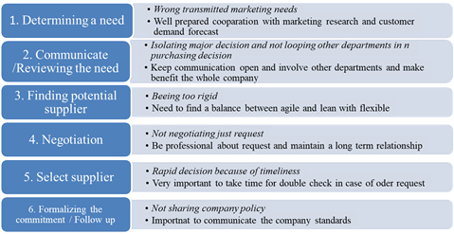
The effectiveness of company’s purchasing ability depends on the procurement system. An inefficient system leads to a whole host of purchasing problems. These mistakes aren’t all that difficult to correct.

Figure 1. Purchasing process steps and possible mistakes in procurement cycle

The most common procurement mistakes have fairly simple solutions. Various problems can be solved with technology. Some of them are a result of human error or organizational shortcomings. Even when using purchase order software, there are still some tasks that need a human touch. It’s easy for purchasing managers to get into the habit of doing things a certain way and overlook areas where the purchasing department can improve. Here are some of the common procurement mistakes.

- Ranking of suppliers
One of the most important steps of companies is to be able to create a structured image using the already existent and potential supply networks. With the help of a supplier model we can create a reviewable supplier ranking. But which are the aspects worth considering? Firstly, the structuring of suppliers is happening based on groups of materials. At factory level, the local professional purchasers are responsible for the operative tasks [5].

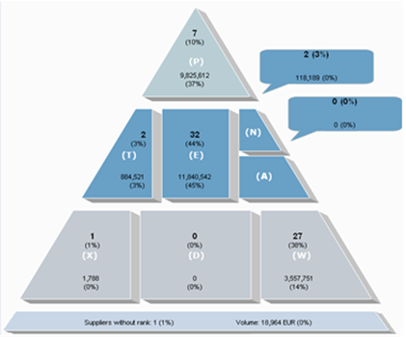

Figure 2. Supplier pyramid
The middle and long term strategical decisions are the tasks of the so-called commodity team leader, who sits at the top of the organisational structure. It is of basic relevance that a price offer can be issued only to those suppliers, who are already present among the company’s suppliers. Only in specially justified cases (a technical specialist) can such a supplier be chosen who is not among this circle of suppliers. For the sake of reviewability, the company places its partners (Figure 2.) into a supplier pyramid according to the following structure.
As a main rule, it can be said that it is needed to acquire information well before the price offer request about the current state of the suppliers classified into the given component group. Regarding each component group, the individual so-called commodity manager is finalizing the classification based on the discussions with the professional purchasers of various factories. A supplier, who held a position with priority status can also lose its position if one of the factory units’ negative experience can duly confirm this.
This database is realised in the so-called supplier pyramid, which has the following meaning.
-P: „preferred supplier” as the name suggests, the preferred suppliers of the given component group are part of this circle, in the event of a favourable price offer they can get new business without any reservation. This ranking can be obtained based on the performance, reliability, quality and other favourable characteristics proven through long years.
-T: „technical specialist” technical specialists, partners who are specialised on a given production technology’s special field. Only in justified case (the competitors are not technically able to produce the given product) do they get business.
-E: „essential” everyday partners: most suppliers belong to this group, among whom there is stiff competition going on. They are reliable partners, but from strategical reasons further ramp-up increase is not justified (it is at the limits of its capacity, its price level is not exceptionally favourable, etc).
-N: „new” suppliers: they do not get new business. In case of supplying serial components undisturbed for one year, they will step up to rank „E”.
-A: „acquired”: a theoretical group, until this very day none of the suppliers ended up in this category.
-X: „to be actively eliminated”: the group of those suppliers, with whom the business has to be laid off as soon as possible, the production equipment has to be transferred to a different supplier. There is a deliberate strategic decision lying in the background, based on which the company does not desire to continue further cooperation.
-D: „determined by customer”: the group which is required by the customers. When THE OES buyer obliges that the spare parts shipped to him can contain exclusively the units produced by the sub-supplier required by him.
-W: „without new business”: supplier that cannot get new business for some reason (problem with capacity). This ranking can be declassified after e.g. expansion of capacity. Experience shows that partners listed into this ranking will receive after longer-shorter time „essential” qualification once again, so we are talking only about a temporary state.

6. Conclusions
The companies cannot afford to choose contractors based only on their prices. It must always be a purpose that the material to be purchased have the appropriate quality, arrive in (at a) right time, in appropriate quantity from adequate sources, at correct prices [7]. To realize it, the purchasing strategy must be well planned, which is easier with the Kraljic matrix calculating the importance of the goods to be purchased and the complexity of reaching the contractors. Finally, risk analysis must be made in every case in order to face the least possible problems and unsatisfied partner relations.
At the present status of research the authors considered only a general view about the purchasing process. The study shows important model for supplier ranking. Authors are looking for the answers which mistakes can happen during the supplier selection and dedication process? How can the companies structure their supplier model and which ranking process can be used?

7. Bibliographical references
- Baily, P., Farmer D.: Purchasing (Strategy and management) (in Hungarian), Műszaki Könyvkiadó, Budapest, 1994.
- Cselényi, J., Illés, B., (ed.): Logistics systems I. (in Hungarian), Miskolci Egyetemi Kiadó, Miskolc, 2004.
- Dickson, G.W. (1966): An Analysis of Vendor Selection Systems and Decision. Journal of Purchasing, Vol. 2, No. 1 (1996), 28-41.
- Cselényi J., Illés B.: Impact of the operation of suppliers and connected logistic systems on the globalization of production. (in Hungarian), Transpack, Vol. 2 (2006), 38-42.
- Telek, P., Bányai T.: Complex design of integrated material flow systems. Advanced Logistic Systems: Theory and Practice Vol.7, No.1 (2013), 105-110.
- Nagy, G., Bányai, Á., Illés, B.: The improvement of the efficiency of purchasing by networking operation. Advanced Logistic Systems: Theory and Practice Vol.10, No. 2 (2016), 79-90.
- Nagy, G., Bányainé tóth, Á., Illés, B.: Supply Chain Optimization for Networking Production Companies. In: Michael Schenk (ed.) 10th International Doctoral Student Workshop on Logistics, Otto-von-Guericke-Universität Magdeburg, 2017, 119-124.

