XII INTERNATIONAL SCIENTIFIC CONFERENCE ON MECHANICAL ENGINEERING – COMEC 2025

Analysis of a Bicycle Traction Mechanism

Análisis de un mecanismo de tracción de bicicleta

António B. Pereira¹, José D. Mendes², Nélia M. Silva³, César Cardoso⁴

1- TEMA - Centre for Mechanical Technology and Automation, Department of Mechanical Engineering, University of Aveiro, Portugal, abastos@ua.pt
2- TEMA - Centre for Mechanical Technology and Automation, Department of Mechanical Engineering, University of Aveiro, Portugal, jmdmendes@ua.pt
3- CIDMA- Centre for Research & Development in Mathematics and Applications, Department of Mathematics, University of Aveiro, Portugal, neliasilva@ua.pt
4- Rodi Industries, S.A., Aveiro, Portugal, ccardoso@rodi.pt

Abstract: The bicycle market is experiencing global growth, driven by increased awareness of health and environmental concerns. Electric models offer pedaling assistance, combining comfort with a low environmental footprint. Both regular and electric bicycles feature a relatively complex mechanism to enable torque application in the forward direction while allowing the pedals to remain stationary when the bicycle is coasting. The rear hub of the bicycle plays a crucial role in transmitting torque during pedaling, with two main types of mechanisms: ratchet and pawl. This study analyzes the ratchet-type rear hub through numerical simulation using finite element analysis, employing a CAD model of the rear wheel. The numerical calculation considered a torque of 498 N·m on the cassette and a maximum spoke pre-tension of 1200 N, resulting in a maximum von Mises stress of 348 MPa. For simulations involving rough terrain, an impact force of 4000 N was applied, yielding a maximum stress of 203 MPa and a rim displacement of less than 1 mm.

Keywords: Bicycle; Modeling and simulation of transportation systems; Mechanical design.

Palabras Claves: Bicicleta; Modelado y simulación de sistemas de transporte; Diseño mecánico.

1. Introduction
The global bicycle market is expanding, primarily due to growing user awareness of health and environmental issues. Many consumers are increasingly opting for electric bicycles, which maintain a very low ecological footprint while offering greater comfort (Zayed, 2016, Christensen et al., 2019, Simonofski et al., (2023).
Bicycle hubs are located at the center of each wheel and, in their most basic function, support the forces applied to the wheel. The front wheel hub is relatively simple, but the rear wheel hub is more complex as it includes a mechanism to transmit the torque provided by the user while pedaling, while allowing free rotation in the opposite direction. This enables the rear wheel to spin freely in one direction while locking in the other.
There are two types of rear hub mechanisms: the ratchet system and the pawl system. Road bike hubs using the pawl drive system rely on a set of pawls that engage with an outer ring surrounding them inside the inner ring. The pawls are positioned at an angle, on a pivot, with teeth at the exterior end. Each pawl is supported by a leaf spring that pushes it outward, forcing it to mesh with the outer ring (Fig. 1).
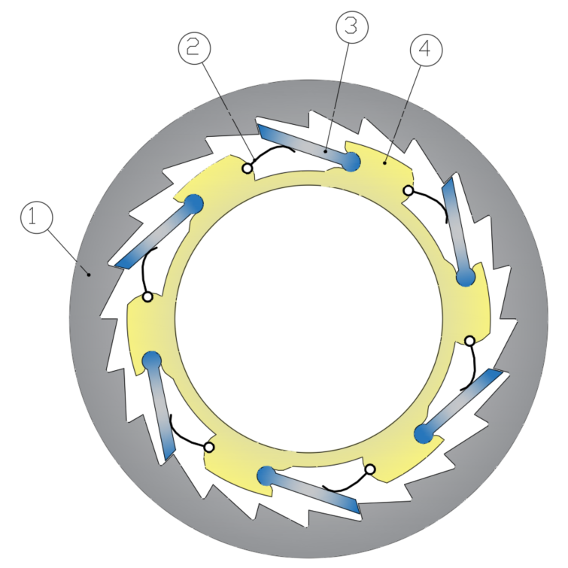
Fig. 1. Hub Pawl system: (1) Outer ring; (2) Spring; (3) Pawl; (4) Inner ring.

When pedaling, the hub rotates in a direction that counteracts the pawls' angle, locking the two components together. When not pedaling and allowing the bike to roll freely, the wheel rotates in the same direction as the pawls' angle, causing them to pivot inward.
This study evaluates a method for analyzing and calculating the rear hub of a bicycle wheel through numerical simulation using finite element analysis.

2. Methodology
Figure 2 shows a schematic of the main traction components of the bicycle under study, with dimensions listed in Table 1, where z is the number of teeth and P is the chain pitch.
Assuming a pedaling weight of 100 kg and a safety factor of 35%, with the dimensions indicated in Table 1, a torque of 498 N·m is obtained at the cassette.
Along with the weight of the bicycle structure and the user, the spoke tension and tire air pressure are the main static loads applied to the wheels. Naturally, the hub geometry directly influences the force applied to the spokes. In fact, the angles formed by the spokes relative to a central plane of the wheel are not equal, so the pre-tension forces applied to the spokes on the left and right flanges are not the same, typically being 1200 N and 800 N, respectively (Chakraborty et al., 2022) (Fig. 3).
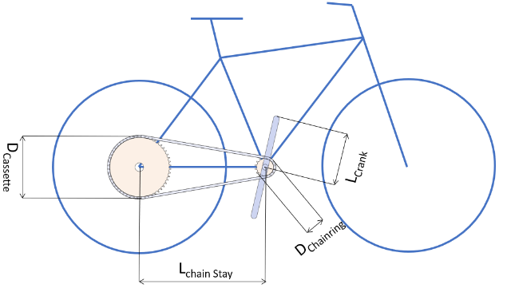
Fig. 2. Key components and their dimensions.
Table 1. Dimensions of the main components according to Fig. 2.
Z_{Chainring} | Z_{Cassette} | P_{Chain} (mm) | D_{Chainring} (mm) | D_{Cassette} (mm) | L_{Crank} (mm) | L_{ChainStay} (mm)
24 | 52 | 12.7 | 97 | 210.2 | 170 | 430
Fig. 3. Model of the rear wheel assembly of a bicycle: front view (left); visualization of different spoke angles (right).
For the maximum force acting on the rear wheel due to impacts on rough terrain, the study (De Lorenzo et al., 1999) recorded a value of 4000 N.

3. Numerical model
The simulation software used was ANSYS, with a complete CAD model of the rear wheel designed in SolidWorks. The rim has a diameter of 616 mm and 32 eyelets for spoke placement.
The finite element mesh was configured with an adaptive element size, automatically controlled by ANSYS. This method allows the software to adjust the element size based on local geometric needs, ensuring finer resolution in critical regions, such as contact areas between the spokes, hub, and rim, while coarser in non-critical regions. This optimizes simulation time without compromising processing time. The resulting mesh comprises 382,534 nodes and 88,792 elements.
In the simulation, it is necessary to separate the spoke tensioning process from the application of external forces, as forces and torques are only applied to the wheel when it has reached maximum stability. Thus, in the first simulation step, pre-tensions of 1200 N and 800 N are applied to the right and left spokes, respectively (Fig. 5).
The boundary conditions considered are:
- Fixation of the rim at the contact region with the ground, restricting displacement in all axes (Fig. 6);
- The remaining part of the rim can only move in the XY axis, being restricted in the Z axis;
- The spokes are welded to the rim and hub.
Fig. 4. Mesh of the rear wheel assembly (top) and zoomed-in view of the hub area (below).

Fig. 5. Spoke pre-tension.
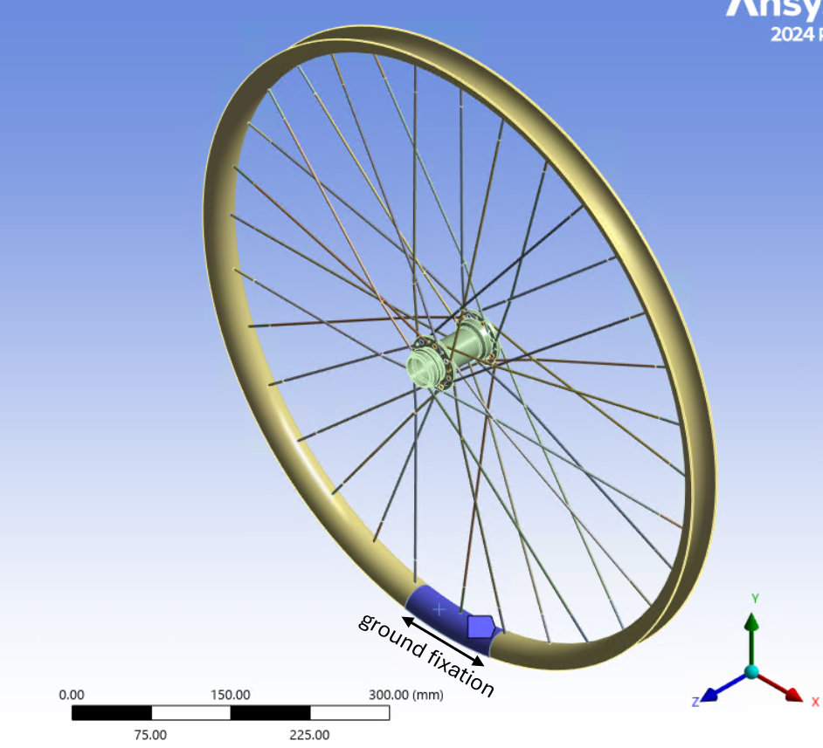
Fig. 6. Rim fixation to the ground.

4. Results and Discussion
Figure 7 shows the von Mises stress on the hub body, with a maximum value of 348 MPa for the simulation of maximum pedaling torque. Fig. 8 shows the deformation of the assembly, with a maximum value of 5 mm occurring at the rim's exterior.
Fig. 7. Von Mises stress.
Fig. 8. Assembly deformation with 16x magnification.
The simulation results for the application of a 4000 N impact force are shown in Fig. 9 for stresses and Fig. 10 and 11 for deformations. In this scenario, the maximum stress is located on the hub flanges, with a value of 203 MPa, and a maximum displacement of less than 1 mm on the rim.
Fig. 9. Von Mises stress for a 4000 N impact force.
Fig. 10. Deformation of the hub for a 4000 N impact force.
Fig. 11. Deformation of the assembly for a 4000 N impact force (magnified 55x).

5. Conclusions
The analysis of the ratchet-type rear hub, conducted through numerical simulation using finite element analysis and a complete CAD model of the rear wheel, demonstrated the following results:
- Considering a torque of 498 N·m on the cassette and a maximum spoke pre-tension of 1200 N, a maximum von Mises stress of 348 MPa was obtained.
- For the simulation on rough terrain, with an impact force of 4000 N, the maximum stress was 203 MPa, with a rim displacement of less than 1 mm.
These results highlight the effectiveness of the numerical model in evaluating the rear hub's performance under different load conditions.

6. Funding
This work was developed in the scope of the Project AM2R – Agenda Mobilizadora para a inovação empresarial do setor das Duas Rodas” [C644866475-00000012 – project n. 15], financed by PRR – Recovery and Resilience Plan under the Next Generation EU from the European Union, and has laboratory support of the Centre for Mechanical Technology and Automation (TEMA).

7. Bibliographic references
Zayed, M. (2016). Towards an index of city readiness for cycling. International Journal of Transportation Science and Technology 5(3), 210–225.
Christensen, H. R. (2019). Smart Biking as Gendered Innovations? The Case of Mobike in China. Lecture Notes in Computer Science 11596, 368-377.
Simonofski, A., Handekyn, P., Vandennieuwenborg, C., Wautelet, Y., Snoeck, M. (2023). Smart mobility projects: Towards the formalization of a policy-making lifecycle. Land Use Policy 125, 106474.
Chakraborty, A., R, S., and Kanhai, P. (2022). Design Optimization of Bicycle Wheel Hub Assembly for Automotive Applications, SAE Technical Paper 2022-01-0262.
De Lorenzo, D. S., Hull, M. L. (1999). A hub dynamometer for measurement of wheel forces in off-road bicycling. Journal of Biomechanical Engineering, 121 (4), 487-493.

