XII INTERNATIONAL SCIENTIFIC CONFERENCE ON MECHANICAL ENGINEERING – COMEC 2025

Embedded Temperature Control for E-bikes Battery Heating

Control de Temperatura Embebido para Calentamiento de Baterías en Bicicletas Eléctricas

José P. Santos¹, Adriano Figueiredo², Tiago Gândara³

1- TEMA - Centre for Mechanical Technology and Automation, Department of Mechanical Engineering, University of Aveiro, Portugal, jps@ua.pt
2- TEMA - Centre for Mechanical Technology and Automation, Department of Mechanical Engineering, University of Aveiro, Portugal, adrianofigueiredo7@ua.pt
3- TEMA - Centre for Mechanical Technology and Automation, Department of Mechanical Engineering, University of Aveiro, Portugal, gandarat11@ua.pt

Abstract: This study evaluates three control strategies—On/Off (Switch), Proportional-Integral-Derivative (PID), and Fuzzy Logic Control (FLC)—for temperature regulation in a low-cost embedded thermal system. Using an ESP32 microcontroller and a lithium-ion battery cell as a case study, each method was implemented and tested under identical conditions. The results indicate that while the On/Off controller is simple, it suffers from significant overshoot and instability. The PID controller improves stability but is sensitive to parameter tuning. In contrast, the FLC demonstrates superior performance in maintaining temperature within the desired range, reducing energy consumption, and adapting to system behavior. The findings suggest that fuzzy logic offers an effective, efficient solution for thermal control in resource-constrained embedded applications.

Keywords: Temperature control, Fuzzy Logic Controller, PID, On/Off control, Embedded system

Palabras Claves: Control de temperatura; Controlador Lógico Difuso; PID; Control On/Off; Sistema embebido;

1. Introduction
The electrification of transportation has emerged as a key strategy to reduce greenhouse gas emissions and dependence on fossil fuels [1]. With continuous advancements in battery technology, power electronics, and energy management systems, electric vehicles (EVs) are becoming increasingly accessible across different market segments. While electric cars and buses have received significant attention, electric bicycles (e-bikes) have rapidly gained popularity due to their affordability, energy efficiency, and practicality for urban mobility [2]. E-bikes combine human power with electric assistance, offering a sustainable and convenient solution for short- to medium-distance travel. As their adoption increases globally, ensuring reliable and efficient operation, even under challenging environmental conditions such as cold weather, has become a priority for both users and manufacturers.
In cold climates, the performance of lithium-ion batteries significantly deteriorates due to increased internal resistance and decreased ion mobility, leading to a substantial reduction in energy capacity and overall system efficiency [3]. This limitation poses a critical challenge in various applications, particularly in electric mobility, where maintaining thermal stability is essential to preserve functionality and extend battery life. As a result, heating systems have become a necessary solution to recover the operating temperature of battery cells in low-temperature environments, often relying on control mechanisms to balance energy consumption and heating effectiveness [4].
Control systems are a cornerstone of modern engineering, enabling the regulation of key variables such as temperature, pressure, and speed across diverse domains, from industrial processes to embedded consumer devices. Their role is essential to ensure stability, performance, and safety in both complex and simple systems [5]. In many real-world applications, especially those involving low-order dynamics, the central challenge lies not in developing sophisticated models, but in selecting a control strategy that balances accuracy, responsiveness, and ease of implementation [6].
This article proposes a comparative study of these three approaches in the context of temperature regulation for a simplified heating setup, simulating conditions similar to external battery heating. The goal is to evaluate each method in terms of stability, overshoot, response time, and energy efficiency, thereby identifying the most suitable control strategy for low-cost embedded systems operating in thermally constrained environments.

2. Related Works
Temperature control systems are essential in numerous industrial and consumer applications, where thermal stability and energy efficiency are critical requirements. Traditional methods such as On/Off (hysteresis) control have long been used due to their simplicity and ease of implementation [7]. However, they often result in oscillatory behavior and poor thermal stability, particularly in systems with slow response or overshoot sensitivity [7, 8].
To improve control precision, Proportional-Integral-Derivative (PID) controllers have been extensively applied. PID control remains one of the most widely used techniques in industrial automation due to its balance between responsiveness and simplicity. Despite its popularity, tuning PID parameters in systems without a clear mathematical model can be challenging and time-consuming, often requiring empirical approaches such as Ziegler-Nichols or trial-and-error strategies [8, 9, 10].
As systems become more complex, intelligent control strategies such as Fuzzy Logic Controllers (FLCs) have gained increasing attention. FLCs enable the integration of expert knowledge into rule-based systems, offering advantages in handling nonlinearities and uncertainties, particularly when a precise mathematical model of the system is unavailable [7, 11]. This methodology has shown strong performance, achieving results comparable to those obtained through Dynamic Programming (DP), which is known for yielding near-optimal solutions [4]. However, unlike DP, which is often computationally intensive and impractical for real-time embedded systems, FLCs offer a lightweight and efficient alternative that is well-suited for implementation in constrained environments [4]. Furthermore, due to their empirical and adaptive nature, FLCs often outperform conventional PID or PI controllers, as reported by several authors in the literature [12, 13].
Given the limitations observed in traditional control approaches, namely the instability of On/Off methods and the tuning challenges of PID controllers, this work aims to explore and compare the effectiveness of a fuzzy logic-based controller in maintaining temperature within a defined range for a lithium-ion battery cell. By implementing all three strategies (On/Off, PID, and FLC) on the same experimental platform using an ESP32 microcontroller, the goal is to quantitatively assess performance in terms of stability, overshoot, energy efficiency, and response time. This comparative analysis not only highlights the practical advantages of intelligent control in embedded systems but also provides a foundation for future developments in adaptive and self-learning temperature control mechanisms.

3. Methodology and Experimental Setup
To determine the simplest type of elementary algorithm for temperature control, three distinct control strategies were tested: the Switch (On/Off) mode, a PID controller, and an FLC. For all the developed algorithms, the test lasted approximately 8 minutes (480 seconds), which was sufficient for the system to reach equilibrium in all cases. Additionally, the test duration was divided into 1-second intervals, during which the algorithms had to determine the time duration for current flow (i.e., the heating period). The objective of the experimental tests was to control the temperature of battery cell around 40°C, specifically within the range of 35°C to 45°C.
For the experiments conducted, an ESP32 microcontroller, a MAX6675 amplifier, a K-type thermocouple, a Solid-State Relay (SSR), and a lithium-ion battery cell were used, as shown in Figure 1. The ESP32 was responsible for controlling the electrical current flow via the SSR, determining whether heating should occur to ensure the desired temperature was achieved. To facilitate subsequent data processing, all collected data were stored in a database. Additionally, it is also important to note that the response of all algorithms was instantaneous, which is why processing time was not considered as one of the evaluation parameters.
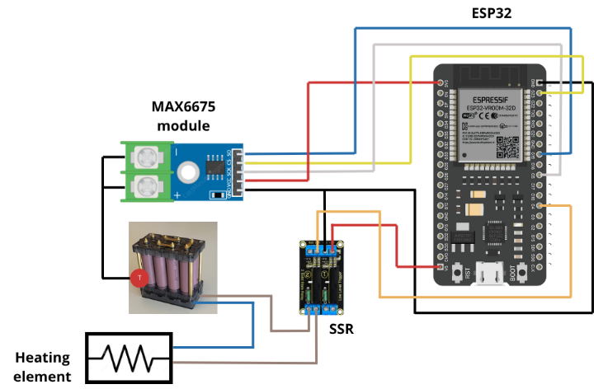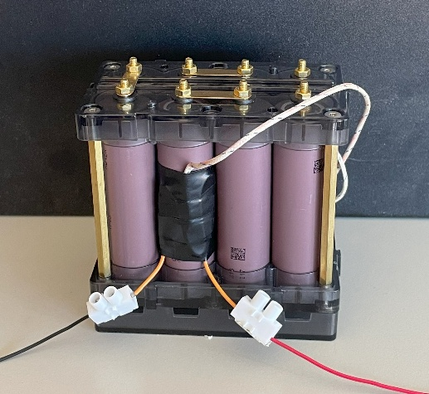
Fig. 1 – Electronic schematic (left) and experimental setup (right).

4. Experimental Results
4.1. Development of the Switch (On/Off) Mode
For the Switch control mode, heating was allowed only when the measured temperature was below the minimum acceptable threshold, i.e., 35°C. This strategy was defined to mitigate overshoot, as the controlled temperature could rise rapidly if current were applied for an extended period. The temperature values were measured every second and if the recorded temperature was below 35°C, current would flow in the following second until the temperature was measured again, with this process repeating continuously. Based on this strategy, the results presented in Figure 2 were obtained.
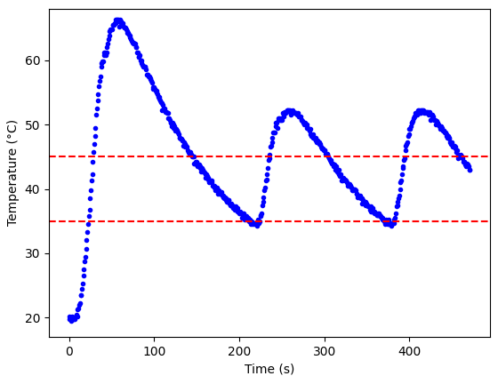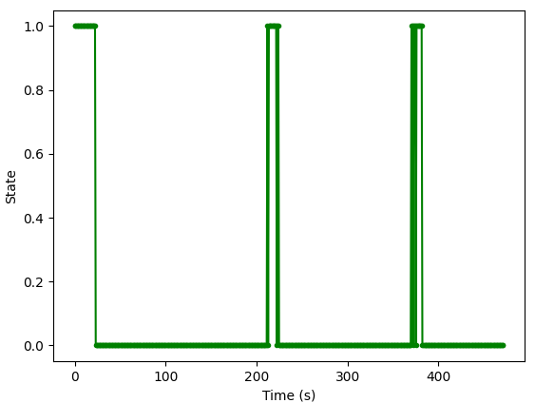
Fig. 2 – Temperature of the battery cell (left) and heating state for the Switch mode (right).
Based on the obtained results, it can be observed that there is an initial rapid increase in temperature beyond the acceptable range, reaching values above 60°C. After reaching this peak, the temperature gradually decreases until it reaches 35°C again, at which point a new heating cycle begins. Since the temperature increase is not instantaneous, the heating process lasts for a few seconds, causing the temperature to rise again above the desired value. These results indicate that a system based on binary (On/Off) control philosophy is not the most suitable approach for temperature regulation.

4.2. Development of the PID Controller
As observed, despite the simplicity of the system being controlled, a controller that only switches on and off based on a predefined setpoint does not yield satisfactory results. Therefore, a PID controller was developed to achieve a more robust solution. Initially, the parameters were selected in a generic and arbitrary manner and were later fine-tuned to obtain the desired system response. This adjustment was performed through a trial-and-error approach, as the mathematical model of the system is not available. If such a model existed, parameter tuning could have been carried out more efficiently using advanced tools or methods such as Ziegler-Nichols [8]. In this type of controller, as mentioned, the input was the measured temperature of the battery cell, while the output was the percentage of time for which heating should occur.
The PID controller developed with the best performance was obtained using proportional, integral, and derivative gains of 5, 1.5, and 0.1, respectively. Additionally, the target temperature (setpoint) was defined as 38°C to achieve a balance between reduced overshoot and maintaining the temperature within the desired range during steady-state operation. Based on the controller described, the results presented in Figure 3 were obtained. These results demonstrate that the developed system performs well, maintaining the temperature within the desired range after reaching equilibrium. However, as in the Switch mode, an overshoot was observed, with temperatures exceeding 55°C.
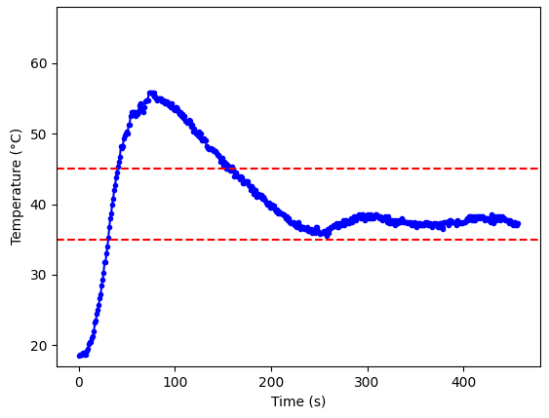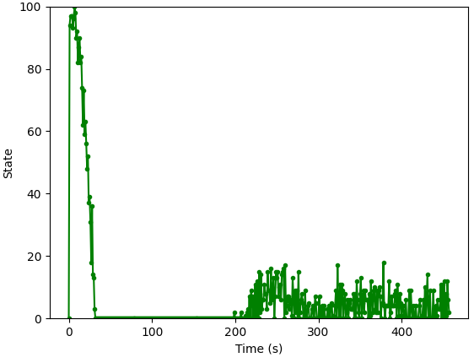
Fig. 3 – Temperature of the battery cell (left) and heating state for the PID controller (right).

4.3. Development of the controller based in diffuse logic (FLC)
Finally, a controller based on fuzzy logic was developed, allowing the system's behavior (rules) to be defined based on experience and intuition. Two system inputs were implemented: the temperature of the battery cell and the difference between the current and previous temperatures. The measured temperature was divided into four fuzzy sets ("Very Low," "Low," "Ok," and "High"), while the temperature difference was divided into three ("Fast Rise," "Stability," and "Fast Growth"). Similarly to the PID controller, the output was defined as the percentage of time during which heating should occur, and was divided into four sets ("Off," "Low," "Medium," and "High").
On the other hand, the rules were defined considering the system's behavior, which exhibits a rapid temperature rise if heating occurs for a significant period. On the other hand, cooling is slow, which implies that the temperature should not exceed the maximum allowable limit, as the return to normal will be gradual. Therefore, the 12 defined rules (4x3 fuzzy sets) took these characteristics into account to ensure efficient temperature control.
After conducting the tests, it was possible to obtain the results presented in Figure 4. It can be observed that the temperature rises to values within the defined range. Additionally, the algorithm's ability to maintain the temperature within the desired range is evident. Finally, it is also noticeable that there is periodicity in the system's response, with the output being similar each time the temperature starts to decrease, making the output easily predictable.
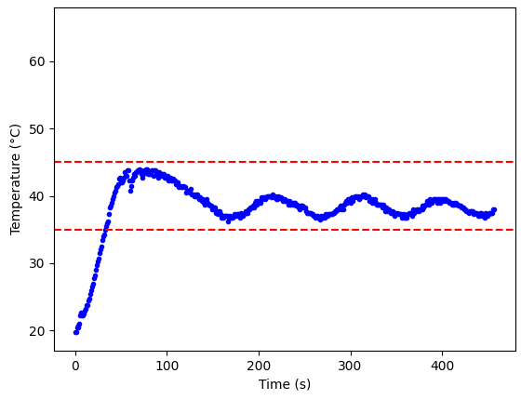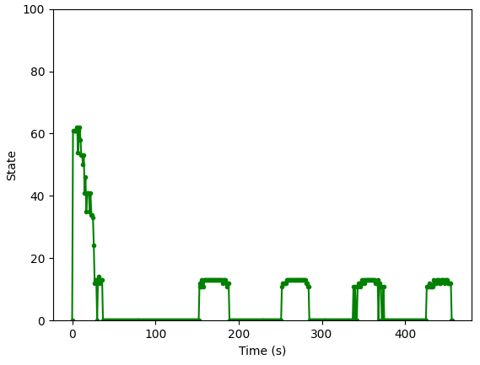
Fig. 4 – Temperature of the battery cell (left) and heating state of the FLC (right).

4.4. Comparative Analysis of the algorithms
Finally, relevant parameters were quantitatively analyzed, including the percentage of time the temperature stayed within the desired range, the percentage of time during which heating occurred, and the time taken to reach the minimum allowable value, as shown in Figure 5.
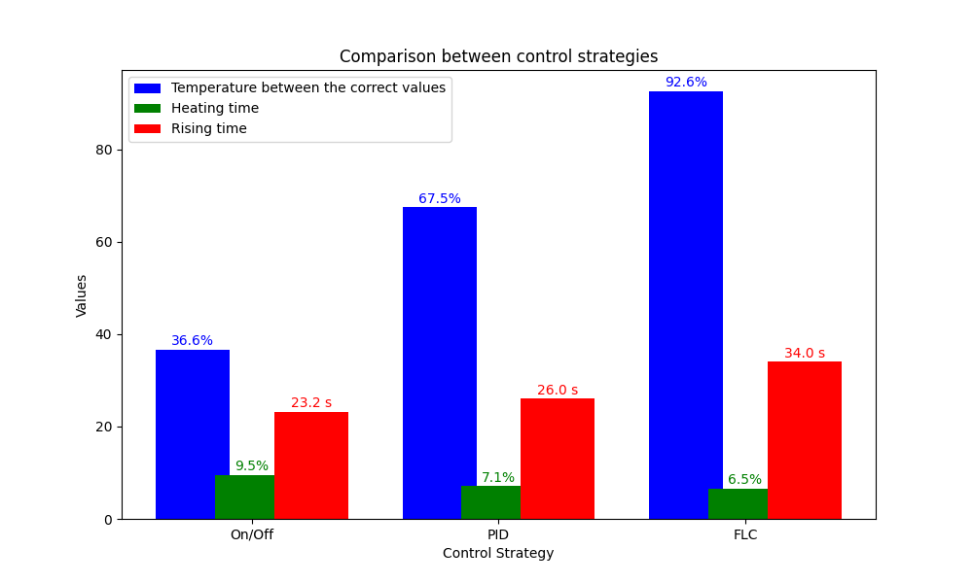
Fig. 5 – Comparison between relevant parameters of the control strategies tested, namely temperature in the pretended values and heating and rising time.
Regarding the percentage of time the temperature stayed within the desired range, it can be observed that the FLC stands out as the algorithm with the best performance. On the other hand, the PID controller showed intermediate performance, maintaining the temperature within the desired range for 67.5% of the time, while the SWITCH mode exhibited the worst performance (36.6%). These performance differences are related to the ability of each method to adapt to varying operating conditions. Thus, the binary control of the SWITCH mode, being more rudimentary, faces greater challenges in maintaining a stable temperature. On the other hand, the PID controller, due to its reliance on initial parameters, while effectively controlling the temperature once equilibrium is reached, struggles to avoid overshooting, which causes the temperature to remain outside the desired range for a considerable period. Finally, the FLC, due to the rules defined based on experience and considering the system's behavior, is able to adapt to different conditions and phases of the system, keeping the temperatures between the predefined limits.
On the other hand, it was observed that the FLC allowed current flow and heating for a shorter period, highlighting greater energy efficiency. Finally, it was found that the SWITCH mode exhibited the shortest rise time to the desired temperatures (23.2 seconds), followed by the PID (26 seconds), with the FLC being the algorithm with the longest rise time (34 seconds). Although this is an important parameter, the shorter rise times of the PID and SWITCH modes were accompanied by considerable overshoot, which is undesirable.
In conclusion, it can be observed that the FLC demonstrates the best performance for temperature control, as it provides greater thermal stability while using less energy. On the other hand, the PID controller presents a trade-off between rising time and stability, making it a viable alternative when a system is required to reach the desired values quickly. Finally, the SWITCH mode exhibited the lowest performance, highlighting the inability of simpler strategies to efficiently control thermal systems.
Thus, for applications that require high precision in maintaining temperature within a specific range, the implementation of fuzzy logic is a suitable option. Alternatively, the PID controller can also be a viable choice; however, correctly tuning its parameters is crucial, which can be challenging in cases where no mathematical model is available to approximate an optimal solution.

5. Conclusions and Future Work
This study evaluated three different control strategies (On/Off, PID, and Fuzzy Logic) for temperature regulation in a low-complexity thermal system, using an embedded platform based on the ESP32 microcontroller. The results demonstrate clear differences in performance between the approaches. The On/Off method, although simple, exhibited poor thermal stability and significant overshoot, proving inadequate for precise temperature control. The PID controller showed improved performance but remained sensitive to parameter tuning and still produced non-negligible overshoot.
In contrast, the Fuzzy Logic Controller consistently maintained the temperature within the desired range for a longer duration, with minimal overshoot and lower energy consumption. This indicates that rule-based intelligent control, even when implemented in a resource-constrained environment, can provide more robust and adaptive behavior than conventional methods.
Therefore, for applications that require thermal stability without relying on a precise mathematical model, FLC presents itself as a highly effective alternative. PID control remains viable when adequate tuning is possible, while On/Off control is best reserved for non-critical or highly tolerant systems.
In the future, the goal is to develop an artificial intelligence-based controller capable of dynamically adapting to distinct types of systems, allowing training to occur during operation. This will provide greater versatility to the monitoring and control system, facilitating its integration into new environments through a real-time calibration process. To achieve this, the development of efficient adaptation and generalization algorithms will be essential, ensuring that the controller can learn from new scenarios without compromising performance. Additionally, research will focus on optimizing response times and minimizing the need for manual intervention, ensuring continuous and autonomous adaptation to different operating conditions.

6. Funding
This work was supported by the PRR – Plano de Recuperação e Resiliência and by the NextGenerationEU funds at Universidade de Aveiro, through the scope of the Agenda for Business Innovation “AM2R - Agenda Mobilizadora para a inovação empresarial do setor das Duas Rodas”. This work was also supported by the projects UIDB/00481/2020 and UIDP/00481/2020-Fundação para a Ciência e a Tecnologia, DOI 10.54499/UIDB/00481/2020 (https://doi.org/10.54499/UIDB/00481/2020) and DOI 10.54499/UIDP/00481/2020 (https://doi.org/10.54499/UIDP/00481/2020).

7. Bibliographic references
1 J. Y. Yong, V. K. Ramachandaramurthy, K. M. Tan, and N. Mithulananthan, “A review on the state-of-the-art technologies of electric vehicle, its impacts and prospects,” Renewable and Sustainable Energy Reviews, vol. 49, pp. 365–385, May 2015, doi: 10.1016/j.rser.2015.04.130.
2 Mordor Intelligence. “Europe E-bike Market - Growth, Trends, COVID-19 Impact, and Forecasts (2023-2028)”. (2024), URL: https://www.mordorintelligence.com/industryreports/europe-e-bike-market
3 J. R. M. D. Reyes, R. V. Parsons, and R. Hoemsen, “Winter happens: The effect of ambient temperature on the travel range of electric vehicles,” IEEE Transactions on Vehicular Technology, vol. 65, no. 6, pp. 4016–4022, Mar. 2016, doi: 10.1109/tvt.2016.2544178.
4 S. Zhang, T. Li e L. Chen, “Fuzzy Logic Control of External Heating System for Electric Vehicle Batteries at Low Temperature”, World Electric Vehicle Journal, vol. 14, n.º 4, 2023. doi: 10.3390/wevj14040099.
5 K. Ogata, Modern Control Engineering, 5th ed., Prentice Hall, 2010.
6 K. J. Åström and R. M. Murray, Feedback Systems: An Introduction for Scientists and Engineers, Princeton University Press, 2008.
7 Z. M. Ali, F. Jurado, F. H. Gandoman and M. Ćalasan, “Advancements in battery thermal management for electric vehicles: Types, technologies, and control strategies including deep learning methods”, Ain Shams Engineering Journal, vol. 15, n.º 9, p. 102 908, 2024, issn: 2090-4479. doi: 10.1016/j.asej.2024.102908.
8 J. G. Ziegler and N. B. Nichols, “Optimum settings for automatic controllers,” Transactions of the American Society of Mechanical Engineers, vol. 64, no. 8, pp. 759–765, Nov. 1942, doi: 10.1115/1.4019264.
9 Åström, K. J., & Hägglund, T. (2006). Advanced PID Control. ISA – The Instrumentation, Systems, and Automation Society.
10 M. Gopal, Control Systems: Principles and Design, 4th ed., McGraw-Hill Education, 2012.
11 J. Wang, Z. Lu and G. Wang, “Design and Application of Temperature Control System Based on Fuzzy PID Algorithm”, in 2022 7th International Conference on Intelligent Computing and Signal Processing, ICSP 2022, Institute of Electrical e Electronics Engineers Inc., 2022, pp. 156–161. doi: 10.1109/ICSP54964.2022.9778658.
12 S. Ahmed, A. Rizwan, F. AtaAllah, H. Rehman, S. Mukhopadhyay e R. Dhaouadi, “EV Traction System’s Battery Thermal Analysis using Fuzzy Logic and PI Controller”, in 2023 International Aegean Conference on Electrical Machines and Power Electronics (ACEMP) & 2023 International Conference on Optimization of Electrical and Electronic Equipment (OPTIM), 2023, pp. 1–7. doi: 10.1109/ACEMP-OPTIM57845.2023.10287059.
13 X. Chen, J. Xu, Y. Fang, W. Li, Y. Ding, Z. Wan, X. Wang e Z. Tu, “Temperature and humidity management of PEM fuel cell power system using multi-input and multioutput fuzzy method”, Applied Thermal Engineering, vol. 203, p. 117 865, 2022. doi: 10.1016/j.applthermaleng.2021.117865.

