COMEC 2025: XII International Scientific Conference on Mechanical Engineering

Technological Innovation and Efficiency in the Sugar Industry: Datazucar's Versat Assistant and AI-Driven Knowledge Transformation

Innovación Tecnológica y Eficiencia en la Industria Azucarera: El Asistente Versat de Datazucar y la Transformación del Conocimiento con IA

Andrey Vinajera-Zamora¹, Elia Teresa Cardenas-Acosta², Amanda González-Cabrera³, …

1- DATAZUCAR, Cuba. E-mail: andrey.vinajera@datazucar.cu, ORCID: 0000-0002-4922-457X
2- DATAZUCAR, Cuba. E-mail: elia.cardenas@datazucar.cu, ORCID: 0000-0002-2398-6701
3- DATAZUCAR, Cuba. E-mail: amanda.gonzalez@datazucar.cu

Abstract: (The abstract must be structured and must not exceed 250 words in length).
- Problem to deal with: The management of technical knowledge for complex industrial software, such as the Versat ERP used by over 20,000 clients in the sugar industry, represents a significant logistical challenge. Traditional support methods based on static documentation and human experts present scalability and efficiency limitations, impacting operational productivity.
- Aims: This research aims to design, implement, and evaluate the functional viability of a sovereign (on-premise) conversational AI platform, named "Versat Assistant," to optimize knowledge management and technical support for industrial software.
- Methodology: The proposed solution is based on a Retrieval-Augmented Generation (RAG) architecture, orchestrated via Docker Compose. The prototype was developed and tested in a CPU-only environment (Intel Core i9, 16GB RAM) using a stack of open-source components, including FastAPI, Streamlit, Ollama, Milvus, and PostgreSQL. A comparative performance analysis of small-scale language models (Qwen3: 0.6B, 1.7B, and 4B) was conducted using an AI-assisted evaluation methodology with Google Gemini 1.5 Pro to assess response quality across a taxonomy of technical queries.
- Results and Discussion: The results validate the functional viability of the RAG architecture, even on general-purpose hardware. A clear positive correlation was found between model parameter size and performance on complex inferential tasks. The qwen3:4b model was identified as a robust baseline for an initial production environment, achieving an average score of 8.0/10. The main limitation identified was not logical failure but high inference latency, empirically justifying the planned transition to a GPU-accelerated production infrastructure.
- Conclusions: This study demonstrates a pragmatic, phased approach to adopting sovereign AI in industrial settings. It provides a detailed case study of implementing an on-premise RAG system, validating its architecture with limited hardware, and establishing a data-driven roadmap for future scaling.

Abstract: This paper details the "Versat Assistant" project, a strategic initiative by Datazucar to implement an Artificial Intelligence (AI) infrastructure aimed at optimizing operational efficiency and transforming knowledge management in the sugar industry. This project establishes a conversational AI platform, based on locally hosted advanced language models (Qwen3), which will integrate with technologies like n8n for task automation, thereby enhancing overall productivity. A core component is its application as a primary knowledge source for Versat software technical support, enabling both internal staff and clients to quickly and accurately access solutions, clarify doubts, and consult documentation. The solution utilizes a Retrieval Augmented Generation (RAG) architecture to provide contextualized answers. It is envisioned that this infrastructure will not only modernize Versat's technical support but also serve as a foundation to enhance other AI projects at Datazucar and optimize the software development lifecycle. The GPU infrastructure requirement is addressed, positioning the "Versat Assistant" as a catalyst for modernization, improved customer service, and the consolidation of a competitive advantage through AI at Datazucar and the sugar sector.

Keyswords: Artificial Intelligence; Industrial Engineering; Knowledge Management; Operational Efficiency; RAG; Conversational Assistant.

Palabras Claves: Inteligencia Artificial; Ingeniería Industrial; Gestión del Conocimiento; Eficiencia Operativa; RAG; Asistente Conversacional.

1. Introduction
The global sugar agro-industry faces constant pressure to modernize its operations to enhance efficiency and sustainability. In this context, the effective management of enterprise software is a critical component. For organizations like Datazucar, which provides software to over 20,000 clients, technical support and knowledge management represent a large-scale logistical challenge. While Large Language Models (LLMs) and Retrieval-Augmented Generation (RAG) architectures promise to revolutionize this paradigm (Lewis et al., 2020), most implementations rely on cloud-based solutions and specialized GPU hardware. This creates a practical gap in the literature: a lack of studies detailing a phased development strategy, where a sovereign (on-premise) RAG architecture is first functionally validated in an accessible CPU-only environment before scaling to a GPU-accelerated production infrastructure.
The "Versat Assistant" project addresses this gap by following a pragmatic, phased roadmap. The current phase, object of this paper, focuses on validating the software architecture on a standard workstation (Dell Precision, Core i9, 16GB RAM) operating in CPU-only mode. This approach allows decoupling challenges: first, solving the software and RAG logic complexity, and then, in a second phase, addressing performance optimization via deployment on a dedicated server infrastructure with GPUs, which is currently under acquisition. The central hypothesis is that a RAG architecture, using small-scale quantized language models (e.g., Qwen3 < 5B parameters), can achieve an acceptable level of functional correctness in a CPU-only environment, thereby validating the software architecture independently of the final hardware infrastructure.

2. Methodology
The methodology employed for the development of the "Versat Assistant" is based on a pragmatic software engineering approach, prioritizing the use of open-source components to build a robust, scalable, and sovereign solution. This section describes the overall system design, the experimental infrastructure, the selected technological stack, and the detailed process for constructing the knowledge base.

2.1. Overall Solution Design: "Versat Assistant"
The architecture of the Versat Assistant is conceived as a microservices system orchestrated by Docker Compose, which ensures the isolation and independent management of each component. The design follows a decoupled web application pattern, with a frontend communicating exclusively with a backend via a RESTful API, allowing for greater flexibility in the future development and scaling of the user interface.
The data flow, illustrated in Figure 1, follows a Retrieval-Augmented Generation (RAG) pattern. It begins with the user's query in the frontend (Streamlit), which is sent to the backend (FastAPI). The backend acts as the system's central orchestrator: (1) it vectorizes the query using an embedding model served by Ollama; (2) it performs a similarity search in the vector database (Milvus) to retrieve the most relevant text fragments from the Versat documentation; (3) it constructs an augmented prompt that combines the original question with the retrieved context; and (4) it sends this enriched prompt to the generative language model (Qwen3) in Ollama to synthesize a final answer, which is then returned to the frontend.
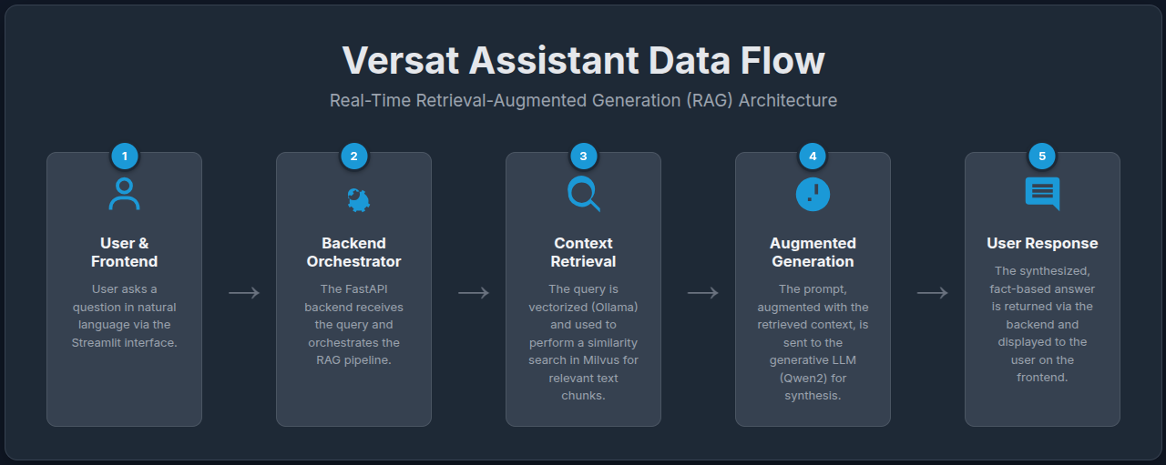
Figure 1. Data Flow of the Versat Assistant.

2.2. Infrastructure and Technological Stack
Experimental Infrastructure: The entire prototyping and development phase has been conducted on a portable workstation (a Dell Precision laptop equipped with an Intel Core i9 processor and 16 GB of RAM), operating exclusively in a CPU-only mode. This environment represents a realistic scenario for agile software validation prior to investment in specialized hardware. The transition to production envisages deployment on a dedicated server infrastructure with high-capacity GPUs (≥24 GB of VRAM).
Technological Stack:
- Model Server (Ollama): Employed as the inference engine. Its efficiency in running language models on CPU was a decisive factor for the prototyping environment.
- Databases (Milvus and PostgreSQL): The system uses a dual-database architecture. Milvus was chosen for its high performance in large-scale similarity searches. PostgreSQL is used to store structured data, such as conversation histories.
- Backend and Frontend (FastAPI and Streamlit): The backend was developed with FastAPI for its asynchronous performance. For the frontend, Streamlit was selected for its capacity to enable extremely rapid prototyping of the user interface, which is crucial in this initial phase (see Figure 2).
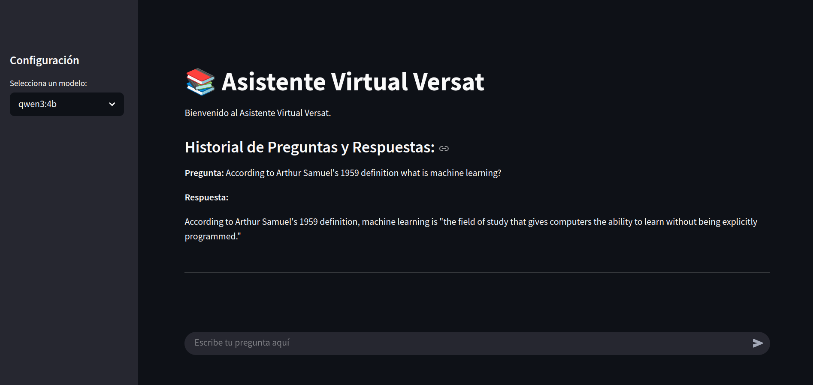
Figure 2. User Interface of the Versat Assistant Prototype.
Language Models Used: Given the CPU-only constraint, quantized models from the Qwen3 family were selected: qwen3:0.6b, qwen3:1.7b, and qwen3:4b, along with the nomic-embed-text embedding model. This strategic selection allows for an agile development cycle while planning the future scaling to larger models.

2.3. Knowledge Base Construction Process (RAG Pipeline)
The methodology to transform Versat's static documentation into a dynamic knowledge base constitutes the core of the project. This ingestion pipeline consists of the following steps:
- Text Extraction: Source documents (PDF, Word) are processed to extract raw textual content.
- Semantic Chunking: The text is divided into smaller "chunks" using a recursive segmentation strategy to preserve semantic coherence.
- Vectorization (Embedding): Each chunk is sent via API to Ollama, which uses the nomic-embed-text model to convert its semantic content into a numerical vector.
- Indexing in Milvus: The resulting vector, along with the original text and metadata, is stored in a Milvus collection, optimized for high-speed similarity searches.
3. Results and Discussion
This section presents the findings from the prototype validation phase. The evaluation was designed to analyze the impact of language model size on the performance of the RAG architecture in a CPU-only environment.3.1. Experimental Design and AI-Assisted Evaluation Methodology
The experiment was structured around a taxonomy of five task categories of increasing inferential complexity: Factual Extraction (FE), Concept Definition (CD), Synthesis and Summary (SS), Comparison and Relation (CR), and Causal or Conceptual Analysis (CCA). A representative test set of questions was compiled in Spanish and English. To ensure an objective evaluation, an AI-assisted methodology was implemented: each response from the Qwen3 models was rated by a larger, more capable language model, Google Gemini 2.5 Pro, acting as an "expert evaluator." Gemini was provided with the original question, the retrieved context (ground truth), and the model's answer, and was instructed to score the quality from 1 to 10 and identify the failure mode.

3.2. Comparative Performance Analysis of the Models
The analysis revealed a strong, predictable correlation between model size and performance, especially on high-complexity tasks.
- qwen3:0.6b Model (Baseline Performance): This ultra-lightweight model proved functional only for the simplest tasks. For Factual Extraction (FE), it scored 7/10, with its primary failure mode being Omission if the fact was not the central focus of the retrieved chunk. In high-inference tasks like Synthesis (SS) and Causal Analysis (CCA), its performance was poor (scores of 4/10 and 3/10, respectively), showing a high propensity for Omission of key information and Hallucination.
- qwen3:1.7b Model (Qualitative Leap): This model represented a significant improvement. It achieved competent scores in Concept Definition (7.5/10) and Synthesis (7.0/10), demonstrating an ability to paraphrase and integrate information coherently. For Comparison & Relation (6.5/10) and Causal Analysis (6.0/10), the model could perform simple inferences if the context was explicit, although Conceptual Misinterpretation remained a risk. This model stands as the minimum viable option for a basic functional assistant.
- qwen3:4b Model (Production Baseline): The 4B model proved to be a robust option. It achieved near-perfect performance on low-inference tasks (FE: 9/10, CD: 9/10) and showed markedly superior capabilities in high-inference tasks, such as Synthesis (8/10). In the most complex tasks (CR: 7/10, CCA: 7/10), it displayed an emergent ability to perform simple logical inferences. The primary risk shifted from coarse confabulation to subtle hallucination, where it could construct plausible justifications not directly supported by the text.
Table I consolidates these results, averaging the performance as evaluated by Gemini.
Type of question | Qwen3 family’s model
Type of question | 0.6b | 1.7b | 4b
Factual extraction | 7 | 8 | 9
Concept Definition | 6 | 7.5 | 9
Synthesis and Summary | 4 | 7 | 8
Comparison and Relation | 3 | 6.5 | 7
Causal or Conceptual Analysis | 3 | 6 | 7
Mean | 4.6 | 7 | 8

4. Conclusions
The quantitative results from the AI-assisted evaluation affirmatively answer the central research hypothesis: an on-premise RAG architecture is functionally viable even with small-scale language models. The 7.0/10 average performance of the qwen3:1.7b model already represents a significant improvement over manual search methods, thus validating the software architecture. More importantly, the comparative analysis demonstrates that the qwen3:4b model (8.0/10) establishes a robust baseline for production. Unlike studies such as Németh et al. (2024), which validate RAG with powerful cloud models, our work quantifies the performance on the lower end of the spectrum with open-source models, offering a practical contribution for organizations seeking sovereign, cost-controlled solutions.
The analysis by task type reveals a critical limitation: performance, even with the 4B model, degrades on high-inference tasks like Causal Analysis (7/10). In comparison to Patil et al. (2025), who report a single aggregate metric, our granular breakdown provides a more nuanced view, indicating that accuracy is not monolithic. The primary limitation of the prototype is therefore not latency (an expected consequence of the CPU environment), but the intrinsic reasoning capability of the models. This finding is strategically important, as it proves that the planned investment in a GPU infrastructure is crucial not only to accelerate response times but, more fundamentally, to unlock the qualitatively superior reasoning capabilities of larger models (e.g., qwen3:30b), which are indispensable for resolving the most complex technical support scenarios.
The practical implications of this research are direct. For Datazucar, the project risk has been mitigated by validating the architecture with minimal investment, and a clear business case for specialized hardware acquisition has been established. The originality of this work lies in the presentation of a realistic, quantified, end-to-end case study on the adoption of sovereign AI, from validation on general-purpose hardware to a data-driven scaling roadmap, in an industrial domain (sugar industry ERP software) previously unexplored in the literature.
In conclusion, the Versat Assistant is positioned as a catalyst for digital transformation at Datazucar. The performance analysis validates the architecture and justifies the investment in GPU infrastructure as the logical next step. This project establishes a scalable, sovereign AI base platform with the potential to expand into more complex automations and to optimize not only support but the entire software development lifecycle, thereby consolidating a durable competitive advantage.
5. Bibliographic references
Lang, G., & Gürpinar, T. (2025). AI-Powered Learning Support: A Study of Retrieval-Augmented Generation (RAG) Chatbot Effectiveness in an Online Course. Information Systems Education Journal, 23(2), 4-13.
Gamage, G., Mills, N., De Silva, D., Manic, M., Moraliyage, H., Jennings, A., & Alahakoon, D. (2024, March). Multi-agent RAG chatbot architecture for decision support in net-zero emission energy systems. In 2024 IEEE International Conference on Industrial Technology (ICIT) (pp. 1-6). IEEE.
Khan, U. H., Khan, M. H., & Ali, R. (2025). Large Language Model based Educational Virtual Assistant using RAG Framework. Procedia Computer Science, 252, 905-911.
Morić, Z., Mršić, L., Filjak, M., & Đambić, G. (2024). Integrating a Virtual Assistant by Using the RAG Method and VERTEX AI Framework at Algebra University. Applied Sciences (2076-3417), 14(22).
Németh, R., Tátrai, A., Szabó, M., & Tamási, Á. (2024). Using a RAG-enhanced large language model in a virtual teaching assistant role: Experiences from a pilot project in statistics education. Hungarian Statistical Review, 7(2).
Patil, B., Alam, R., Kalal, T. V., Porwal, P., Kushwaha, N. S., & Sharma, N. (2025, April). BNS Mitra: RAG-Optimized LLM Based AI-Powered Legal Virtual Assistant. In 2025 3rd International Conference on Communication, Security, and Artificial Intelligence (ICCSAI) (Vol. 3, pp. 1501-1506). IEEE.

