## 2nd International Conference of Information Processing CIPI - IOTAI 2019

#### International Workshop of Internet of Things & Artificial Intelligence

**Video Iris Recognition Based on Eye Image Quality Evaluation**

***Real Time Video Iris Recognition Based on Eye Image Quality Evaluation***

**Eduardo Garea Llano1**

1-Eduardo Garea Llano. Advanced Technologies Application Center, Cuba, egarea@cenatav.co.cu.

**Abstract:** In this work, an approach for video iris recognition is presented. It is based on a scheme of evaluation of quality of the eye image simultaneously with the process of video capturing. A measure of image quality that takes into account the elements defined in the ISO / IEC 19794-6 2005 standard and its combination with automatic detection methods is proposed. The experiments developed on two international databases and own video database demonstrate the relevance of the proposal.

***Abstract:*** *Video-based eye image acquisition in the visible spectrum for iris recognition has taken great importance in the current context of the extensive use of online video surveillance cameras and mobile devices, due to the increasing number of applications in the cloud that use these biometrics for carrying out secure banking transactions, access controls and forensic applications among others. In this work, an approach for video iris recognition is presented. It is based on a scheme of evaluation of quality of the eye image simultaneously with the process of video capturing. A measure of image quality that takes into account the elements defined in the ISO / IEC 19794-6 2005 standard and its combination with automatic detection methods is proposed. The experiments developed on two international databases and own video database demonstrate the relevance of the proposal.*

**Keywords:** Iris Recognition; Quality Measure; Video.

***Keywords:*** *Iris Recognition; Quality Measure; Video.*

**1. Introduction**

Near-Infra-Red (NIR) light (in the range of 780 nm to 840 nm) is capable of effectively capturing the iris pattern since light in this range is scattered in the internal structures of the iris regardless of the color it is, or the possible low contrast between the iris and the pupil in those individuals with dark irises. However, most commercial sensors, such as video surveillance cameras, or webcams do not have NIR sensors to perform this type of capture. On the other hand, the rise of mobile devices such as smart phones and their integrated cameras are already used for various biometric applications. Nevertheless, in the case of iris biometry this can be hampered by the limiting factor of not having NIR sensors. Therefore, if you intend to use a sensor that works in the Visible Spectrum (VS) (in the range of 380 nm to 720 nm) to capture iris patterns, the success could be limited only to those instances of light color iris and that are captured in a controlled scenario. In view of the growing popularity of iris biometry based on this type of sensor [1], it is important to address this problem due to the wide spectrum of applications that can be developed. The acquisition of video-based eye images for iris recognition is an interesting alternative in the current context of the extensive use of mobile devices and video surveillance cameras [2-3]. This modality can provide more information from video capture of eye region.

The problem of iris biometric systems based on video is the generated large amount of information from the video capture and how to decide what information will be passed to the system in order to perform the recognition process. A metric for evaluating the quality of eye images combined with a fast automatic image detection can be an alternative. In this work, an approach for real time video iris recognition is proposed; it is based on a scheme based on the quality evaluation of the eye image in real time simultaneously with process of video capture. For this purpose, a measure of eye image quality is proposed, it takes into account the elements defined in the ISO/ IEC 19794-6: 2005 standard [4]. The combination of the proposed measure with automatic eye detection method ensures that eye images are extracted so that they do not have elements that negatively influence the identification process such as closed eyes and out-of-angle look. The work is structured as fallows. Section 2 discusses the related works, section 3 presents the proposed approach, in section 4 the experimental results are presented and discussed, and finally the conclusions of the work are set.

**2. Related Works**

Evaluating the quality of iris images is one of the recently identified topics in the field of iris biometry [5-6]. In general, quality metrics are used to decide whether the image should be discarded or processed by the iris recognition system. The quality of iris images is determined by many factors depending on the environmental and camera conditions and on the person, being identified [5]. Some of the quality measures reported in literature [6] focus on the evaluation of iris images after the segmentation process, which allows the systems in their capture stage to accept low quality images. The main problem of these approaches is that the evaluation of the iris image quality is reduced to the estimation of a single or a couple of factors [3], such as out-of-focus blur, motion blur, and occlusion. Other authors [6-7] use more than three factors to evaluate the quality of the iris image: such as the degree of defocusing, blurring, occlusion, specular reflection, lighting, out of angle. Its main lack is they consider that the degradation of some of the estimated parameters below the threshold brings to zero (veto power) the measure that integrates all the evaluated criteria. This may be counterproductive in some systems where the capture conditions are not optimal.

The ISO / IEC 19794-6: 2005 [4] standard identified several properties of the iris image that influence the recognition accuracy. These factors include the distance of the acquisition system from the user, the pixel density of the iris texture and the degree of image blurring. In practice, some of these factors can be controlled by the correct selection of the camera, the correct analysis of the Depth of Field (DOF) and the Field of Vision (FOV). A quality measure that considers the parameters established in the standard [4] and evaluates detected eye image before the segmentation can produce a reduction in errors in the next steps of the system with a consequent increase in recognition rates.

**3. Proposed Approach**

Figure 1 shows the general scheme of the proposed approach. Our proposal is based on a new quality metric and its combination with a previous stage of eye image detection. This approach will ensure that detected eye images do not have elements that negatively influence the identification (illumination, sharpness, blurring, gaze, occlusion and low pixel density of image).

**3.1. Iris Video Capture and Eye Detection**

In [8] the authors perform an analysis of the implication of using iris images in the VS. They demonstrated how the use of a white LED light source positively influences the recognition rates of an iris recognition system. In our proposal, these precepts using a similar design to capture the video were assumed. Detection of eye images is achieved through the classical Viola and Jones algorithm [9]. A detector was trained to detect open eyes containing pupils and iris with or without specular light reflection. The iris training set consisted of 4000 labeled eye images taken from the MobBio [10], UTIRIS [11] databases and an own dataset. The region training set was manually prepared by means of the selection of the rectangular regions enclosing the eye region, and then these samples were saved and rescaled all to a size of 24 x 24 pixels. In the training phase, the classifier was exhaustively trained using these sets of regions by the cascade detectors in a wide variety of training images.

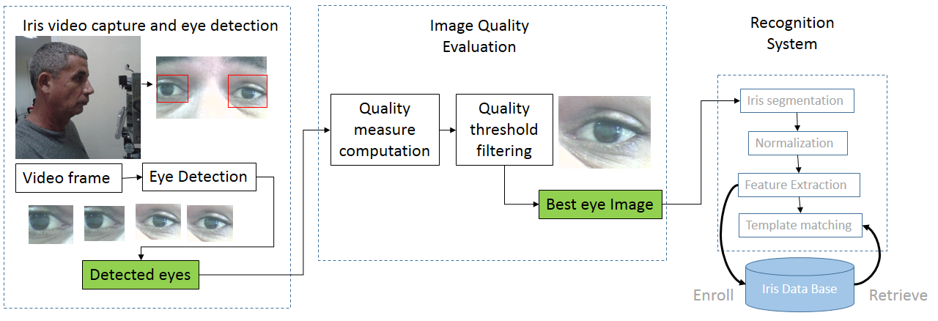

Figure. 1. General scheme of the proposed approach (created by the author)

**3.2. Image Quality Evaluation**

Among the parameters established by the standard [4], the focal distance indicates the optimal distance between the subject and the camera for a given pixel density and the focal length is the zoom of the subject in the image. Pixel density is defined in the standard as the sum quantity of the pixels that are on the diagonal length of the iris image. The standard [4] states that the pixel density of an iris image should be at least 200 pixels and contain at least two lines of pixels per millimeter (2 lppmm). If from detected eye images we can know their pixel densities (*EDens*), it is possible to establish a percentage relation between the eye region and the iris region. It will allow us to estimate the iris pixel density (*IDens*) in the captured image. For this, it can be assumed that the iris represents 25 -30% of an eye image. Therefore, if the concept of pixel density is extrapolated from the iris to the eye using the classical Pythagorean Theorem, it is possible to determine the pixel density of an eye image by equation 1, where *w* and *h* are the width and height in pixels of the detected eye image. Then it is possible to estimate the value of *IDens* by equation 2, where, *ciris* is the approximate percentage (25-30) of the detected eye image representing the iris.

|  |  |  |  |
| --- | --- | --- | --- |
|  | (1) |  | (2) |

**3.3. Quality Measure for Eye Images**

When an image is blurred or out of focus, it loses the details of the edges. In [3], the Kang & Park method was used to evaluate the quality of NIR iris images. This method applies a high-pass filter in the spatial domain and then calculates the total power using Parseval's theorem, which states that the total power has been conserved in the spatial and frequency domains. The method proposes a convolutional kernel of 5x5 pixels and consists of three square box functions, one of 5x5 size with amplitude -1, one of 3x3 size and amplitude +5, and four of 1x1 size and amplitude of -5 (figure 2). Theoretically, the operator can detect the high frequency of the iris texture much better and the processing time is reduced due to the small size core. It is possible that this behavior can be similar in different conditions of iris image capture and in images captured in the VS. Taking into account, that the sensor pixel density of an iris is a very important element that influences the quality of the images, we propose its combination with the Kang & Park method to obtain a quality measurement of the iris image (*Qindex)*. The proposed *Qindex* is obtained by equation 3

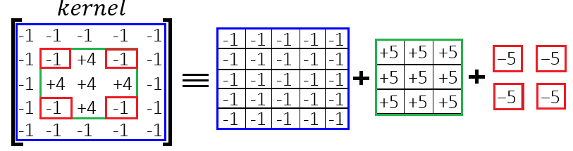

Figure 2. General Scheme of the Kang & Park Filter (created by the author)

|  |  |
| --- | --- |
|  | (3) |

Where: *kpm* is the average value of the image pixels obtained as result of the convolution of the input eye image with the Kang and Park kernel. *UDens* is the threshold established by the standard [4] for the minimum *IDens* with which it will be possible to obtain a quality image. *Ukpm* is the estimated threshold of *kpm* with which it will be possible to obtain a quality image, in [3] the authors, from their experimental results, recommend a threshold = 15. *ent* is the entropy of the eye image. The entropy of an iris image only depends on the amount of gray levels and the frequency of each gray level, so it has proven to be a good indicator of the amount of texture information present in the images. *Uent* is the estimated threshold of *ent* with which it will be possible to obtain a quality image.

**3.4. Experimental Determination of the thresholds for *Qindex***

Experimentally, we have verified that the images of iris that have a quality according to the international standard have an entropy higher than four. For this experiment, we took a set of 300 images from the MobBio [10] (150 images) and UBIRIS [11] (150 images) databases and perform the evaluation of their quality by the parameters of pixel density and response of the Kark and Park filter. The experimental results established that those with an index of quality equal to or greater than 1 have an entropy with a value equal to or greater than four, so we assume this value as the value of *Uent*.

The values that *Qindex* can reach will depend on the thresholds selected for *IDens, kpm*, and *ent.* Thus considering the threshold *UDens*= 200 established by the standard, *Ukpm*=15 experimentally obtained in [3] and *Uent*= 4 experimentally obtained by us, the minimum value of *Qindex* to obtain a quality eye image would be 1, higher values would denote images of higher quality and values less than 1 images with a quality below the standard:

If *Qindex* <1, the image has a quality below the parameters established by the standard. If *Qindex* = 1, the image complies with the quality parameters established by the standard. If *Qindex*> 1, the image has a higher parameters set by the standard quality.

One aspect to explore in this case would be to determine under what minimum values of *Qindex* it is possible to obtain acceptable recognition accuracies for a given configuration of a system.

**4. Experimental Results and Discussion**

In order to validate the proposal, our experimental design was aimed at verifying the influence of the proposed quality measure in the verification task by evaluating it using two benchmark iris image databases and an own iris video dataset.

**4.1. Implemented Pipeline for Experiments**

Three basic functionalities compose the implemented pipeline for experiments.

*Iris image acquisition:* The Iris image acquisition module is based on the approach described in the previous sections.

*Image segmentation:* In this module we used segmentation algorithm proposed in [12]. This method is based on the information of the different semantic classes present in an eye image (including sclera, iris, pupil, eyelids and eyelashes, skin, hair, glasses, eyebrows, specular reflections and background regions) by means of a Fully Convolutional Network (FCN).

*Iris texture feature extraction:* For the purpose of experiments in this work, we experimented the combination of two feature extraction methods with the segmentation proposed in [12] in order to verify the robustness of the proposed quality measure with respect to the use of different features for the recognition. Scale-Invariant Feature Transform which extracts SIFT-based key points [13], and Uniform Local Binary Patterns (LBP) [14].

**4.2. Iris Datasets**

MobBio is a multi-biometric dataset including face, iris, and voice of 105 volunteers. The iris subset contains16 images of each individual (1680 images) at a resolution of 300 × 200. UTIRIS dataset is an iris biometric dataset containing iris images of the same persons. The database is constructed with 1540 images from 79 individuals. Our (CENATAV) database consists of 82 videos of 41 people taken in two sessions of 10 seconds each at a distance of 0.55 m. The camera used was a Logitech C920 HD Pro Webcam. In order to guarantee a high-resolution iris image, the videos were captured at resolution of 1920 x1080. The videos were taken in indoor conditions with ambient lighting and presence of specular reflections to achieve an environment closer to the poorly controlled conditions of a biometric application. The database contains images of people of clear skin of Caucasian origin, dark skin of African origin and mestizo skin, it is composed by 26 men and 15 women, in a range of ages from 10 to 65 years (see examples in figure 3).

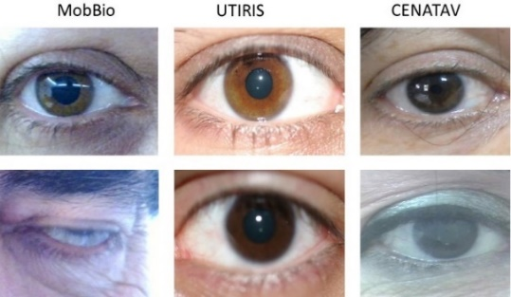

Figure 3. Samples of eye images from MobBio, UTIRIS and CENATAV datasets. Samples of eye images with Qindex>=1(above) and Qindex<1(below). (created by the author)

**4.3. Experimental Results**

The evaluation of accuracy of the proposed approach was assessed by the degree of influence of the eye image quality on verification accuracy. The verification accuracy was estimated by Equal Error Rate (EER) at False Acceptance Rate (FAR) ≤0.001%. The EER is the location on ROC or DET curve, where the False Reject Rate (FRR) and FAR are the same, or is computed as the point where False Nonmatch Rate = False Match Rate (FNMR = FMR). Table 1 shows the comparison of the EER obtained by the implemented system on MobBio and UTIRIS databases, taking two different intervals of Qindex and images with a Qindex>1 for our dataset to reject or accept the eye images to be processed.

The results in the experimented databases show that as the value of the Qindex increases, the system supports high quality images and rejects low quality images (See examples in figure 3). This increase in quality, results in a decrease in the EER, with the most significant result in UTIRIS where an EER = 0.04 is achieved with the 71.8% of the database and Qindex>1 when FCN is combined with LBP. However, in the MobBio, increase in the Qindex threshold results in a significant decrease in the number of images to be compared.

The results obtained on the CENATAV dataset show a high performance of the verification process obtaining an EER of 0.01, which corroborates the relevance of the use of the proposed quality index in a real application. The average time it takes to analyze a frame of 1920 x1080 pixels, in a PC with an Intel Core i5-3470 processor at 3.2 GHz and 8 GB of RAM, is 20-30 milliseconds. This allows it to be used in any video iris recognition application.

Table 1. Experimental results on MobBio, UTIRIS and CENATAV datasets (created by the author)

|  |  |  |  |  |
| --- | --- | --- | --- | --- |
| Database | Qindex | % of images processed | EER  SIFT | EER  LBP |
| MobBio | 0.7-1.0 | 52.6 | 0.27 | 0.25 |
| 1.01-1.32 | 26.3 | 0.25 | 0.22 |
| UTIRIS | 0.7-1.0 | 20.5 | 0.07 | 0.06 |
| 1.01-1.32 | 71.8 | **0.06** | **0.04** |
| CENATAV | >1.0 | 100 | **-** | **0.01** |

**4. Conclusions**

In this paper, we propose a new eye Image Quality Evaluation Approach for Biometric Iris Recognition in the VS. It combines automatic detection methods and a new image quality measure, based on the elements defined in the ISO / IEC 19794-6: 2005 standard, to ensure the high quality of eye images to be processed. We analyzed the relevance of the image evaluation stage as a fundamental step to filter the information generated from the iris video capture. The experimental results showed that the inclusion of the proposed approach within an iris recognition system limits the passage of low quality images to the system, which results in an increase of recognition rates.

**5. Bibliographical references**

[6] Daugman J, Downing C. Iris Image Quality Metrics with Veto Power and Nonlinear Importance Tailoring. In: Rathgeb C, Busch C. Iris and Periocular Biometric Recognition. IET Pub. 2016, 83-100.

[3] Garea-Llano E, García-Vázquez M, Colores -Vargas JM, Zamudio-Fuentes LM, Ramírez-Acosta AA. Optimized robust multi-sensor scheme for simultaneous video and image iris recognition. Pattern Recognition Letters 2018, 101: 44-45.

[2] Hollingsworth K, Peters T, Bowyer K. Iris recognition using signal-level fusion of frames from video, IEEE Trans. Inf. Forensics Security 2009, 4: 837-848.

[11] Hosseini MS, Araabi BN, Soltanian-Zadeh H. Pigment Melanin: Pattern for Iris Recognition. IEEE Transactions on Instrumentation and Measurement 2010, 59: 792-804.

[4] ISO/IEC 19794-6:2005. Part 6: Iris image data, ISO.

[14] Liao S., Zhu X., Lei Z., Zhang L., and Li S. Z. Learning multi-scale block local binary patterns for face recognition. In Proc. Int’l Conference on Biometrics (ICB’07), pages 828–837, 2007.

[13] Lowe DG Distinctive image features from scale-invariant key points. International Journal of Computer Vision 2004, 60: 91-110.

[10] Monteiro C, Oliveira HP, Rebelo A, Sequeira AF. Mobbio 2013: 1st biometric recognition with portable devices competition, available in: <https://paginas.fe.up.pt/~mobbio2013/>.

[12] Osorio-Roig D., Rathgeb C., Gomez-Barrero M., Morales-González Quevedo A., Garea-Llano E. and Busch C. Visible Wavelength Iris Segmentation: A Multi-Class Approach using Fully Convolutional Neuronal Networks. - 17th International Conference of the Biometrics Special Interest Group. BIOSIG 2018, Lecture Notes in Informatics (LNI), Gesellschaft f¨ur Informatik, Bonn 2018 1.

[1] Raja KB, Raghavendra R, Vemuri VK, Busch C. Smartphone based visible iris recognition using deep sparse filtering. Pattern Recognition Letters 2015, 57: 33-42.

[8] Raja KB, Raghavendra R, Busch C. Iris Imaging in Visible Spectrum using White LED. 7th International Conference on Biometrics Theory, Applications and Systems (BTAS), 2015, IEEE.

[5] Schmid N, Zuo J, Nicolo F, Wechsler H. Iris Quality Metrics for Adaptive Authentication. In: Bowyer KW, Burge MJ. Handbook of Iris Recognition (2nd Edition). Advances in Computer Vision and Pattern Recognition, Springer-Verlag London 2016, 101-118.

[9] Viola P, Jones M Rapid Object Detection Using a Boosted Cascade of Simple Features. Mitsubishi Electric Research Laboratories, Inc., 2004 201 Broadway, Cambridge, Massachusetts 02139.

[7] Zuo J, Schmid NA. An automatic algorithm for evaluating the precision of iris segmentation. In: International Conference on Biometrics: Theory, Applications, and Systems (BTAS’08), Washington, DC, USA.2008.