**X INTERNATIONAL SCIENTIFIC CONFERENCE ON MECHANICAL ENGINEERING, COMEC 2019**

**Weld joints metallography characterization in aluminum alloys AA5754 Cold Metal Transfer welding process**

**Eriel Pérez Zapico1, Carlos René Gómez Pérez2**

1-Eriel Pérez Zapico. Universidad Central “Marta Abreu” de Las Villas, Cuba, e-mail address: [zapico@uclv.cu](mailto:zapico@uclv.cu)

2-Carlos René Gómez Pérez. Universidad Central “Marta Abreu” de Las Villas, Cuba, e-mail address: [crene@uclv.edu.cu](mailto:crene@uclv.edu.cu)

**Abstract:**

In this work, the metallographic characterization in square groove weld of aluminum alloys sheets AA5754 Cold Metal Transfer welding process was developed. The parameters current and tension were remained constant. The pulse correction and welding speed were varied in order to study their influence in various bead dimension. The weld geometry from macrographs study was obtained. Pulse correction have a significantly influence on bead width and penetration depth while welding speed have great influence on dimension of heat affect zone. The predominantly microstructure in fused zone is interdendritic network of aluminum-silicon eutectic. The paper seek to understand the relationship between welding parameters and weld pool dimensions and structural metallographic. Based on the results, was possible the optimization of welding process.

**Keywords:** Cold Metal Transfer, aluminum alloy, metallographic

**1. Introduction**

At present the automotive and naval industries requires increase the efficiency lighter structures. Indeed, this aspect is guarantee using high mechanical strength and stiffness metal alloys, which are presents in aluminium alloy AA5754.

During welding aluminium alloys Shielding Metal Arc Welding (SMAW) and semiautomatic Gas Metal Arc Welding (GMAW) or Gas Tungsten Arc Welding (GTAW) processes are commonly employed [1]. The best results obtain of welding applying the GTAW and GMAW processes, decreasing the influence of welder’s skill and experience on the quality of joints [2]. However, the aluminium alloys welding using GMAW process result complex and special, even for skilled welders in steels welding, mainly by the relatively high thermal conductivity and lower melting point of aluminium alloys, which can lead to sheet perforations [3].

Moreover, the surface pieces aluminium oxide formed melts at 2038 °C and the aluminium base metal melts at 650 °C conduce to inhibition of filler metal penetration, increasing of defects formation and low mechanical resistance of weld [4]. This aspect, is solved using GTAW process whit Argon shielding gas (Tungsten Inert Gas, TIG), due to its cleaning action and enhance penetration [1], very important aspects for welding; however, the process is not very productive.

Important role the welding source, allows regulating spray arc welding (GMAW) or pulsed arc (GTAW) transfer methods as the most recommended for aluminium welding [5]. However, the conventional technology used for aluminium welding, as processes described above, makes relatively slow and expensive this manufacturing process, since still depend largely of welder skill [6, 7].

To combine the processes benefits the automation increased, through precise regulation, among others, using the Cold Metal Transfer (CMT) process whose main characteristic achievement hot moments and others "cold" during welding execution [8, 9].

Fronius developed specifically the CMT welding process to joining aluminium sheets and dissimilar metal materials, reducing the thermal input and therefore the energy consumption, which makes the CMT process a sustainable manufacturing technology. CMT including a novel system of control movement of electrode wire into the welding process. The invention is essentially based on the establishment of the electric arc that allows drop formation and the retracting movement of wire contacts the workpiece and when short-circuit is detected the arc is extinguished, the drop is deposited in the welding pool and electrode is retracted and cycle is repeated at 50 Hz again.

This technology from 2004 [9] is marketed; however, no studies have addressed related to aluminum welding applications. Authors study the advantages and limitations in these new applications, or the influence of best essential variables related to robotized transfer cold metal welding process on the properties of aluminium alloys AlMgSi and AlMg, intended for marine and automotive applications [10-12].

Moreover, the incorporation of pulsed arc period can modify the amount of energy during the process, specifically, the characteristics of energy input during the welding, aspect not mentioned so far in the literature.

Precisely the aim of this work was the metallographic characterization and evaluation the influence of pulse correction function and speed welding of geometrics beads of thin sheets of aluminium AA5754 welds to optimize CMT welding process, becoming this process a sustainable technology for modern industry.

The metallographic characterization of welded joints of thin sheets of aluminium AA5754 CMT welding will reveal the quality of the weld and the influence of the parameters studied during the formation of different metallographic compounds and the dimensions of weld and heat affected zone influencing on mechanical properties of weld joints.

**2. Methodology**

The chemical composition of AA-5754 aluminium alloy show in Table 1. For each weld joint, two plates of dimensions 300 × 80 × 3 mm were welded to make a square groove weld of 300 × 160 × 3 mm.

**Table 1.** Chemical composition of aluminium alloy AA5754 [14]

|  |  |  |  |  |  |  |  |  |  |
| --- | --- | --- | --- | --- | --- | --- | --- | --- | --- |
| Wt.% | Si | Fe | Cu | Mn | Mg | Cr | Zn | Ti | Al |
| AA5754 | 0,4 | 0,4 | 0,1 | 0,5 | 2,6-3,6 | 0,3 | 0,2 | 0,15 | balance |

To perform welding is used Cold Metal Transfer process. The experimental setup is show in figure 1, included a VR 70004R/G/W/F++ inverter type source, a MOTOMAN anthropomorphic robot, an Agilent 34970A acquisition system by thermocouples and a PicoScope oscilloscope. The electrical parameters such as current and tension remain constant in 120 A and 19 V respectability. The shielding gas used are Argon with a constant flow of 12,6 l/min. The electrode wire feed speed was kept constant ratio 7,6 m/min. The arc length correction maintained at 0 % and not considered among the welding parameters. The standard wires commercially available for aluminium alloy are used ER5356 diameter 1,2 mm. The weld seam resulting following CMT welding of the AA5754Al-Mg alloy plate under the above-mentioned conditions is presented in Figure 2.

The experiments carried out varying two levels of welding speed and two of pulsed correction parameters and were used according to the experimental plan shown in Table 2, four weld joints were obtained and one replications was made for each of the tests. For select each combination the values of pulsed correction and welding speed several previous experimental tests were carried out, which allowed to establish the optimal ranges.

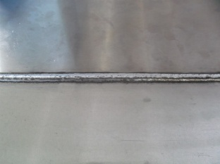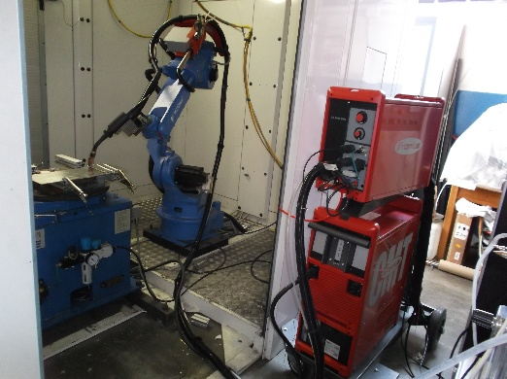

**AA5754 Plate**

Figure 1. The experimental setup and AA5754 plate following CMT welding operation.

**Table 2.** Experimental plan

|  |  |  |
| --- | --- | --- |
| **Test** | **Vs (mm/s)** | **Pulse correction (%)** |
| 1 | 11 | +2 |
| 2 | 16 | +2 |
| 3 | 11 | -2 |
| 4 | 16 | -2 |

The metallographic samples were cut to carry out microstructural studies of the transverse section of weld joint. Samples were polished from 80 to 2400 grit The SiC paper followed by diamond paste (size 1 µm) to obtain mirror finish. The inclusion studies of un etched specimens were carried out at 100X magnification using optical microscope ZEISS AXIOSKOP 40 and Scanning Electron Microscope (SEM) PHENOM proX, equipped with an Energy Dispersive Spectrometer (EDS) to obtain the chemical composition and phase structures. The specimens were etched using Keller’s reagent (95 ml H2O, 2,5 ml HNO3, 1,5 ml HCl, 1 ml HF) for optical and SEM investigations to ascertain weld bead profile and changes in microstructure of base and weld metal.

**3. Results and discussion**

The 5xxx aluminium alloys series sometimes contain particles of Mg2Al3, Mg2Si, and intermetallic phases with chromium and manganese. Fine particles of Mg2Si precipitated during the rolling. If carried through to final sheet, this amount of precipitate would cause an objectionable milky appearance in a subsequently applied anodic coating [13].

The AA5754 aluminium alloy present a microstructure characterized by the presence of numerous secondary phases (Figure 2).

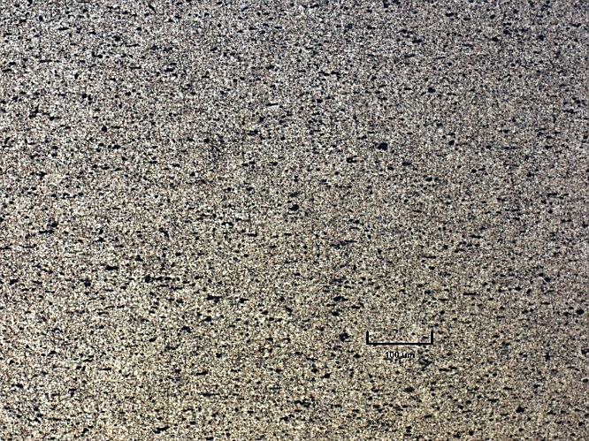

**100 um**

Figure 2. Base material optical micrographic aluminium alloy AA5754.

In particular acicular form light gray particles are (Fe,Mn)Al6, while dark gray rounded are (Fe,Mn)3SiAl12 (Figure 3).

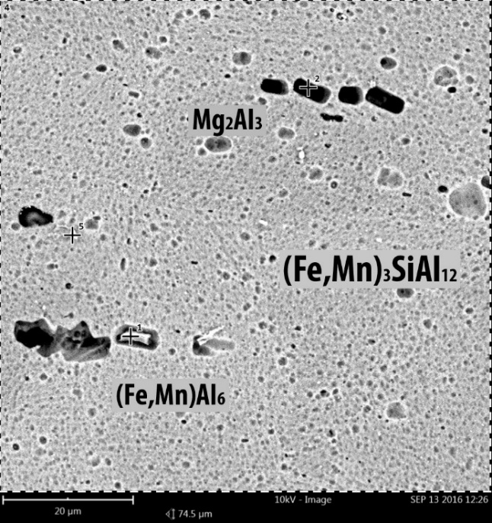

Figure 3. Base material SEM micrographic aluminium alloy AA5754.

The macrostructure of cross sections of joints 1, 2, 3 and 4 after standard metallographic preparation and etching are shows in Figure 4 and present differences in dimension of weld bend geometry.

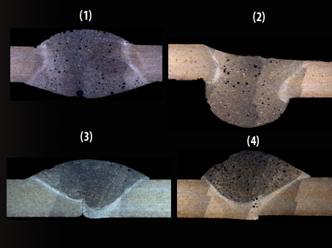

Figure 4. Optical macrographs of joints cross-sections

The welds 1 and 2 show a complete penetration, being excessive in 2, while the weld 3 and 4 can be seen incomplete. Sample 2 show greater weld width. In the case of sample 2 a concave aspect of binding is observed, while the rest is convex (Figure 4-2).

**Table 3.** Geometric welds parameters

|  |  |  |  |  |
| --- | --- | --- | --- | --- |
| Test | HAZ (mm) | b (mm) | hp (mm) | hr (mm) |
| 1 | 0,515 | 5,28 | 3 | 1,408 |
| 2 | 0,761 | 6,046 | 3 | -0,272 |
| 3 | 0,309 | 3,945 | 1,794 | 1,608 |
| 4 | 0,277 | 5,041 | 1,587 | 2,292 |

The presence of pores shows some instability of process product of flux of shielding gas and filler metal selected. In all metallographic samples, the heat affected zone (HAZ) and Fused Zone (FZ) area clearly visible. The HAZ wider shown in test 2.



Pulse correction

Welding speed

Penetration depth

Figure 5. Principal effects of penetration depth plot

According to the principal effects plot carried out an analysis of welding parameters behaviour against geometric variables of weld joints, which shows that as the increase pulse correction, the penetration depth (Figure 5) and joint width (Figure 6) increases.

Moreover, with increasing welding speed it decreases the depth of penetration, while the weld width increases, due to the influence of pulse correction in the current intensity, increasing power during application of process.



Pulse correction

Welding speed

Figure 6. Principal effects of width weld plot

In figure 7 is presented the influence of welding parameters variation in the dimension of HAZ. In all test evaluate, the dimension of HAZ is incrementally when the welding parameters are increases.



HAZ

Pulse correction

Welding speed

Figure 7. Principal effects of HAZ weld plot

The surface graph in figure 8 show the desirability function evaluated at each experimental design point to optimize the welding parameters. The goals of each responses are currently set as minimize HAZ and maximize penetration depth and joint width. Among experimental design points, maximum desirability is reached in test 1.



Pulse correction

Welding speed

Desirability

Figure 8. Estimated response area plot

Edge of fusion zone of a weld is show in figure 9. The base metal is located on the left and the weld bead is located on the right. The structure is the interdendritic network of aluminium-silicon eutectic (dark) in weld bead (right); dark band of equiaxed dendrites of aluminium with much Mg2Al3 precipitate near dendrite boundaries forming the dark band in the heat-affected zone.

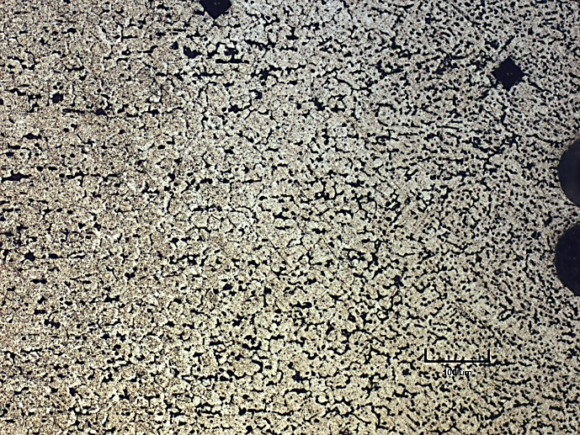

**100 um**

Figure 9. Optical micrograph showing the heat affect zone 10X

Figure 10 shows the microstructure in the ZF. Evidence a fine dendritic microstructure because of high cooling rate. Interdendritic network of aluminium - silicon eutectic is present in the matrix solid solution. The dendritic grow to crystallographic direction of directions parallels to heat flow giving rise to elongated grains [14-16].

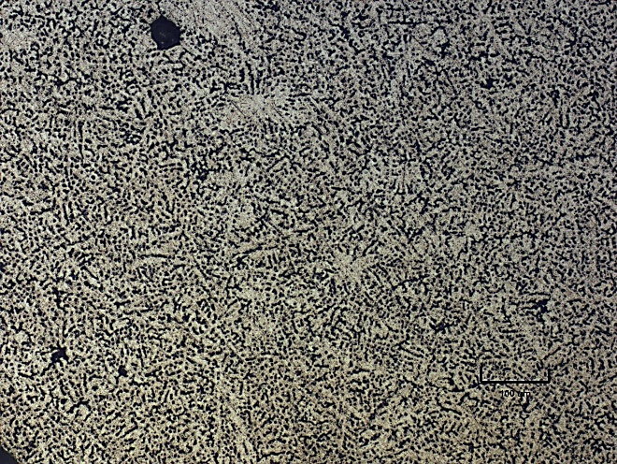

**100 um**

Figure 10. Optical micrograph showing the fused zone 10X

**4. Conclusions**

A series of Cold Metal Transfer welding experiments was conducted on the square groove welds of AA5754 aluminium alloy plate of thickness 3 mm. The current and tension were constants and the pulse correction and welding speed were varied in accordance whit experimental plan. The shielding gas flow was kept constant and an ER5356 filler metal of 1,2 mm diameter was used. The pulse correction parameter influences directly on the variation of width, reinforcement height and penetration depth increasing their dimensions, while the welding speed decreases. The aluminium alloy AA5754 presented a structure characterized by numerous presence of secondary phases containing acicular particles form (Fe,Mn)Al6 and (Fe,Mn)3SiAl12. The HAZ presented equiaxed dendrites of aluminium with much Mg2Al3 precipitate near dendrite boundaries forming the dark band in the heat-affected zone and the FZ is an interdendritic network of aluminium-silicon eutectic is present in the solid solution matrix structure. As a metallographic characterization consequence it was possible the optimization of CMT welding process of AA5754 aluminium alloy using welding speed 11 mm/s and pulse correction + 2 %.

**5. Bibliographical references**

1. Aranda, J., M. Armada, P. González, J.M. de la Cruz. Automatización para las industrias marítimas un Estudio de la situación de España. Red Temática Automar. Comité Español de Automática 2005.
2. Technical Service. Guia para Soldar Aluminio. Lincoln Electric.
3. Technical Service. Soldadura con gases de protección para aluminio. Messer Iberica de Gases.
4. AWS, Welding Handbook. Novena Edición. Vol. 2 9ed. Vol. 2.
5. American Welding Society AWS. Welding Handbook Ninth Edition, Volume 1. Welding Handbook Ninth Edition, Volume 2.
6. Technical Service. Nuevos procesos de soldadura. Fronius International, 2004.
7. Kou, S., Welding Metallurgy. Second ed. 2003: John Wiley & Sons, Inc. 454 pp.
8. Vicker, M.C., Eric, N.P., B. T., Alexandrov, J. C., Lippold, Cold Metal Transfer Weld Overlays – Application in Nuclear power Repair, in FABTECH 2013. Chicago, Illinois.
9. Fronius. CMT: Cold Metal Transfer. 2005 [cited 2010 20 enero]; Available from: [www.fronius.com](http://www.fronius.com).
10. de Luna Alanís, R. E., Gómez-Pérez, C. R, Características geométricas de uniones soldadas obtenidas con transferencia metálica fría. TECNOGESC 2016. VII Encuentro de Tecnologías y Gestión del Conocimiento. 20 y 21 de octubre de 2016.
11. de Luna Alanís, R.-E., Gómez-Pérez, Carlos René. (2015). Influencia de los parámetros de la soldadura metálica fría en las aleaciones AA5083 y AA6061. Ingeniería Mecánica, 18(1), 42-51.
12. de luna Alanís, R.-E., Gómez-Pérez, Carlos-René (2016). Las correcciones de arco y de pulso y el voltaje en la transferencia metálica fría. Rev. Ingeniería Mecánica, 19(2), 94-102.
13. Aaronson, H. I. et at., Metallography and Microstructures, Volume 9, Metals Handbook, 1985.
14. Messler, R.W., Principles of Welding, Wiley-VCh, 2004
15. Porter, D.A., Easterling, K.E., Phase Transformations in Metals and Alloys, Chapman & hall, 1992.
16. Verhoeven, J.D., Fundamentals of Physical Metallurgy, Wiley, 1975