**X International Scientific Conference on Mechanical Engineering COMEC 2019**

**Modeling of Contact Temperature During Surface Grinding**

**Pavel Kovač1, Borislav Savković2, Marek Vrabel3**

1-University of Novi Sad, Faculty of Technical Sciences, Serbia, [pkovac@uns.ac.rs](mailto:pkovac@uns.ac.rs)

2- University of Novi Sad, Faculty of Technical Sciences, Serbia, [savkovic@uns.ac.rs](mailto:savkovic@uns.ac.rs)

3-Slovak Technical University Kosice, Faculty of Mechanical Engineering, Slovakia, <marek.vrabel@tuke.sk>

**Abstract:** In comparison to machining with geometrically defined cutting edges, grinding manifests clear procedural differences that effect the machinability of the materials. Grinding is achieved by means of a number of individual grit engagements. During grinding is increased amount of friction and deformation work, from which results a higher conversion of heat flow in the process. The paper presents the modeling of the contact temperature between the wheel and the workpiece during surface grinding. The measurement of the contact temperature during grinding was performed firstly by using an artificial thermocouple that was incorporated into the workpiece, using a developed acquisition system connected with the computer. Measurement of values was carried out by factorial plan of the experiment. Input experimental data were elements of the cutting regime: table speed, transverse shift and grinding depth and output data contact temperature. The processing of data using the response surface methodology determines the adequate dependence in the form of the power function and the estimated influence of individual input factors. Then modeling was done using artificial neural networks. Finally, a comparison of the calculated values with the both models was performed and the better model of surface grinding process was adopted.

**Keywords:** Grinding regime, Machinability, Experimental, Contact temperature.

**1. Introduction**

Grinding as a cutting process, impossible elementarily reduced to the one cutting edge process, it contains so many undefined factors that, as the theoretical and empirical data of various authors are still very different.

The reason for this is the first indeterminate geometry of the blade, then the vague and irregular spacing and grain size as the direct tooling, the type and quality of the binder and cavities as additional factors of indeterminacy as well as practically unknown but very influential amount of grains wear.

To date there are many research papers, but they are specific and do not fully cover all influencing factors, so they are a little confident in a wider range of applicable data. In this respect, there are great needs and possibilities for research [1-5].

Machinability is understood as a property of a material that allows for chip removal under given conditions. It thus describes the behavior of a material during chip forming. The machinability of a material must always be considered in conjunction with the machining method, the tool and the machining parameters. In comparison to machining with geometrically defined cutting edges, grinding manifests clear procedural differences that effect the machinability of the materials. During grinding, machining is achieved by means of a number of individual grit engagements. Together with the strongly negative tool orthogonal rake angle of the grit, there is, in contrast with geometrically defined chip removal, an increased amount of friction and deformation work, from which results a higher conversion of energy in the process. This in turn can lead to heavier thermal stress on the surface layer. Small depths of cut result from the geometrical process characteristics of grinding and the high cutting speeds. Thus, the grain size of the workpiece material as well as the size of inclusions (e.g. carbide) play a role with respect to machinability.

The main share of the energy inserted into the process is converted into heat. Thus, all system components involved in machining experience thermal stress or dissipate heat. The total heat flow rate qt spreads in the contact zone to the grinding wheel (qs), the workpiece (qw), the chips (qspan) and the cooling lubricant (qkss) (Fig. 1). How high the particular share of heat flow is depending on, among other things, the heat conduction coefficient of the workpiece material, the cooling lubricant and the grinding wheel as well as the heat transfer coefficient [6-8].

Heat flow into the workpiece can lead to a local rise in temperature. This increase in temperature can, depending on the magnitude and action time, produce thermal structural changes in the workpiece surface layer. The action time of the heat and the temperature level can be favorably influenced by applying a cooling lubricant.



Figure 1. Energy distribution and heat flow during cutting

**2. Experiment and method**

For contact temperature measurement used were embedded thermocouple NiCr-Ni embedded in workpiece. Wire of thermocouple were 0.1 mm diameter, ball welded at the end with diameter od 0.5 mm with insulation of ceramic tube 0.9 mm dimension and two axial canals. Far from temperature influence to instrument was used plastic insulation. Workpiece was square shaped with embedded thermocouple shown in Fig 2. Material of workpiece was steel for cementation C 1220, with average hardness 61 HRC. Tool material were grinding wheel designation 286OK8V. Machine tool was Surface grinding machine LZT K. Grinding wheel speed was constant 31,5 m/s. Machining was done without cooling and lubrication agent.

Figure 3 shows scheme of the acquisition system for the temperature measurement during grinding process.



Figure 2. Position of embedded thermocouple in workpiece b) detail of thermocouple on top of workpiece



Figure 3. User interface (front panel window)

**2.1. Mathematical model for contact temperature**

* During the study, a system was set up with:
* Certain workpiece material (MO)
* Certain grinding wheel (KT)
* Constant speed (v)
* Working in the same workplace (MPOA)
* With the same cooling and lubricating agents (SHP)

On the basis of the given constant parameters in the study, was obtained the mathematical model shown in Figure 4. As the input parameters were: the grinding depth (a), the lateral feed of the grinding wheel (Sb) and the table speed (Vp) are taken.



Figure 4. Mathematical model developed for the experiment

**3. Neural network methodology**

The basic architecture of a Neural Network typically consists of an input function, which can take the form of binary, continuous or normalized data: a processing architecture which consist of transfer function description, summation function, and relative learning strategy: a method for identifying and learning from past errors in estimates: and finally, a mechanism for feeding error corrections back into the network [9]. Figure 5 shows the schedule of data that is used for network training, validation or test data.

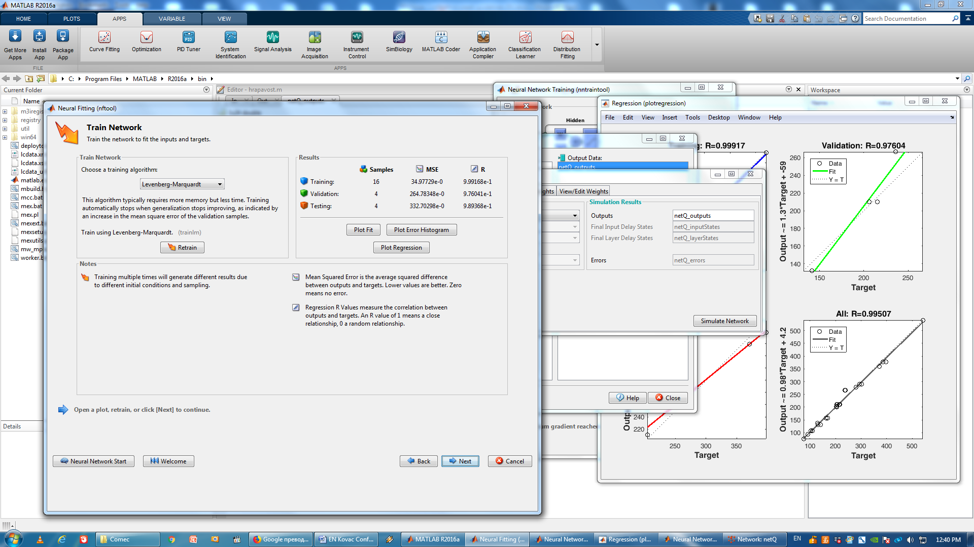

Figure 5. Percentage distribution of data in the creation of a neural network

A two-layer feed-forward network with sigmoid hidden neurons and linear output neurons (fit net), can fit multi-dimensional mapping problems arbitrarily well, given consistent data and enough neurons in its hidden layer. The network is trained with Levenberg-Marquardt backpropagation algorithm (trainlm), unless there is not enough memory, in which case scaled conjugate gradient backpropagation (trainscg) will be used. Elected as Levenberg-Marquardt, back propagation networks. This algorithm typically requires more memory but less time. Training automatically stops when generalization stops improving, as indicated by an increase in the mean square error of the validation samples. The architecture of the designed network comprises three inputs parameter and one output parameters at a time, and a single hidden layer of ten neurons. With the help of back propagation training data set (Input parameter related to output parameters) is set to utilize to train the neural network. Three input parameter and one output parameters are considered. The selected input parameters should be easily variable and can be easily changed by the operator, Figure 6.

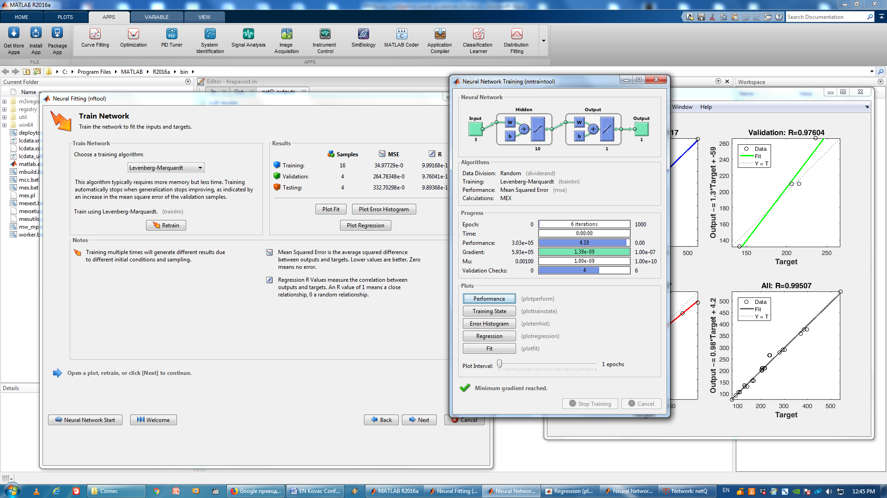

Figure 6. The window created by a neural network

The regression plot of the ANN for cutting force is shown in figure 4. The regression plots display the network outputs with respect to targets for training. From this plot, the value of the regression coefficient is found to be more than 99.9% which strongly justifies the acceptability in the prediction capability of the models. In case of the dry ANN model, the regression coefficient has a higher value; hence, it can be concluded that this model is accurate. Figure 7. shows graphic coefficients of regression for training, test and validation data.

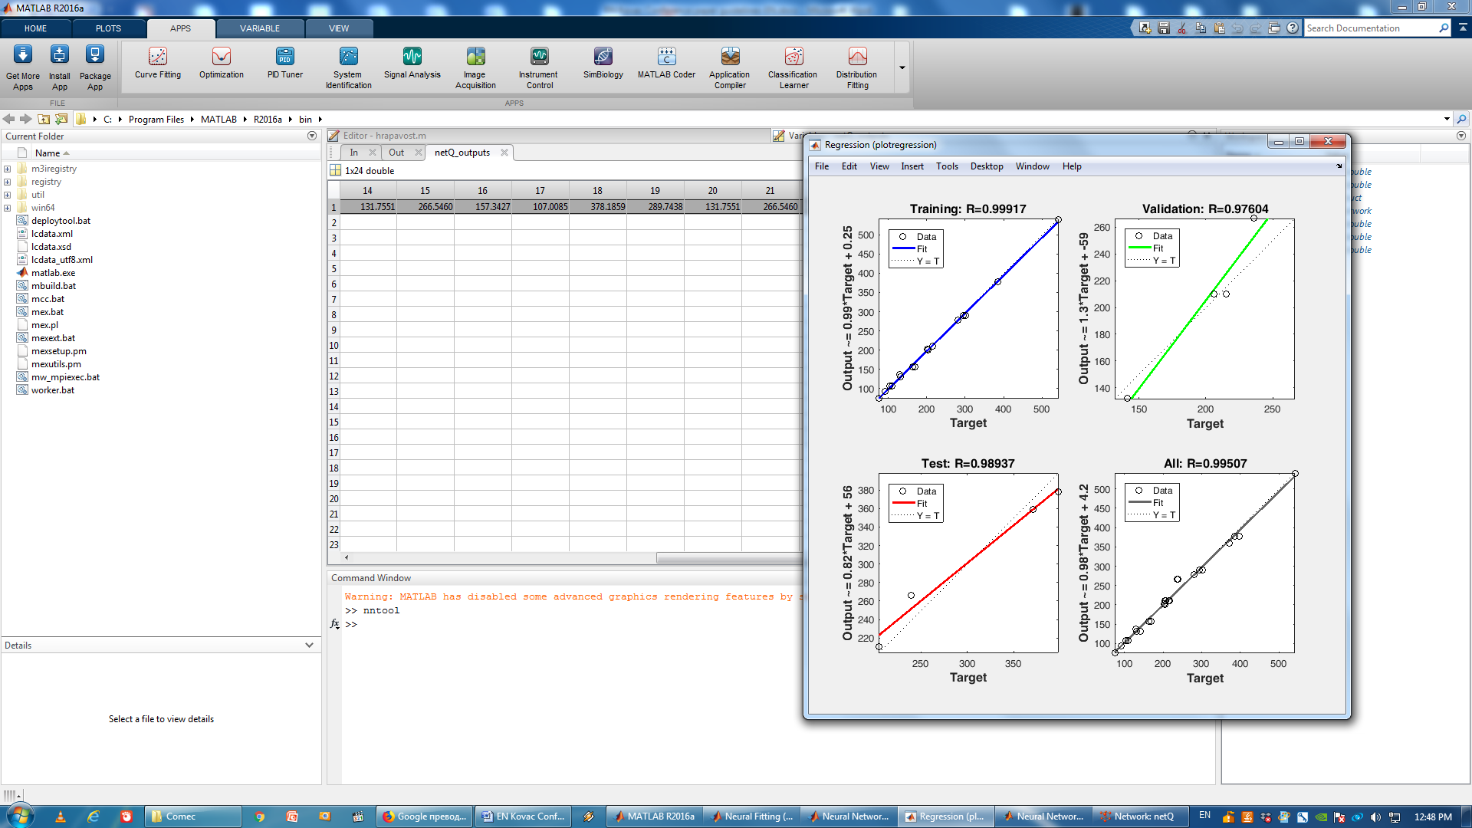

Figure 7. Coefficient of Regression (plotregression)

Variation of experimental parameters is based on three levels of values, so that each mean value between the two adjacent levels is the geometric mean of these values. For better model settings used were 5 levels variations. The selected levels of factors are shown in Table 1.

Table 1. Levels of experimental parameters for surface grinding process

|  |  |  |  |
| --- | --- | --- | --- |
| Level (code) | Vp (m/min) | Sb (mm/hod) | a (mm) |
| High (1.41) | 32 | 16 | 0.027 |
| Upper (+1) | 24 | 12.00 | 0.02 |
| Medium (0) | 12 | 6.00 | 0.01 |
| Lower (-1) | 6 | 3.00 | 0.005 |
| Low (-1.41) | 4.5 | 2.25 | 0.0038 |

The experimental plan during grinding was carried out on the basis of the three factorial central compositional plans. The plan matrix is shown in Table 2. Measured and modeled by RSM and neural network values of contact temperatures during Surface grinding are shown in Table 3. Parameters for significance and adequacy model determination are in Table 4.

Table 2. Orthogonal plan of the matrix

|  |  |  |  |  |  |  |  |
| --- | --- | --- | --- | --- | --- | --- | --- |
| No. | x0 | x1 | x2 | x3 | Vp (m/min) | Sb (mm/w) | a (mm) |
| 1 | 1 | -1 | -1 | -1 | 6 | 3 | 0.005 |
| 2 | 1 | 1 | -1 | -1 | 24 | 3 | 0.005 |
| 3 | 1 | -1 | 1 | -1 | 6 | 12 | 0.005 |
| 4 | 1 | 1 | 1 | -1 | 24 | 12 | 0.005 |
| 5 | 1 | -1 | -1 | 1 | 6 | 3 | 0.02 |
| 6 | 1 | 1 | -1 | 1 | 24 | 3 | 0.02 |
| 7 | 1 | -1 | 1 | 1 | 6 | 12 | 0.02 |
| 8 | 1 | 1 | 1 | 1 | 24 | 12 | 0.02 |
| 9 | 1 | 0 | 0 | 0 | 12 | 6 | 0.01 |
| 10 | 1 | 0 | 0 | 0 | 12 | 6 | 0.01 |
| 11 | 1 | 0 | 0 | 0 | 12 | 6 | 0.01 |
| 12 | 1 | 0 | 0 | 0 | 12 | 6 | 0.01 |
| 13 | 1 | -1,41 | 0 | 0 | 4.5 | 6 | 0.01 |
| 14 | 1 | 1,41 | 0 | 0 | 32 | 6 | 0.01 |
| 15 | 1 | 0 | -1,41 | 0 | 12 | 2.25 | 0.01 |
| 16 | 1 | 0 | 1,41 | 0 | 12 | 16 | 0.01 |
| 17 | 1 | 0 | 0 | -1,41 | 12 | 6 | 0.0038 |
| 18 | 1 | 0 | 0 | 1,41 | 12 | 6 | 0.027 |
| 19 | 1 | -1,41 | 0 | 0 | 4.5 | 6 | 0.01 |
| 20 | 1 | 1,41 | 0 | 0 | 32 | 6 | 0.01 |
| 21 | 1 | 0 | -1,41 | 0 | 12 | 2.25 | 0.01 |
| 22 | 1 | 0 | 1,41 | 0 | 12 | 16 | 0.01 |
| 23 | 1 | 0 | 0 | -1,41 | 12 | 6 | 0.0038 |
| 24 | 1 | 0 | 0 | 1,41 | 12 | 6 | 0.027 |

Table 3. Measured and modeled values of contact temperatures

|  |  |  |  |  |  |  |
| --- | --- | --- | --- | --- | --- | --- |
| No. | Vp (m/min) | Sb (mm/hod) | a (mm) | Exp | RSM | NN |
| θ | Θm | θ |
| 1 | 6 | 3 | 0.005 | 204 | 193.00 | 200.68 |
| 2 | 24 | 3 | 0.005 | 92 | 105.61 | 92.96 |
| 3 | 6 | 12 | 0.005 | 130 | 143.72 | 137.31 |
| 4 | 24 | 12 | 0.005 | 75 | 78.64 | 75.60 |
| 5 | 6 | 3 | 0.02 | 541 | 512.61 | 539.35 |
| 6 | 24 | 3 | 0.02 | 281 | 280.49 | 278.90 |
| 7 | 6 | 12 | 0.02 | 371 | 381.72 | 359.16 |
| 8 | 24 | 12 | 0.02 | 202 | 208.87 | 202.18 |
| 9 | 12 | 6 | 0.01 | 204 | 200.78 | 210.27 |
| 10 | 12 | 6 | 0.01 | 206 | 200.78 | 210.27 |
| 11 | 12 | 6 | 0.01 | 216 | 200.78 | 210.27 |
| 12 | 12 | 6 | 0.01 | 215 | 200.78 | 210.27 |
| 13 | 4.5 | 6 | 0.01 | 295 | 307.61 | 289.74 |
| 14 | 32 | 6 | 0.01 | 132 | 131.05 | 131.76 |
| 15 | 12 | 2.25 | 0.01 | 239 | 247.35 | 266.55 |
| 16 | 12 | 16 | 0.01 | 170 | 162.98 | 157.34 |
| 17 | 12 | 6 | 0.0038 | 110 | 101.54 | 107.01 |
| 18 | 12 | 6 | 0.027 | 385 | 404.27 | 378.19 |
| 19 | 4.5 | 6 | 0.01 | 302 | 307.61 | 289.74 |
| 20 | 32 | 6 | 0.01 | 141 | 131.05 | 131.76 |
| 21 | 12 | 2.25 | 0.01 | 236 | 247.35 | 266.55 |
| 22 | 12 | 16 | 0.01 | 164 | 174.30 | 157.34 |
| 23 | 12 | 6 | 0.0038 | 103 | 101.54 | 107.01 |
| 24 | 12 | 6 | 0.027 | 398 | 404.27 | 378.19 |

The final expression for the contact temperature for surface grinding is:

θ = 22226.6173 v-0.435 s-0.2137 a0.7046  (1)

Table 4. Parameters for significance and model adequacy assessment

|  |  |
| --- | --- |
| Fr0 | 613531.77 |
| Fr1 | 1322.43 |
| Fr2 | 316.18 |
| Fr3 | 3470.62 |
| Fa | 4.37517 |

The model adequacy, assessment of the significance and assessment of model accuracy were also performed. On the basis of the adopted threshold probability 95%, the model is adequate and all input parameters are significant.

**5. Conclusion**

Based on the equation (1) it is possible to determine the contact temperature for the values ​​of the cutting regime and on the basis of it to estimate the possibility of defect occurrence in the surface layer after machining. It is also possible and reverse process procedure: choose a temperature that will not leave unwanted effects in the surface treatment layer, and then choose the appropriate cutting regimes.

The measured temperature does not reach the values ​​at which changes in the material structure will occur. This, however, does not have to be valid if samples of smaller dimensions than these were used in the experiment.

Based on data processing it can be concluded:

• The applied method of measuring the contact temperature is accurate, reliable and economical.

• The mathematical model is adequate and all parameters of the cutting regime are significantly influential.

Based on the exponents in determined equation it can be concluded:

* the cutting depth affects the temperature the most; Its increase is temperature increasing because more work is spent on plastic deformation, which is the main source of heat
* the processing speed has the greatest influence on the contact temperature; Its increases are temperature decreasing. This explains that higher speed shortens the contact time of the heat source with the processing
* the smallest impact has a transverse shift; its increase reduces the contact temperature, which is surprising, but a large number of experiments have been performed to confirm this.

Based on the methodology used for the experiment and artificial neural networks, it is possible to quickly determine the necessary dependencies with a large number of input parameters and various combinations of tools and processing.

**6. Bibliographical references**

1. Yamada, K., Ueda, T., Hosokawa, A.: A Study on Aspects of Attrition Wear of Cutting Grains in Grinding Process*,* International journal of precision engineering and manufacturing, 2011, Vol.12, No.6, pp. 965-973.
2. Gomes, M.O., Neto, L.M.G, Pereira, R.B.D., Lauro, C.H., Brandao, L.C.: Influence of cutting parameters on surface hardening of 52100 steel in flat grinding process, The International Journal of Advanced Manufacturing Technology, 2018, Vol.96, pp.751-764.
3. Nosenko, V. A., Nosenko, S. V.: Mathematical Models of Operating Time and Cutting Capacity for Various Stages of Flat Creep Feed Grinding of Horizontal Surface by Circle of Direct Profile, Journal of Machinery Manufacture and Reliability, ISSN:1052-6188, 2010, Vol.39, No.4, pp. 380-385.
4. Matyukha, P. G., Poltavets, V. V.: Determination of Grinding Conditions for Renewal of a Wheel Cutting Ability Allowing for Its Variation During the Machining Process, Journal of Superhard Materials, ISSN:1063-4576, 2017, Vol.39, No.3, pp. 186-191.
5. Nosenko, A.V., Zotova, S.A., Nosenko, S.V.: Run and Cutting Power of a Conical Camber Disk under Creep Feed Grinding of a Horizontal Face, Journal of Machinery Manufacture and Reliability, 2009, Vol.38, No.4, pp. 373-378.
6. Klocke, F.: Manufacturing Processes 2, Grinding, Honing, Lapping, RTWH, Springer, 2009, pp.433.
7. Jaeger, J.C.: Moving Sources of Heat and the Temperature at Sliding, Contacts, Proc. of the Royal Society of New South Wales 76 (1942), pp.203-224.
8. Stephenson, D., Jin, T.: Physical basics in Grinding, European Conference on Grinding (2003), Aachen.
9. Kovač, P., Savković, B., Rodić, D., Mankova, I.: Artificial Inteligence Approache to Modeling of Cutting Force and Tool Wear Relationships During Dry Machining, Journal of Production Engineering, 2018, Vol.21, No.2, pp.13-18.