X International Scientific Conference on Mechanical Engineering COMEC 2019

The Chip Formation Process the Base for Biomaterials Machinability

Borislav Savković¹, Pavel Kovač², Dragan Rajnović³, Jovan Grujić⁴

1- University of Novi Sad, Faculty of Technical Sciences, Serbia, savkovic@uns.ac.rs
2- University of Novi Sad, Faculty of Technical Sciences, Serbia, pkovac@uns.ac.rs
3- University of Novi Sad, Faculty of Technical Sciences, Serbia, draganr@uns.ac.rs
4- Grujić&Grujić d.o.o., Novi Sad, Serbia, grujicigrujicns@gmail.com

Abstract: The work gives study into the problem of the machinability of biomaterials. In the study used were three materials: 316 LVM, Ti-6Al-4V and Co-Cr-Mo, which are the most prevalent in biomedicine materials that found successful application as implants in the human body due to their good mechanical properties, corrosion resistance, and machinability process. A special review is given to theory of milling prosses and machinability. By use of the quick stop method samples of the chip root produced are suitable for the detailed metallographic analysis by a light or scanning el microscope. This chip compression ratio was used as the base for definition mentioned materials machinability.
Keywords: Machinability, Experimental, Biomaterials, Chip Formation.

1. Introduction
Machinability during cutting is no doubt the key question of technology of machining. The efficiency of its solution depends to a great extent on the technological characteristics of the process, such as: the accuracy and quality of the treated surface. Machinability relative material properties of the work piece, which is defined as the ease with which processing is performed. As the technological properties of the material, is the tendency of material to be processed easier or more difficult machining processes corresponding to the narrow spectrum of the machining conditions. Machinability is defined as the ability of a the biomaterials to be processed by appropriate methods [1].
Machinability of the material is very important in metal cutting. It depends on the cutting speed, the stability of the tools, the quality of the treated surface, and so on. Parameters and phenomena, such as the state and quality of the surface layer, cutting temperatures, cutting forces, etc., are strictly related to the geometry and shape of the chip roots. In this paper an experiment was performed for different types of biomaterials sample. After obtaining the samples, the samples go to the microstructure study during chip formation process.

2. Chip Formation Process
The formation of chip is a very complex process and it takes place a series of physical and chemical phenomena. In order to be able to see the appearance of the process, it breaks into several characteristic phases. In the first phase, the tool has the task of compacting the material in front of the rake surface until the strain in the material achieves the strength of the tear material. At the time when the stress exceeds this value, a break of the material ahead of the tool appear and this is defined as a second stage of chip formation. Further penetration of the tool creates a shear Strain, the value of which increases more and more. When the internal shear stresses exceed the strength of shear material, the material is sheared. This process represents the third phase of the chip formation education of the paper [2]. Depending on the deformation behavior of the material of the workpiece, there are various mechanisms for chip forming with the continuous and discontinuous flow of the chip [3].
2.1 The mechanisms of chip formation
Depending on the applied material of the workpiece and cutting conditions, there are the following mechanisms for chip forming process, Figure 1:
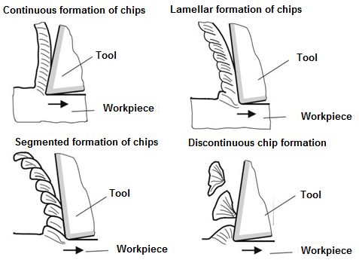
Figure 1. Mechanisms of chip formation types [4]
2.2 Chip compression ratio factor
During the cutting process, it may be seen that the chip thickness (a_{s}) is substantially greater than the depth of the cut (a) proving that the deformations affected in figure 2. The value of this deformation is defined by the ratio of these two thicknesses, which is called the compression factor of the chip λ.
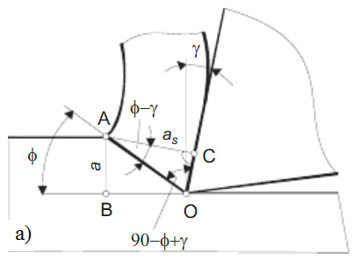
Figure 2. Comparison of the depth of cut and chip thickness [5]
The value of the chip compression ratio can be geometrically interpreted over the flank angle and shear angle. The value of the chip compression ratio moves in the range 2 ÷ 5. High values must be avoided, since a higher degree of deformation of materials requires a much higher energy consumption, which gives an undesirable effect. Accordingly, the cutting process is considered to be well-adjusted if the chip compression ratio is within the limits 2 <λ <3.
2.3 Model of chip formation
The model shown in Figure 3 is based on the study of micrographs and the chip root of the cutting zone, from which can be noticed the direction of the grain in structure elongation of an angle ψ from the shear plane. This angle is called the angle of grain texture. The shear divides the deformed part of the cutting layer from the root of the chip where the deformation is complete. The shear occurs simultaneously over the entire chip thickness of the chip, assuming there is no shear in the direction of the OA line.
Figure 3. Model chip formation [5]
Based on the metallographic image of the chip root, it can be determine the shear angle Φ, the rake angle γ and the angle of inclination of the grains texture ψ. On the basis of these data it can be obtained the chip compression ratio according to the following equation:
$λ=\frac{\cos\left(ϕ-γ\right)}{\sin{ϕ}}$ (1)
Where:Φ- angle of shear plane; γ- rake angle.
3. Experimental research
To obtain samples of chip root, which will be used for research, was developed a method to quick stop of the cutting process. This is a method based on the breakdown of the workpiece due to internal stresses in the material caused by the cutting forces. The samples were prepared so that it has reached the corresponding relationship between the speed, feed, and the depth of cut and the material fracture occurs near at the part of workpiece where is of the chip tooth.
Cutting was carried out on a vertical milling machine, without the use of cooling and lubricating agents, Figure 4. The main spindle carrier is rotated at an angle of 15° in relation to the vertical axis so that the tool engages the sample with the entire cutting-edge width, while the sample is fitted with appropriate accessories to ensure the highest stability due to the force generated during cutting. The width of the samples was 8 mm, and the dimensions of the tile is 12x12 mm. During cutting, the cutting regimes were constant. In the test, a head of a face milling cutter Ø125mm with a removable hard metal inserts K20 of the following characteristics was used (l=IC=12,7 mm; feed=3,18 mm/t; bs=1,4 mm; b=1,4 mm). All experiments were performed with the one tooth cutting. Cutting regimes have been adopted on the basis of the recommended cutting speed for the materials that were used in the study: f₁=0,1÷0,3 mm/tooth, speed V=160÷260 m/min.
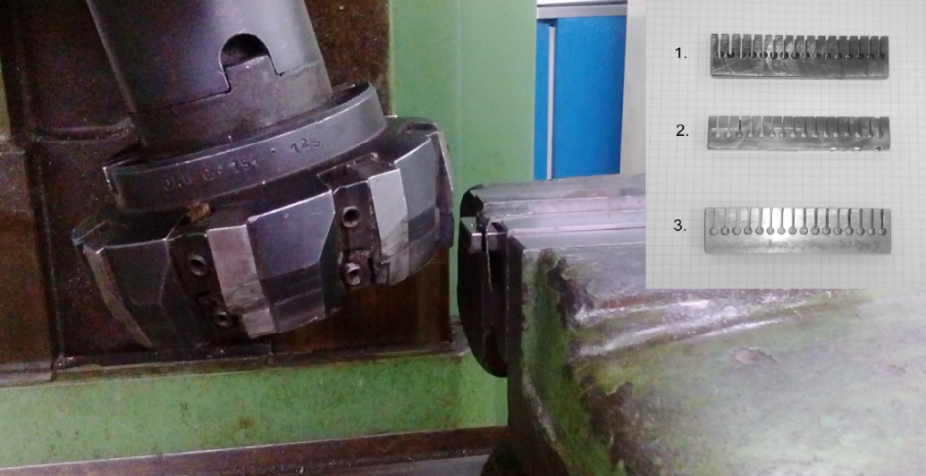
Figure 4. The milling head with exchangeable cutting plates and the prepared samples for chip rooth production (created by the authors)
The samples thus obtained were prepared for metallographic analysis to investigate the process of chip forming. Preparation of samples is done in a few steps [6]:
- The samples flow into the thermoplastic resin,
- Grinding of samples,
- Polishing of the samples.
3.1 Materials in the experiment
During the experiment, samples were made of the following materials:
- Chromium-nickel steel (316 LVM)
- Co-Cr-Mo suitable for casting and
- Ti-6Al-4V.
Chrome-nickel steel alloy represents an iron, a Co-Cr-Mo and Ti-6Al-4V are among the super alloys.
Chromium-nickel steel (316 LVM). Today it appears a large number of alloys used in commercial applications classified as stainless steels. This type of alloy finds its great application in orthopaedic surgery. Austenite steels Cr-Ni Fe have high corrosion resistance, but they are exposed to contact corrosion, strain corrosion [7]. This alloy is defined by a label 316LVM AISI ASTM F55 its chemical structure is defined as the production conditions and component as well. Mechanical characteristics can be regulated by deformation in cold, and depending on deformation, the tensile strength moves in the range of 650-2000 N/mm² [8].
Super alloys Co-Cr-Mo is suitable for moulding. In order to achieve good casting results, it is necessary to use a material of maximum strength, i.e. electric cobalt, chromium and molybdenum, with mandatory vacuum / vacuum application of the process of melting and casting. The shape and size of the grains formed during curing, crystallization, affects the mechanical properties of the cast. The presence of gases in molten metal is detrimental as it creates microporous and the other negative inclusions that occur during casting curing period.
Super alloy Ti-6Al-4V. This alloy has very high tensile strength and this value reaches up to 1100 N/mm². Super alloy Ti-6Al-4V is the most commonly used titanium alloy. The Ti-6Al-4V alloy offers the best overall performance for various applications for weight reduction in aviation, automotive and marine equipment, also has numerous applications in medicine, biocompatibility is great, especially when direct contact with body tissue or bones is needed [9].

Table 1. Chemical composition of tested materials (created by the authors)
 | The content [%]
Steel  316LVM | Fe | Cr | Ni | Mo | Mn | Si | Cu | C | N | S | P | Nb | V
 | bal | 17-19 | 13-15 | 2.25-3 | 2 | 0.75 | 0.05 | 0.01 | 0.1 | 0.01 | 0.025 | - | -
Alloy  Co-Cr-Mo | Co | Cr | Mo | W | C | Ni | Fe | Si | Mn | N | S | Ti | P
 | bal | 27-30 | 5-7 | 0.20 | 0.35 | 1 | 0.75 | 1 | 1 | 0.25 | 0.01 | - | 0.02
Alloy  Ti-6Al-4V | Ti | Al | V | Nb | O | N | C | H | Fe | Ta | Zr
 | bal | - | - | - | 0.18 | 0.03 | 0.08 | 0.015 | 0.2 | - | -

4. Results of experimental research
Super alloy Co-Cr-Mo
From Figure 5 it can be noticed that the casting dentritic structure is visible M₂₃C₆ (dark surfaces) interdentritic primary carbide images, in addition, large grains are visible that extend up to 2 mm. Metal carbide M₂₃C₆ has a significantly higher hardness compared to the base material, which can lead to significant tool wear and thus affect the quality and accuracy of the machined surface. The grain boundaries are large and they have not influenced the chip formation. It is also present the porosity of the material. From microparticle images (Figure 5.a) we see that hard carbides are at the grain boundaries. From Figure 5.b) it can be seen that the carbide made a deposit due to tool warming and oxidation. In addition, there is the porosity.
a)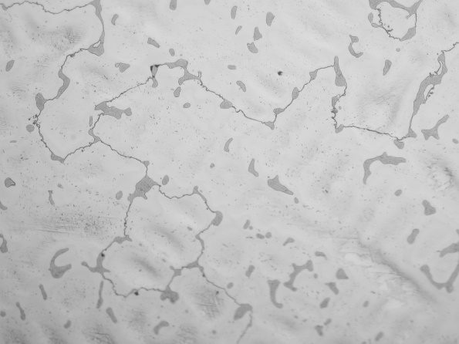 b)
Figure 5. Microstructure of Super Alloy Co-Cr-Mo (created by the authors)

Alloy Ti-6Al-4V
Figure 6 shows the forged microstructure of Ti-6Al-4V alloy, showing the fine grain structure of alpha (light grain) and beta (dark grain) phase. Grain size moves around 10 µm. The relationship between alpha and beta is in a ratio 60:40. Less porosity in relation to Co-Cr-Mo super alloy. In the cutting area itself, plastic deformation of the alpha and beta phase and slugging of the sputum along the boundary surface of the beta phase is observed. The characteristic of titanium alloys is that during conventional cutting occurs lamellar chips. The cause of this is the constant alternation of pressure and sliding in the chip formation zone.
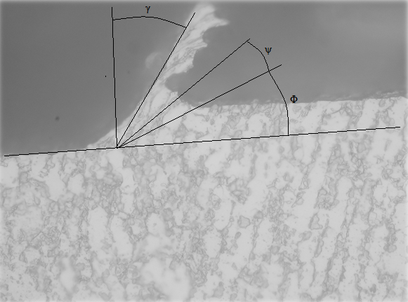
Figure 6. Microstructure of Ti-6Al-4V (created by the authors)
Chrome-nickel steel alloy
From Figure 7. it can be seen that, in the microstructure base is an austenitic basis with polygonal grains of size up to 40 µm, there is porosity, but to a lesser extent than the case in Co-Cr-Mo alloy. The measured microhardness is considerably higher than the other two materials and amounts 353.3 HV. Due to the high cutting forces in the cutting zone, and the higher temperature is created what is the cause of the deformation and strengthening of the chip (the assumption is that it turns into martensite). When processing 316 LVM steel, it can also be seen on the BUE deposits that occur during processing and cracks in the chip are also reported.
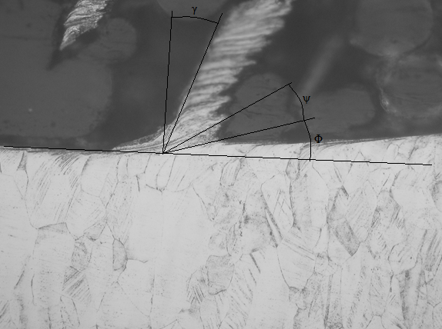
Figure 7. Micro-structure of chromium-nickel steel (created by the authors)
The formation of the chip and machinability has a great influence on the grain size, as experimental results have shown. In steel, it can be seen continuous chip, ie, accumulation of material due to the deformation reinforcement of the surface layer, and in the chip itself there occurs a deformation where grains of size 40 μm deform and coalesce and build a long undesired chip that can damage the tool and the machine.
When Ti-6Al-4Valloy is machining, this is not the case, was not observed significant accumulation of material chips is thin and short. Grains present in the microstructure of the alpha and beta phases are up to 10 μm, and therefore, during the deformation of the material and formation of the chip, a thin and short chip forms. It has also been observed that at the grain boundaries between the alpha and beta phases, an initial crack can also occur which can leads to the discoloration of the chip.
While Co-Cr-Mo super alloy is similar to steel as with this material, it is significantly larger grains of up to 2 mm, and during the chip formation the interaction between hard metal carbide and the basic structure results in leakage of material and obtaining a higher thickness of the chips.
From metallographic images of the chip root in which the graphic method was use, determines the parameters of the deformation of the chip, that is, the chip compression ratio using the above formula. Measured values are shown in Table 2.

Table 6. Determining factors of chip compression compression ratio on the basis of microstructure images (created by the authors)
Sample | λ | Φ | ψ | γ
1. | 2.44 | 17˚ | 11˚ | 24˚
2. | 1.95 | 21˚ | 15˚ | 31˚
3. | 4.13 | 15˚ | 12˚ | 14˚

The Higher value of λ must be avoided, because the higher the degree of deformation required and far greater power consumption, resulting in an undesirable effect. The cutting process is thought to be well adjusted if the chip compression ratio is within the boundaries 2 < λ < 3.
The results show that the 316-LVM steel cutting chip compression factor is not very suitable, so other processing regimes should therefore be chosen (speed, feed and depth of cut) to get a value that moves within the limits of 2-3.
For Co-Cr-Mo results, λ = 2.44 shows that is within the given limits, it satisfies this aspect.
For Ti-6Al-4V the value of λ is negligibly lower than the optimum value. Looking from the aspect of the quality and accuracy of the process for the selected cutting conditions, satisfactory results were obtained, as no significant accumulation of the material on the rake surface and the wear of the tools was noticed.
5. Conclusion
Based on the obtained results of experimental research and their mutual comparison, it can be seen that Ti-6Al-4V was best shown for the same cutting regimes and with the same material of the cutting tool for the following reasons:
- Greater tool life,
- Substantially lower porosity of the material,
- No material deposits BUE,
- Prepared chips have favorable shape,
- It proved to be suitable for processing at higher cutting speeds (results obtained with higher processing regimes are not shown in this paper because the other two materials have not been shown to be suitable for processing and the inability to further their comparison).
The machinability of the Co-Cr-Mo alloy did not prove to be suitable for the selected treatment regimens and the material of TM K20 cutting tool, due to the formation of the BUE hard metal carbide deposits on the chest surface and the considerable wear of the tool due to this phenomenon. These phenomena affect the accuracy and quality of the treated area. From the aspect of the compression ratio, the results were favorable. Accordingly, the mashinability of the material should be viewed on the basis of a number of influencing factors and, therefore, optimal cutting conditions are chosen.
Finally, the 316 LVM steel mashinability proved to be slightly better in relation to the workability of Co-Cr-Mo, since the BUE deposits formed in the s tool's roots did not have a major impact on tool wear. Therefore, it can be concluded that the quality and accuracy of the treated surface is better but not satisfactory because the processing regimes and the material of the cutting tool are not the most optimal for this material, which is also shown by the increased value of the chip compression ratio (λ=4.13).

6. Bibliographical references
- Savkovic, B.: Modeliranje funkcija obradivosti pri procesu obrade glodanjem, Doctoral dissertation, Faculty of Technical Sciences, Novi Sad, 2015.
- Kovač, P., Šiđanin, L.: Uticaj procesa nastajanja strugotine na stanje obrađene površine, Tribologija u industriji, 1995, pp.12-16.
- Teonshoff, H.K., Denkena, B.: Basics of Cutting and Abrasive Processes, Berlin, 2013.
- Milikić, D., Gostimirović, M., Sekulić, M.: Osnove tehnologije obrade rezanjem, Univerzitet u Novom Sadu, Fakultet tehničkih nauka, Novi Sad, 2008.
- Kovač, P.: Teorija obradih procesa, Univerzitet u Novom Sadu, Fakultet tehničkih nauka, 2014.p.15-23
- Narushima, T., Ueda, K.: Co-Cr-Mo Alloys Effective Metallic Biomaterials, Advanced in Metallic Biomaterials, 2015. pp.157-178.
- Buhagiar, J., Bell, T., Sammons, R., Dong, H.: Evaliation of biocompatibility of S-phase layers on medical grade autenic stainless steels, Journal of Materials Science: Materials in Medicine, Vol. 22, 2011, pp.1269-1278.
- Kajzer, W, Kajzer, A., Grigiel-Pradelok, M., Ziebowicz, A., Ziebowicz, B.: Evaluation of Physicochemical Properties of TiO₂ Layer on AISI 316LVM Steel Internded for Urology, Information technologies in Medicine, Vol. 472, 2016, pp.385-389.
- Austin, D.C., Bevan, M.A., East, D., Brown, A.D.: Microstuctural Investigation and Impact Testing of Additive Manufactured Ti-6Al-4V, Characterization of Minerals, Metals and Materials, 2017, pp.191-199.

