One possible option to promote the Local Sale Program for Construction Materials: Recycled concrete aggregates

L. Martínez-Fernández¹, M. Alvarez-Luna²
Central University Marta Abreu of Las Villas, Santa Clara, CP 54830, Cuba
lesday@uclv.edu.cu
Abstract. The construction industry is one of those that most change the environment because it requires a large consumption of natural resources and produces large volumes of waste. Even though most of the construction materials that are wasted are considered waste, in reality, they are residual and for many their final destination is to go to landfills, but some have great potential to be recycled and reused and in this way reincorporate them into the construction. Waste management is a culture that must be implemented with the participation of all people. The results of reusing block residues to convert them into aggregates and reincorporating them into the production process in the elaboration of blocks are presented. The social, economic and environmental benefits of having recycled aggregates are presented to strengthen the local program for the sale of construction materials.

Keywords: Blocks; Recycled aggregates; Small Scale Production

- Introduction
The construction industry is one of those that most changes the environment because it requires a large consumption of non-renewable resources and produces large volumes of waste. For this reason, research is being carried out to recycle waste in construction to meet the needs of the inhabitants. It is a call to take responsible actions with our planet.[2]
Reusing debris as aggregates for concrete is a great challenge throughout the world. The economic loss is 10% of the total cost of work [1]. For this reason, Cuban society is worried.
An important purpose is to use materials that are not natural aggregates to store the reserves of natural aggregates for the most important works.
The main objective of this work is to demonstrate the potential of aggregates of recycled concrete to strengthen the availability of aggregates at the local level.

  - Housing completed in the Villa Clara province. Resource allocation.
The construction of houses in the province has not reached the growth rate demanded by the population. On the one hand, the repair and urgent reconstruction, which has occurred due to the scourge of meteorological events and on the other hand, the allocation of aggregates in a centralized manner to the different municipalities from the main quarries of the province.

Figure 1 shows that for the small-scale production workshops located in the different municipalities the supply of aggregates for transport and energy is exacerbated.

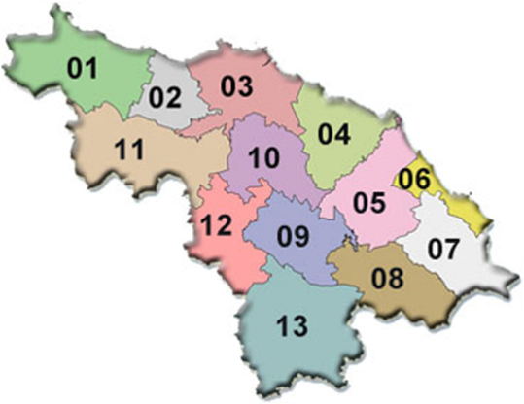
El Purio 41,6 km
Palenque 44,2 km
El Hoyo 47,9 km
Legend
01: Corralillo 06: Caibarién 11: Santo Domingo
02: Quemado de Güines 07: Remedios 12: Ranchuelo
03: Sagua la Grande 08: Placetas 13: Manicaragua
04: Encrucijada 09: Santa Clara
05: Camajuaní 10: Cifuentes

Figure 1: Identification of aggregate quarries in Villa Clara and an estimate of the distances to the city of Santa Clara.

1.2 Recycling blocks as alternatives to aggregate.

A viable option to minimize damage to the environment is the use of recycled aggregates. An example of this is the availability of non-conforming blocks that remain in the yards of ecomaterials workshops without productive use (see Figure 2). In this way, environmentally friendly waste management is achieved and the exploitation of non-renewable raw materials is reduced.

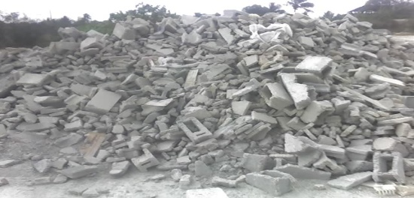
Figure 2: Photo taken at the debris storage site

- Results and Discussion

  - Properties of recycled aggregate
The results obtained are consistent with the reports of Etxeberría, M .; Pavón, E .; Páramo, A. R. and Poon, Chi-Sun, these can be summarized in:
- The high absorption value for these materials is due to the fraction of mortar adhered to the natural aggregate.

  - Mechanical behavior of the blocks
A benefit is observed in the mechanical behavior when are used arid recycled fine
The elaborated blocks are type II (500x200x150). Should reach a resistance value to the compression from 4 MPa to the 7 days and 5 MPa to the 28 days. [2] The reached results are represented in the Figure 3.
When it is used 25 and 50% of recycled fine aggregate, the blocks are according with the standard, but it doesn't happen this way for superior substitutions to 75%.
Figure 3: Compression strength.
  - Physical behavior of the blocks

The results of absorption are presented in the figure 4.
The values of absorption stay below 10%.
It is possible to conclude that when are substituted natural aggregates for recycled aggregates in a separate way; the tendency is to increase the absorption.

Figure 4: Absorption.

References
- ASOCIACIÓN ESPAÑOLA DE GESTORES DE RCD, G. E. A. R. Guía española de áridos Reciclados procedentes de residuos de construcción y demolición (RCD). Madrid, España, 2012.
- NC: 247 (2013) Bloque huecos de hormigón.
- PAVON, E; ETXEBERRIA, M. & MARTINEZ, I. Propiedades del hormigón de árido reciclado fabricado con adiciones, activa e inerte. Revista de la Construcción [en línea]. 2011, vol.10, no. 3, pp. 4-15.

