X International Conference on Mechanical Engineering “COMEC2019”

Magdeburg Logistics Model – The Smart Logistics Zone as a Concept for Enabling Logistics 4.0 Technologies

Magdeburg Logistics Model – The Smart Logistics Zone as a Concept for Enabling Logistics 4.0 Technologies

Niels Schmidtke¹, Elke Glistau², Fabian Behrendt³

1 - M. Sc. Niels Schmidtke, Fraunhofer Institute for Factory Operation and Automation IFF, Magdeburg, Germany, niels.schmidtke@iff.fraunhofer.de
2 - Dr.-Ing. Dr. h. c. (UCLV) Elke Glistau, Otto von Guericke University, Magdeburg, Germany, elke.glistau@ovgu.de
3 - Prof. Dr.-Ing. Fabian Behrendt, SRH Fernhochschule – The Mobile University, Riedlingen, Germany, Fraunhofer Institute for Factory Operation and Automation IFF, Magdeburg, Germany, fabian.behrendt@mobile-university.de

Abstract:
- Statement of the problem: Intelligent linking in the context of Industrie 4.0 alters the objectives and possibilities of designing logistics solutions in the production economy today and tomorrow [1]. There is a growing need for an expanded theory of logistics that helps to characterize existing solutions as well as systematically develop new solutions and bring them together effectively and efficiently.
- Objective(s): The objectives are the development of a model of thinking and a procedure model for current and future logistics solutions including Logistics 4.0. The article explains the newly developed "Smart Logistics Zone" (SLZ).
- Methodology: The SLZ is defined as a scalable examination and action area for analysis, evaluation, planning, control, regulation and (re-) configuration of logistics solutions [2]. New to the thinking model are the generation of solutions from (logistic) objects, processes, systems and the relevant infrastructure as well as the scalability of the considered zone. The framework model provides a quantifiable target system. The process model in turn allows a systematic solution development using method and technology databases.
- Results and Discussion: Several possible views on logistics, which are considered as aspects in the SLZ, are being elaborated. Other aspects of the presented concept such as intelligence and spatial categories are discussed as well. In the outlook a sample factory serves as a scalable examination area for the SLZ.
- Conclusion: In its application, the SLZ demonstrates a new perspective on the analysis, planning and evaluation of logistics systems. The approach is designed as a scalable tool. It can be adaptively applicable to various intralogistic and extralogistic problems.

Keywords:
Logistics 4.0; Digital Transformation; Magdeburg Logistics Model; Smart Logistics Zone;
New thinking model

1. Introduction
The digital transformation of the industry with its technological components has a direct influence on the orientation of logistics processes within companies as well as in entire company networks. Through the development and integration of new technologies more and more rigid corporate structures and control architectures are dissolving. The vision ranges from decentralized networks of modular conveyor, storage and handling technology to the application of artificial intelligence in data evaluation and interpretation for smart services in logistics [3]. The essential requirement is to identify, locate and control logistics objects and to record and interpret their states in order to achieve target-oriented interaction in the sense of holistic networking.
In this context, industrial and retail companies are currently faced with high investment costs, so that a complete implementation of technology concepts usually does not take place in one go but in several integration steps [4]. Often the situation arises that companies successively adapt, supplement or replace existing plants and processes. As a result, different forms of automation and digitization interact in workspaces, e.g. agent-based autonomous transport units can be used alongside simple floor conveyors with or without electric drives for internal material transport. So-called cyber-physical systems (CPS), whose actions are based on algorithms and data structures, are combined with human emotional decisions and actions. These human-machine interactions must be organized and designed in such a way that a functioning working environment is created and that various technical facilities and human beings can work together according to their needs and situation. To achieve a successful implementation, suitable technology concepts and methods need to be developed and integrated. With regard to logistics, it is therefore possible to act according to requirements and situation-appropriate.
This is where the Smart Logistics Zone (SLZ) finds its approach [2]. This concept aims at a goal-oriented interaction of logistics systems, processes, objects and the participating logistics infrastructures.

2. On the way to Logistics 4.0
In the course of digitization, production and logistics processes will change lastingly due to the use of new technologies. This leads to the emergence of new challenges, which at the same time can be understood as drivers for digital transformation [5]. The technological perspective includes technological components, such as CPS, Internet of Things and Services (IoTS), cloud or edge computing, as well as the paradigms of an “Industrie 4.0”, such as integration, flexibility and decentralization. These paradigms can be understood as the basis for "Logistics 4.0" and significantly influence the targeted holistic networking of logistics objects. Such technological components serve i.a. localization, identification, control, configuration and connectivity. On the one hand, they are characterized as enablers and on the other hand, they are drivers for efficiency potentials of logistics [6].
Due to the close connection of production and logistics systems, there will be no Industrie 4.0 without adaptive CPS in logistics. Logistics must be just as flexible and versatile as the production systems supported by it due to its characteristic as a crosscutting function in value creation networks [7]. The basic tasks of logistics will remain unchanged even in the context of Industrie 4.0. The responsibility of logistics lies in fullfllling its function according to the "8 R Factors of Logistics" [8]. The focus is on the use of innovative technologies with the aim to create new concepts for planning, control and realisation as well as for the control of material and information flows, e.g. in the form of cyber-physical production and logistics systems (CPPS / CPLS) [9]. Because of technological change, the complexity and dynamics of the processes involved as well as their scope and intensity of coordination are increasing [10]. In this context, the basic tasks of logistics ("8 R Factors of Logistics ") as well as the requirements to be met must be considered from an extended perspective of Industrie 4.0. The logistics tasks are viewed from a physical and an information technology perspective. The focus is on the one hand on the object view, which refers to operands such as goods (physical) and information (information technology). On the other hand, the process view is considered, which includes operations such as material flow as well as information and communication flow. Figure 1 shows the object-related and process-related requirements from the two perspectives in order to ensure the performance of the core tasks within the framework of Logistics 4.0 with the right object, in the right quantity, at the right location, at the right time, at the right cost, in the right quality, ecologically correct and with the right information.
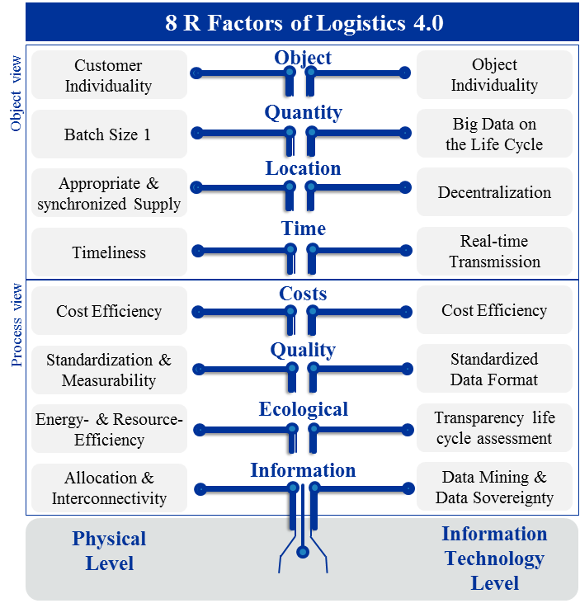
Figure 1. 8 R Factors of Logistics 4.0 (created by the authors) [11]
3. Methodology
Conceptual aspect: „Methodology”: The necessary methodology of the SLZ can be described as a process model, based on a model for planning operative logistics [12]. The application of the procedure model (Figure 2) provides a systematics. It enables the creation of connections and similarities between logistic operands, operators and operations based on their characteristics. This makes it possible to span and delimit logistics spaces at different locations.
The SLZ design is based on a two-part process. In the Demarcation Phase, specific objectives (individually required logistics services) are formulated taking into account the technological and organisational conditions. In the Analysis Phase, Logistics Zones are identified based on the characteristics of the logistic entities. This means, Logistics Zones can be spanned and linked through the analysis of the characteristic structures (considering occuring target conflicts). The Design Phase includes the creation of a technology catalogue, a function-
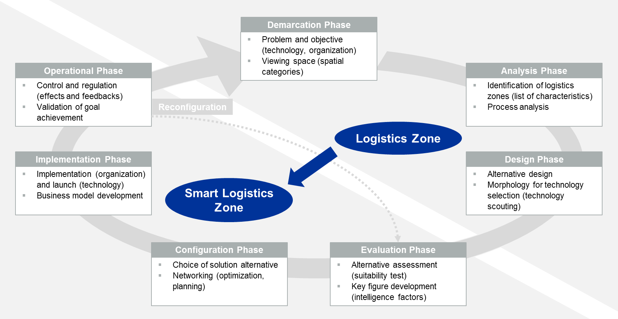
Figure 2. Procedure model for the design of the Smart Logistics Zone (created by the authors)
oriented clustering of the technologies as well as the transfer of existing and potential solutions into a morphology. The transition to Smart Logistics Zones takes place through the linking of logistic operators and operands. In the Evaluation Phase the evaluation of the (technological) alternatives as well as the suitability in the sense of a specific objective is to be accomplished by means of a key performance indicator (KPI) system. At this point, the concept of technical intelligence factors is taken up and compared with (technology) costs in order to give a recommendation regarding the choice of technology by drawing up balance of arguments. As a result, it is necessary to elaborate further the intelligence factors with concrete technical and economic indicators (e.g. using different technology groups). The approach is selected using an aggregated top KPI for each defined target dimension and the consideration of the interaction of object, process, system and infrastructure. For this purpose, the customer requirements must be quantifiable. The KPI system helps to realize holistic considerations, to set priorities and to prevent one-sided interpretations. Typical aspects of requirement are effectiveness, efficiency, time, costs, quality, flexibility, performance, safety and environment. In the Configuration Phase and the Implementation Phase, an alternative solution corresponding to the specific objective is selected and implemented (technologies as system solutions, and even organizational solutions). The operational control sequences are controlled and regulated during the Operational Phase and the achievement of objectives is validated. The findings on the interdependencies can be used effectively. These findings can be checked within the framework of a (re-)configuration using new technologies to increase the overall intelligence of the viewed Logistics Zone. As a result, implementation of the measure can be initiated.
The goal is to map logistics zones adaptively and versatily over an entire logistics network and to reconfigure existing logistics zones according to the situation. In this context, logistics zones can be linked due to their similar characteristics and a global optimization of the considered logistics system is made possible.

4. Discussion
In summary, the SLZ represents a scalable examination area and action area for the analysis, evaluation, planning, control and regulation of logistics solutions [2]. It comprises the interaction of logistic objects, processes, systems and the involved logistic infrastructure in a needs-based and situative manner under the aspect of a human-technology organisation. Furthermore, it is a new thinking model for the area of logistics. It is a conceptual model with a large universal validity, which can be transferred and used versatily for theoretical and/or real logistic situations. The SLZ offers an open framework model of logistics, into which already known and newly developed logistics solutions and procedure models of logistics and logistics 4.0 can be integrated. This explicitly includes an open collection of concepts, methods and technologies. This collection includes, for example, methods (data analytics, AI), tools (software, cloud solutions) and technologies (radio technologies, assistance systems, conveyor and transport technology). [13]
A systematic approach in the SLZ supports a logical, consistent, purposeful and planned approach, which follows a division into procedural phases (Figure 2). The SLZ thus offers a solution systematics: it supports principle experiments and the formation of theoretical models for the development and combination of functional principles.
The aim is to create an action area that is intelligently planned, controlled and regulated. This should be able to perceive oneself and one's environment and to derive recommendations for actions according to prevailing requirements and situational conditions. Rigid system boundaries are removed by intelligent cross-linking, while the approach of logical subdivision into object, process and system is expands to include the logistic infrastructure.
The Object view: Tab1e 1 contains an illustrative list of logistic objects with a focus on intelligent objects.
Table 1. Example for (intelligent) obejcts in Logistics (created by the authors)
Logistics Objects | Example of application für intelligent logistics objects
Persons | Participants in passenger transport
Intelligent material | Perishable food
Intelligent part | Replacement parts, maintenance and repair
Intelligent assembly/module | Vehicle components
Intelligent products | Vehicles
Intelligent packaging | Perishable food, medicinial products
Intelligent vessels | Storage, material supply, waste bins
Intelligent pallet | Supply chain
Intelligent containers | Air traffic, shipping
Intelligent cargo | trailer-, truck-, rail-, ship-, flight-loads
Nesting | Intelligent packaging in intelligent vessels within intelligent containers

The process view: It defines fundamental, combined and integrated business process, and operations within the material, information, financial and energy flow. Conventionally, processes can be based on best practices (benchmarking) and redefined (process reengi-neering). Furthermore, familiar sample processes (JIT, KANBAN) can be applied and existing processes (Kaizen, Lean, TQM) can be improved. The process view makes use of proven descriptive models such as SCOR (plan, source, make, deliver, return), defined material flow operations such as transport, storage, handling, sorting, packaging or information flow operations such as recording, processing, outputting, saving or securing information. In addition to the material and information flows, the financial parameters within the network must be recorded and financially controlled. Important financial goals are securing the profitability and liquidity of the companie with logistics services (tracking costs, revenues, cash flow). New to the analysis is the energy flow. Examples for energy operations are e.g. the conversion, enlarging, reducing, changing direction, conducting, insulating, collecting, dividing, mixing and separating of energy [14].
The System view: The processes are implemented as an HTO system (human, technical, organisational system) and its infrastructure. For this purpose, it must be determined how the human being and with which technical support (partial, complete) the processes are to be implemented. Cyber-physical systems of different levels are typical for Logistics 4.0 solutions. These include, for example, cellular transport systems (autonomous AGVs), intelligent container management systems or modular storage and conveying technologies in which the human beings functions in different roles (assisting, controlling or monitoring).
The infrastructure view: New is the formulation of requirements for the infrastructure and the target-oriented use of the possibilities of the infrastructure [9]. The term infrastructure is used here in a broad sense. In addition to the economic definition of infrastructure, there is also the logistical reference, which explicitly includes areas, buildings, roads and paths, energy, media and universal technology. By means of object, process, system and infrastructure (e.g. as integration platforms), practical logistics solutions can now be defined in an effective interplay. The SLZ thus reaches far beyond the traditional system approach.
Conceputal aspect „Intelligence“: The "8 R Factors of Logistics" model (Figure 1) is used and modified to characterice the requirement for SLZ. Table 2 describes exemplarily the requirements for the intelligence of the Logistics Zone. This intelligence can be supplemented by human intelligence and/or replaced by the intelligence of the technical solution. For this purpose, typical technologies and methods of Logistics 4.0 are named and assigned. Table 2 offers a checklist with which the requirements of the particular logistics task can be recorded, specified and quantified in the SLZ. Depending on the components of the SLZ, a decision can then be made as to whether the required intelligence is assigned to the object, the process, the system or the infrastructure. Thus, the model simultaneously opens the possible solution space for which variants can be generated and evaluated.
The challenge lies in determining the right and necessary level of intelligence and autonomy in the overall concept. The SLZ, as a solution method, defines the solution space at these points and determines a target-oriented result. Here, the concept envisages the development of a suitable KPI system (Figure 2), which supplements the classic KPI of logistics (e.g. delivery reliability, quality, flexibility, capability) [15] with (new) indicators of digital transformation by further aspects (intelligence factors in logistics, Chapter 3).
Table 2. Modified “R Factors of Logistics”-model in application on the Smart Logistics Zone with naming of intelligence requirements and typical technologies and methods (created by the authors)
Aspect | R Factors of Logistics | Requirements for intelligence | Technologies and methods
Identity | the right object | - Self-reflextion and identification | - Wireless technologies (LPWAN, 5G)  - Augmented and assisted reality (AR)
State variables | in the right quantitiy | - Recording and evaluation of quantities  - Error signaling and problem recognition  (environment, safety)  - Deviation management | - Sensor technology, e.g. for counting, wheiging, level measuring  - Gateway-cloud interfaces  - Integrated systems for monitoring and control  - Actuating elements (gripper, distributor, positioner)
 | At the right location | - Localisation and navigation (e.g. determination of routes) | - Sensor technology for localisation, navigation, decision making, mobility
 | At the right time | - Time management (z.B. idle time of waiting time)  - Error signaling and problem recognition  (environment, safety) | - Systems for time measurement  - Real-time communication  - simulationen and scenarios  - Actuating elements (controller)
 | At the right cost and revenue | - Evaluation and optimization of costs | - Process digitalisation  - Performance Measurement  - Performance Management
 | In the right quality | - Status detection  - evaluation  - Error signaling and problem recognition  (environment, safety)  - Error prevention | - Sensor technology, e.g. for the measurement of temperature, vibration, incidence of light, energy consumption  - Assistance technology  - AR for predictive maintencance  - Actuating elements (vibration dampers, clamping and braking elements)
 | in the righti assignment | - Self organisation  - Networking and communication | - Real-time communication  - Internet of Things and Services  - Direct assignment  - Just-in-Real-Time  - Swarm and Platooning
Data | with the right Data /information | - Information management (provision, storage, processing) | - Condition Monitoring  - Data Analytics  - Cloud & Cyber Security  - Live-Data

Conceptual Aspect „Zone“: The SLZ's viewing area is spanned in an application-specific way, so that its characteristics can be defined context-related. The zone can be viewed using the following criteria:
- Characteristics level (include multiple dimensions explicitly within logistics solutions)
- As a term for typical models (mathematical space, information technology space, geographical space or economic space)
- As a term for typical spatial categories in logistics (Figure 3)
- Holistic approach, for the clarification of great efficiency potentials especially in the design and interaction of object, process, system and infrastructure.
The spatial categories describe structural and function-specific characteristics of geographically delimitable examination areas. Following [16] and [17], the categories logistics hub (e.g. ports, airports, freight distribution centres), production logistics (assembly supply, order picking, etc.), transport routes (road, rail, waterway, ports, airports) and urban (urban area) or rural (rural area) can be distinguished from each other.
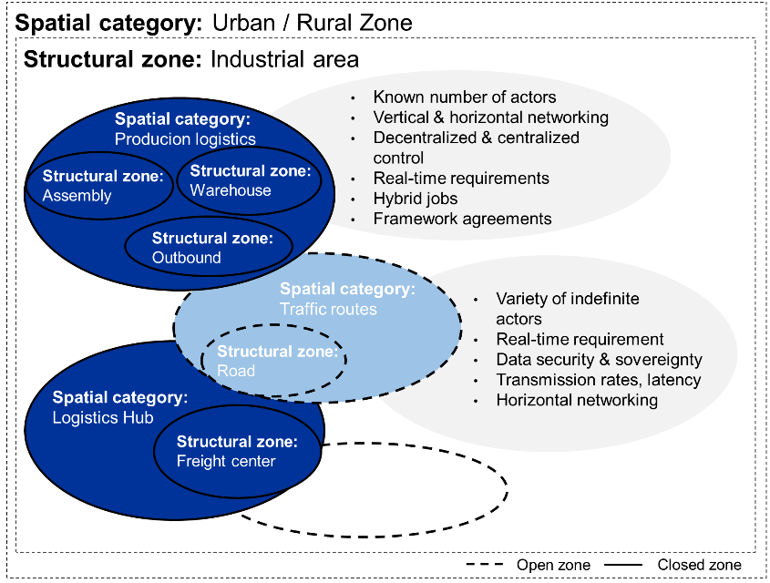
Figure 3. Spatial category and structural zone within the Smart Logistics Zone (created by authors)
5. Conclusion
In its application, the SLZ sees itself as a planning system in which any reference problems of logistics can be presented in a test and demonstration environment. In the intralogistics of production systems, a target-oriented (smart) selection of process-stabilizing and/or process-improving technologies and methods is carried out. The structure of the exemplarily selected sample factory (Figure 4) and the process sequences defined therein serve as a scalable examination area for the SLZ.
The described technology-based solution approach serves to eliminate the low degree of linking of logistic processes and their objects as well as to avoid isolated technical solutions. The requirements for process stabilisation and improvement are met by targeted technology selection. It is claimed that this will result in efficient (intelligent) logistics and automation solutions for intralogistics in the future. The determination of intelligence and its development in technical systems is supported by selective and target-orienteted selection of technologies. The resulting improvement by determining the system-inherent intelligence of the system at object, process, system and infrastructure level is to be emphasized as a distinguishing feature of the SLZ.
Proof of Concept: The next work steps include the application of the process model on the basis of defined reference problems. The sample factory (Figure 4) represents an entire process of production of goods and services. This ranges from goods receipt, storage technnology, order picking and assembly to goods issuing department of a manufacturing company. The process of full and empty container supply is used as an example. In a test environment, networkable technologies are to be selected for a target process and the adaptability of the Logistics Zone tested. Examples include the use of a tugger train system communicating in real-time or the use of autonomous AGVs in conjunction with drones (activity analysis), which are to be combined in an integrative and intelligent material flow concept. The development of KPI for the identification of increased efficiency is one of the next steps in the concept development.
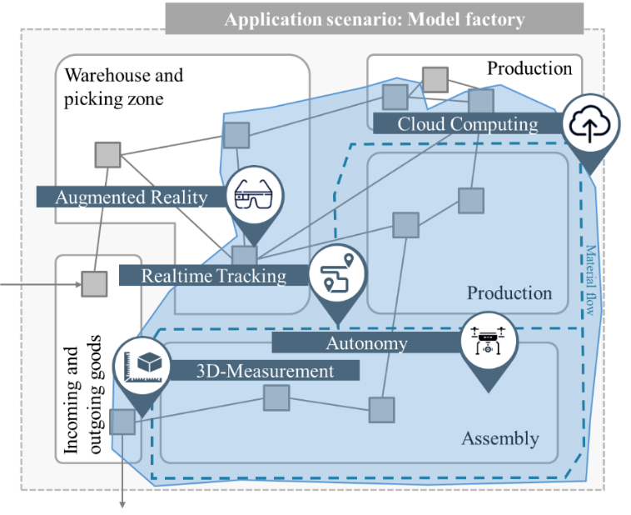
Figure 4. Application Scenario: Model factory (created by authors)
The SLZ's approach demonstrates a new perspective on the analysis, planning and evaluation of logistics systems. The application of the approach should take place in various intra- and extralogistic problems. Due to the structure as a scalable tool, this should be possible in an adaptive way. In intralogistics in particular, the type of production facility [18] plays just as important a role as the selection of the right tools and methods [8].

6. Bibliographical references
- Schenk, M (2015): Produktion und Logistik mit Zukunft. Digital Engineering and Operation. In: Springer Vieweg (VDI-Buch), Berlin, Heidelberg.
- Behrendt, F, Poenicke, O, Schmidtke, N, Richter, K (2018): The Smart Logistics Zone as an enabler of Value-added services in the context of Logistics 4.0, ISSL Symposium der BVL
- Bousonville, T (2017): Logistik 4.0 – Die digitale Transformation der Wertschöpfungskette. Springer Fachmedien Wiesbaden
- Helmke, B (2019): Digitalisierung der Logistik. In: Hartel, D., H.: Projektmanagement in Logistik und Supply Chain Management. Wiesbaden, pp.183-188.
- BMWi (2018): Den digitalen Wandel gestalten. Online: http://www.bmwi.de/Redaktion/DE/Dossier/digitalisierung.html, Access 18/01/2018
- Hausladen, I (2016): IT-gestützte Logistik. 3., aktualisierte und erweiterte Auflage. Wiesbaden: Springer Gabler, pp. 53-54
- Bauernhansl, T, ten Hompel, M, Vogel-Heuser, B (2014): Industrie 4.0 in Produktion, Automatisierung und Logistik. Anwendung, Technologien, Migration. Wiesbaden: Springer Vieweg, pp. 321
- Illés, B, Glistau, E, Coello Machado, N (2007): Logistik und Qualitätsmanagement. 1. Auflage. Miskolc, Hungary: University of Miskolc, pp. 3
- Lieberoth-Leden, C, Röschinger, M, Lechner, J, Günthner, W A (2017): Logistik 4.0. In: Handbuch Industrie 4.0. Geschäftsmodelle, Prozesse, Technik. München, München: Carl Hanser Verlag; Ciando, pp. 451–507.
- Göpfert, I (2016): Logistik der Zukunft - Logistics for the Future. 7. Aufl. 2016, pp. 320
- Schmidtke, N, Behrendt, F, Meixner, S, Thater, L. (2018): Technical potentials and challenges within internal logistics 4.0. In: IEEE. In: 2018 4th International Conference on Logistics Operations Management (GOL)IEEE, pp. 1-10
- Beckmann, H (1996): Theorie einer evolutionären Logistikplanung. Basiskonzepte der Unternehmensentwicklung in Zeiten zunehmender Turbulenz unter Berücksichtigung des Prototypingansatzes, Dissertation, Universität Dortmund
- Gronau, N.; Theuer, H.: Potenziale autonomer Technologien in Produktion und Logistik. In: Siepermann, C.; Eley, M.: Logistik gestern, heute, morgen. Berlin 2011, p.247.
- Koller, R (2013): Konstruktionslehre für den Maschinenbau: Grundlagen zur Neu- und Weiterentwicklung technischer Produkte mit Beispielen. Springer-Verlag. 3. Auflage. Seite 36
- Muchna, C; Brandenburg, H.; Fottner, J.; Gutermuth, J.: Grundlagen der Logistik – Begriffe, Strukturen und Prozesse. Wiesbaden 2018, p. 45.
- Richter, K (2018): Plattform “Digitale Netze und Mobilität”: Konvergente Netze im Umbruch – Anforderungen an Konnektivität, Flexibilität und Künstliche Intelligenz. Ergebnisdokument der Fokusgruppe Aufbruch in die Gigabit-Gesellschaft, S.10.
- Richter, K (2017) b: IoT-Konnektivität im Intelligenten Logistikraum Betrachtung von Strukturräumen. Wernigerode
- Schenk, M.; Wirth, S.; Müller, E.: Factory Planning Manual. Berlin Heidelberg 2010, pp. 226-228.

