XVIII SYMPOSIUM OF ELECTRICAL ENGENEERING

Sonido focalizado, simulación y experimentación para aplicaciones biomédicas.

Focused sound, simulation and experimentation for biomedical applications.

Marysol García Pérez¹, Teodoro Córdova Fraga², José Alfredo Soto Álvarez³

1-Marysol García Pérez. Science and Engeneering Division, University of Guanajuato, Mexico, m.garciaperez@ugto.mx
2-Teodoro Córdova Fraga. Science and Engeneering division, University of Guanajuato, Mexico, theo@fisica.ugto.mx
3-José Alfredo Soto Álvarez. Science and Engeneering division, University of Guanajuato, Mexico, jasa@fisica.ugto.mx

Resumen:
Planteamiento del problema: El estudio validado para analizar la densidad en hueso es la densitometría ósea, la cual utiliza una dosis muy pequeña de radiación ionizante para producir imágenes del interior del cuerpo. Se han desarrollado procedimientos basados en el sonido, ofreciendo ventajas como la de no utilizar radiación, así como, tener un dispositivo portátil para su uso en el ámbito médico. La propagación de la onda acústica está influenciada no sólo por la masa ósea sino también por la estructura ósea y las propiedades del material. Objetivo: El objetivo de este trabajo es analizar si existe concordancia entre la simulación y los resultados experimentales, incidiendo sonido focalizado en cilindros de diferentes materiales. Metodología: En el presente trabajo se describen los resultados obtenidos aplicando sonido focalizado por medio del dispositivo electroacústico “Radar Óseo”. El equipo fue construido en el laboratorio de Física Médica de la Universidad de Guanajuato “Radar óseo”, en el cual se han realizado algunas modificaciones necesarias en la programación a frecuencias específicas para su uso en la caracterización de materiales con diferentes densidades. Se realizaron las medidas con cilindros de madera, parafina, plástico y hueso; la longitud media de estos cilindros es de 20 cm, un transductor y receptor fue colocado en las caras de cada cilindro. Resultados y Discusión: De forma paralela, se realizaron simulaciones mediante el método de diferencias finitas, el cual se obtiene de reemplazar las derivadas en las ecuaciones diferenciales con aproximaciones de diferencias finitas, proporcionando un sistema de ecuaciones algebraico que debe resolverse en lugar de la ecuación diferencial. Conclusiones: El método se resolvió para la ecuación de onda en una geometría simplificada en una dimensión, permitiendo la comparación de las mediciones experimentales con los resultados numéricos.

Palabras clave: Sonido Focalizado, Materiales, Diferencias, Finitas

Abstract: The validated study to analyze bone density is bone densitometry, which uses a small dose of ionizing radiation to produce images of the inside of the body. It has been developed procedures based on sound, offering advantages such as not using radiation, as well as having a portable device for use in the medical field. The propagation of the acoustic wave is influenced not only by the bone mass but also by the bone structure and the properties of the material. Objective: The aim of this research is to analyze if there is agreement between the simulation and the experimental results, with sound focused by cylinders of different materials. Methodology: In this work, the results obtained applying focused sound by an electroacoustic device “Bone Radar” are described. This device was built in the laboratory of Medical Physics of the University of Guanajuato, the necessary modifications were made programming specific frequencies for its use in the characterization of materials with different densities. Measurements were made with cylinders of different materials with 20 cm in length, placing the transducer and receiver on the cylinder faces. Results and discussions: In parallel, simulations were carried out using the finite difference method, this method is obtained by replacing the derivatives in the differential equations with finite difference approximations, providing a system of algebraic equations that must be solved instead of the differential equation. Conclusions: The method was solved for the wave equation in a simplified geometry in one dimension, allowing the comparison of the experimental measurements with the numerical results.

Keywords: Focused Sound, Materials, Difference, Finite

1. Introduction
Inside traumatology field, the best validated methods for the estimation of osteoporotic fracture risk are X-ray based bone density, these methods are used to estimate bone mineral mass and density. Sound procedures present the advantages like lack of radiation, lower price and the possibility of making a portable device.
The form of propagation of the sound wave, in addition to being influenced by the bone mass, is also affected by the structure and properties of the material. So that, it is necessary to decrease the fracture risk in osteoporotic femur with effective treatment due to the cause of high cost and considerable mortality.
Barkmann (2007) et. al. scanned the femora in transverse transmission mode using focused ultrasound, reporting that speed of sound is a variable which is positively correlated with the true velocity in bone and with bone width, beyond bone volume fraction and bone thickness, bone structure also contributes to speed of sound. Finding in the results of the study that speed of sound can predict total bone mass density with adequate accuracy.
Kapicioglu (2008) et. al. developed an electroacoustic sound transmission-detection system to explore developmental dysplasia of the hip (DDH), this studied was carried in 22 patients where it was validated in four different hip and knee positions. Sound transmission values of dysplastic hips were always lower than that of normal hips when the hip and knee was flexed during measurements. Sound transmission values decreased with age.
Padilla (2017) et. al. also performed the validity and reliability of electroacoustic probe for the diagnosis of hip dysplasia in neonates, probe showed moderate sensitivity and high specificity, and high repeatability in immaturity hip.
The most general definition of sound is a longitudinal wave in a medium. The simplest sound waves are the sine waves, which have the frequency, amplitude and wavelength completely specified. The intensity of ultrasound is attenuated exponentially as it passes through a medium, some of the energy is scattered and some is absorbed (Hughes 2001).
In this paper is presented the wave equation solution for one dimension as a result of a problem of initial values with boundary conditions using an approximation in finite differences, with the objective of analyzing if there is coherence with the experimental part when influencing a sound wave for different materials.
The approximation in finite differences of a partial differential equation consist of defining the functions and variables involved in a discrete set of points in the domain where a solution of the equation is sought (Guzmán 2010). Thus, the function f is defined only in the points of the domain ($t^{n}, x_{j}$) and denote these values of the function $f_{j}^{n}$. It is also considered that $j=0,1,…,N$ and $n=0,1,…,N_{t}.$

2. Methodology
The experimental results are based on the “Bone Radar” device, which was designed and built in the Medical Physics laboratory of the Science and Engineering Division at the University of Guanajuato (Ponce 2019). The corresponding programming was made to make the device capable of sending a sound wave in one specific frequency according to what was found in the literature, this frequency was the following: 256 Hz. As shown in figure 1.

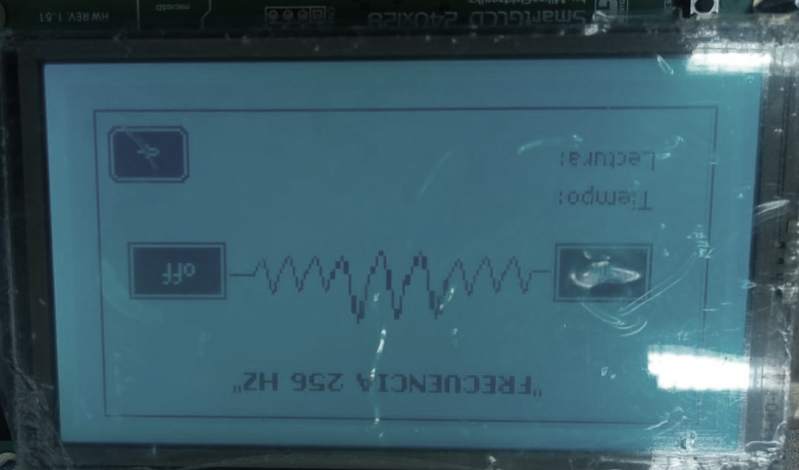
Figure 1. Screen that allows the user to send the frequency of their preference

The device consists in a transducer that is responsible for sending the sound signal and a receiver that transduces it to a value in decibels. The programming is done through a microcontroller integrated to the Smart GLCD screen 240x128 (MikroElektronika®). It can be seen in figure 2 the complete device with its transducer and receiver.

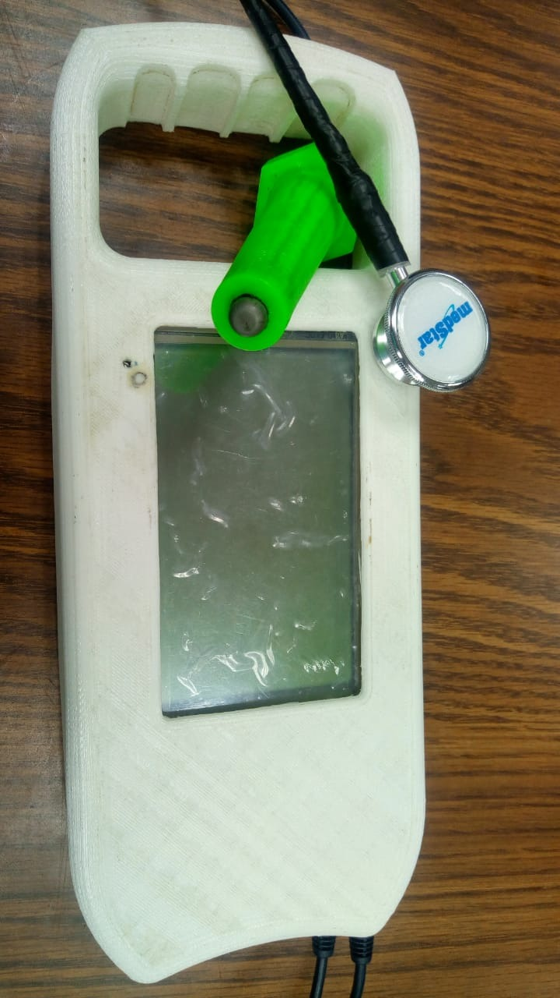
Figure 2. Electroacoustic device “Bone Radar”
The electroacoustic device was used to analyze the response of cylinders with different materials (wood, plastic, paraffin and bone), each one with different density, and then plastic and wood cylinders with different lengths, to make the measurement, the material was placed on a base, the transducer and the receiver are placed in the cylinder caps, as shown in figure 3.

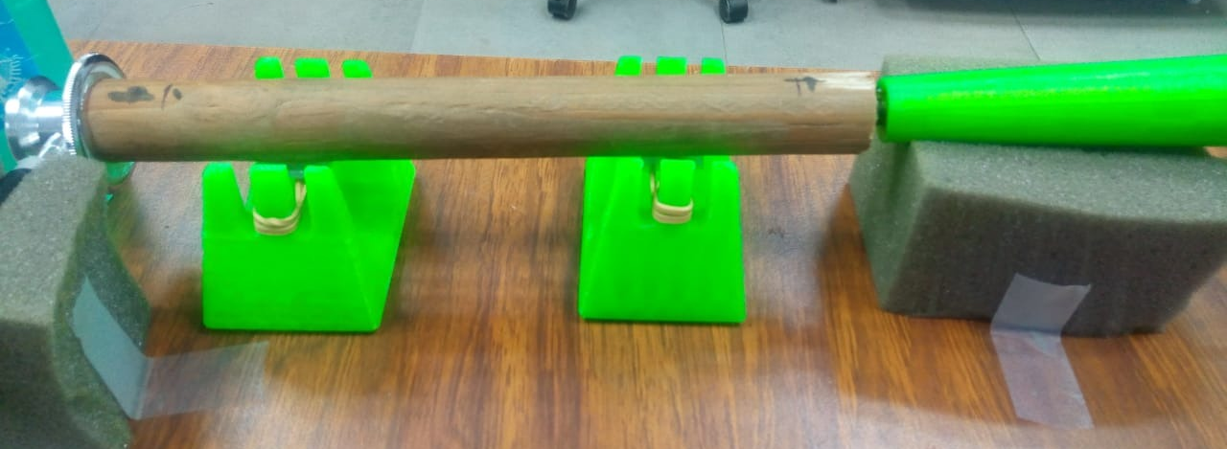
Figure 3. Experimental setup for the transducer and receiver with the cylindrical material to be measured

Each cylinder of different material was measured and weighed to calculate its density respectively. Figure 4 shows the measurements taken to obtain the densities of each cylinder.

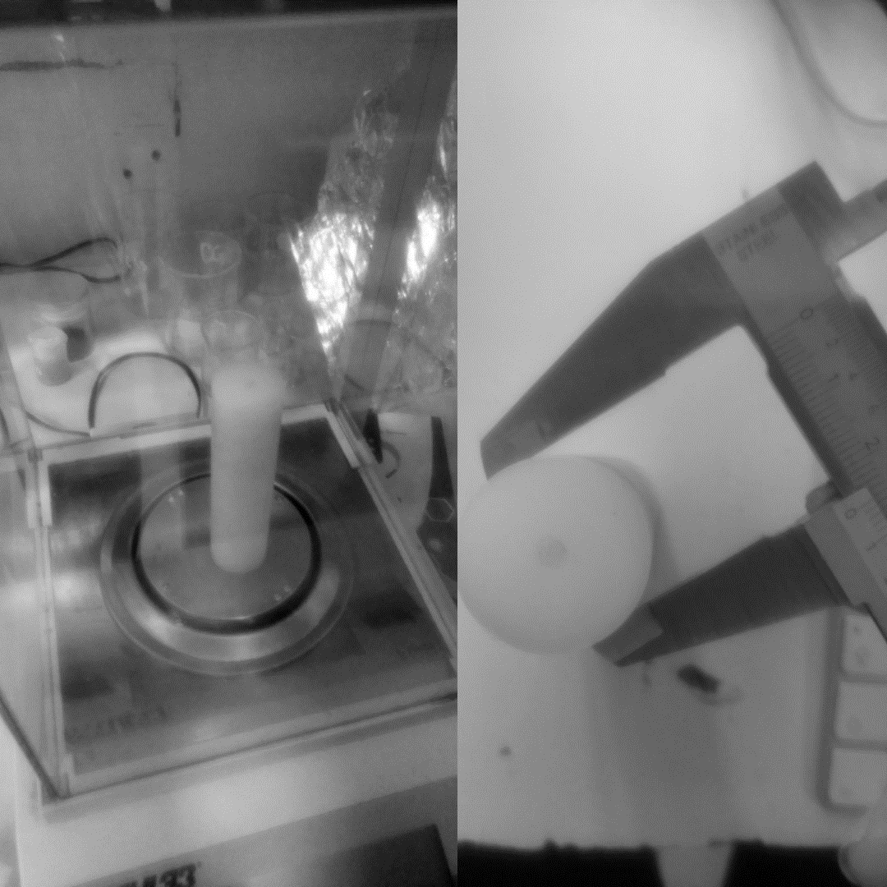
Figure 4. Method followed to measure and weigh each of the materials.

The simulation of the wave equation was carried out parallel to experimental analysis by the finite difference method, it was programmed in Matlab® Software.
It was solved by explicit centered finite difference scheme for spatial and temporal discretization, the wave equation described as:
$$\frac{∂^{2}u}{∂t^{2}}-c^{2}\frac{∂^{2}u}{∂x^{2}}=0 (2.1)$$
where c is defined as the speed of the wave.
The temporal and spatial discretization can be written as:
$$\frac{∂^{2}u}{∂t^{2}}= \frac{u_{i}^{n+1}-2u_{i}^{n}+u_{i}^{n+1}}{∆t^{2}} (2.2)$$

$$\frac{∂^{2}u}{∂x^{2}}= \frac{u_{i+1}^{n}-2u_{i}^{n}+u_{i-1}^{n}}{∆x^{2}} (2.3)$$

Replacing equation 2.1 with the discretization of equations 2.2 and 2.3, we obtain the discretized wave equation:

$\frac{{u_{i}}^{n+1}-2{u_{i}}^{n}+{u_{i}}^{n-1}}{∆t^{2}}-c^{2}\frac{{u_{i+1}}^{n}-2{u_{i}}^{n}+{u_{i-1}}^{n}}{∆x^{2}}=0, (2.4)$

The variable of interest is $u_{i}^{n+1}$, so a compact form for the equation in differences is presented in matrix form:

${\vec{u}}^{n+1}={\left(\frac{c∆t}{∆x}\right)}^{2}D_{xx}{\vec{u}}^{n}+2{\vec{u}}^{n}-{\vec{u}}^{n-1}+{\vec{u}}_{cc1}+{\vec{u}}_{cc2}$ (2.5)

3. Results and discussion
In the following table (Table 1) and figure (Figure 5), the mean intensities and densities corresponding to the cylinders of different materials are shown. It is observed that the lower the density of the material, the intensity registered in the receiver of the device increases, therefore the density of the object is inverse to the intensity of sound that arrives.
Table 1. Mean intensities and densities of different materials

Material | Intensity(dB) | Density(gr/cm³)
PVC | 4.0090 | 1.13
Candle | 4.5833 | 1.11
Wood | 4.8240 | 0.75
Bone | 4.9262 | 0.67

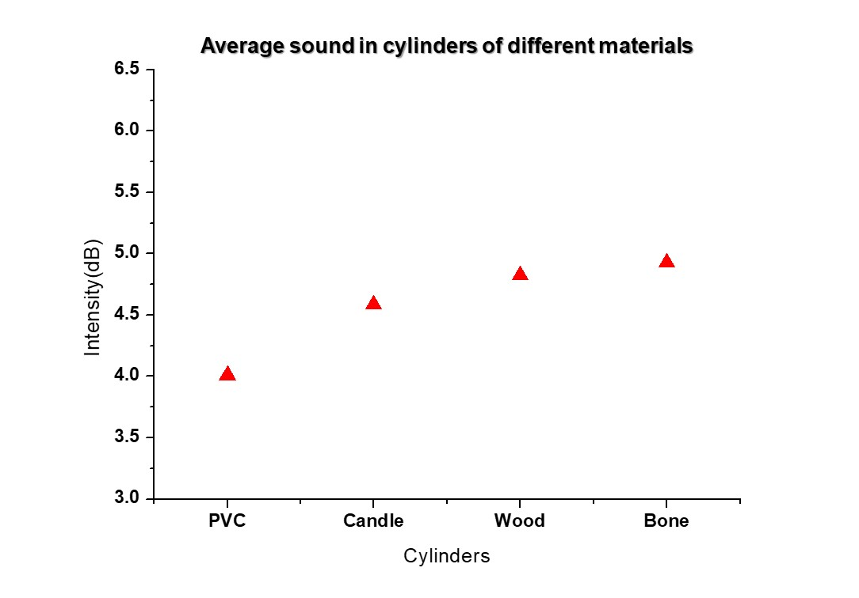
Figure 5. Average sound intensity received in each material

Using the same measurement procedure, the average sound intensity was obtained in pvc cylinders with two different lengths: 6 and 10 cm, and wood of three lengths: 6, 10 and 20 cm. Table 2 shows the means corresponding to the cylinders with different lengths.

Table 2. Mean intensities and densities in cylinders with different lengths

 | Length(cm) | Intensity(dB) |  | Length(cm) | Intensity(dB)
Wood | 6 | 5.9533 | PVC | 6 | 5.8114
 | 10 | 5.5015 |  | 10 | 5.0398
 | 20 | 4.8240

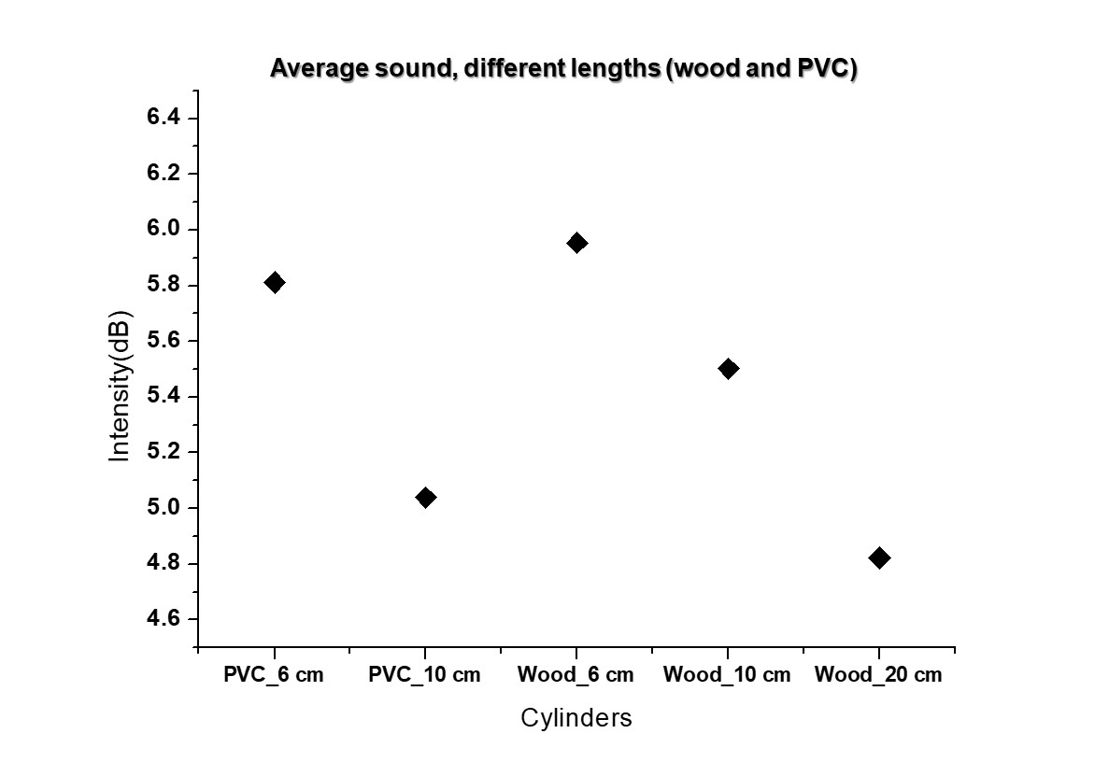
Figure 6. Average sound intensity received in cylinders with different lengths

It can be observed that the intensity averages in which the sound is received decrease as the length of the material is greater. So, it can be inferred that there is an attenuation in the sound signal due to the length of the material used as the medium where the wave is propagating.
In the part of the simulation, Matlab® programming was carried out by solving the wave equation in one dimension by the finite difference method.
A sinusoidal function is established as an initial condition. For the temporary discretization, 500 temporary steps was used, increasing by 0.01 units. While, for the spatial discretization, it was used 100 steps, increasing by 0.5 units. When the solution is plotted, the sine wave is observed changing over time. As the time progresses, the wave is attenuated, passing through the origin to the negative part and so on (See Figure 7).

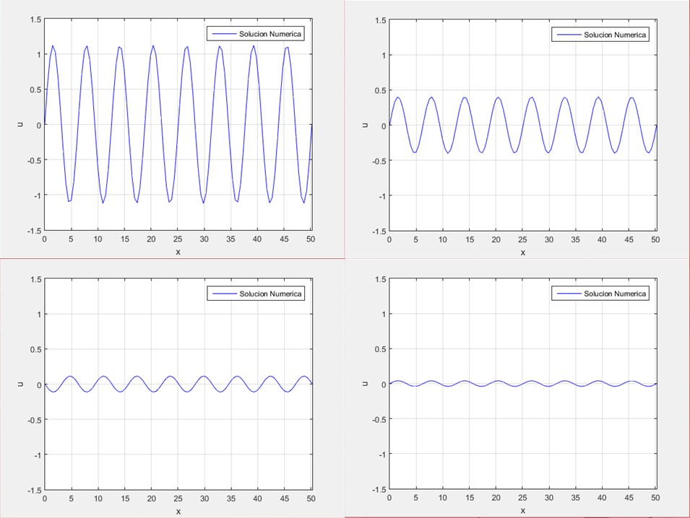
Figure 7. Graph of the solution by the method of finite differences through time of the wave equation in one dimension (nx=100, nt=500, dx=0.5, dt=0.01)

4. Conclusions
Preliminary results are shown by simulating the wave equation, a new simulation is been designing to include the material and geometry by which the acoustic wave will be influenced.
Hughes (2001) et. al. mentions in their article that the sound loses energy when it propagates through a medium, obtaining as a result an attenuation in its intensity. This could be demonstrated in the simulation performed with the wave equation in one dimension by the finite difference method as well as in the experimental part and in the measurements made through cylinders of different materials with the “Bone Radar” device. It can be verified that the density of the material affects the propagation of the sound wave, so it is intended in the future to implement this device for medical applications such as, determining the density of the bone in the area of trauma at the time of performing a surgery or to make an opportune diagnosis of some abnormality at a bone level. It was evidenced in Barkmann (2007) that it is a high correlation between speed of sound and bone mass index, although the final aim is to estimate the bone strength as an important factor of the estimation of the risk of fracture.

5. Bibliographical references
Antunes A.J.M., Leal R.C.P., Teixeira O. et. al. (2014) “Finite Difference Method for Solving Acpustic Wave Equation Using Locally Adjustable Time-steps”. Procedia Computer Science. 29 627-636.
Barkmann R., Laugier P., Moser U., et. al. (2007) “A method for the estimation of femoral bone mineral density from variables of ultrasound transmission through the human femur”. Elsevier. 40 37-44
Guzmán F.S. (2010) “Solución de la ecuación de onda como un problema de valores iniciales usando diferencias finitas”. Revista Mexicana de Física. 56(1) 51-68.
Hughes S. (2001) “Medical ultrasound imaging”. Physics Education. 36 468
Kapicioglu M.I. and Korkusuz F. (2008) “Diagnosis of Developmental Dislocation of the Hip by Sonospectrography”. Clinical Orthopaedics and Related Research. 466(4) 802-808.
Padilla N., Medina D., Ruiz M.L. et. al. (2014) “Diagnosis of Developmental Dysplasia of the Hip Using Sound Transmission in Neonates”. Health. 6 2510-2516.
Padilla N., Olvera G., Delgado. S. et. al. (2017) “Validity and reliability of electroacoustic probe for diagnosis of developmental dysplasia of the hip”. BMC Pediatr. 17 149.
Ponce D. et. al. (2019) “Utility, Validation and Comparison of Electroacoustic Device and Bone Densitometry in Osteoporosis Diagnosis”. Physiological Measurement
R.J. LeVeque, (2007) “Finite Difference Methods for ordinary and partial differential equations”, Siam.
Sakamoto S., Tsuru H., Toyoda M. and Asakura T. (2014) “Finite-Difference Time-Domain Method”. Computational Simulation in Architectural and Environmental Acoustics.
Wilson D.K., and Liu L. (2004) “Finite-Difference, Time-Domain Simulation of Sound Propagation in a Dynamic Atmosphere”. Engineer Research and Development Center.

