**COMEC 2019**

**Introduction of a hungarian automobile cluster and industry 4.0**

**Borodavko, B1., Illés, B2. and Bányai, Á.3**

1- PhD student, Institute of Logistics, University of Miskolc, Hungary, beata.borodavko@uni-miskolc.hu

2- professor, Institute of Logistics, University of Miskolc, Hungary, altilles@uni-miskolc.hu

3- associate professor, Institute of Logistics, University of Miskolc, Hungary, altagota@uni-miskolc.hu

**Abstract:** Today the clusters already get a role in the progress and shaping the increase of competitiveness of SMEs, and these, trust-based networks may help the small enterprises utilize special resources by sharing the knowledge, and by the fact that the benefits of these can be reached with smaller costs compared to those outside the cluster. In my research, I analyse the beneficial co the answer how the cluster organisations can follow and match to the trends of Industry 4.0

**Keywords:** supply chain, automotive, supplier network, cluster, industry 4.0

**1. Introduction**

The last century brought significant changes to the automotive industry and represents a significant economic and technological force in the life of countries connected to the industry. The goal of the research is to showcase the practical functioning of the cluster organisation in Hungary and to reveal their economy-enhancing effects and advantages. [1].

**2. Cluster network levels**

From the general point of view we can define 3 levels of regional network in clusters. These can be macro, mezzo and micro levels.

**Macro level**

**Mezo level**

**Micro level**

Figure 1. Cluster network level [4].

Macro level:

- Contributes to the survival and consolidation of SMEs

Mezo level:

- The employment-rate increases in the given region

- It provides work for research centers in the region

- Contributes to the improvement of the region’s competitiveness and image

Macro level:

- The market size of the enterprise can be increased, the market weight of the

- cluster members is bigger

- The innovative power of the enterprise in increases

- The reputation of small companies can be increased

- The flow of professional informational exchange becomes faster

# Example from Hungarian Automotive cluster organization - HOHAC

Central Eastern Europe start to become the center of the automotive industry, practically all significant manufacturers from Europe and from the Far East have manufacturing sites in the region. At the present, there are four carmakers (Original Equipment Manufacturers), SUZUKI, GM, Mercedes and AUDI and from 2020 BMW with assembling or motor manufacturing capacities in Hungary. It is in the interest of the manufacturers to receive spare parts from local or close suppliers, thus the companies of the region, and the member companies of the North Hungary Automotive Cluster (NOHAC) have good chances to become suppliers or to strengthen their present positions. [4].

When formulating the goals of NOHAC, the success factors needed for reaching these goals have to be formulated as well. Depending on the degree of influence the success factors below have upon the goals, the success factors can also turn into risk factors.

The six goals below have to be formulated in connection with the NOHAC’s operation: [6].

1. The strengthening of the region’s international competitiveness, the improvement of the region’s ability to renew
2. Growing the effectiveness of long-term cooperation between automotive enterprises
3. Common utilization of the existing automotive infrastructures, technologies, capacities, respectively, acquisition and operation of new ones
4. Securing an expert staff with skills suited for the needs of the automotive enterprises, the intermediation of the needs of the enterprises
5. Dissolving the distrust between automotive enterprises, ensuring the possibility of informal communication, effective flow of information.
6. Strengthening the connections from outside the network (with other networks, with the aim of transferring the technology)

The reasons for setting goals:

1. The economy of the region is dominated by the big multinational, export-oriented enterprises and branches generating a lower added value. Hence there is, in any case, a need to improve the economy’s ability to renew, which can be ensured first of all by bringing into view the activities with a higher added value, the innovation and the R + D. (Research and Development)

2. The increase of the long-term cooperation relationships can contribute to the competitiveness of the members.

3. Many member enterprises posses the special infrastructure, assets, installations and technologies related to the automotive industry, as well as such free capacities, which others could, especially the small and middle enterprises, exploit and utilise. HOHAC could help find, as a kind of coordinator, find and offer these free capacities and could contribute to aid the potential partners to find each other.

4. The lack of well-qualified workforce causes a problem to almost all cluster member enterprise, starting from the skilled workers all to the engineers.

5. The most important reason of the extraordinary low level of cooperation, common projects and developments between Hungarian automotive enterprises is the distrust. Most companies still look with fear at the cooperation with others, at the sharing of information or technology. The distrust is especially high between the domestically owned SME sector and the big multinational enterprises.

6. Many similar clusters to the NOHAC can be found in domestic and foreign regions – connected either to the automotive or other sectors. The experiences obtained by these organisations on the field of network development can be useful to the NOHAC as well. Especially important is the cooperation with other automotive networks and clusters.

# Influence and benefits of Industry 4.0 for the automobile industry

Industry 4.0 started as a German government-driven digitalization program that initially addressed the manufacturing industry. Its key focus was on improving production processes through increased automation enabled by Internet of Things (IoT) technologies, often referred to as "smart factory." The initial objective was to maintain the strong position of the German manufacturing and automotive industry. Industry 4.0 is becoming increasingly global and cross-industry, driving CIOs to align their global digital business initiatives with Industry 4.0 to reap its benefits. In addition, it sought to support small and midsize businesses (SMBs) with their digitalization initiatives through networking opportunities with vendors and more mature enterprises, through access to innovation labs, and financially with funding programs. [3], [4].

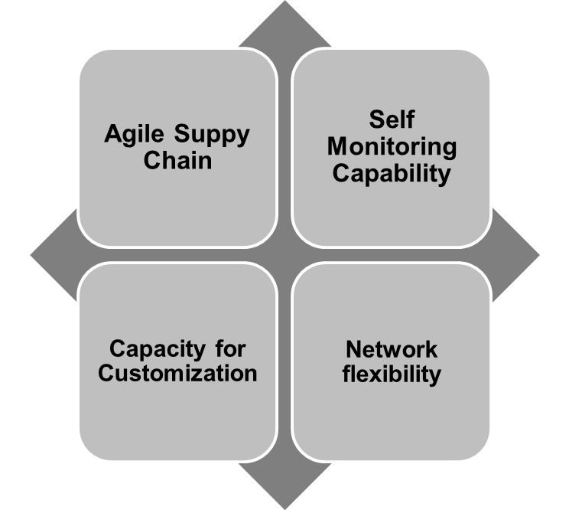

Figure 2. Benefits of Industry 4.0 for the automotive industry

1. Agile Supply Chain: Industry 4.0 gives OEMs and suppliers the agility to quickly adapt manufacturing specifications in response to changing standards.
2. Self-monitoring capability: 24 hours of production causes critical reliability of equipment. Robust monitoring systems to identify potential maintenance issues – like self-protection mechanism control- before they cause downtime
3. Capacity of customization: More personalization and shorter delivery time for those vehicles
4. Network flexibility: Automotive manufacturer have locations all over the world. All location of manufacturer is strategically connected
5. **Industry 4.0 in the company “mindset”**

The automotive industry is looking prepared towards Industry 4.0 [7].

To a vast majority of the enterprises questioned in the research made by the PwC Hungary Supplier Research, to around 80% the concept of Industry 4.0 is already known, and they feel it is inevitable that the manufacturing processes will change. More than 25% is already using Industry 4.0 solutions in the production, while the majority calculates in middle term that – firstly, in the research-development, in the production and the logistics – the technological innovations will appear. The companies of the Hungarian automotive industry are dedicated regarding the willingness to invest towards the growth.

Some elements of the Industry 4.0 concept, such as the smart factory, the Internet of Things or the connected cars – appear in different fields of the enterprises.

In harmony with the growth of the demand and the requirements the suppliers have to work intensively to constantly improve the effectiveness of the production and to promote the innovation so that they suit the growing needs.

The result of the research survey is that the Industry 4.0 is unavoidable for the automotive industry and that the future of the Hungarian automotive industry lies in the development of the infrastructure, the innovation and the research-development supporting environment.

# Summary

The paper summaries the cooperation possibilities of small and medium-sized automotive suppliers and logistical service providers supported by network integrator or cluster organisation as virtual logistics centre. [3].

The research introduce an existing automobile cluster in Hungary and discover the benefits of industry 4.0. The authors are looking for the answer how can SMU´s react for the digitalization changes and which benefit can the companies get from Industry 4.0.

Clusters improve competitiveness by refining the service quality of joint and service industries of the region. Regional clusters improve the competitiveness of the region. Clusters can significantly decrease the transaction costs of the enterprises within a region by lower expense of partner finding, faster recognition of consumer preferences, quick transfer of knowledge, and fiduciary capital. During the formation of clusters the risk factors must be measured and multiplicative effects – which are resulted by the operation of clusters – must be identified. Industry 4.0 is the new standard. The techniques needed for this vision are already available on the market. The digitization of factories, power plants and logistics centers brings about changes that will not be possible with the traditional approaches of conventional logistics.

**6. Bibliographical references**

1. Bergman, E.M.–Feser, E.J. (1999) Industry Clusters: A Methodology and Framework for Regional Development Policy in the United States. – Boosting Innovation. The Cluster Approach. OECD, Paris. pp.243-268.
2. J. Cselényi, B. Illés: Logisztikai rendszerek. Miskolci Egyetemi Kiadó. 2004
3. B. Illés: Logisztikai rendszerek. Miskolc 2007
4. Nagy Z. (szerk.) (2007) Beszállítói hálózatok építése. Miskolc
5. NOHAC Yearbook (2019)
6. J Walendowski, H. Kroll, E. Schnabl (2016) Regional Innovation Monitor Plus, Thematic Paper 3 - Industry 4.0, Advanced Materials (Nanotechnology).