X. Internationale Wissenschaftliche Konferenz Maschinenbau

Development of a steering and braking system
for automated cargo-bikes

Lars Junge¹, Michael Schmidt², Sebastian Zug³, Stephan Schmidt⁴
1- Lars Junge, Otto-von-Guericke-University, Institute of Mobile Systems, 39106 Magdeburg, Germany, lars.junge@ovgu.de
2- Michael Schmidt, Otto-von-Guericke-University, Institute of Mobile Systems 39106 Magdeburg, Germany, michael1.schmidt@ovgu.de
3- Sebastian Zug, TU Bergakademie Freiberg, Software development and Robotics, 09596 Freiberg, Germany, sebastian.zug@informatik.tu-freiberg.de
4- Stephan Schmidt, Otto-von-Guericke-University, Institute of Mobile Systems 39106 Magdeburg, Germany, stephan.schmidt@ovgu.de

Abstract: To relieve busy urban areas of automobile traffic and exhaust emissions, bike sharing systems are increasingly being implemented. In order to expand the limited transport capacity of a bicycle, cargo bikes are used for private transport in the narrow urban area. The problem is often the availability of a cargo bike at a determined time. The limited number and possibly inhomogeneous distribution in the urban area reduces availability of the cargo bikes. To increase the acceptance of the system, the goal must therefore be to significantly increase the availability at all locations in the urban area. So far, the consumer had to get to the means of transport, now the cargo bike should autonomously navigate to the user and maneuver.
This article focuses on the actuators and their modeling as an elementary part of the overall system to enable the automated journey of a cargo bike. There are currently no off-the-shelf components available for braking and steering. The steering and braking system must be able to be controlled separately from each other by humans or automatically, in order to allow manual and automatic operation. For brake and steering a suitable concept is developed, a simulation model is built and evaluated. In addition, the steering mechanism is evaluated with measured values on the real test vehicle.

Keywords: autonomous, automated, bike, cargo-bike, steering, brake

1. Introduction
Electrification and automation are current megatrends that will significantly change our understanding of mobility in the future. Electrified vehicles are replacing the ones driven by combustion engines and help to avoid local emissions. Automated and connected vehicles allow to transport goods and services if required and offer "Mobility as a Service". You order a fitting vehicle at a certain point in time to the starting point of your journey, use its service and release it again at your destination. These developments are not limited to the urban environment. Especially at early stages of this development the greatest implementation potential, due to the current legal situation, is available on closed factory areas with specialized micro-mobiles that are adapted to the specific application.
As a first use case, the authors address the operation of an automated bike sharing fleet on a larger factory site. The bicycles can be used by the employees on the entire site for business trips. Upon request, the employee is provided with a vehicle available directly at his current location. The employee then rides the electrically assisted bike to his destination on the factory site and can immediately release his vehicle when he reaches that destination. The bicycle is then directly available for further transportation tasks. Conventional Bike-Sharing systems, suffers from manual redistribution of the vehicles which can be omitted in the automatic scenario, thus helping the system operator to save significant operating costs when compared to traditional bike-sharing concepts.
The realization of this vision requires complete automation of the entire driving process. In addition to fundamental aspects of localisation, environmental perception, prediction and planning, there is also the problem of actuator technology for steering and braking systems [1]. So far, no automated steering or braking systems for load bikes are commercially available.
This paper therefore addresses the conception, simulation and evaluation of an active steering and braking system for a three-wheeled cargo bike. Based on an analysis of the requirement profile, an active system is designed, parameterised on the basis of a simulation study and finally implemented. The functional capability is verified by testing the real system in defined use cases.

2. State of the Art
Various groups around the world are currently working on the realization of automated bicycles and focus on different aspects of the overall system. At the Technical University of Kaiserslautern [2] and Cornell University [3] the self-stabilization of a single-track bicycle is implemented with the help of the steering movement of the front wheel. The current challenges for both teams are to improve the control technology for self-balancing the wheel when stand-still and under disturbance influences such as wind.
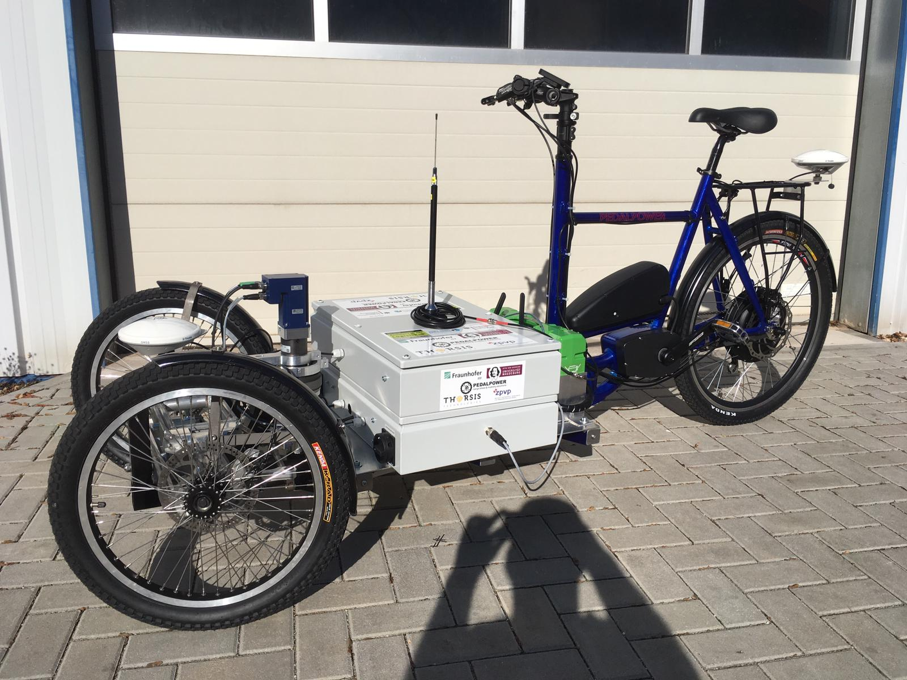
Projects with automated tricycles are carried out at the Massachusetts Institute of Technology[4] and at the University of Washington Bothell[5]. The Bothell team is using a recumbent tricycle with a pair of wheels in front. The steering and brakes of the micromobile are also electrically operated. A linear servo motor is used as the actuator for the steering, its movement is transmitted to the track rods of the two front wheels. There is no handlebar for manual operation by human driver. The wheel is remote controlled by a radio control. For the electrical operation of the brake, an electromagnet is used on each brake calliper. The lifting magnet pulls the rope of the brake bowden cable with constant force. Position and force are difficult to control with this design. MIT is also developing a three-wheeled autonomous bike with a pair of front wheels. The special feature of this bike is the presence of a windscreen and a surrounding occupant protection. With automated steering and braking, the planned call and guidance system has parallels to the OvGU projects.
Figure 1 Cargo bike X-Loader (test vehicle)
In our application the model X-Loader of the company Pedalpower is used, wich is equipped with a two-track front axle. In the following the steering components of this model are described. Due to the two-track front axle of the test vehicle, a steering mechanism is required to transfer the steering rod angle to the front wheels. There is a loading area between the front wheels and the handlebars. From the handlebar to the rear wheel, the frame geometry is similar to a normal single-track bicycle.
Due to the intermediate loading area, the head tube of the handlebars of the X-Loader reaches under the floor assembly of the bike. At the lower end of the steering column, a lever mechanism translates the steering movement under the loading area into a front head tube. The rotary motion is transferred from the head tube to the front wheels via two tie rods. Due to this design there are several potential engagement points on the steering mechanism to automate the steering.
On conventional bicycles, various braking systems are used for deceleration [6], [7]. The brake is usually actuated via the handbrake lever on the handlebar. The force is then transmitted from the lever to the brake via a cable pull or hydraulically with master and slave cylinders. Two notable brake types are rim brake systems and disc brakes.
Steering and braking assistance are not required on conventional bicycles due to manual operation by the rider. However, electric control is required for the automated operation of a bicycle steering and deceleration system.
To determine the current state of development, a patent search was carried out with the DEPATISnet of the German Patent and Trade Mark Office. The results of the full text search for electric steering and brakes on bicycles are considered for the state of the art. The special search for electrically assisted steering systems on bicycles for the automated application did not yield any relevant results. In the field of electrically actuated brake systems, utility patents exist for the automated actuation of wheel brakes.
All utility models include the electrical engagement of the bicycle brake systems. Manual operation by humans is no longer needed, which forms the basis for automating the breaking functions
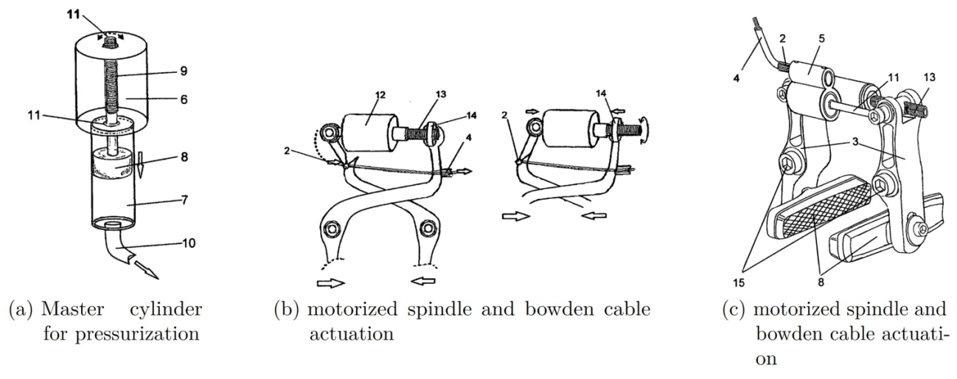
Figure 2. Patented automated brake actuation [8]-[10]

3. Automation of the steering and braking system
3.1 Steering
According to the concept of automated bike-sharing the bikes are supposed to provide both manual and automated driving modes. Therefore, the steering motor must not have any feedback on a manual ride and is decoupled from the steering mechanism by a magnetic clutch. When driving in automated mode this clutch is engaged and the motors torque is transmitted to the steering mechanism. In order to monitor the actual orientation of the front wheels a magnetic angle sensor is used. Both the magnetic clutch and sensor are mounted at the front head tube of the vehicle.
The steering kinematics are modelled as two-dimensional system with one degree of freedom. Torque at the front head tube is both simulated and measured, see Point S in Figure 4.

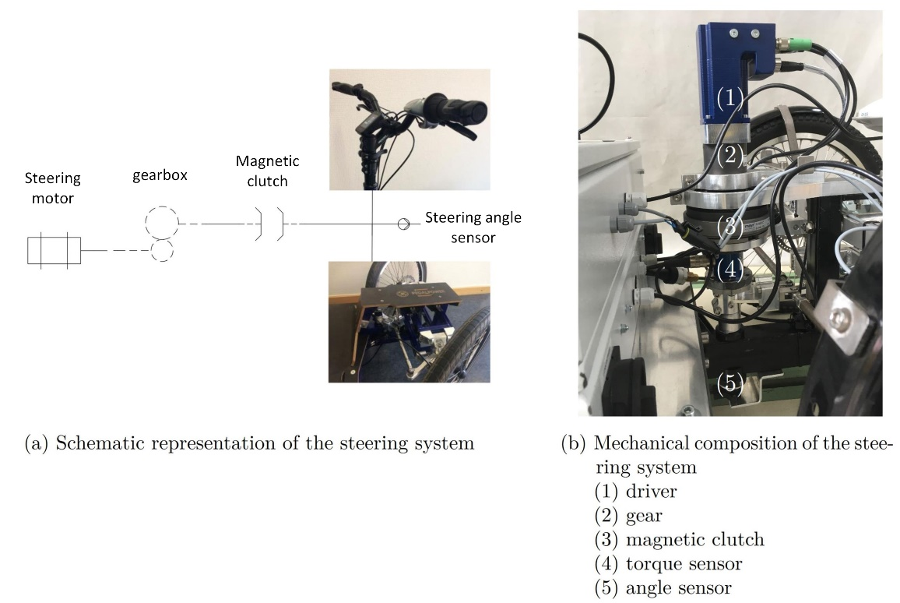
Figure 3. Automated steering of the test vehicle
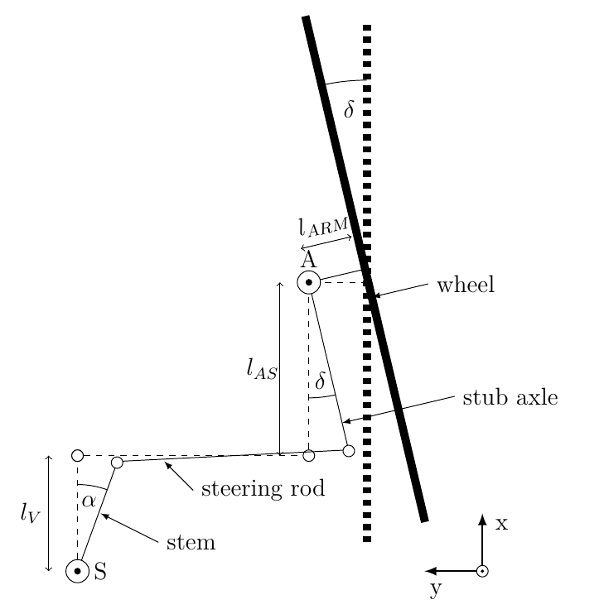
Figure 4. Modelling of the steering mechanics
Figure 5 shows the simulation model built in Matlab/Simulink. It is composed of an actuator modelled as a BLDC motor which transmits torque to the head tube via the subsequent mechanism. The speed/torque model of the actuator was specified by means of a characteristic curve taken from the motors data sheet. A gearbox is added to the motor to convert the generated motor torque and the motor speed. The converted output torque is therefore dependent on the gear ratio of the gearbox and is additionally reduced by its efficiency.
The gearbox is connected to a magnetic clutch which transmits the output torque and the output speed to the flange of the control head. The control head rotates about its vertical axis and converts the rotation into a rotation of the front wheels via the steering kinematics as shown in Figure 4. The steering angle $δ$ is the resulting angle between the vehicle's longitudinal axis and the wheels. A counterforce opposes movement of the wheels, which can be approximated as drilling torque via a mixed non-linear friction as a Stribeck curve. The parameterization of the friction characteristic curve is carried out experimentally and approximately by determining the breakaway torque as well as the counterforce during continuous movement.
The control head S also contains the driver's manual intervention point, which is realized via a simple torque source, as well as a steering angle sensor that detects the absolute angular position $α$ of the control head. The steering model is completed by an angular position controller which generates the input voltage for the electric drive from a setpoint value and the current steering angle.
The simulation model of the steering system was used to estimate the final power and torque requirements based on defined use cases and to select a specific drive motor.

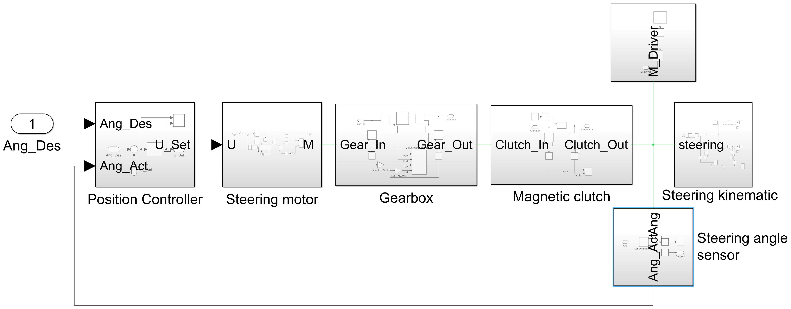
Figure 5. Overall simulation model of the steering system
3.2 Braking system
To automate brake engagement for the bike, the existing braking system at the front wheels is adapted. In the test vehicle, two brake calipers, each at one front wheel, are operated manually via a handbrake lever. Deceleration must be possible in both manual and autonomous modes. For this purpose, a changeover valve is introduced into the hydraulic circuit. In the manual case, operation is carried out conventionally via the handbrake lever. In the automated case, the brake calliper pair is actuated by a master cylinder driven by a linear actuator (see Fig.6). 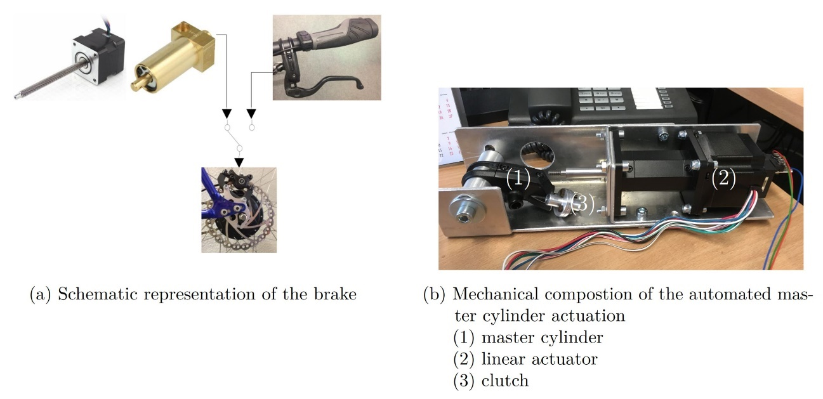
Figure 6. Automated brake of the test vehicle
Switching between the modes takes place without pressure when the vehicle is at a standstill and when changing driving modes. For this purpose, a pressure sensor is installed in the automated hydraulic circuit, which also serves to evaluate the simulation model of the brake and to enable pressure-controlled operation of the braking system.
Figure 7 shows the complete model of the braking system. In the overall model, the master cylinder of the handbrake lever can be actuated by manual force according to the concept, or an additional second master cyinder can be actuated by the linear motor. Since Simulink/Simscape does not provide a linear actuator model by default, a separate model based on the electromechanical coupling was implemented and parameterized using data from a data sheet.
Both master cylinders generate the pressure $p$ in the brake line due to a force $F_{Drive}$, which is transfered via a lever onto the surface $A$ of the cylinder. In addition to this fundamental relationship, the model takes into account an additional holding force on the cylinder wall in the static case and a friction force $F_{R}(\dot{x})$ proportional to the speed in the dynamic case, as well as the inertia $m∙\ddot{x}$ of the piston.
The dynamic behaviour of the hydraulic system can be modelled approximately as a second order system, taking into account the inertia and viscosity of the medium as well as the hydraulic resistance of the lines. Components from the hydraulic toolbox of Simscape Simulation are used to build the model.
The model of the brake translates the hydraulic pressure in the brakes slave cylinder into a friction force on the brake disc. A simple longitudinal dynamic vehicle model and a controller for setting the desired deceleration complete the overall model.
In analogy to the steering system, the simulation model was first parameterized using the known component parameters and then used to determine the power and actuating force requirement of the linear actuator on the basis of defined use cases.

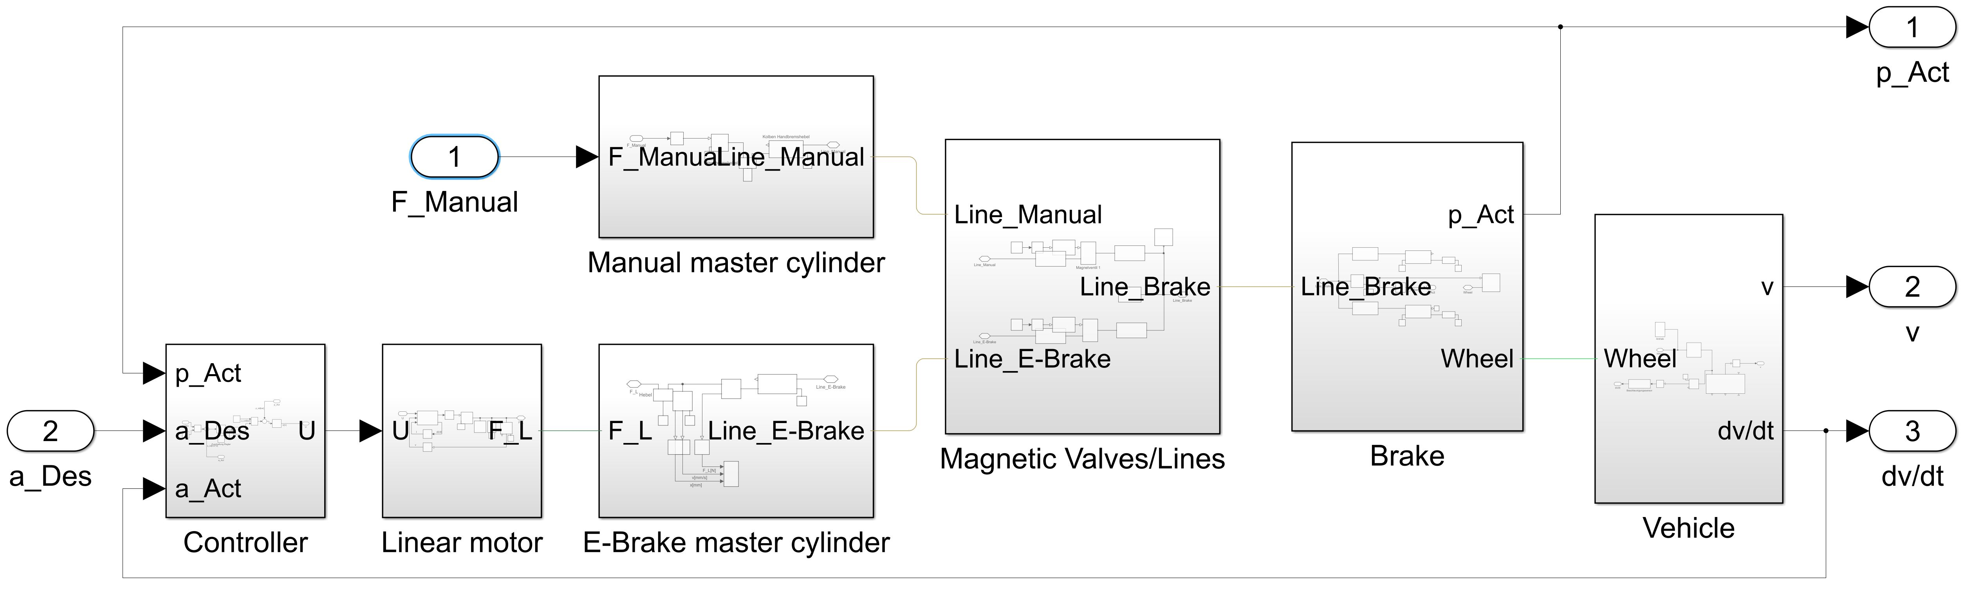
Figure 7. Overall simulation model of the braking system
4. Results and Discussion
4.1 Steering torque simulation and measuring
In order to evaluate the simulative results from the steering model, the steering torque is measured on the real test vehicle. The assembled steering torque sensor is used on the front head tube (compare Fig. 3b). The measured values are recorded by the sensor via an analog to CAN converter with Simulink. The vehicle is at a standstill and performs a sinusoidal steering trajectory over the entire steering angle range. The motor receives the steering angle setpoints from Simulink via the CAN interface. The measurement is first carried out at vehicle idle and then repeated with increased load on the bed. Step by step, $10 kg$ weights are placed on the cargo bed of the cargo bike and the associated steering torque curve is recorded. The automated cargo bike is supposed to carry payloads of up to $50 kg$ automatically on factory premises. Therefore, the experiment is performed for up to $50 kg$ of additional load.
In a second test, a steering angle step is recorded without any additional payload on the cargo bed. At the beginning, the steering mechanism is located in the right-hand steering angle and receives a setpoint for the opposite steering angle. The measurement of the steering angle is done with the steering angle sensor, which sends its data via the CANopen interface to the recorder PC. The measurement is carried out to determine the limits of the steering angle control for the following higher-level trajectory control loops.
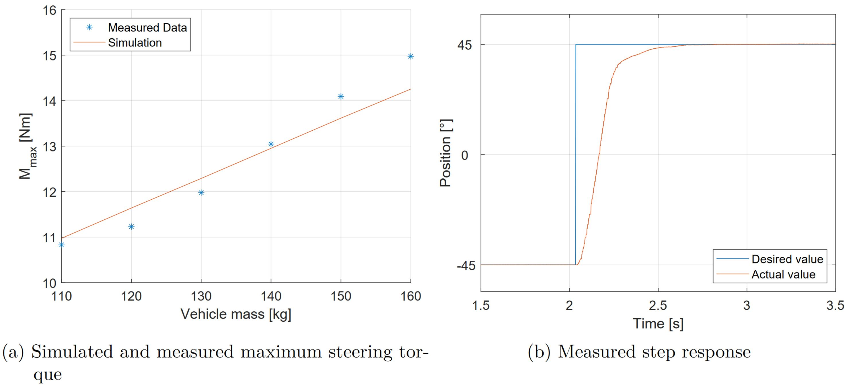
Figure 8. Recorded and simulated steering values
Figure 8a compares the results of the simulation model with a real measurement of the steering torques. In the simulation and the experiment a sinusoidal steering movement with the frequency of $1 rad/s$ was performed. The average maxima of the steering torque were plotted on the diagram. The expected linear relationship between the vehicle mass and the necessary steering torque was confirmed. The measurement is intended to evaluate the simulation model in order to enable the parametrization of the steering drive train of future cargo-wheel test vehicles / prototypes. By measuring the maximum steering torque, the entire automated steering powertrain consisting of engine, transmission and magnetic coupling can be dimensioned. In the Figure 8b a steering angle step of the position-controlled system is shown from one steering end stop to another. The step response serves to identify the dynamics of the steering system. These results must be considered in a trajectory planning algorithm when defining emergency maneuvers for sudden obstacles in the target path.
4.2 Comparison of manual and electromechanic braking
The brake can be actuated electrically in addition to the manual operation. In order to achieve the same braking power for manual activation, the linear actuator must be able to generate the same brake pressure in the hydraulic system. The pressure during manual operation is determined by the geometric characteristics of the brake lever and the master cylinder.
The simulation of the overall brake model is done once using the handbrake lever and again using the linear actuator. For both partial simulations, the vehicle model is accelerated to a speed of approximately $25 km/h$ during the first second of the simulation period. Then follow the brake tests with the two different brake actuations. The master pistons of both subsystems are identical in design. During manual engagement, the handbrake lever is pressed with a continous manual force. The electromechanical brake actuation by the linear motor takes place directly on the master piston. The E-brake applies forces to the main cylinder and receives its reference from a superimposed deceleration controller. In Figure 9a the piston positions of the two master cylinders are shown over simulation time. Compared to the movement of the position of the manually operated cylinder, the piston end position is only reached about half a second later due to the feed speed of the linear actuator. The diagram in Figure 9b shows the corresponding brake pressures. Before brake Engagement, there is no pressure in the brake system. The constant manual activation causes a permanent static pressure after overcoming the brake pad air gap. The brake pressure resulting from the controlled E-brake increases due to the desired target deceleration to a static value, and is drops after the vehicle has stopped.
The simulation results are intended to demonstrate the feasibility of an electromechanical brake engagement. With the modeled linear drive a brake system pressure similar to manual operation can be achieved. Compared to manual brake engagement, the linear drive is limited in its feed rate. As the air gap is overcome, this results in a time offset until the E-Brake can generate pressure in the brake system (approx. $250 ms$).
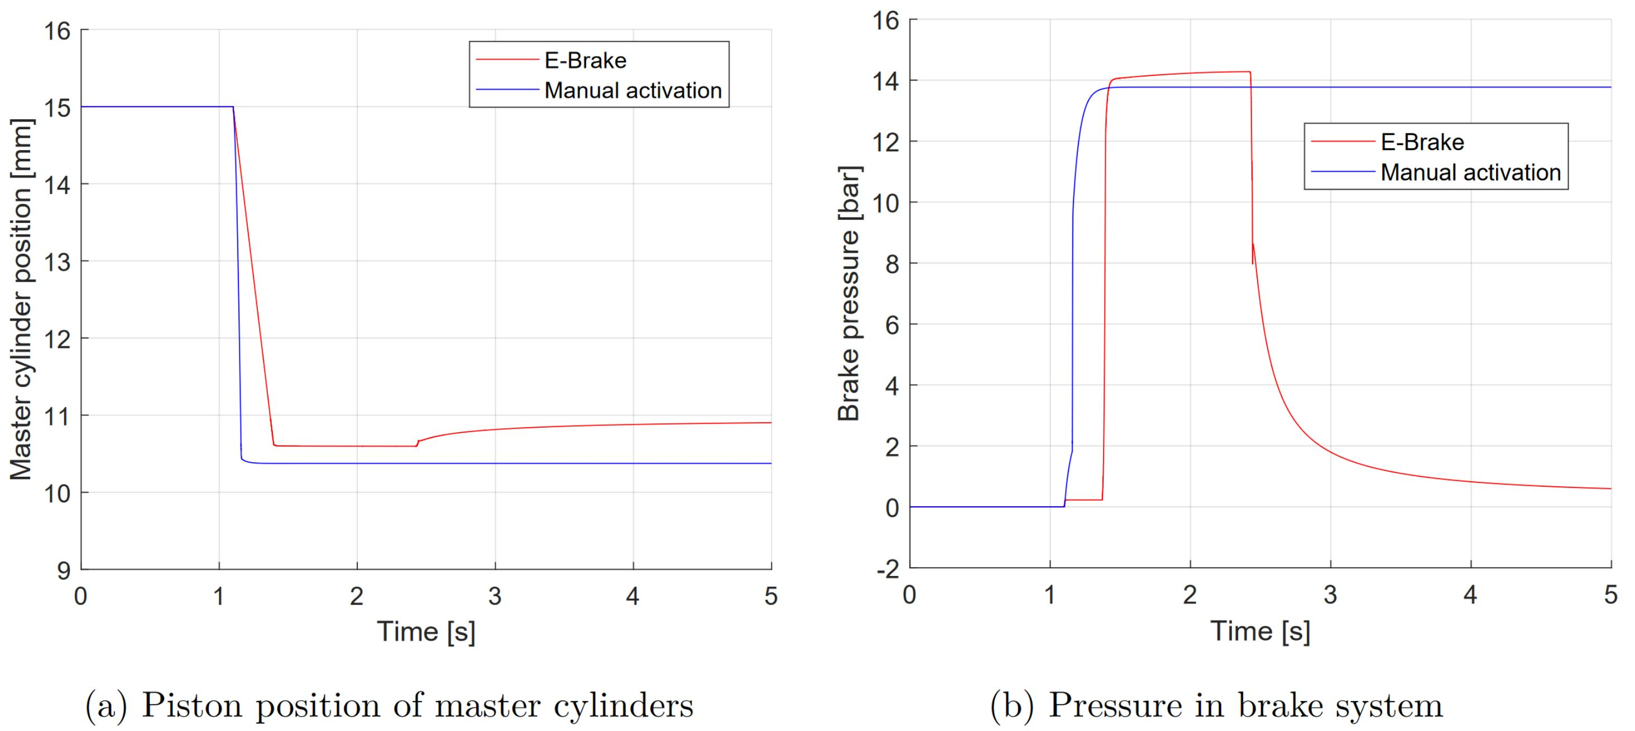
Figure 9. Manual and electromechanical brake activation
5. Conclusion and Outlook
A steering model was evaluated using the measurement and simulation values from the steering tests. Additional Measurements of the phase and frequency response are necessary for further system identification. The results of the hydraulic simulation should show the feasibility of an electromechanical actuated cargo bike brake. In the next step, the hydraulic brake system must be put into operation in order to compare the simulation results with measurements.
In the further course of the project, identification test runs will be performed in order to determine the tire parameters of the vehicle and to identify an overall model of the horizontal dynamics. In the next step, this model is used to set up a vehicle observer and a lane control system.

Acknowledgments
The project is funded as a joint project by the German Federal Ministry of Education and Research (BMBF) on the basis of the guideline for the promotion of SME-centered, strategic R&D alliances in networks and clusters (KMU-NetC). The project is part of the ZIM network "Assistance in Logistics".

Bibliographical references
[1] Zug, Sebastian; Schmidt, Stephan; Assmann, Tom; Krause, Karen; Salzer, Sigrid; Seidel, Martin; Schmidt, Michael ;Fessel, Karl: BikeSharing-System der 5. Generation. BUIS-Tage (2018) (in German)

[2] Turnwald, Alen: Autonomes Zweirad, https://www.eit.unikl.de/liu/forschung/autobike_g.html, Version: Juni 2018 (in German)

[3] Bike, CU: Autonomous Bicycle, https://bike.engineering.cornell.edu/status.html, Version: Juni 2018

[4] Tinn, Phil: An Alternative Autonomous Revolution, https://www.media.mit.edu/projects/pev/overview/, Version: Juni 2018

[5] Folsom, Tyler C.: The Elcano Project, http://www.elcanoproject.org/ Version: Juni 2018

[6] Radgeber, Die: V-Brakes, https://radgeber-freiburg.de/selbsthilfe/workshops/article/v-brakes, Version: Juni 2018 (in German)

[7] bike:Workshop-AbhilfebeiquietschendenScheibenbremsen, https://www.bike-magazin.de/service/bike_wissen/workshop-was-tun-bei-quietschenden-scheibenbremsen/a614/fotostrecke/468878/8281457.html, Version: Juni 2018 (in German)

[8] Blatt, Hans-Peter; Wambsganss, Rita: patent: Zusatzbremseinrichtung für Fahrzeuge aller Art motorisiert oder unmotorisiert, welche mit oder ohne Funksignal sowohl optisch, automatisch oder manuell pneumatisch oder mechanische Bremsvorgänge durchführt. Birkweiler, August 2015. – Patent Nr.:DE 20 2015 003 101 U1 (in German)

[9] Blatt, Hans-Peter; Wambsganss, Rita: patent: Fahrradbremse welche in manuell mechanisch seitengesteuerter Funktion über einen Scharnier-ähnlich abknickenden Bremshebel, oder alternativ ferngesteuert mittels einer elektrischen Motorspindel-Steuerung einen Bremsvorgang einleitet. Birkweiler, Mai 2016. – Patent Nr.:DE 202016 001 649 U1 (in German)

[10] Blatt, Hans-Peter; Wambsganss, Rita: patent: Fahrradbremse mit zwei mittig drehbar gelagerten Bremshebeln, welche in unabhängiger getrennter Bedienfunktion durch mechanisch-hybride Bowdenzug- bzw. alternativ sicherheitsferngesteuerter Motorspindel-Steuerungsfunktion einen eigenständigen Bremsvorgang einleiten kann. Birkweiler, Juli 2016. – Patent Nr.:DE 20 2016 001 940 U113 (in German)

