Error analysis of written English essays

Evelina Miščin¹

1- Evelina Miščin, RIT Croatia, Croatia, evelina.miscin@croatia.rit.edu:

Abstract:
- Statement of the Problem: Academic Writing is an obligatory course at the RIT (Rochester Institute of Technology) Croatia. Both Croatian students and native speakers struggle with writing as it is the least favorite skill.
- Objectives: The aim of this study was to investigate the errors in the essays of fifty RIT Croatia students and to see whether the students have attained an adequate understanding of how to reduce errors in writing.
- Methodology: Fifty students participated in this research – forty-five Croatian and five native English speakers. The essay was a part of their obligatory assignment. It had to have seven pages or about 2,500 words. Students could write on any topic of their interest. After they had submitted the draft version, their errors were indicated, and students had to submit the improved version. Both versions were compared to see whether students understood their mistakes and if they corrected them properly. Also, mistakes were classified to determine what type of mistakes occurs most frequently.
- Results and discussion: It was determined that Croatian students struggle with grammatical mistakes like articles, transition words, subject-verb agreement, verb tenses, prepositions, then with syntactic mistakes like sentence fragments or run-on sentences while the native speakers have problems with grammar – mostly verb tenses. They also lack metalanguage and do not understand tips given by the professor; thus, were not able to correct mistakes properly.
- Conclusion: The results should help in redesigning a syllabus which would be more student friendly and target the areas students mostly struggle with.

Keywords: Errors; Essays; Academic English; Writing skills

1. Introduction
Writing is the least favorite skill among most of the students. They are frequently competent in other skills, but when it comes to writing, most of them struggle. Therefore, at the RIT Croatia, Writing seminar is an obligatory course which all students have to take in order to improve their skills and be able to produce research papers in other subjects as well. Apart from classes which are held two times a week (80 minutes each) for fifteen weeks, there is also a Writing laboratory for weaker students where they can come to talk about their specific problems. There are also two tutors – senior students who excelled in writing and who can advise them.
Other theoreticians also mention problems with writing. Thus, Amoakohene (2017) analyzed 50 scripts of students of Health and Allied Sciences in Ghana, using four stages – collection of samples, identification of errors, description of errors and evaluating the errors. His research showed that students could not effectively apply the rules of usage of the English Language. Most mistakes were related to the grammatical category, followed by errors from the mechanical category (punctuation), and in the last place were errors related to the structure (2.3%). Amoakohene (2017) also mentions some other studies with similar results (Quibol-Catabay 2016, Pineteh 2013, Safaraz 2011 – as quoted in Amoakohene (2017)).
Afrin (2016) analyzed 89 non-English major students from Microbiology, Film and Media studies, Pharmacy, Business Administration and Computer Science in Bangladesh. He collected data through writing sample analysis, questionnaire and interviews. His results indicate that spelling mistakes were the most common writing problem, followed by misuse of tenses, subject-verb agreement, punctuation and articles and capitalization are in the last place.
Khan and Akter (2011) were analyzing types of mistakes of 300 students that they most commonly make in their papers regarding grammar, spelling and discourse. They established that the most common mistakes were in spelling, number, wrong use of words (collocations) and capitalization.
Al-Khairy (2013) investigated 75 Saudi English-major undergraduates to see their most frequent writing problems. He used a 32-item structured Likert-scale questionnaire. As the investigation showed poor written competence, he established the reasons for poor academic writing skills which include low English language proficiency, insufficient number of courses, teachers’ lack of interest and inappropriate teaching methods. The most common problems in academic writing are erroneous use of grammar, lexical items, irregular verbs, prepositions, spellings, and punctuation.
Mustaque (2014) wanted to find out the writing problems encountered by the tertiary level students in Bangladesh. Her research instrument were questionnaires and writing samples of 120 students. She found out that their written work lacks fluency with innumerable lexico-semantic errors, errors with verbs, prepositions, articles, nouns.
Fahmida (2010) also investigated errors in academic writing in Bangladesh and divided them into lexical, spelling, grammatical and punctuation errors. She started by distinguishing errors and mistakes as interpreted by Corder (1974) and said that errors represented a lack of competence, while a mistake occurred when learners failed to perform their competence (p. 5). Fahmida mentioned another classification of errors based on Corder and these are presystematic errors (which occur when the learner is unaware of the existence of a particular rule in the language), systematic errors (occur when the learner has discovered a rule, but it is a wrong one) and postsystematic errors (which occur when the learner, who knows the correct rule, uses it inconsistently). The participants of her research were 50 students of two private universities of Bangladesh. She collected their argumentative essays as well as questionnaires filled in both by students and their teachers. The questionnaires reflected teachers’ opinion on students’ capability of writing essays and making errors. The most common errors include syntactic errors, lexical errors, grammatical errors, spelling and punctuation errors. Her conclusion is that the course is not adequate for developing students writing.
A very extensive study was carried out in the Sultanate of Oman which involved 1114 school students and 317 university students (Al Seyabi and Tuzlukova:2014). They were concerned with problems that students face when writing in English, struggling mostly with lexical and content aspects of writing.
Miščin (2012) investigated collocational mistakes of medical students and presented a figure from James (1998) which shows the hierarchical order of mistakes (1998:229).

THE MOST SERIOUS THE LEAST SERIOUS
Lexis > spelling > negation > word order > prepositions > verb forms > concordance
Figure 1 Hierarchical order of mistakes according to McCretton and Rider
This figure indicates that the most important mistakes are lexical (including collocations) and the least serious concordance.

2. Methodology
The purpose of this research was to investigate the errors of fifty RIT students of the Fall 2018 semester, after their mistakes had been indicated in the draft version. Forty-five students were Croatian and five were native English speakers. Non-native speaker were of CEFR C1 - C2 level as all their classes are in English (RIT is an American college with its subsidiary in Zagreb). The essay was their final assignment on any topic of their interest. It should have included 2,500 words. The whole semester students were taught how to write properly. They had Writing Seminar twice a week for fifteen weeks, thirty classes altogether. and the class topics were as follows: introduction to academic writing; audience, purpose and process; finding your subject; writing your topic sentence/thesis statement; finding details, examples and facts; making a plan/arranging your ideas; collecting research materials; plagiarism, citing sources; drafting; improving your paper/peer review; different kinds of essays; most frequent mistakes and presentations. Some grammatical points were also revised like indirect questions, transition words and hedging. During the semester students also had to submit several assignments before the final version and they were: short proposal, summary, working bibliography, annotated bibliography and draft. The assignments were checked by Turnitin, a plagiarism checker. After their draft had been returned, they were supposed to correct it and submit the final version. Then, the final version was compared with the draft to see if the students understood what their mistakes were and if they corrected them accordingly. The list of mistakes was drawn to help students improve their writing in future.

3. Results and discussion

Turnitin enables marking of errors by speech bubbles which do not only indicate where the mistake has been made, but also, it allows a user to write comments inside. Therefore, students were warned about their mistakes by mentioning what type of mistake they have made – e.g. grammar, wrong word, missing article, wrong tense, punctuation, spelling. Although they were offered a possibility to speak with their instructor during office hours to be able to clarify their mistakes, only few of them used this opportunity. That is why not all the mistakes were corrected as they were not able to correct them by themselves.
Figure 2 shows what it looks like when mistakes are indicated.

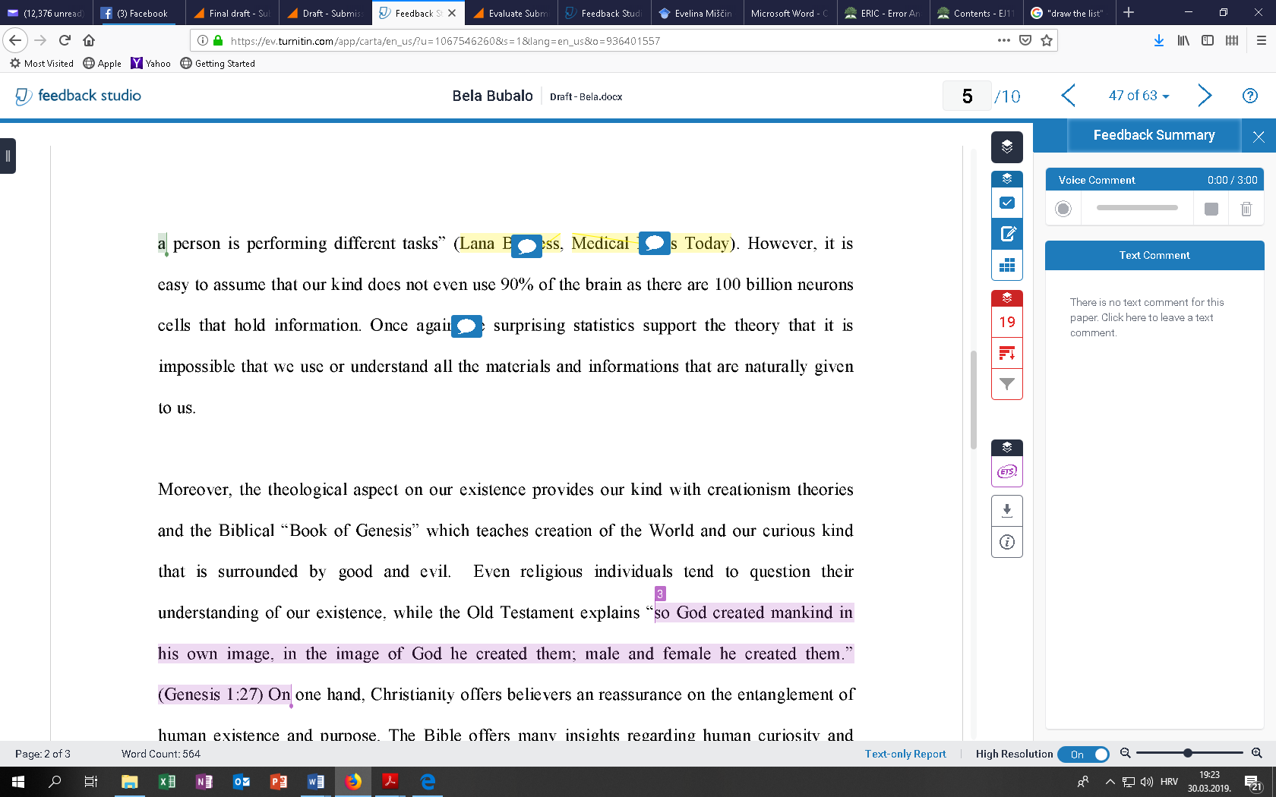

Figure 2 How mistakes are indicated in Turnitin

The most frequent mistakes made by non-native speakers were divided into several categories:
- Grammatical errors – wrong articles or the lack of articles, wrong prepositions, tense error, error in indirect questions, lack of subject verb agreement
- Lexical errors – wrong use of vocabulary (wrong words, wrong collocations), wrong word form
- Spelling errors
- Punctuation errors
- Syntactic errors – fragmented sentences, run-on sentences, wrong sentence structure.
- Structural errors – missing topic sentences, missing supporting sentences
- Problems with referencing

Graph 1 Number of mistakes per categories (non-native speakers)

Grammatical errors were most frequent. Although students are quite fluent speakers of English, when it comes to writing they tend to make a lot of mistakes. Some examples will be mentioned - less and less children (instead of ‘fewer and fewer children) (the problem with countable and uncountable noun determiners). Students also struggle with indirect questions – examples - ‘Another great concern is, will our children forget how to write’. Or ‘People can’t choose who will they love’. However, most of the students had problems with articles. Since there are no articles in Croatian, students were either using articles randomly, even abundantly or were not using them at all. Another frequent grammatical problem is a lack of subject verb agreement – e.g. ‘Only a few people is familiar with the phenomenon.’ Another common grammatical mistake is the use of the wrong tense – most frequently replacing Present Simple by Present Continuous – e.g. ‘A cow is living in harsh conditions’.
Lexical errors were mostly connected with wrong words, especially wrong collocations. The example is ‘We can see a clear coloration (instead of ‘connection’) between the ability to learn a foreign language…” Students also used wrong connectors – e.g. ‘As well, he used physical indications such as skin electricity…’ ‘This research will deal with players who deserved the induction into the Hall of Fame…’ Lexical errors also include the wrong word form – e.g. ‘Let’s image that we are buying new shoes.’
Spelling errors indicated the lack in using spellcheck or Grammarly which would help in diminishing their number. Some examples are ‘whit’ (instead of ‘with’), fiends (instead of ‘friends), who’s (instead of ‘whose’).
Punctuation errors mostly included the lack of comma or its abundance. However, students are also not quite clear when to use semi-colon and they sometimes use it instead of a comma. The example of the wrong use of comma is: ‘Another thing is that, a lucid dream is a state of mind where …’
Syntactic errors mostly include run-on sentences – e.g. ‘He did not achieve this incredible feat by being talented alone, it was completed because of his unbelievable discipline…’ Another syntactic error includes fragmented (incomplete) sentences – e.g. ‘While, only the strongest can withstand all the pressure and be lucky enough to reach the eternal glory.’ Another one is – ‘We are buying a new dress. And there are two colors to choose.’ Also, students struggle with a correct word order – e.g. ‘They were motivated by him and started playing the sport which they so much enjoyed. Another example – ‘It still was there.’
Referencing errors mostly included the lack of mentioning in-text sources after the quotations. Another error was either listing a reference that was not mentioned in the text or not mentioning the source from the text in the final list of references.
On the other hand, the most frequent mistakes made by native speakers included:
- Punctuation errors – using a semi-colon instead of a colon – e.g. ‘Two topics have been recently in the spotlight worldwide; mass shootings and America.’ Or forgetting a full stop after the bracket.
- Grammatical errors – e.g. when talking about America, one student wrote – ‘Not all of her mass shootings were in schools.’ Another student does not know conditional sentences and uses ‘will’ in the if clause – ‘We are a long way off from true singularity, if it will even happen.’ Another grammatical mistake is a lack of subject – verb agreement – e.g. ‘There are so many resources online that allows people to learn every day. Or another one ‘People who have malicious intent has the ability…’
- Spelling mistakes – mixing American and British spelling and not using one consistently (e.g. analyse). Surprisingly, native speakers also tend to mix ‘then’ and ‘than’.
- Lexical errors – using a wrong word form – e.g. ‘Regarding transportation, automobiles have had a devastated impacted on our planet. Another example is ‘It was more common to find natural fit people…’
- Syntactic errors – word order – e.g. ‘Technology now is ingrained in our daily lives.’ Also, students tend to use incorrect word order and redundant words -e g. ‘With a smartphone, it wakes you up with its alarm.’
- Referencing – not putting sources in the alphabetical order

Graph 2. Number of mistakes per categories (native speakers)

Native speakers were better than non-native in correcting their mistakes in the final version. They had better understanding of their mistakes and required fewer corrections than non-native speakers. Also, they were less reluctant to ask what the proper form should be.
4. Conclusions
This paper aimed to explain the most common errors of non-native and native students of RIT Croatia. It showed some similarities and differences between these two groups. Better results could be obtained if most critical areas were addressed and if most common errors were shown in the class, asking students to comment on them and try to correct them.
Organizational problems (lack of topic sentence, lack of supporting sentences and incomplete conclusion) were not mentioned as students most frequently corrected them immediately or did them satisfactorily the first time. This area hgad been dealt extensively in classes either by asking students to write their own paragraphs or to recognize topic sentences, thesis statements in written assignments.
One of the flaws of the research could be a small number of subjects, particularly of native speakers. Sometimes they seem confident in using their own mother tongue, but quite intimidated when metalanguage is dealt with.
The results should help in devising lectures in a way to address most common problems. Future studies could be oriented towards only one specific area, particularly the one students have most problems with.

5. Bibliographical references
1. Afrin, S. (2016). Writing Problems of Non-English Major Undergraduate Students in Bangladesh: An Observation. Open journal of Social Sciences, 4, 104-115.
http://exdoi.org/10.4236/jss.2016.43016
2. Al-Khairy, M.A. (2013). Saudi English-Major Undergraduates’ Academic Writing Problems: A Taif University Perspective. English Language Teaching, 6, 1-12. http://dx.doi.org/10.5539/elt.v6n6p1
3. Amoakohene, B. (2017). Error Analysis of Students Essays: A Case of First Year Students of the University of Health and Allied Sciences, Vol 6, No. 4, 54-68. Retrieved on 30 March 2019 from
https://doi.org/10.5430/ijhe.v6n4p54
4. Fahmida, B. (2010). Bangladeshi Tertiary Students’ Common Errors in Academic Writings. Retrieved on 30 March 2019 from http://dspace.bracu.ac.bd/handle/10361/252
5. James, Carl (1998). Errors in Language Learning and Use: Exploring Error Analysis. Harlow: Pearson
6. Khan, H.R. and Akter, M.Z. (2011). Students’ Mistakes and Errors in English Writing:
Implications for pedagogy. 8, 11, 23, Retrieved on 30 March 2019 from
http://dspace.ewubd.edu/bitstream/handle/123456789/411/Harunur_Rashid_Khan.pdf?sequence=1&isAllowed=y
7. Miščin, E. (2012). Glagolske kolokacije u engleskome jeziku medicinske struke. Unpublished doctoral thesis. University of Osijek.
8. Mustaque, S. (2014). Writing Problems among the Tertiary level Students in Bangladesh: A Study in Chittagong Region. Language in India, 14, 334. Retrieved on 30 March 2019 from http://www.languageinindia.com/jan2014/shakiladissertation.html
9. Pineteh, E. (2013). The academic writing challenges of undergraduate students: A South African case study. In Amoakohene, B. (2017). Error Analysis of Students Essays: A Case of First Year Students of the University of Health and Allied Sciences, Vol 6, No. 4, 54-68. Retrieved on 30 March 2019 from
https://doi.org/10.5430/ijhe.v6n4p54
10. Quibol-Catabay (2016). Error analysis in students’ writing. In Amoakohene, B. (2017). Error Analysis of Students Essays: A Case of First Year Students of the University of Health and Allied Sciences, Vol 6, No. 4, 54-68. Retrieved on 30 March 2019 from
https://doi.org/10.5430/ijhe.v6n4p54
11. Sarfraz, S. (2011). Error analysis of the written English essays of Pakistani undergraduate students: A case study. In Amoakohene, B. (2017). Error Analysis of Students Essays: A Case of First Year Students of the University of Health and Allied Sciences, Vol 6, No. 4, 54-68. Retrieved on 30 March 2019 from https://doi.org/10.5430/ijhe.v6n4p54.
12. Seyabi, F.A. and Tuzlukova, V. (2014). Writing Problems and Strategies: An Investigative Study in the Omani School and University Context. Asian Journal of Social Sciences & Humanities, 3, 34. Retrieved on 30 March 2019 from http://www.ajssh.leena-luna.co.jp/AJSSHPDFs/Vol.3(4)/AJSSH2014(3.4-05).pdf

Figure 1. Source: James: 1998, p. 229
Taken from RIT platform MyCourses
The graph designed by the author.
The graph designed by the author.

