INTERNATIONAL SYMPOSIUM INDUSTRY AND ENERGY

Logistics 4.0 in the manufacturing company:
Goals, processes and solutions

Logística 4.0 en la empresa manufacturera:
Objetivos, procesos y soluciones

Elke Glistau¹, Norge Isaias Coello Machado², Sebastian Trojahn³

- Prof. h. c. Dr.-Ing. Dr. h. c. (UCLV) Elke Glistau. Otto-von-Guericke University Magdeburg, Germany. elke.glistau@ovgu.de
- Prof. Dr.-Ing. Dr. h.c. Prof. h.c. Norge Isaias Coello Machado, Universidad Central „Marta Abreu“ de Las Villas, Cuba. norgec@uclv.edu.cu
- Prof. Dr.-Ing. Sebastian Trojahn. Anhalt University of Applied Sciences Bernburg. Germany. Otto von Guericke University Magdeburg, Germany. sebastian.trojahn@ovgu.de

Abstract:
- Problem: Logistics 4.0 means the application of Industry 4.0 in the logistics area. There is a large number of new, individual solutions of Logistics 4.0 especially in manufacturing companies, which originate from research work and industrial developments. The scientific task is to generate logistics overview knowledge and to systematize it appropriately.
- Aims: Research questions are:
(1) What are the goals and potentials of Logistics 4.0 related to the logistics of manufacturing companies?
(2) How can Logistics 4.0 solutions be described and systematized by using the "Smart Logistics Zone" model?
(3) Where in the logistics of manufacturing companies do Logistics 4.0 technologies find application?
(4) How does Logistics 4.0 change supply chain management and information logistics?
- Methodology: The research is based on an evaluation of current scientific publications and own scientific projects in the area of Logistics 4.0. A further basis forms many years of scientific work and practical experiences in the area of logistics. The multistage model of the "Smart Logistics Zone" is used, which can be used for the aspects of analysis, evaluation and planning of logistics systems.
- Results and Discussion: The paper lists typical logistics goals and potentials of Logistics 4.0, gives an overview about typical solution fields in logistics 4.0 in the manufacturing company by using the model of the “Smart Logistics Zone". It systematizes Logistics 4.0 solutions in intralogistics and supply chain management.
- Conclusions: Some new or improved systematics are presented in this paper: These are the model of the “Smart Logistics Zone” and typical solutions of Logistics 4.0 in the manufacturing company. These are oriented exemplarily to the material flow and to the supply chain management.

Keywords: Logistics 4.0; Intralogistics; Smart Logistics Zone; Manufacturing company; Supply Chain Management

Palabras Claves: Logística 4.0; Intralogística; Zona Logística Inteligente; Empresa de fabricación; Gestión de la cadena de suministro

1. Introduction: Logistics in manufacturing companies and research questions
Logistics 4.0 means the application of Industry 4.0 in the logistics area. This means the merging of logistics with digitization, networking and automation. Logistics is realized by five types of logistics service providers, which are briefly characterized in Table 1. Material flow processes and energy flow processes are primarily handled by 1PL to 3PL, while information flow processes are important for all five logistics service provider types. Financial flow processes are mapped as material flow processes or/and mostly as information flow processes.

Table 1. Characteristics of logistics service providers 1PL to 5 PL (cf. Hosie et. al., 2012; Gruchmann et.al., 2018; Hausladen, 2020)
Logistics service provider | Explanation
1PL: First Party Logistics | Self: Logistics is carried out by the company itself; these have e.g. own fleet of vehicles and own warehouses.
2PL: 2nd Party Logistics Service Provider | THW service providers: Service providers who undertake transport, handling and warehousing (THW) services for others e.g. freight forwarders, shipping companies, warehouses, courier, express and parcel service providers; generally own the necessary operating resources themselves.
3PL: 3rd Party Logistics Provider | System service providers: In addition to THW, they handle e.g. labeling, packaging, customs clearance, assembly, repairs, typically contract management, freight forwarding, order fulfillment, returns processing, logistics optimization.
4PL: 4th Party Logistics Provider | Supply chain system integrators: Integrate, optimize and manage the supply chain, select and engage 2PLs and 3PLs (subcontractors), usually do not have their own operating resources.
5PL: 5th Party Logistics Provider | Supply Network Manager: coordinates and optimizes supply chains and supply networks; often provides consulting services.
Logistics fulfills integrating and safeguarding tasks in the manufacturing company. Certain terms have become established for the individual logistics tasks and areas (cf. Figure 1). Logistics solutions in manufacturing companies thus belong to thirteen more or less overlapping logistics areas as well as to so-called supply chain management for the control and optimization of logistics chains and logistics networks. (cf. Illés et. al., 2012; Schedlbauer, 2008)

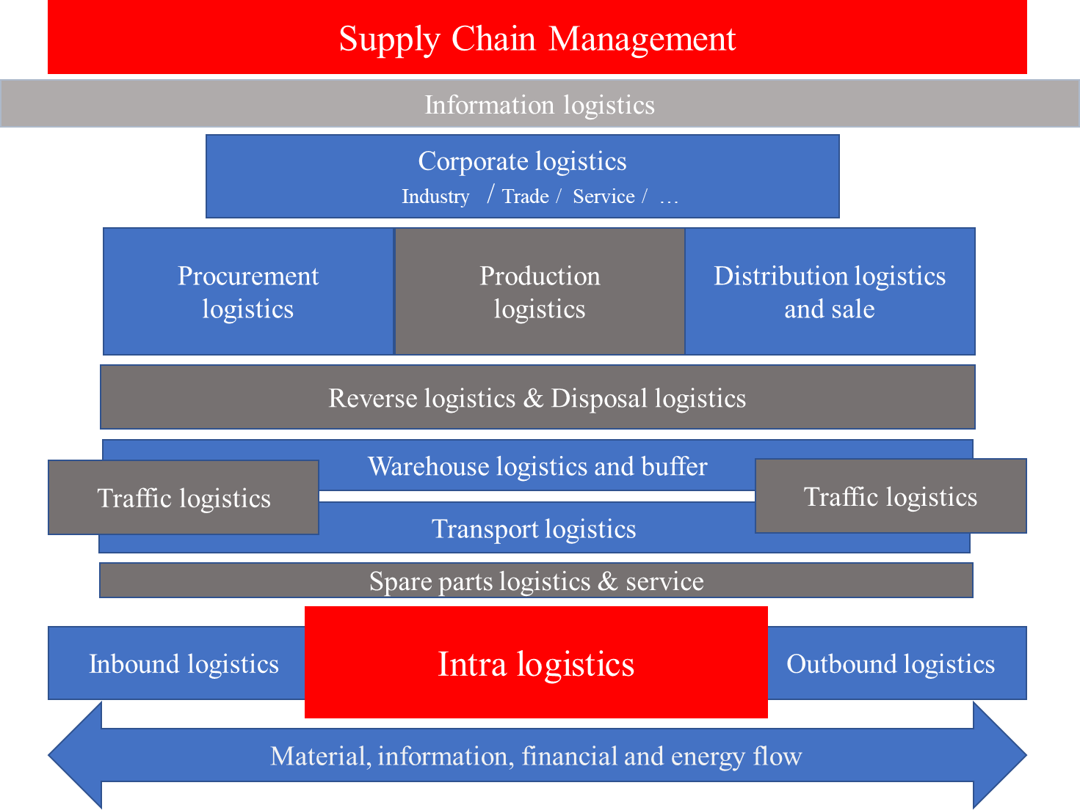
Figure 1: Relevant logistics areas for manufacturing companies
(own elaboration)
(cf. Illés et. al., 2012; Schedlbauer, 2008)

The list in Figure 1 illustrates the difficulties for manufacturing companies in creating an overall view for Logistics 4.0 solutions. This is expressly not just about digitizing traditional logistics solutions and closing interfaces, but also about rethinking and implementing new logistics solutions. This also means rethinking traditional, task- or function-based logistics (cf. Figure 1) in favor of a flexible and process-oriented view that also explicitly links production and logistics together to form holistic new processes. "However, the fourth industrial revolution is not only transforming processes in production and value creation, but also the world of work, organizational forms and structures in companies, and the competence and qualification requirements for employees." (Acatech, 2016) Logistics 4.0 offers new logistics solutions based on digitization and networking. These replace or improve previous solutions. At the core of the manufacturing company is intralogistics (cf. Figure 1), which according to the definition of the VDMA (Verband Deutscher Maschinen- und Anlagenbau e.V. - German Engineering Federation) is understood as "the organization, control, execution and optimization of the internal flow of materials, the flow of information and the handling of goods in industry, trade and public institutions" (VDMA, 2004). This definition lacks financial and energy flows, which are not explicitly mentioned. However, the financial flow in the contract logistics and block chain application as well as the energy flow for the implementation of systemic solutions, technologies gets special importance. In addition, for manufacturing companies, there are the physical logistics at the interfaces and outside the company under consideration as well as the supply chain management functions especially of the 4PL and 5PL.
The paper aims to answer the research questions:
(1) What are the goals and potentials of Logistics 4.0 related to the logistics of manufacturing companies?
(2) How can Logistics 4.0 solutions be described and systematized with the help of the "Smart Logistics Zone" model?
(3) Where in the logistics of manufacturing companies do Logistics 4.0 technologies find application?
(4) How does Logistics 4.0 change supply chain management and information logistics?

It is important to emphasize that digitization and networking are only two criteria, albeit essential ones, for designing logistics processes and systems.

2. Methodology
The research is based on an evaluation of current scientific publications and own scientific projects on the area of Logistics 4.0. The research is based on many years of scientific work and practical experience of the authors in the field of logistics. In order to obtain an overview of Logistics 4.0 solutions, various systematizations can be used. This paper uses the Smart Logistics Zone model developed in Magdeburg (cf. Behrendt et. al, 2018; Behrendt et. al, 2019; Schmidtke et. al, 2019; Glistau, 2020) as the basis for systematizing Logistics 4.0 solutions. The basic model is shown in Figure 2.

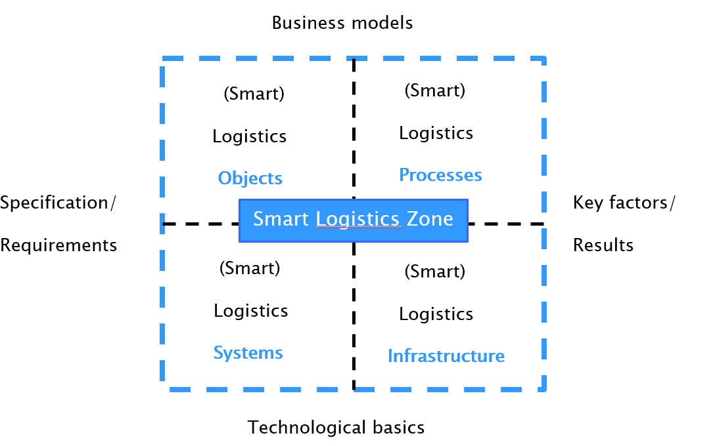
Figure 2. Basic model of Smart Logistics Zone model (Glistau, 2020)

In the context of this paper, the considerations are focused on the logistics view level (object, process, system and infrastructure) supplemented by a target consideration. The entire methodological procedure is shown in Figure 3. After goals and potentials of Logistics 4.0 are described as an open collective list, the solution view as a “Smart Logistics Zone” is detailed in the second step. Then, goals and “Smart Logistics Zone” are combined to generate a systematic goal and evaluation tool in the form of a tableau. From this tableau, the top goals are methodically prioritized in line with the strategy. In relation to the specific goals of a company and thus goal-focused, digitization and networking are thought of from two perspectives. On the one hand, the material flow of the logistical objects (executive) is brought into focus, which naturally runs and must be designed in an integrated manner with the information flow, financial flow and energy flow. Logistics 4.0 takes the approach of digitizing and linking the material flow throughout. To do this, you mentally move from input to output, or vice versa, to the logistical objects in order to define lean, sustainable and efficient processes. On the basis of a literature analysis supplemented by own research projects, current overview knowledge of Logistics 4.0 solutions is to be achieved.
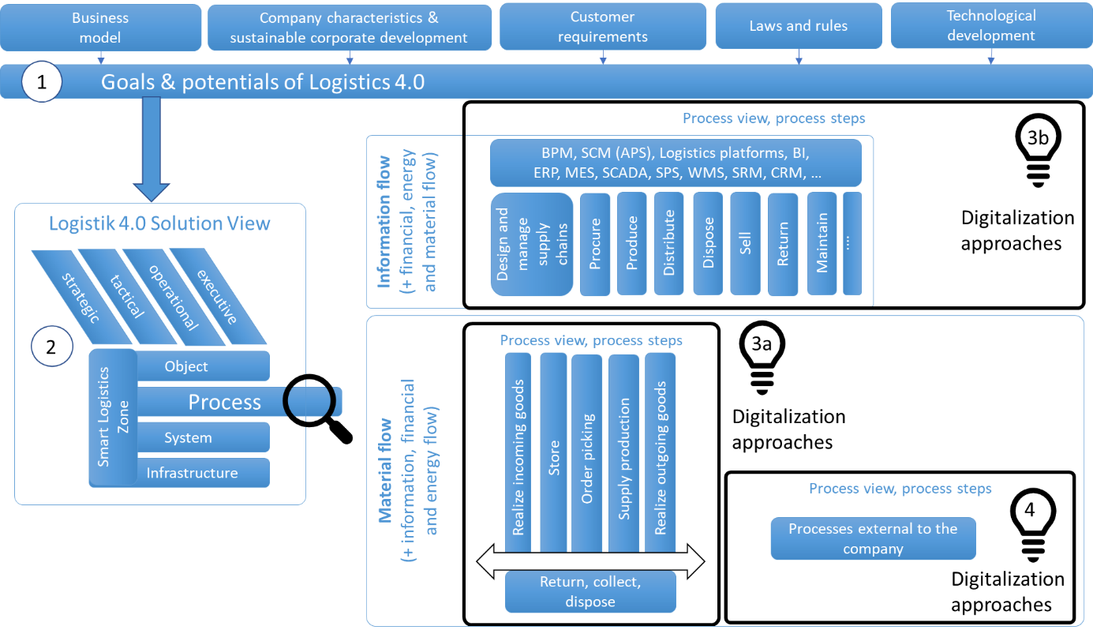
Figure 3. Methodical procedure
(own elaboration)

A second simultaneously necessary view is represented by the supply chain management processes and information logistics, which, using Logistics 4.0 technologies, create continuous information chains and information networks and determine, plan, optimize, execute and regulate supply networks quasi from above (strategic, tactical, operational to executive) horizontally (from sources to sinks) and vertically (from strategy to execution and back). Based on a literature analysis, current research approaches are to be identified and listed. This is to generate current overview knowledge.

3. Results and Discussion
3.1 Result 1: Identification of goals and potentials of Logistics 4.0 in manufacturing companies
The introduction of Logistics 4.0 solutions is not an end in itself. Digitization and networking are tools for achieving corporate goals that result from customer requirements, environmental requirements (e.g. legislation), or also represent the company's own requirements in order to be able to fulfill these requirements more effectively. A system of goals and performance indicators helps to realize holistic considerations, to set priorities and to prevent one-sided interpretations. The following research question is answered:
(1) What are the goals and potentials of Logistics 4.0 in relation to the logistics of manufacturing companies?
Typical aspects and categories of requirements are effectiveness, efficiency, time, costs, quality, flexibility, performance, safety, sustainability, communication/interaction, transparency and resilience, adaptivity and scalability. (cf. Behrendt et. al., 2019) Intelligence and the ability to optimize tasks, processes and systems become important as a means. The strategic orientation and essential goals and potentials are influenced by the business model, customer requirements, the aspiration for specific sustainable corporate development, laws and regulations, and technological development. The following list is an open collection of examples of the goals of manufacturing companies with regard to Logistics 4.0: (cf. Muchna et. al., 2018; Bräkling et. al., 2020; Lasch, 2021)
- Reduction of costs through optimization of logistics processes (transport, picking, handling, storage, etc.) and service processes,
- Reduction of maintenance and servicing costs,
- Increasing speed, flexibility, security and controllability of processes,
- Improvement of quality and transparency of data flow along supply chains,
- Reliable localization and tracking of logistic objects,
- Continuous quality control of logistic objects,
- Reduction of process times (loading),
- Reduction of errors (condition detection and continuous media and systems),
- Reduction of necessary personnel and extension of operating hours,
- Increased performance/productivity through adapted work tools,
- Increased communication and interaction with customers and suppliers
(e.g. customer needs, sales forecasts, transparency in order fulfillment),
- Greater sustainability through e.g. optimization of resource use and implementation of climate protection measures,
- Minimizing energy consumption for logistics services and intelligent energy management.
In addition to the classic automation (replacement of manual activity by mechanized or automated activity) of Logistics 2.0 and 3.0, Logistics 4.0 solutions thus make a noticeable qualitative contribution by means of digitization and networking, e.g. in the areas of:
- Automated and continuous material flow,
- Automated and end-to-end flow of information,
- Automated and end-to-end financial flow,
- Reduction and optimization of energy flow required for logistics and intelligent energy management,
- Automated and networked warehouse technology,
- Seamless identification and necessary status recording of logistical objects,
- Seamless digital documentation,
- Ergonomic and preventive employee support,
- Smart data analysis for planning, control and optimization,
- Digitized and networked processes,
- Process integration for all types of processes.
It is typical that Logistics 4.0 solutions in manufacturing companies consist of many individual solutions, which themselves are also constantly improved and reconfigured, but which ultimately only develop their full efficiency through their interaction.

3.2 Result 2: Application of the model "The Smart Logistics Zone" to systematize Logistics 4.0 solutions in the manufacturing company
Applied to the solution space of Logistics 4.0, the Smart Logistics Zone model (Behrendt et. al, 2018; Behrendt et. al, 2019; Schmidtke et. al, 2019; Glistau, 2020) uses the subdivision of logistics concepts and logistics solutions in the core area into objects O (smart logistics objects), processes P (new software-integrated processes), systems S (logistics operators, cyber-physical materials handling modules, new work aids) and infrastructures I (smart infrastructures) for systematization. (cf. Figure 2) It is explicitly emphasized that the respective Logistics 4.0 solution can focus on one of these areas, but requires all four components (object-process-system-infrastructure = OPSI or SPOI) to function in an integrated manner. Thus, all Logistics 4.0 solutions can each be described as a separate Smart Logistics Zone, but if necessary, can additionally be classified into one or more of the four focal areas in order to increase clarity. The following research question is answered (2) How can Logistics 4.0 solutions be described and systematized using the Smart Logistics Zone model?
For this purpose, the logistic solution is decomposed into the four components mentioned above:
- O: A logistics object: is defined as the good/(person) to be transported/stored or otherwise logistically handled. The term thus includes, for example, the good, its packaging, and the base or container used to transport it. Current research concerns: smart materials, smart parts, smart products, smart pallets, smart boxes, smart containers (more interesting for transport logistics) and smart packaging. One way is to make the object more intelligent, e.g., through sensors, data processing, and other technologies. Another, legitimate way is to leave the object relatively "dumb" (identification only) and put the intelligence e.g. in the system or the infrastructure.
- P: New software-integrated processes: facilitate and automate the logistical processes of goods movement and all business processes e.g. purchase processing and payment. New concepts for integrated tracking and tracing processes, automatic video controls, virtual warehouses, augmented reality, supply chain optimization, industrial data space, big data, business intelligence, and self-learning processes are examples. They affect both the entire supply chain and the information logistics of individual functions such as transport or storage.
- S: Systems: The processes are implemented as an HTO system (human, technical, organizational system) and its infrastructure. For this purpose, it must be determined how the human being and with which technical support (partial, complete) the processes are to be implemented. Driverless, autonomously operated logistics operators: These transport people or goods from one place to another, over land, air and water, inside or outside enclosed spaces. In intralogistics, for example, automated guided vehicles and mobile robots are of interest. In transport logistics, unmanned cars, trucks, buses, cargo bikes, unmanned aerial vehicles, driverless train operation and robotic ships are examples of technologies and technical solutions that are also of interest for transport in intralogistics. Cyber-physical material handling modules: They house and relocate goods automatically or remotely. Examples include intelligent shelving, robot-assisted storage systems and modular networked continuous conveyor systems. New work aids: Facilitate work in manual logistics, make it possible in the first place, or reduce errors. Examples are logistics concepts with assistance robots, data glasses and gloves, intelligent clothing and intelligent contact lenses.
- I: Smart infrastructures describe environments that promote and facilitate primary logistics operations. Examples internally in the enterprise are intelligent gates and intelligent ramps. In traffic logistics, there are solutions such as the smart road, the smart intersection, the smart traffic light, the smart street lamp, and others that can also be used internally as a solution idea. Research question 1 and research question 2 will be linked together to generate a structured table of objectives and evaluation. (Table 2)
Table 2. Structure of the goals and evaluation criteria of Logistics 4.0 using SLZ (own elaboration)
(Only a few key figures for clarification the framework and the idea)
Aspects | Evaluation Parameters of Logistics 4.0
 | Key figures | Object  (O) | Process  (P) | System  (S) | Infrastructure  (I)
 | Applicable to the entire logistics solution | Material, product, service, request, order, packaging, box, pallet, container | Planning, procurement, production, delivery, return, acceptance | Human  Resources, CPS, CPLS, tools, IT systems | Areas, buildings, roads, energy, media, universal technology
Efficiency | Degree of Economy | Profit | Process efficiency | Productivity | Energy efficiency
Effectivity | Degree of goal achievement | Customer satisfaction | Degree of fulfilment of customer requirements | Value-added ratio | Degree of fulfilment of company requirements

Continuation Table 2.
Aspects |  | Evaluation Parameters of Logistics 4.0
 |  | Key figures | Object  (O) | Process  (P) | System  (S) | Infrastructure  (I)
 |  | Applicable to the entire logistics solution | Material, product, service, request, order, packaging, box, pallet, container | Planning, procurement, production, delivery, return, acceptance | Human  Resources, CPS, CPLS, tools, IT systems | Areas, buildings, roads, energy, media, universal technology
In the sense of the 8 R Factors of Logistics | Time | Delivery period | Delivery time | Set-up times and processing time, transport time | Machining time | Commis-  sioning time
 | Costs | Investment costs and operating costs | Operating costs | SCM costs, Operating costs | Operating costs | Investment costs and operating costs
 | Quality | Material and product defects; Degree of transparency | Breakdowns, Product defects | Breakdowns, Degree of transparency, Service level | Material and product defects, breakdowns | Infrastructure errors
 | Safety and Security | Manipulation | No demages | Manipulation Process | Manipulation System | Manipulation Infrastructure
 | Environment | non-damaging | non-damaging | non-damaging | CO₂ neutral | CO₂ neutral
 | Perfor-mance | Utilization | Throughput | Type and quantity | Utilization System | Utilization Infrastructure
 | … | … | … | … | … | …
In the sense of  Logistics 4.0 | Resilience | Degree of resistance | Redundant objects | Reaction speed in case of malfunctions | Reaction speed in case of malfunctions | Infrastructure robustness
 | Adaptivity | Flexibility, Variable material input | Flexibility of use of objects | Flexible processes | Flexible use of system | Flexibility of use of infrastructure
 | Scalability | Degree of changeability of the size | Object scope and composition | Modulari-  zation | Modulari-zation | Modulari-zation

The results in table 2 can be used, for example:
- For target determination and target collection as target specifications,
- To mark priority objectives,
- For the representation of potentials,
- For entering actual values,
- To prove the quality of the solution and realize evaluation procedures.

  - Result 3: Logistics 4.0 in the manufacturing company: Current status
Result 3 answers the research question: (3) Where in the logistics of manufacturing companies do Logistics 4.0 technologies find application? In order to realize digitization, the company must take several views: As the master of flows, the main focus of logistics is on processes. In accordance with logistics science, we should start with the flow of materials and thus with the physical view. If the published applications are classified along the main material flow processes in intralogistics, an overview of the potential application fields and their possibilities is generated. (Table 3) In doing so, practically a person is located on the logistical object from the goods receipt of raw materials, individual parts and modules up to the goods shipment as individual part, module or product to be shipped and accompanies the entire material flow through the company (shown here in simplified form for only one location). In addition to the material flow, the overall process integrates the associated information flow, financial flow and energy flow. In order to create sustainable, simple and fast material flow processes, all processes must be thought of in the same way backwards from the sink to the source.
Table 3. Examples of Logistics 4.0 (t.w. Logistics 3.0) in the field of intralogistics
examples (cf. Straub et. al., 2017) and own elaboration
Main intralogistics processes  (cf. VDI 4400, 2001 ff.) | Examples of logistics 4.0 (partly 3.0)
Realize goods receipt  (e.g. receiving, empties, returns, quality control, booking, repacking and staging) | - Loading dock management  - Intelligent gates for batch and single object identification  - Automated and networked unloading  - Automated and networked quality control  - Digital booking and documentation  - Automated and networked repacking and staging  - Automated and networked transport
Warehousing  (e.g. put away, inventory control, take out of stock) | - Optimized storage space allocation  - Energy-optimized warehouse operation  - Sensor-based inventory control and AI-supported inventory and warehouse optimization  - Drones for inventory as first pilot projects  - Use of shuttle systems
Picking  (e.g. replenishment, provide, prepare, carry out, merge) | - Informational assistance (pick-by-light, terminals, pick-by-vision, pick-by-voice, including error messages and troubleshooting)  - Physical assistance (conveyor technology, pick-by-shuttle; manipulators, pick-by-robot; exoskeletons)  - Cognitive assistance (sensor systems, image recognition systems) (Schenk, 2015)

Continuation Table 3.
Main intralogistics processes  (cf. VDI 4400, 2001 ff.) | Examples of logistics 4.0 (partly 3.0)
Supply and dispose of production  (e.g. provide and supply, remove production, collect and dispose of waste products) | - Transport and transfer by using automated discontinuous conveyors (e.g. forklift; autonomous driverless transport system)  - Transport and transfer by using automated continuous conveyors (e.g. chain conveyors, roller conveyors, belt conveyors)  - Solutions for JIT, JIS and E-KANBAN  - Intelligent controls e.g. with decentralized solutions and swarms
Realize goods issue  (e.g. staging and assembling, checking, packing and documents, shipping and loading) | - Augmented reality and algorithms for load planning and optimization.  - Automated and networked provisioning and sorting processes  - Automated and networked packaging and loading unit formation  - Digital receipts  - Automated and networked loading
Return, collect and dispose  (e.g. collect, separate/sort, return, store, recycle) | - Smart waste bins and digital waste management  - Digital documentation of the material composition

  - Result 4: Logistics 4.0 in the manufacturing company: Supply chain management and information logistics
The second way to initiate digitization and networking is via holistic supply chain management (SCM) and information logistics, and thus via business processes and the associated information flows, as it were. SCM is defined in different ways in the scientific literature and in terms of its relation to logistics by different authors. This is not to be discussed further here. As a working definition of SCM, this paper uses a definition by Göpfert: "Supply chain management forms a modern conception for corporate networks for the development of cross-company success potentials by means of the development, design, control and realization of effective and efficient flows of goods, information, money and finance." (Göpfert, 2016) Energy flows are not mentioned separately in this definition, but must also receive adequate attention in terms of holism and sustainability. In the understanding of this paper, the SCM includes the holistic logistics: from the sources to the sinks (operational logistics and inter-operational logistics) and thus arranges itself as a development phase, algorithms and tools of logistics.
In general, SCM is divided into supply network design, supply chain planning and supply chain execution for plannable and standardized chains (cf. Kuhn et. al., 2002; Schulte, 2017) This structure follows the general management logic from strategic to tactical/operational to realization (executive). Lot size one and flexible value creation processes are synonyms for the new possibilities to design cross-company chains and networks on a case-by-case basis, but where feasibility and efficiency must still be questioned. Here, supply chains must be created and executed on a case-by-case basis. This is state of the art for individual production or e.g. logistics for valuable cultural goods, heavy transports, hazardous transports or logistics in crisis and disaster areas. SCM create information chains and information networks and determine, plan, optimize, control, execute and regulate supply networks horizontally (from sources (e.g. suppliers) to sinks (e.g. customers) and vertically (from strategy to execution and back).
Within the levels, various tasks are to be performed. They include, e.g., network design, demand planning, network planning, supplier integration), customer integration, procurement, production, distribution, disposal, maintenance (varying degrees of foresight from planning to scheduling, if necessary), and others, complete order fulfillment and execution of advanced logistics operations including event capture and event management in terms of operations, tracking and tracing activities, and overall incident control. (cf. Fleischmann, 2018) (cf. Werner, 2020 p. 87).
Digitization and networking are coupling partners, software tools, and data across all four flows.
Many supply chain management strategies have evolved over the last five years and have been successfully re-implemented into existing or new software tools. Table 4 below provides key examples of an open collection of research approaches currently being pursued and researched in connection with digitization and networking in supply chain management. These are initiated by changes in strategic target categories (e.g. sustainability and resilience) and IT technologies (e.g. blockchain and AI).

Table 4. Examples of current research approaches in SCM in connection
with digitization and networking
Research Approach | Application examples
Big Data Algorithms inclusive Predictive analytics  (Maleshwari, 2021) (Werner, 2020, p. 258 ff.) | Demand forecasting, inventory and warehouse layout optimization, intelligent transport and route planning, capacity planning, supply chain visibility, risk and resilience analysis
Blockchain and Smart Contracts  (Henke et. al., 2020) | Contracts, proof of transactions, confirmation and proof of proper transfer of goods, collaborative document management, digital signatures
Cloud-computing  (Novais, 2020) | State of the art and basics for new development: Supply chain management and all logistics tools as Software as a service
Data Management  (Decken, 2018) | Data and Text Mining for analyzing texts und using algorithms, Digital Data Management for recognizing mistakes and errors and excluding inactive datasets
Digital Twins  (Marmolejo-Saucedo et. al., 2019) | Virtual twins as a testing ground for running scenarios and running simulations for e.g. transport, capacity or inventory
Kognitive Supply Chain (Werner, 2020 p. 256 ff.) | Supply Chain Execution System, Adaptive Supply Chain Systems, Predictive Analytics in der Supply Chain
Machine Learning and AI  (Babaee Tirkolaee et. al., 2021) | Supplier selection, supply chain risk prediction and security rating, improving demand and sales forecast accuracy, disruption control, route management.
Energy management  (Waldhelm, 2021) | Evaluation of resource use, energy management for autonomous driving functions
Sustainability and climate protection  (Busch & Graberg, 2021) | Holistic assessment of supply chains, recycling networks, product carbon footprint, life cycle assessment
Resilience  (Werner, 2020 p. 227 ff.) (Hosseini et. al., 2019) (Kleemann et.al., 2021) | Functioning risk management, prioritization of customers, back-up suppliers, alternative transport routes
Smart Maintenance  (Bokrantz, 2020) | Implementation of condition-based maintenance networks
Supply Chain 4.0  (Aktas et al., 2021)  (Ivanov, 2018) | Flexible networks by using the design principles (e.g. modularity, virtualization, interoperability and real-time capability)

Industry in Germany is a global leader in the automotive and mechanical engineering sectors, other sectors as the healthcare sector are becoming increasingly important. To maintain this, the integrated processes of supply chain management and physical logistics must be further improved and designed in a targeted manner through digitization and networking.

4. Conclusions
The theory of logistics as a science must be further developed. Therefore, some new and improved systematics are presented in this paper.
The first result of this work is the collection of digitization goals and their networking and systematization with the "Smart Logistics Zone" model. (Cf. Table 2) This newly links the structure of the logistics solution (OPSI) with the target categories (from efficiency to scalability) in the form of a matrix and thus enables a systematic collection and subsequent prioritization of the respective authoritative targets according to the current corporate strategies and corporate characteristics. This allows the engineer a strictly goal-oriented approach and a goal-related evaluation. Especially the process goals play a decisive role for the logistics engineer.
Result 2, the application of the “Smart Logistics Zone” model to Logistics 4.0 solutions, documents and proves their practicality and usefulness in creating a regulatory framework. Logistics 4.0 solutions can thus be classified and characterized.
Result 3 is a listing of current Logistics 4.0 solutions related to the main processes of material flow (including integrated information, finance and energy flow). It documents the current state of knowledge. The strict orientation to the physical flow creates transparency for the fulfillment of the physical logistics task. Result 4 lists results related to supply chain management. Table 4 documents current research approaches of SCM in connection with digitalization and networking. This provides current overview knowledge.
Countless players are involved in the digital transformation process, so there is a permanent task of understanding, describing and classifying what is emerging in order to identify new opportunities and development paths in good time.
5. Bibliographic references
ACATECH (2016) Kompetenzentwicklungsstudie Industrie 4.0. acatech – DEUTSCHE AKADEMIE DER TECHNIKWISSENSCHAFTEN, München; Fraunhofer-Institut für Materialfluss und Logistik IML, Dortmund; equeo GmbH, Berlin: 2016, p. 5
Aktas, E., Bourlakis, M., Minis, I., Zeimpekis, V. (2021 Supply Chain 4.0: Improving Supply Chains with Analytics and Industry 4.0 Technologies. Kogan Page Publishers, 312 pages
Babaee Tirkolaee, E., Sadeghi, S., Mansoori Mooseloo, F., Rezaei Vandchali, H., Aeini; S. (2021) Application of Machine Learning in Supply Chain Management: A Comprehensive Overview of the Main Areas, Mathematical Problems in Engineering, vol. 2021, Article ID 1476043, 14 pages, 2021. https://doi.org/10.1155/2021/1476043
Behrendt, F., Poenicke, O., Schmidtke, N., Richter, K. (2018) The Smart Logistics Zone as an enabler of Value-added services in the context of Logistics 4.0. ISSL Symposium der BVL 2018.
Behrendt, F., Schmidtke, N., Glistau, E., Wagner, M. (2019) Der Intelligente Logistikraum - neue Gestaltungsformen im Kontext der digitalen Transformation. In: Industrie 4.0 Management - Berlin: GITO mbH Publ., Vol. 35.2019, 4, pp. 35-38
Bokrantz, J., Skoogh, A., Berlin, C. and Stahre, J. (2020), "Smart maintenance: instrument development, content validation and an empirical pilot", International Journal of Operations & Production Management, Vol. 40 No. 4, pp. 481-506. https://doi.org/10.1108/IJOPM-11-2019-0746
Busch, M., Graberg, T. (2021) Sustainable Production Ordnungsrahmen zur Gestaltung von Nachhaltigkeit in produzierenden Unternehmen: Zeitschrift für wirtschaftlichen Fabrikbetrieb, vol. 116, no. 4, 2021, pp. 203-207. https://doi.org/10.1515/zwf-2021-0043
Decken ,T. (2018) Warum Digitalisierung nicht mehr warten kann. The Source Magazine, 3rd edn, January 2018
Fleischmann, B. (2018): Begriffliche Grundlagen der Logistik. In Tempelmeier (Hrsg.): Begriff der Logistik, logistische Systeme und Prozesse. Fachwissen Logistik
Glistau, E. (2020). Cover picture In: Schenk, Michael [Publisher]; Glistau, Elke [Publisher] 13th International Doctoral Students Workshop on Logistics, June 16, 2020 Magdeburg
Göpfert, I. (2016) Die Anwendung der Zukunftsforschung für die Logistik. In Logistik der Zukunft – Logistics for the Future. p.71. Wiesbaden. Springer Fachmedien Wiesbaden, 2016
Gruchmann; T., Melkonyan, A., Krumme, K.: Logistics Business Transformation for Sustainability: Assessing the Role of the Lead Sustainability Service Provider (6PL). Logistics. 2018,2, 25, doi:10.3390/logistics2040025
Hausladen, I. (2020) IT-gestützte Logistik: Systeme, Prozesse, Anwendungen. Springer Gabler.4. edit. p.13.
Hellingrath, B., Hegmanns, T., Maaß, J. C. Toth, M. (2008) Prozesse in Logistiknetzwerken – Supply Chain Management, In: Arnold, D., Kuhn, A., Furmans, H., Isermann H, Tempelmeier, H. [eds.] 2008, p. 104 ff.
Henke, M., Schulte, A.T., Jakob S. (2020) Blockchain-basiertes Supply Chain Management. In: ten Hompel, M., Bauernhansl T., Vogel-Heuser B. (eds) Handbuch Industrie 4.0. Springer Vieweg, Berlin, Heidelberg. https://doi.org/10.1007/978-3-662-58530-6_116
Hosseini, S., Ivanov, D., Dolgui, A. (2019) Review of quantitative methods for supply chain resilience analysis. Transp. Res. Part E: Logist. Transp. Rev. 125, 285–307
Hosie, P., Sundarakani, B., Tan, A. (2012) Determinants of fifth party logistics (5PL): Service providers for supply chain management. October 2012. Internationale Journal of Logistics Systems and Management 13 (3):287-316. DOI: 10.1504/IJLSM.2012.049700
Illés, B., Glistau, E., Coello Machado, N. I. (2012) Logística y Gestión de la Calidad. 1. Edition. Universidad de Miskolc. p.2
Ivanov, D., Tsipoulanidis, A., Schönberger, J. (2019) Digital Supply Chain, Smart Operations and Industry 4.0. In: Global Supply Chain and Operations Management. Springer Texts in Business and Economics. Springer, Cham. https://doi.org/10.1007/978-3-319-94313-8_16
Kleemann F., Frühbeis R. (2021) Grundlagen von Resilienz und Supply Chain Management. In: Resiliente Lieferketten in der VUCA-Welt. essentials. Springer Gabler, Wiesbaden. https://doi.org/10.1007/978-3-658-34337-8_2
Kuhn, A., Hellingrath, B. (2002) Supply Chain Management: Optimierte Zusammenarbeit in der Wertschöpfungskette. Heidelberg. Springer Verlag Berlin Heidelberg. p.142
Maheshwari, S., Gautam. P. &. Jaggi C. K. (2021) Role of Big Data Analytics in supply chain management: current trends and future perspectives, International Journal of Production Research, 59:6, 1875-1900, DOI: 10.1080/00207543.2020.1793011
Marmolejo-Saucedo J.A., Hurtado-Hernandez M., Suarez-Valdes R. (2020) Digital Twins in Supply Chain Management: A Brief Literature Review. In: Vasant P., Zelinka I., Weber GW. (eds) Intelligent Computing and Optimization. ICO 2019. Advances in Intelligent Systems and Computing, vol 1072. Springer, Cham. https://doi.org/10.1007/978-3-030-33585-4_63
Muchna, C; Brandenburg, H.; Fottner, J.; Gutermuth, J. (2018): Grundlagen der Logistik – Begriffe, Strukturen und Prozesse. Wiesbaden, p. 45.
Novais, L., Maqueira Marín, J.M. and Moyano-Fuentes, J. (2020), "Lean Production implementation, Cloud-Supported Logistics and Supply Chain Integration: interrelationships and effects on business performance", The International Journal of Logistics Management, Vol. 31 No. 3, pp. 629-663. https://doi.org/10.1108/IJLM-02-2019-0052
Schedlbauer, M. J. (2008) Adaptive Logistikplanung auf Basis eines standardisierten, prozessorientierten Bausteinkonzepts. München. TU München. Lehrstuhl für Fördertechnik Materialfluss Logistik. Dissertation. p. 8
Schenk, Michael (Hrsg.): Produktion und Logistik mit Zukunft – Digital Engineering and Operation. Berlin Heidelberg: Springer Vieweg, 2015] p. 122 ff.
Schmidtke, N., Glistau, E., Behrendt, F. (2019) Magdeburg Logistics Model - The Smart Logistics Zone as a Concept for Enabling Logistics 4.0 Technologies. X International Conference on Mechanical Engineering. “COMEC 2019”
Schulte, C. (2017) Logistik: Wege zur Optimierung der Supply Chain. 7. Ed. München. Franz Vahlen GmbH (Publ.)
Straub, N.; Kaczmarek, S., Hegmanns, T., Niehues, S. (2017) Logistik 4.0 – Logistikprozesse im Wandel. Technologischer Wandel in Logistiksystemen und deren Einfluss auf die Arbeitswelt in der oprativen Logistik. Industrie 4.0 Management 33(2017)2. p. 48, 49.
VDI 4400, Blatt 1 Logistikkennzahlen für die Beschaffung (2001); Blatt 2 Logistikkennzahlen für die Produktion (2004); Blatt 3 Logistikkennzahlen für die Distribution (2002). Beuth Publ.
VDMA, Forum Intralogistik (2004). http://foerd.vdma.org/viewer/-v2article/render/16118581
Waldhelm, A. (2021) Neue Möglichkeiten. MTZ Extra 26, 48–49 (2021). https://doi.org/10.1007/s41490-021-0334-5
Werner, H. (2020) Supply Chain Management; Grundlagen, Strategien, Instrumente und Controlling. 7. Ed., Springer Gabler

