Pre-processing oriented to segmentation of digital images of plant
cells from Theobroma Cacao L.
Adriel Alejandro Aliaga Benavides^{1,2}[0000-0002-1682-1490], Yudisel Santana Pacheco²[0000-0002-7725-6632], Antonio Mustelier Hechavarría²[0000-0002-3474-955X] and Yuniel Guzmán Bazán²
¹ Department of Computer Engineering, University José Eduardo Dos Santos, Bié Polytechnic School, Street Padre Fidalgo, Kuito, Bié, Angola
² Department of Computer Engineering, University of Granma, Headquarters Blas Roca Calderío, Blanquizal km 1½, Manzanillo, Granma, Cuba
lncs@springer.com
Abstract.
It is proposed a system of pre-processing images of histological samples of Theobroma Cacao L., capable of preparing these images towards segmentation, whose purpose will be the identification and counting of cells. The results obtained by techniques and methods that are applied in the reduction of noise, edge detection and contrast enhancement are compared, highlighting in it the median, bilateral, morphological gradient and amplitude improvement. It is evident how the application of the proposed image pre-processing system shows good results in the preparation of images, which must subsequently be segmented in order to identify cells of Theobroma Cacao L. in later projects. The application of the Otsu’s method with Watersheet algorithm in the contour identification obtains successful results with an average superior to 94%, for a total of 20 samples.
Keywords: First Keyword, Second Keyword, Third Keyword.
- Introduction
Cell counting is of vital importance for the characterization of the different morphogenic events that occur in the in vitro culture. It is used in the characterization of cell dedifferentiation or redifferentiation events. Specifically, for the study of cell suspensions, cell counting has several applications, among them cell line characterization, consistency of primary cultures, description of somatic embryogenesis events, organogenesis, physiological, genetic, cell cycle studies and the establishment of reproducible culture conditions for a specific purpose, which may be micropropagation or production of secondary metabolites. Traditionally in plant biotechnology, cell counting cameras are used for this type of evaluation, with Neubauer chambers being fundamentally employed for microorganisms and Funchs Rosenthal for plant cells, which are estimated to have approximate values of cells number per volume unit, accuracy depends on sample size, homogeneity, and number of fields subjected to counting.
Taking into account the very asynchrony of morphogenic events and that plant cells are characterized by their tendency to form cell groups, which make counting more difficult, these methods are not exact. In the laboratories of the Centre for Plant Biotechnology Studies (CEBVEG) of the University of Granma, reagents are not always available to achieve the disintegration of cell groups, or with counting chambers, the method used is the direct count of the number of cells in a known volume, with the use of optical microscopes with digital cameras coupled to a computer, which allows a higher image quality, but does not solve the problem of human error in cell counting. Therefore, the accuracy of the count will depend on suitable instruments available to observe and analyze individualized cells, for which it is necessary to conduct studies aimed at the design of software for the classification and counting of cells.
- Image pre-processing system
The main foundation of the pre-processing in the images obtained in the CEBVEG is the high concentration of irrelevant objects and the scarce definition of the objects of interest (cells), making it difficult to detect the really relevant elements of the image. For this reason, it is necessary to pre-process the image that guarantees noise reduction, edge detection of objects and contrast enhancement. For this it is necessary to know a prior characterization of the input images obtained in the image acquisition phase.

  - Characterization of the input images
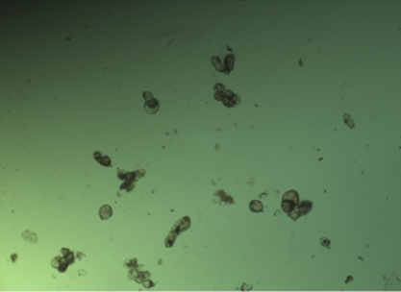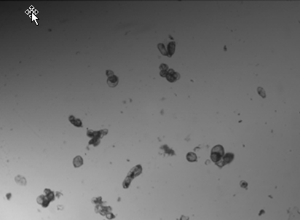
Fig. 1. a) Obtained image, b) Obtained image in grey-scale.
Note that the images obtained in the capture phase have an uneven luminosity, in addition they have irrelevant objects in some regions that do not constitute cells and that in turn are much smaller than the cells. These objects are irrelevant to the CEBVEG researchers, since they constitute to a large extent the microscopic contamination that the liquid in which the sample prepares (is prepared) presents.
  - Theoretical basis
In the phase of pre-processing of digital images that is proposed, three fundamental processes are involved, they are:
- Noise reduction for which techniques or algorithms were analyzed, such as Gaussian, median, average, and bilateral.
- Detection of edges where the methods analyzed were Canny, Sobel, Laplacian and the Morphological Gradient.
- Contrast enhancement in which the equalization methods of the histogram were analyzed, (such as) amplitude improvement of the gray scale, inverse function, and square and cubic.
Noise reduction
In this first process, the median and bilateral filters, as well as the results obtained in their combination, stood out for their results independently. Next, both filters are detailed.
Median
Median filtering is a nonlinear signal processing technique developed by Tukey that is useful for noise suppression in images. In one-dimensional form, the median filter consists of a sliding window encompassing an odd number of pixels. The center pixel in the window is replaced by the median of the pixels in the window. The median of a discrete sequence $a_{1}, a_{2},……, a_{N}$ for N odd is that member of the sequence for which (N – 1)/2 elements are smaller or equal in value and (N – 1)/2 elements are larger or equal in value. For example, if the values of the pixels within a window are 0.1, 0.2, 0.9, 0.4, 0.5, the center pixel would be replaced by the value 0.4. In this example, if the value 0.9 were a noise spike in a monotonically increasing sequence, the median filter would result in a considerable improvement [1].
Operation of the median filter can be analyzed to a limited extent. It can be shown that the median of the product of a constant K and a sequence is
$MED\left\{K\left[f\left(j\right)\right]\right\}=K[MED\{f(j)\}]$ (1)
However, for two arbitrary sequences f(j) and g(j), it does not follow that the median of the sum of the sequences is equal to the sum of their medians. That is, in general,
$MED\left\{f\left(j\right)+g(j)\right\}≠MED\left\{f\left(j\right)\right\}+MED\{g(j)\}$ (2)
The sequences 0.1, 0.2, 0.3, 0.4, 0.5 and 0.1, 0.2, 0.3, 0.2, 0.1 are examples for which the additive linearity property does not hold [1].
An important property of median filters, particularly useful in image processing, is that they preserve edges or stepwise discontinuities in the signal. Median filters can be used for removing impulses in an image without smearing the edge information; this is of significant importance in image processing [2].

Bilateral
In this filter, a convolution is applied to the image with a function that is a weighted average of the pixels in a neighborhood.
A bilateral filter has two filter kernels: a spatial filter kernel $F(p, q)$ that measures spatial distance between two pixel locations p and q and a range filter kernel $G(I_{p}, I_{q})$ that measures the intensity/range distance between two pixel values $I_{p}$ and $I_{q}$ . If the range filter kernel G is computed using an additional image T, the resulting filter becomes a joint/cross bilateral filter. Let$I_{p}^{T}$denote the joint bilateral filtered value at pixel location p,
$I_{p}^{T}=ω_{p}^{-1}\sum_{qϵΩ_{p}}{F\left(p,q\right)G\left(T_{p},T_{q}\right)I_{q}}$ (3)
where
$ω_{p}=\sum_{qϵΩ_{p}}{F\left(p,q\right)G\left(T_{p},T_{q}\right)}$ (4)
is a normalizing parameter at the corresponding pixel location, and the Gaussian kernel is usually selected as the range filter kernel in practice [3]:
$G\left(T_{p},T_{q}\right)=exp\left(-\frac{{|T_{p}-T_{q}|}^{2}}{2{σ_{R}}^{2}}\right)$ (5)
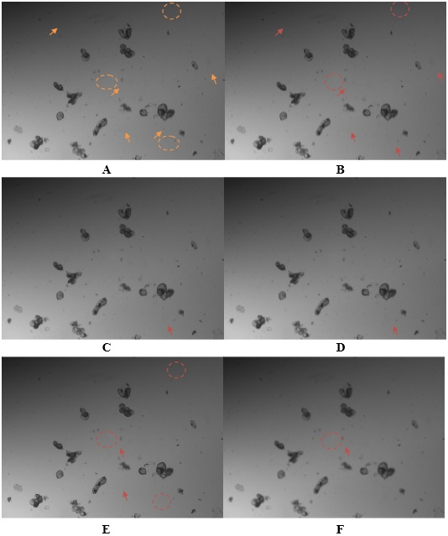
Fig. 2. A) Fragment of original grey scale image, B) Median filtering of A, C) Gaussian filtering of A, D) Average filtering of A, E) Bilateral filtering of A and F) Mean Filtering of A
In this first part, the aim is to reduce noise, as long as the edges of the objects are not significantly affected, since in later phases it is necessary to work on the detection of these. This analysis requires the visual appreciation of experts because generally the noise reduction modifies the contour of the objects. In figure 2 A) some example marks (of or with small points) have been established, of small points that could be considered noise (an arrow for a point, a discontinuous circle for a group of points). By enlarging Figure 2 it is shown how the application of the median and bilateral filters preserve a little more edges, than the filters, Gaussian, average and average, also the number of red marks (zone of noise eliminated in its entirety or that are practically imperceptible) is greater with the medium and bilateral filters than with the rest, the mean perceives a greater change to the rest of the filters without obtaining the good results of the median and the bilateral. To do this OpenCV has been used in version 3.1.0 and the parameters used in each case were:
- Median filtering: a linear opening size of 3.
- Gaussian filtering: a 3x3 core and a standard deviation value for the core σ = 0.
- Average filtering: a 3x3 core.
- Bilateral filtering: a diameter of 9 for the neighborhood of the pixels and both sigma values of 9.
- Mean filtering: a linear opening size of 5.
Joint bilateral weighted median filter alleviates the texture transferring problem, while maintaining edge-preserving property [4]. Finally, it is decided to combine the application of the median filter, the bilateral filter and figure 3 is obtained, in which an adequate conservation of the edges and information of the cell objects is observed and the elimination of the indicated points is achieved in Figure 2 A) and similar ones:
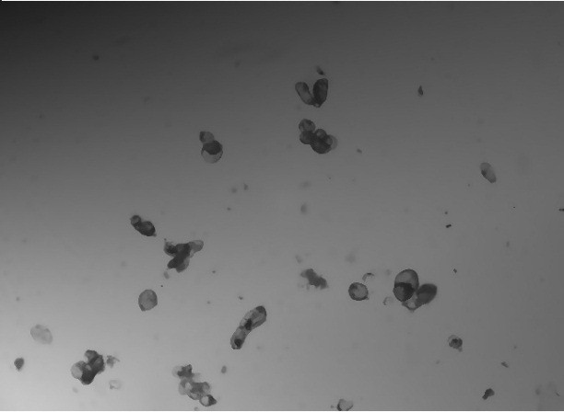
Fig. 3. Fusion of median and bilateral filtering.
Edge detection
In this second process, the application of the morphological gradient was highlighted by its results, where Laplacian and Canny methods were also analyzed. Next, the selected method is detailed.
Morphological Gradient
The basic concept of morphological signal processing is to modify the shape of a signal, by transforming it through its intersection with another object, the structuring element (SE). The basic operators of mathematical morphology (MM) include dilation, erosion, opening, and closing. According to the theory of MM, two factors are determinative for morphological analysis: the morphological operator and the SE. In practice, morphological operators are chosen based on different application scenarios of signal processing, for example the morphological gradient [5].
The difference between the maximum and the minimum gray-levels inside the pixel neighborhood; is equivalent to compute the morphological gradient [6]. Dilation and erosion (morphological operations) can be combined to achieve a variety of effects. For instance, subtracting an eroded image from its dilated version produces a "morphological gradient," which is a measure of local gray-level variation in the image [7]. Normally, the morphological operations are defined as operations on sets of pixels. Regard G as the set of all the pixels of the matrix that are not zero. M is the set of the non-zero mask pixels. With $M_{p}$ is denote (denoted) the mask shifted with its reference point (generally but not necessarily its center) to the pixel p. Erosion is then defined as

$G ⊝M=\left\{p: M_{p} ⊆G\right\}$ (6)
and dilation as
$G ⊕M=\{p: M_{p} ⋂ G≠∅\} [7].$ (7)

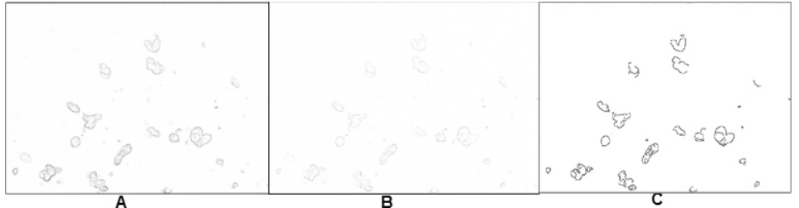
Figure 4: A) Gradient morphological method for figure 3 (inverted version), B) Laplacian method for figure 3 and C) Canny method for figure 3 (inverted version).

In figure 4 it can be observed that the morphological gradient shows better results in the accentuation of edges for the result of the previous process shown in figure 3. In the Laplacian application with results similar to the gradient, but with less highlighted edges, all the opposite, in the application of Canny where the edges are more emphasized but these in turn frequent losses of sections essential for later analysis.
Contrast enhancement
In this third process, the results of the histogram equalization and amplitude improvement in the gray scale in which the latter was selected were highlighted, as well as the inverse, square and cubic function methods. Next, the first two methods are detailed.
The histogram
Histogram is one simple but very important statistical feature of an image. It has been commonly used in image processing. Intensity histogram is a distribution of the grey level values of all the pixels within the image. Each bin in the histogram represents the number of pixels whose intensity values fall in that particular bin. A 256 grey level histogram is often used, where each grey level corresponds to one bin. Using $b_{i}$ to represent the $i^{th}$ number of bins, the histogram can be represented as follows:

$h\left(i\right)=\#\left\{\left(x,y\right), f\left(x,y\right)∊b_{i}\right\}$ (8)
where # represent the Cardinality of the set [8].
Consequently, the histogram includes a set of equations that describe information contained in the image. With the value of $h\left(i\right)$ described above and with the dimension of the matrix of the image in pixels whose value is M x N, it is proposed that:
- The probability that the gray level i appears in the image is presented as
$p\left(i\right)=\frac{h(i)}{MxN}$ (9)

- The average of the histogram, represents the brightness of the image, therefore
$brightness=μ=\frac{1}{MxN}\sum_{x=1}^{M}{\sum_{y=1}^{N}{f\left(x,y\right)=\sum_{i=0}^{I-1}{i∙p(i)}}}$ (10)
$f\left(x,y\right)$ represents the level of gray that is in the coordinate pixel$(x,y)$ and I is the number of grays that have been used in the image.
- Associated with the contrast of the image is the variance of the histogram whose value gives the dispersion of the levels of grays in it.

$$contrast=σ^{2}=\frac{1}{MxN}\sum_{x=1}^{M}{\sum_{y=1}^{N}{{\left(f\left(x,y\right)-μ\right)}^{2}}}=$$
$\frac{1}{MxN}\sum_{i=0}^{I-1}{{(i-μ)}^{2}∙h\left(i\right)=}\sum_{i=0}^{I-1}{{(i-μ)}^{2}∙p\left(i\right)}$ (11)
The reading of the histogram of an image is very important for its analysis and determination of image processing techniques that allow its improvement, for example, if the histogram of the image resulting from the second process "Edge detection" shown in the figure is analyzed. 4 A), you have to:
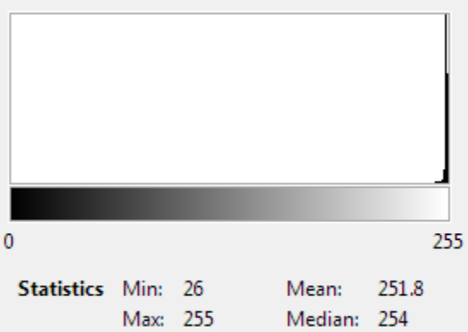
Fig. 5. Histogram of figure 4 A)
It can be seen that there is a high concentration of occurrences of gray levels with values close to 255, where for gray level values less than 26 the number of occurrences is zero. As identified, the histogram corresponds to a very clear image where it is known that the value 0 represents black and 255 represents white. It is also observable that although there is a minimum of 26, the average is 251.8 and the median 254, both values are very close to 255, which indicates that the great majority of gray levels tend to be close to 255, so that the image corresponding to the histogram has very little contrast (equivalent to saying that the variance of the histogram is very low). There are methods within the image processing able to enhance the contrast in images with these conditions, then two of them are detailed.

Histogram equalization
Histogram equalization is a technique which consists of adjusting the grey scale of the image so that the grey level histogram of the input image is mapped onto a uniform histogram. The histogram equalization technique is based on a transformation using the histogram of a complete image in histogram equalization, the goal is to obtain a uniform histogram for the output image. Let the variable r represents a random variable which indicates the grey level of an image. Initially we can assume that r is continuous and lies within the closed interval $[0:1]$ with $r = 0$ representing black and$r = 1$ representing white. For any r in the specified interval let us consider a transformation of the form:
$S = T\left(r\right)$ (12)
The transformation produces a level S for every pixel value r in the original image. It is assumed that the transformation T satisfies the following criteria:
- $T(r)$ is a single valued function, monotonically increasing in the interval $[O:1]$.
- $T(r)$ lies between 0 and 1.
The first condition preserves the order from black to white in the grayscale, and the second one guarantees that the function is consistent with the allowed range of pixel gray values [9, 10].
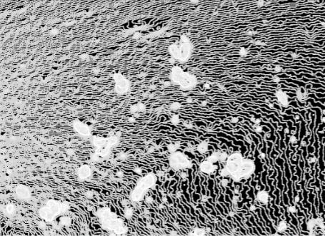
Fig. 6. Application of histogram equalization to figure 4 A).
Amplitude improvement of the gray scale
The improvement of amplitude is a technique of image processing used and endorsed in multiple investigations, applications of this are mentioned in multiple scientific publications such as [11, 12] that coincide in that mfVEP amplitude improvement can contribute to functional recovery after acute ON.
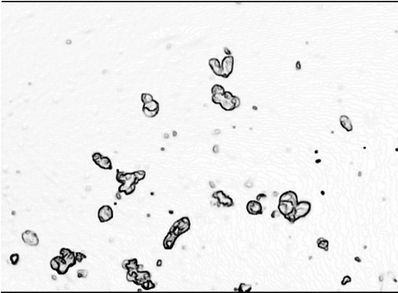
Fig. 7. Application of amplitude improvement to figure 4 A).
The transformation known as amplitude improvement is defined by a linear transformation equation and its effect is to expand the dynamic range (range of existing gray levels) of the original image to the entire possible dynamic range. In its general expression, a linear approximation by sections is allowed. The general expression for the improvement of the amplitude is given by the function:
$q=\left\{\begin{aligned}K_{1}p 0≤p≤p_{1} \\ K_{2}\left(p-p_{1}\right)+q(p_{1}) p_{1}≤p≤p_{2} \\ K_{3}\left(p-p_{2}\right)+q(p_{2}) p_{2}≤p≤p_{3}\end{aligned}\right.$ (13)
The difference obtained in Figure 7 is remarkable with respect to Figure 6, in terms of the alteration obtained in information not relevant to the one sought. This shows the superiority of the amplitude improvement over the equalization of the histogram in the image obtained by the morphological gradient.
  - Proposed pre-processing system
The figure 8 shows a simplified diagram to necessary pre-processing into entry image:
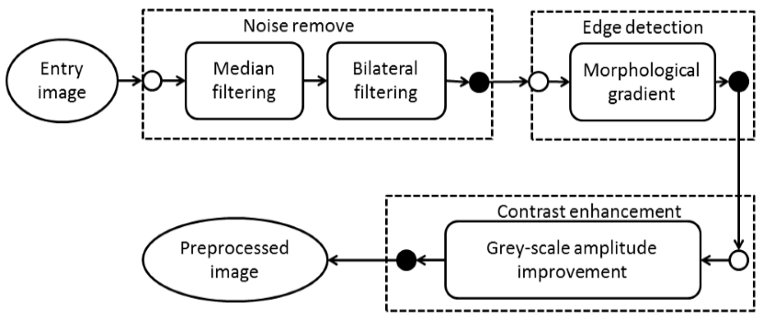
Fig. 8. Proposed pre-processing system.
- Results and analysis
The application of any pre-processing system to an input image, aims to direct the image towards a state, whose characteristics of the output image are superior to those of the input image to achieve a certain purpose. In this case, the system proposed in figure 8 pretends that the output image presents better conditions for segmentation, whose purpose is the identification and counting of cells of Theobroma Cacao L. (TCL) in later stages to (or than) those treated in this investigation. Once Figure 7 is obtained as a result of introducing Figure 1 A) into the proposed system, it can be observed that when applying a contour search algorithm, the results of Figure 9 B) are superior to that shown by Figure 9 A).
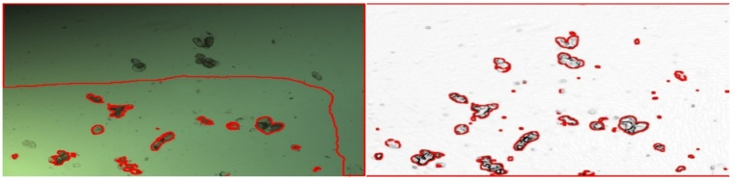
Fig. 9. A) Application of algorithm to find contours in figure 1 A), B) Application of algorithm to find contours in figure 7.
Segmentation techniques can be generally categorized into two frameworks, edge-based [13]–[15] and region based [16]–[18] approaches. As a segmentation technique, Otsu’s method is widely used in pattern recognition [19]–[21], document binarization [22]–[24], and computer vision [25]-[26]. In this research Otsu method was combined with Watersheet algorithm. The algorithm applied for the search of contours is made up of the following general steps:
- Finding an estimated threshold of gray levels of the cells, using the Otsu thresholding.
- Applying Watersheet algorithm to find contours in the thresholded image.
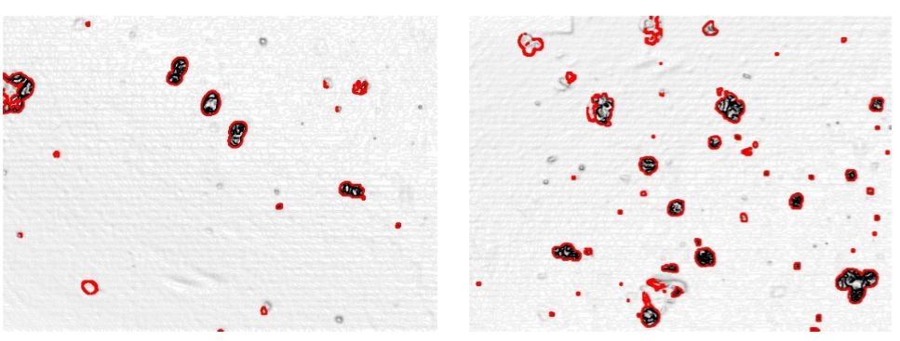
Fig. 10. Find contours in experimental sample image A), find contours in experimental sample image B) (finding or to find)
In figure 9 A) 15 regions with TCL cells are observed with the naked eye, of which 8 have a good identification of their contour, for a 53.33% success, inferior to figure 9 B) where 13 regions are obtained with good identification of its contour for an 86.67% success. In Figure 10 A), of 6 regions with TCL cells, they adequately identify their contour 6, for 100% success. In Figure 10 B), of 14 regions with TCL cells, they adequately identify their contour 13, for a 92.86% success. It should be clarified that for a total of 20 samples an average success of more than 94% was obtained, which shows excellent results, higher than the average opted for the input images of 58.14%.
By applying the COMIUV algorithm that allows to rank the models and however, it takes into account user comparison priorities [27], Given the evaluation of indicators in Table 1, the superiodity of the images resulting from the application of the proposed system on the input images can be observed, for the segmentation, a step that must be carried out later in the continuity of the investigation, this is evidence with a COMIUV value of the output images that duplicates that of the input images, as shown in figure 11.

Table 1: Indicators to be evaluated by COMIUV for a set of 20 TCL cell sampling images.

Indicators | Priority | Good | Input  Image | Output Image
Average contour identification | 1 | Yes | 58,14% | 94,76%
Average of non-relevant objects | 2 | No | 14,6 | 8,3
Average contrast evaluation by experts on a scale of 0 to 10 | 3 | Yes | 6,7 | 10

Fig. 11. Results obtained from the COMIUV application.
- Conclusions
The combination of the median and bilateral in the input image, allows the elimination of some non-relevant objects and maintain an adequate conservation of the edges and information of cell objects. The morphological gradient shows better results than the Laplacian and Canny methods in the accentuation of edges, as well as the amplitude improvement exceeds the equalization of the histogram in the image of the morphological gradient. The application of the image pre-processing system proposed in figure 8, shows good results in the preparation of images, which must subsequently be segmented in order to identify cells of Theobroma Cacao L. in later projects. This is demonstrated by the application of the Otsu’s method with Watersheet algorithm in the identification of contours with success results with an average superior to 94%, for a total of 20 samples, good results are also shown in the comparison of the input and output images through COMIUV.
References
[1] Al-Juboori, S. S.: Signature Verification Based on Moments Technique. Ibn AL-Haitham Journal for Pure and Applied Science, 26(2), 385-395 (2017).
[2] Vaseghi, S. V.: Advanced Digital Signal Processing and Noise Reduction. 4th edn. Wiley-Interscience, (2008).
[3] Yang, Q., Ahuja, N., Tan:Constant, K. H.: Time Median and Bilateral Filtering. International Journal of Computer Vision, 112(3), 307-318 (2015).
[4] Yang, Q., Ahuja, N., Yang, R., Tan, K. H., Davis, J., Culbertson, B., Wang, G.: Fusion of Median and Bilateral Filtering for Range Image Up sampling. IEEE Transactions on Image Processing, 22(12), 4841-4852 (2013).
[5] Santhana, A., Murali, N.: Early Classification of Bearing Faults Using Morphological Operators and Fuzzy Inference. IEEE Transactions on Industrial Electronics, 60(2), 567-574 (2013).
[6] de Andrade, M. C.: An Interactive Algorithm for Image Smoothing and Segmentation. Electronic Letters on Computer Vision and Image Analysis, 4(1), 32-48 (2004).
[7] Gautam, K., Quadri, N., Pareek, A., Choudhary, S. S.: A Face Recognition System Based on Back Propagation Neural Network Using Haar Wavelet Transform and Morphology. Emerging Trends in Computing and Communication, 87-94 (2014).
[8] Zhou, H., Wu, J., Zhang, J.: Digital Image Processing – Part One. Ventus Publishing ApS (2010).
[9] Singh, V., Singh, M.: Analysis and Transformation of Image Using Spectral Transformation Technique. IEEE International Conference on Signal and Image Processing, 108-112 (2010).
[10] Behnia, S., Ahadpour, S., Ayubi, P.: Design and implementation of coupled chaotic maps in watermarking. Applied Soft Computing (2014).
[11] Wu, K., Huang, X., Tan, G., Ye, L., Wu, A., Zhong, Y., Jiang, N., Shao, Y.: Whole-brain voxel-based analysis of diffusion tensor imaging and its correlation with visual evoked potential in patients with optic neuritis. Int J ClinExp Med, 9(8), 16971-16980 (2016).
[12] Klistorner, A., Arvind, H., Garrick, R., Graham, S. L., Paine, M., Yiannikas, C.: Interrelationship of optical coherence tomography and multifocal visual-evoked potentials after optic neuritis. Invest Ophthalmol Vis Sci, 51, 2770-2777 (2010).
[13] Liu, C., Liu, W., Xing, W.: A weighted edge-based level set method based on multi-local statistical information for noisy image segmentation, Journal of Visual Communication and Image Representation, 59, 89–107 (2019).
[14] Zhou, Y., Shi, W., Chen, W., Chen, Y., Li, Y., Tan, L., Chen, D.: Active contours driven by localizing region and edge-based intensity fitting energy with application to segmentation of the left ventricle in cardiac CT images. Neurocomputing, 156, 199-210 (2015).
[15] Sudharshan, D., Kareem, B., Shehran, A.H.: A review on detecting anomalies in tablet blisters using image segmentation. In: 2nd International Conference on Inventive Systems and Control (ICISC). IEEE (2018).
[16] Rehman, F., et al: A Region-Based Deep Level Set Formulation for Vertebral Bone Segmentation of Osteoporotic Fractures. Journal of digital imaging, 1-13 (2019).
[17] Nida, N. et al: Melanoma lesion detection and segmentation using deep region based convolutional neural network and fuzzy C-means clustering. International journal of medical informatics, 124, 37-48 (2019).
[18] Sharma, M. et al: Computer Based Diagnosis of Leukemia in Blood Samples Using Improved Region Based Deformable Models. In: 2nd International Conference on Trends in Electronics and Informatics (ICOEI). IEEE (2018).
[19] Sirisha, P., Raju, C. N., Reddy, R. P. K.: An efficient fuzzy technique for detection of brain tumor. Int. J. Comput. Technol., 8(2), 813–819 (2013).
[20] Bindu, C. H., Prasad, K. S.: An efficient medical image segmentation using conventional OTSU method. Int. J. Adv. Sci. Technol., 38, 67–74 (2012).
[21] Gupta, P., Malik, V., Gandhi, M.: Implementation of multilevel threshold method for digital images used in medical image processing. Int. J., 2(2), (2012).
[22] Moghaddam, R. F., Cheriet, M.: AdOtsu: An adaptive and parameter less generalization of Otsu’s method for document image binarization. Pattern Recognit., 45(6), 2419–2431 (2012).
[23] Zhang, Y., Wu, L.: Fast document image binarization based on an improved adaptive Otsu’s method and destination word accumulation. J. Comput. Inf. Syst., 7(6), 1886–1892 (2011).
[24] Nina, O., Morse, B., Barrett, W.: A recursive Otsu thresholding method for scanned document binarization. In Proc. IEEE WACV, pp. 307–314 (2011).
[25] Xu, X., Xu, S., Jin, L., Song, E.: Characteristic analysis of Otsu threshold and its applications. Pattern Recognit. Lett., 32(7), 956–961 (2011).
[26] Hongmin, C., Zhong, Y., Xinhua, C., Weiming, X., Xiaoyin, X.: A New Iterative Triclass Thresholding Technique in Image Segmentation. IEEE Transactions on image processing, 23(3), (2014).
[27] Aliaga, A., Santana, Y., Mustelier, A., Guzmán, Y.: Computer Algorithm for comparing and ordering models based on indicators and user value. Revista Facultad de Ingeniería, 26(46), 61-69 (2017).

