**SIMPOSIO INTERNACIONAL “DESARROLLO HUMANO, EQUIDAD Y JUSTICIA SOCIAL”**

***VI SIMPOSIO INTERNACIONAL DE ESTUDIOS HUMANÍSTICOS***

**Title**

**Using Portfolio as a Virtual Alternative Assessment Tool in the subject Didactics of English language**

***Título***

**El uso del portafolio como instrumento de evaluación alternativa en la asignatura Didáctica de la Lengua Inglesa**

**Juana Idania Pérez Morales1, Alicia Maria Moya Torres2**

1- Juana Idania Pérez Morales. Universidad Central “Marta Abreu” de Las Villas, Cuba. [juanap@uclv.edu.cu](mailto:juanap@uclv.edu.cu)

2- Alicia María Moya Torres. Universidad Central “Marta Abreu” de Las Villas, Cuba. [aliciam@uclv.edu.cu](mailto:aliciam@uclv.edu.cu)

**Abstract:**

Today’s world context affected by COVID-19 is demanding new forms of learning environments and our society is not an exception. This paper aims to describe the implementation of portfolio as a valuable alternative assessment tool for fourth and 5th year students in the English Language Major at UCLV. A qualitative methodology with a descriptive and exploratory approach was used in this research for the analysis of students' portfolios. The study was carried out in the subject Didactics of English Language where the portfolio was used as the final evaluation. It consisted of a four-lesson plan system to develop the language skills: (speaking, listening, reading and writing). The structure of the lesson, stages, aims, teaching aids, time for each part of the lesson, content, techniques and procedures, tasks orientation, were the units used for the analysis. The portfolios were uploaded in Moodle Platform using PDF and WORD formats with a personalized style. The activity was successfully completed; however, some inconsistencies were detected in the aims, the techniques, and the task types. In general, the experience was positively evaluated and the results impacted on the students' professional training. Likewise, teachers also received a washback upon their own teaching practices and feedback on students' learning. All in all, this was a valuable experience that can be a reference for other educational contexts.

**Keywords:** Language Teaching; Portfolio; Alternative Assessment; Didactics; Virtual learning

***Palabras Clave:*** Enseñanza de lenguas; Portafolio; Evaluación alternativa; Didáctica; aprendizaje virtual

**1. Introduction**

Portfolio-based Assessment is crucial in language assessment. It represents the development of the students’ learning process outcomes, trains autonomous learning, and stimulates metacognitive awareness. It represents a new and alternative method of assessment to the existing conventional methods.In fact, alternative assessment was one of the solutions to reduce students’ anxiety during exams and other types of conventional procedures, to monitor students’ learning progressions, and to eliminate daily, weekly, and mid semester grades (Daniels et al, 2001). It is a good choice of testing students’ ability since there was not pressure to complete the tasks (Wilcox (2002).

Alternative assessment refers to informal assessment protocols which are frequently used in the classroom (Clapham, 2000). It can be referred to as a non-traditional assessment type with forms of performance observation and portfolios that outline a detailed picture of student performance in line with the curricular goals (Bozgodan, 2009).

The conceptual framework of portfolios is constructivism and a student-centered approach where learners are actively involved in constructing meaning with the focus on production in the evolving process (Bozgodan, 2009). Portfolios focus on process rather than the product, development rather than achievement. In the student-centered class, students are encouraged to create and develop their own learning style. Students feel a sense of ownership of their own product during the process and are empowered. The teacher acts as a mediator and guide rather than as a main source of information (Boghian, 2012).

This paper aims to describe the implementation of portfolio in the subject Didactics of English Language as a valuable alternative assessment tool for summative purposes in the English Language Major at the Universidad Central “Marta Abreu” de Las Villas. In this major students are trained to become translators and interpreters and also language teachers. The portfolio was aimed at developing and asse ssing lesson planning skills in the future language teachers.

* 1. **Defining portfolio**

Portfolio is a type of alternative assessments in which students produced a set of writing (Johnson, 1997). Tierney et al. (1990, as cited in Johnson,1997) defined portfolio as a medium for continuous assessment containing useful collection of students’ work, in which it would assess their performance, ability, progress and learning stages like selecting, contrasting, distributing, self-assessment, and setting learning goals.

On the other hand, Herman et al (1992 as cited in (Agustina, 2011) defined portfolio as a set of students’ tasks which were examined and evaluated based on marking standards in order to decide students’ performance or a study program. Portfolio, in fact, has been used to underline and represent the authenticity of assessment, students’ critical thinking skills, self-evaluated assessment which encouraged flexibility and challenges (Zhu, 1997). Students have more time to study outside the classroom, are more independent and responsible, and demonstrate higher thinking order and problem solving (Bachman, 1996) (Zhu, 1997)

In this paper portfolio is used for evaluating lesson planning skills according to some assessment criteria on students’ performance in the subject Didactics of English Language.

* 1. **Didactics of English Language**

Foreign Language Didactics deals with the teaching and learning process of foreign language in an institutional setting. It concerns with the development of the communicative competence through the four language skills (listening, reading, speaking and writing).

In Higher Education in Cuba this process aims at developing the communicative competence; hence, the subject Didactics of English language at the UCLV deals with the language teaching from a contextualized communicative perspective.

In this subject students should be able to design CLT lesson plans based on the diagnosis of their students’ educational needs. They should also apply different skills and strategies at work with different sources of information, including the use of information and communication technologies, for their training as future teaching professionals, showing responsibility and dedication to study.

**Developing students Portfolio as a final evaluation in Didactics of English Language**

In order to develop a good portfolio, students need to follow several components: rationale, goals and objectives, evaluation criteria, selecting portfolio content carefully, students’ reflection and teacher’s responses (Boyle, 1994). Rationale is used to describe the reason why a student wrote a portfolio.

There are some questions that need to be addressed when considering the design of a portfolio. Those questions are:

1. Purpose: What is the purpose(s) of the portfolio?

2. Audience: For what audience(s) will the portfolio be created?

3. Content: What samples of student work will be included?

4. Process: What processes (e.g., selection of work to be included, reflection on work, conferencing) will be engaged in, during the development of the portfolio?

5. Management: How will time and materials be managed in the development of the portfolio?

6. Communication: How and when will the portfolio be shared with pertinent audiences?

7. Evaluation: If the portfolio is to be used for evaluation, when and how should it be evaluated?

What are the stages in developing the portfolio?

First, samples of students’ work are collected. Second, systematic observation, orientation and monitoring are used to help students. Students should previously know each assessment criteria negotiated with the teachers. Third, students’ works are organized in a way they show their learning development and progression. A teacher, then, elaborates a checklist/rubric or inventory to evaluate students’ performance based on the assessment criteria. Fifth, rating scales are supported by the quality of students’ work and help the teacher track down students’ strengths and weaknesses so that he would be able to give feedback on the areas that need to be improved. Finally, a report of students’ learning achievement is given for better understanding of students’ strengths and weaknesses. Students might also examine and evaluate their own portfolio through self-assessment and peer assessment.

After grading students’ works, teachers and students should examine and evaluate the use of portfolio at the end of the course. Usefulness factors, reliability, validity, impact, interaction, authenticity, and practicality were going to be discussed as the barometer of analysis (Bachman & Palmer, 1996).

**2. Methodology**

A qualitative methodology with a descriptive and exploratory approach was used in this research for the analysis of students' portfolios. A sample of fourth and fifth year students’ portfolios was chosen for assessment `purposes. The study was carried out in the subjects Didactics of English Language (in fourth year) and the Teaching Practice (in fifth year) where the portfolio was used for summative assessment purposes. Exceptionally, for fifth year students the portfolio was used as an alternative assessment tool to evaluate the Teaching practice because of the virtual educational context imposed by COVID-19.

The portfolio consisted of a four-lesson plan system to develop the language skills: (speaking, listening, reading and writing) considering the structure of the lesson, stages, aims, teaching aids, time for each part of the lesson, content, techniques and procedures, tasks orientation, as the units for the analysis.

**Why use Portfolio assessment in Didactics of English Language?**

According to the curriculum D, Didactics of English Language is taught in the fourth year of the English language major. Then, the skills acquired in this subject are applied in the teaching practice period in fifth year. Both subjects include systematic evaluations and a portfolio as the final activity. Generally, these portfolios have been handed in as word and PDF documents, but in virtual learning environments, the fact of using Moodle platform, gave better opportunities to implement digital portfolios for evaluation.

**What is the aim of the Portfolio?**

Portfolios not only demonstrate a compilation of the student’s materials that exemplifies their knowledge, beliefs and skills acquired in the subject, but also provide a space for the students to reflect on their learning process and improve it. It is a useful record that can also be shared and edited several times. It is also used as a formative evaluation tool that determines if the students have meet their goals in the subject.

**What structure does it take?**

* Cover page (portfolio title , institution, major ,subject, tutor, date etc)
* Student Profile ((Name, photo, school year)
* A Dossier: (material evidence of the learning process in the subject. Word documents, PDF, videos, PPTs etc.) The design of four descriptive lessons considering :
* Structure of the lesson
* Lesson type according to :
  + - Language skills(reading, speaking, listening and writing ) Stages considering the skills ( presentation , practice and production for the productive skills or before, while, after for receptive skills)
    - The linguistic content: grammar, vocabulary and pronunciation
* Level of students, aims, contents, approaches and methods, teaching aids, activity type, forms of organizing classroom activities, time for each activity, evaluation and feedback and a reflection page.

**Criteria for the evaluation**

Assessment criteria for evaluating lesson planning skills in Didactics of English language were set. The criteria were designed to assist students in reflecting upon their skills and knowledge acquired in Didactics of English language (self assessment) and also for the final evaluation. Gaining an accurate picture of the teaching skills can help students set new goals in the learning process which will have an impact in their future profession as a teacher.

**Assessment criteria upon the lesson planning skills**

* Structure of the lesson: Introduction, body and conclusions
* Lesson type (according to the four language skills, stages, and to the linguistic contents)
* Level of students: (beginners, intermediate, upper intermediate, advanced)
* Aims of the lesson (considering the skill, knowledge and attitudes)
* Contents (Knowledge: language subskills, linguistic contents )
* Approaches and methods (procedures٫ techniques: role plays٫ games cloze dialogues٫ debates٫ jigsaw activities٫ presentations٫ etc),
* Teaching aids and other resources (textbook, workbooks٫ software٫ video – lessons٫ pictures٫ realia, etc.)
* Forms of organizing classroom activities (individual work٫ pair work group٫ work whole class٫ in rows inside and outside circles٫ etc)
* Activity type
* Evaluation and feedback

**Rubric for the lesson plan evaluation**

The development and use of a rubric for assessing the quality of standards-based lessons plans, depends on the determination of quality indicators for standards-based planning and teaching. The following is a rubric for assessing standards-based Lesson Plans.

|  |  |  |  |  |
| --- | --- | --- | --- | --- |
| **Criteria** | Performance level | | | |
| 5 | 4 | 3 | 2 |
| Lesson type | The stages match the lesson type considering the skill ( productive, receptive) or the linguistic contents( grammar , vocab, pronunciation)  The lesson plan covers all the stages | The stages match lesson type considering the skill  The lesson plan covers most of the stages | The stages do not match lesson type considering the skill  The lesson plan covers some stages of the lesson. | The stages do not match lesson type considering the skill  The lesson plan does not cover all the stages of the lesson. |
| Aims formulation | Objectives lead to the development of the language subskills and integrate them  The three components (skills, contents and attitudes) are visible totally and clearly stated | Objectives lead to the development of the language subskills   The three components are visible not totally and clearly stated | Objectives partially lead to the development of the language subskills  Two components are visible, not clearly stated | Objectives do not lead to the development of the language subskills.  The three components of the aims are not visible |
| Contents | They are related to aims  Including the four language subskills and integrating them | They are related to aims but with some inconsistencies    Including the four language subskills | They are related to aims,  but not sufficiently to  assess expected  learning outcomes.  Not including the four language subskills | Unrelated to aims  Not including the four language subskills |
| Approaches and methods | The lesson plan reflects CLT approach and some other methods in the activities.  Integration of language skills | The lesson plan reflects CLT approach in the activities.  Integration of language skills | The lesson plan reflects CLT approach in some activities.  Poor integration of language skills | The lesson plan reflects CLT approach and its principles.  Do not integrate language skills |
| Aids | Related to the aims and the contents All the materials are authentic  All the materials are updated | Related to the aims and the contents All the materials are authentic  Not all the materials are updated | Related to the aims and the contents  Not all the materials are authentic  Not all the materials are updated. | Not related to the aims and the contents  Uses authentic materials  Materials are not updated. |
| Activities | Activities are diverse  Related to aims  All instructions are clear  Balanced time  All the activities are graded for the students’ level of language | Activities are diverse  Related to aims  Not all instructions are clear  Balanced time  Most of the activities are graded for the students’ level of language | Activities are diverse  Not all related to aims  Not all instructions are clear  Balanced time    Some activities are graded for the students’ level of language | Activities are not diverse  Unrelated to aims  Vague instructions  Not balanced time  Activities are not graded for the students’ level of language |
| Evaluation and feedback | Most of the activities include  evaluation and feedback | Some activities include  evaluation and feedback | A few activities include  evaluation and feedback | The activities do not include  evaluation and feedback |

Since Moodle has been the digital platform available to work with in our university we have implemented one of its sources (activities) Moodle Portfolio. It is designed to provide users with the tools to create a personal learning development environment.

Moodle portfolio provides different pages covering: Information, categories, my portfolio with chapters, association of artifacts with competencies, views, external links, export/import, share portfolios, but we will make customary use mainly of some of them as follow:

The information page will be used in English Didactics subject to display the personal information of the student. (Name, school year, language level etc.) The teacher will create chapters with instructions for the students to complete them. Here the students can upload documents, videos, PPTs, etc that will be included in the View page, later the teacher can browse through a particular student contribution and may click on Grade to give overall feedback comments and grade.

This virtual environment turns out to be an important instrument since students do not depend on a specific location to work; learners and instructors can work and communicate wherever they are and can comment on their works as interaction takes place. In addition, learners can easily attach documents of all format types (text files, sound, picture and video files, etc.)

**3. Results and Discussion**

The portfolios were uploaded in Moodle Platform using PDF and WORD formats with a personalized style. It contained a systems of lessons plan of each language skill. (See fig. 1 in the annexes) A board of experienced professors checked them and provided feedback to students so that the students could reflect on the observations and finally edit them. Thus a process of constructing knowledge occurred to improve the students’ lesson planning skills. The final draft was graded using the rubric and the assessment criteria. 90% of the students were graded with the highest marks. (5 and 4). Students’ perceptions about the task were positive, highlighting the possibility the portfolio gave them to grow professionally.

However, some inconsistencies were detected in some of the components of the lesson plans: aims, the techniques, and the task types. Also, some language mistakes still prevail (grammar mistakes, word order, collocations).

**Most common mistakes found in the portfolios designs**

* Lesson plans without clear learning objectives
* Activities sometimes are not graded for the students’ real level of language knowledge and skills
* Lack of correlation between the time needed for the complexion of the activities and the time allotted to them in the lesson plan
* Lack of tasks clear and concise instructions
* Problems with the warm up section in respect to motivation to the topic of the lesson
* Difficulties for designing the conclusion stage of the lesson and designing assignments for independent work according to the level of the students and the aim of the lesson.
* Some of the writing tasks do not reflect the setting and purpose, which are basic components for communicative tasks
* Some of the tasks do not reflect the technique (student-teacher interaction, individual work, pair work, group work) for developing them.
* Not all the lessons contain procedures and feedback
* The formative part of the aim is frequently missed.

In general, the experience was positively evaluated and the results impacted on the students' professional training. Also, portfolio had an impact on teachers who gave comments and suggestions to their students. Teachers’ comments and suggestions contained positive and negative feedbacks related to students’ academic performance.

While feedbacks aimed at improving students’ performance, teachers also receive a washback upon their own teaching practices. In this case, teachers orientated their own practices emphasizing on those aspects, most of students fail, during the lesson planning

**4. Conclusions**

The portfolio was successfully implemented as an assessment tool for the Didactics of English language in the English Language major at the UCLV. The Portfolio can also be adapted to the learners’ needs helping the users develop autonomous, individual and collaborative learning and experience a real sense of ownership of it.

The use of portfolio assessment benefited both students and teachers. The findings revealed that students articulated their perceptions in three major themes, namely developing self-monitoring from the students’ learning processes, generating discipline and autonomous language learning attitudes.

Thus, the future use of portfolio assessment will be for formative assessment concerning more about students’ learning process than the learning product. Pedagogically speaking, this study indicates that the use of portfolio can provide opportunities for students to monitor their learning progress, and enhance their self-confidence and learning motivation.

It is recommended the use of portfolio embedded in Moodle platform for future work, as it contains several options for monitoring, editing and interaction. +

**5. Bibliographic references**

Agustina, R. (2011). Portfolio as an alternative assessment i language testing. *Eksplanasi*, 1-6.

Bachman, L. P. (1996). *Language Testing in Practice: Designing and Developing Useful Language Tests. .* Oxford: Oxford University Press.

Boghian, I. (2012). THE DIDACTICS OF ENGLISH LITERATURE FROM THE PERSPECTIVE OF STUDENT-CENTERED STRATEGIES. *Journal of Innovation in Psychology,Education and Didactics*, 29-36.

Boyle, J. (1994). Portfolios: Purposes and Possibilities. Assessment Update. *TESOL Quarterly*, 653–675.

Bozgodan, D. (2009). Portfolio use in foreign language learning. *Egitin Facultesi*, 793-814.

Clapham, C. (2000). Assessment and Testing. *Annual Review of Applied Linguistics*, 147-161.

Cole, B. S. (1997). Portfolio Assessment: Challenges in Secondary Education. . *The High School Journal*, 261-272.

Johnson, J. R. (1997). *Portfolios: Clarifying, Constructing, and enhancing.* Lancaster: Technomic Publishing Company, Inc.

Zhu, W. (1997). Alternative Assessment: What, Why, How. *Journal of Physical education*, 17-18.

**Annexes**

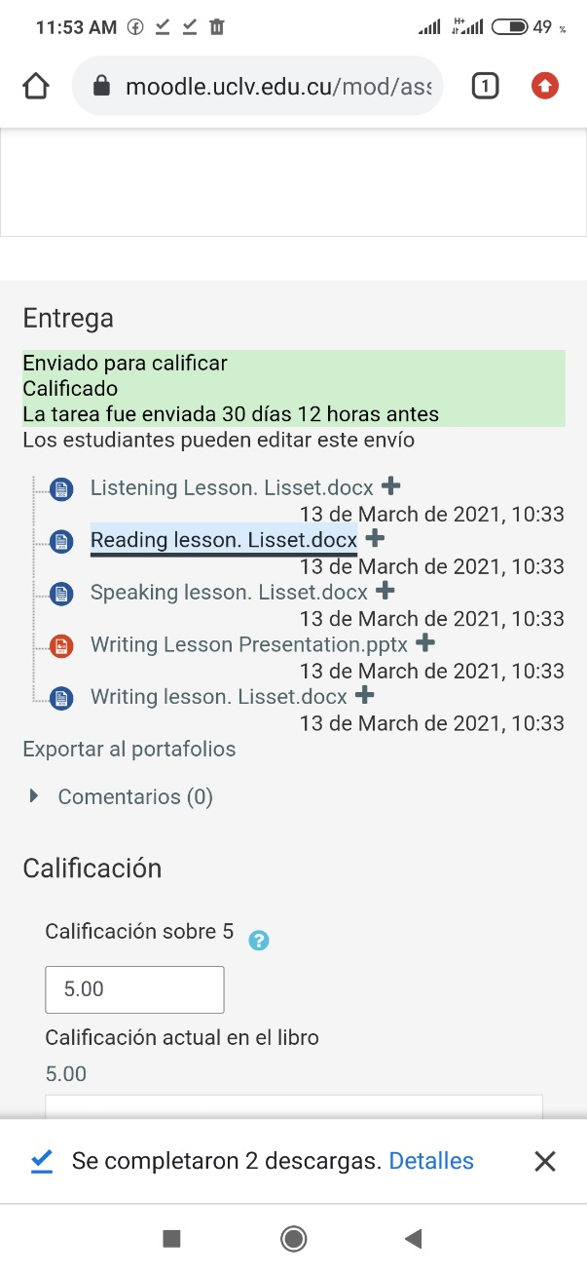 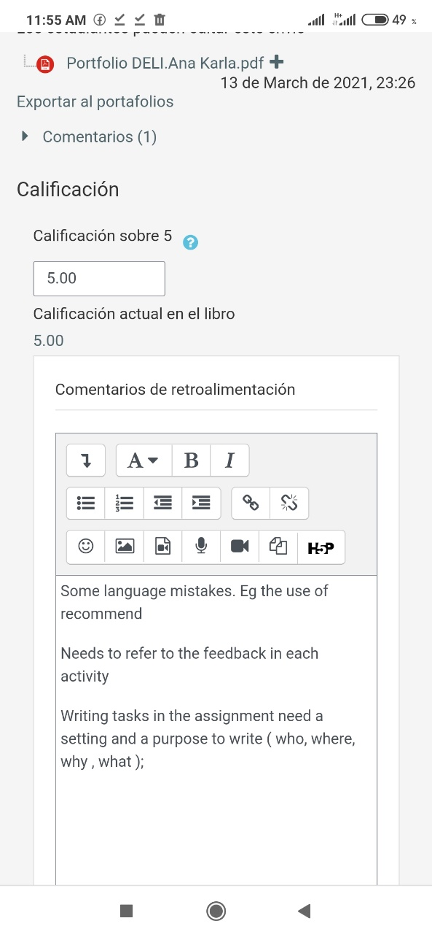

Fig 1. Sample of portfolio in Moodle platform Fig 2. Sample of feedback on student’s portfolio