VI Symposium of Logistics and Quality Management COMEC 2023

Education and research development directions in logistics

Direcciones de desarrollo de la educación y la investigación en logística.
Péter Tamás¹, Béla Illés²
1- Péter Tamás . Institue of Logistics of University of Miskolc, Hungary peter.tamas@uni-miskolc.hu
2- Béla Illés . Institue of Logistics of University of Miskolc, Hungary bela.illes@uni-miskolc.hu

Abstract
In Hungary, the University of Miskolc, the predecessor of the Institute of Logistics, was the first to start teaching logistics in higher education in the early 1980s. Over the past 40 years, the field has undergone a significant transformation and has become a leading academic research centre in Hungary and internationally. Thanks to the massive digitalisation of logistics systems, the field has considerable potential for development. The paper describes the most important current events as well as future development directions.
Keywords: evaluation, selection, logistics service provider, industry 4.0, digitalization

Introduction
The predecessor of the Institute of Logistics of the University of Miskolc was founded in 1951 as the Department of Lifting Machinery, and in 1956 it was renamed the Department of Transport Equipment. In the early 1980s, the education of logistics started, and in 1992 the department was renamed the Department of Material Handling and Logistics. Over the past 70 years, the education and research portfolio has been continuously transformed in response to corporate needs, with the former and current heads of the Institute playing a major role. The current education and research staff of the Institute is ideal, consisting of 3 professors, 3 associate professors, 3 assistant professors, 1 master's lecturer, 1 assistant lecturer and 1 research assistant. Logistics is one of the most dynamically developing fields of science today [1].
This is thanks to the new technologies and mindset that characterise the 4th Industrial Revolution. It can be said that those companies that are able to meet specific customer needs at low cost and/or with high service quality can remain competitive [2]. The production of specific products and services increases the complexity of processes, which are essential to develop and optimise them efficiently by applying Industry 4.0 solutions. In essence, new challenges are emerging in logistics, which necessitates a dynamic change in education and research [3]. In the following chapters of this thesis, the educational and research activities of the Institute of Logistics of the University of Miskolc and its development direction will be presented.

Description of educational activities
The Institute has a very broad educational portfolio. It provides training at all levels, from a few days of basic training to PhD courses. The new courses currently running and those to be launched in the future (in bold) are described below, and additional information is provided on the new courses because of their unique nature.

BSc/MSc courses programmes:
- BSc in Logistics Engineering (from September 2014). Specialisations: Production/Service Process Engineering
- MSc in Logistics Engineering (from September 2010).
- Specialisations: Industry 4.0 Process Engineer, Recycling Logistics, International Logistics
- MSc in Logistics Engineering in English (from September 2023). Specialisations: Digital Logistics
- BSc in Logistics Engineering in English (from September 2024). Specialisations: Process Engineer, Product/Service

The BSc in Logistics Engineering in English is designed to train process engineers, while the MSc is designed to train students in the application of new digital technologies in logistics.
Our main professional subjects for the BSc course are: Materials Science and Testing; Fundamentals of Machine Elements; Basics of Technical Description; Computer Studies; Vehicle Components; Mechanical Technologies; Technical Logistics; Material Handling Machines; Simulation Modelling of Logistics Processes; Logistics Systems; Fluid Transport Systems and Machines; Transportation Systems; Quality Assurance in Logistics; Service Logistics; International Logistics; Reverse Logistics
Our main subjects for the MSc course are: Numerical Methods and Optimization; Modern Information Technologies; System Engineering and System Modeling; Data Structures and Algorithm; Introduction into Datamining; Environmental Management; Projectmanagement; Intelligent Material Handling Machines and Systems; Industrial Automation; Design of Material Handling Systems and Warehouses; Simulation Examination of Logistics Systems; Quality Management of Logistics Systems; Industry 4.0 and Logistics; Mechatronics in Logistics; Standard Solutions in Logistics Networks; Industry 4.0 Information Systems; Modeling and Simulation of Transport Systems

PhD programme:
- Material Flow Systems and Logistics Informatics

Postgraduate specialist training courses:
- Lean process improvement engineer/specialist
- Logistics simulation engineer
- Industry 4.0 process development engineer
- Tracking system development and operation engineer/specialist (from September 2023)
- Logistics packaging development engineer/specialist (from September 2023)
- Warehousing process development and operation engineer/specialist (from September 2023)

This courses are mainly post-graduate courses, which can be applied for with a BSc degree. The following is a brief description of our newest courses to be launched in the future.

Tracking system development and operation engineer/specialist
- Aim of the training: to train professionals who, by deepening their knowledge in the field of technical training already acquired, are able to define the requirements of a monitoring system for a logistics process under study, to plan the design/upgrading of the system, to coordinate its implementation and to operate the system once implemented.
- Duration of training: 2 semesters
- Corporate partners: IBCS Hungary Ltd., GS1 Hungary Nonprofit Zrt.
- Core subjects: Identification standards; Identification technologies; Material flow systems
- Subjects: Data sharing and data management; Process development methods; Implementation and operation of product tracking systems; Tracking in industrial practice; Design of tracking systems; Simulation studies of logistics systems; Optimisation of logistics systems
- Additional skills: Database management skills; Project management; Data security and protection

Logistics packaging development engineer/specialist
- Training objective: to train professionals capable of professionally designing the packaging of finished products, components, other raw materials and auxiliary materials, and of defining and evaluating the relevant requirements for validation.
- Duration: 2 semesters
- Corporate partners: Robert Bosch Power Tool Kft., Mapack Kft., GS1 Magyarország Nonprofit Zrt., Alfra Consulting Kft.
- Core subjects: Packaging materials knowledge; Packaging systems and requirements; Product traceability systems in logistics; Packaging testing standards and methods; Computer-aided packaging design; Packaging equipment recycling; Packaging testing machines and their applications; Simulation studies of packaging logistics processes; Optimisation of packaging equipment in the supply chain; Packaging testing machines and their applications; Packaging logistics process simulation studies; Packaging equipment optimisation in the supply chain
- Complementary skills: problem solving methods in packaging technology; packaging design; legal interpretations in logistics

Warehousing process development and operation engineer/specialist
- Aim of the training: the aim of the training is to train professionals who, by deepening their knowledge in the field of technical training already acquired, are able to define the development objectives, plan the development, coordinate the implementation and operate the warehouse systems processes.
- Duration of training: 2 semesters
- Corporate partners: ÁTI DEPO ZRt., IBCS Hungary Kft., QLM Logistics Solutions Kft., GS1 Magyarország Nonprofit Zrt., IBCS Hungary Kft., Colibre Design & Development Kft.; Warehousing systems and innovations; Warehouse materials handling technologies and innovations; Identification technologies and innovations; Warehouse safety and security.
- Subjects: Warehouse process operations; WMS software and innovations; Site load management systems; Warehouse process development methods; Warehouse process optimisation methods; Inventory management; Warehouse automation.
- Additional skills: Customs warehousing; Project management; Monitoring warehousing processes.

Short training courses:
- Lean tools and methods
- Industry 4.0 and logistics
- Simulation of logistics processes
- Optimization of logistics systems

Our objectives for education development are summarised in the table below.

Educational level | Development period
Educational level | Within 1 year | Between 1-3 years | Over 3 years
BSc/MSc | Launch of BSc/MSc in English. | Development and launch of a double degree course with KSTU | Establish a double degree programme with other universities
BSc/MSc | Modernisation of teaching materials  Developing the share of e-learning training  Improving educational infrastructure  Involving corporate lecturers in training
PhD | Increasing the share of foreign students  Modernising teaching materials  Increasing the share of e-learning  Improving educational infrastructure  Involving corporate lecturers in training
Postgraduate specialist training course | Launching already accredited training | Create new training programmess based on company needs.
Postgraduate specialist training course | Modernisation of teaching materials  Increasing the share of e-learning  Improving educational infrastructure  Involving corporate lecturers in training
Short training courses | Create new training courses based on company needs  Modernisation of teaching materials  Increasing the share of e-learning  Improving training infrastructure  Involving company lecturers in training
Table 1 Development of educational activities

Description of research activities
To meet the needs of companies, the Institute carries out research in a number of areas, including:
- logistics systems design,
- process simulation development of logistics systems,
- development of a product tracking system,
- optimisation of logistics processes,
- design and operation of virtual logistics centres,
- logistics planning and testing of packaging, unit loads.

It is a special recognition for the institute that one of the 4 competence areas defined by the University of Miskolc (sustainable natural resources, logistics 4.0 and digital technologies, advanced materials and technologies, innovative engineering) belongs to the logistics area, so the services provided to companies are made known to the partner companies of the university in the form of competence sheets [4].
In order to support research activities, three laboratories are continuously developed (Logistics Process Simulation Laboratory, Logistics 4.0 Laboratory, Virtual Logistics Laboratory). In addition to their research tasks, the laboratories actively support educational tasks.
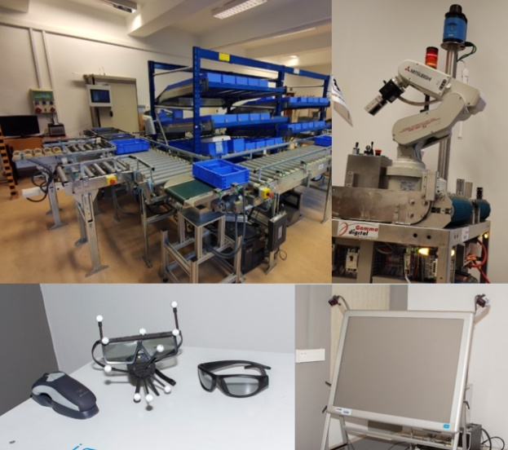
Figure 1 Laboratory infrastructure of the Institute of Logistics (own source)

The Institute has been involved in the management and implementation of several national and international projects in the past decades, of which the following are highlighted without claiming completeness.

UMI-TWINN project (2016-2019) [5]
Participants:
- ME, Institute of Logistics (project coordinator),
- TU Graz (Austria),
- Fraunhofer IFF (Magdeburg),
- Intelligentsia (Luxembourg).
Key objectives:
- To increase the scientific excellence of the University of Miskolc in the field of logistics,
- Strengthening the research and innovation capacities of the University of Miskolc and its partners,
- To enhance the research profile of the University of Miskolc and its partners.

ERASMUS+ PRODLOG project (2017-2021) [6]
Participants:
- OVGU (Magdeburg, Germany) (project coordinator),
- ME, Institute of Logistics,
- SIGMA (France, Aubière),
- UAS (Germany, Landshut),
- MADI (Russia, Moscow),
- VSUWT (Russia, Novgorod),
- GKU (Kazakhstan, Almaty),
- KazATC (Kazakhstan, Almaty),
- KSTU (Kyrgyzstan, Bishkek),
- KNAU (Kyrgyzstan, Bishkek).
Key objectives:
- to enhance the scientific excellence of the University of Miskolc in the field of logistics,
- to strengthen the research and innovation capacities of the University of Miskolc and its partners,
- enhancing the research profile of the University of Miskolc and its partners.

Development and implementation of a parameterizable simulation test model for the production of small series body components for AUDI HUNGARIA MOTOR Kft.

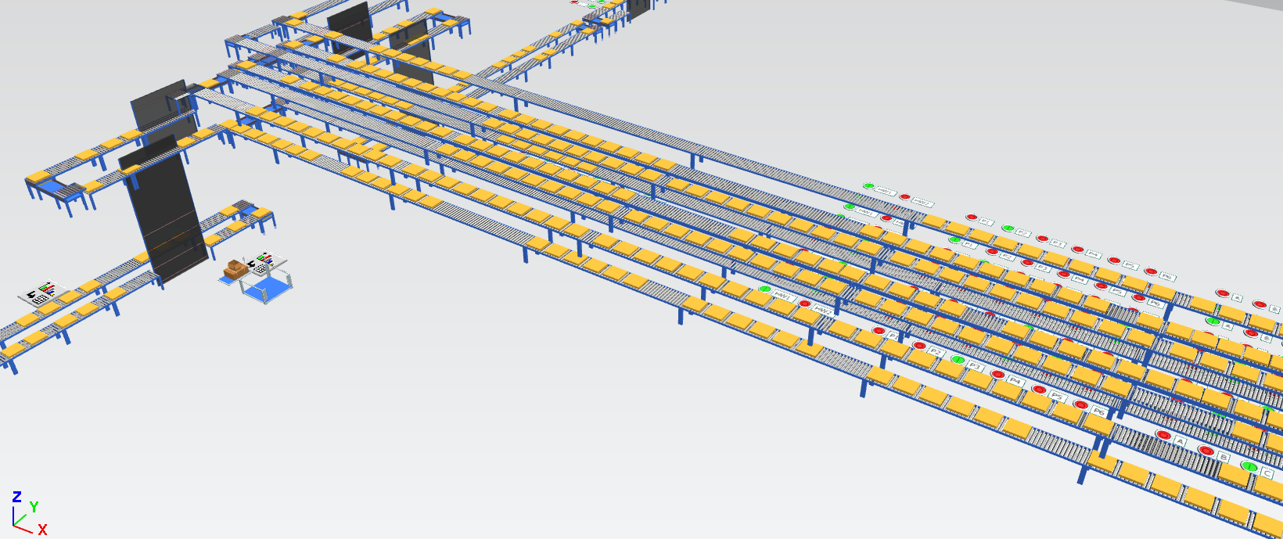
Figure 2 Simulation study (own source)
Determining the capacity requirements and design of the storage system to be developed for ISI Automotive Hungary Ltd.

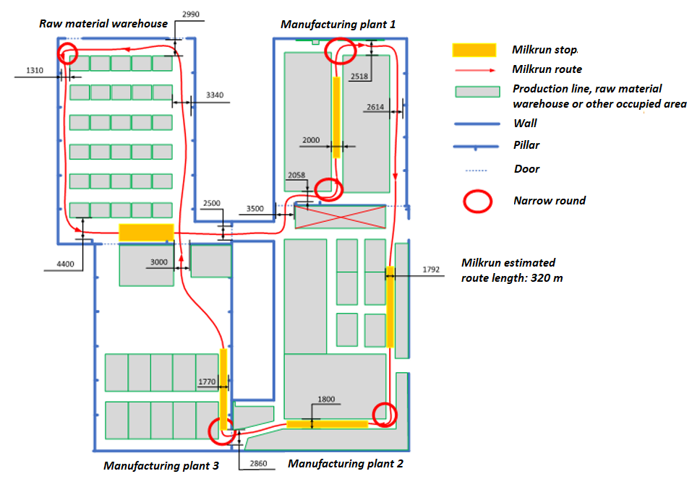
Figure 3 Storage process design (own source)

Within the framework of the Science and Innovation Park project, research infrastructure, human resources and services for companies have been planned in the following areas:
- Competence Centre for Packaging Technology and Logistics Quality Assurance,
- Logistics Simulation and Process Improvement Competence Centre,
- Product Identification and Virtual Logistics Competence Centre.
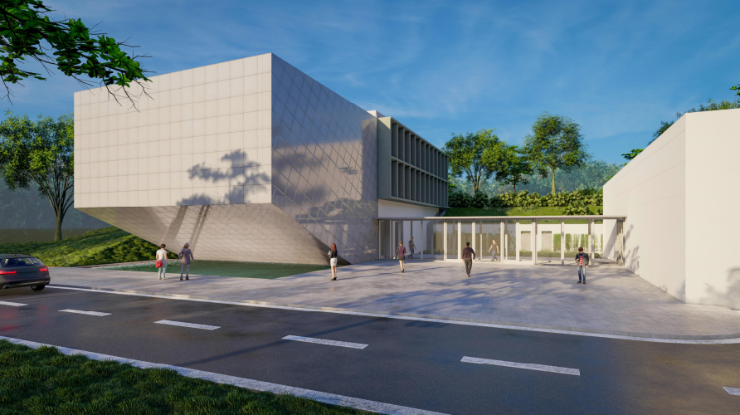
Figure 4 Visualiation of the Logistics Research Centre (Project documentation)
Our research objectives are summarised in the table below.
Development area | Development period
Development area | Within 1 year |  | Between 1-3 years | Over 3 years
Institutional laboratory infrastructure development | Integration of tracking technologies (RFID/barcode readers, etc.)
Institutional laboratory infrastructure development | Continuous update of simulation frameworks (Plant Simulation, PTV VISSIM/VISUM, ArtiosCAD, Visual Components)  Development of sample systems (TDK, thesis, PhD thesis, company assignment)
Institutional human resources development | Employment of 1 additional researcher (task: laboratory operation, industrial research tasks)
Institutional human resources development | Training of teachers, researchers on the software and technologies to be used
Science and innovation park project | Review and update of the concept | Implementation of the investment |  |  | Operation of a research centre
Table 2 Developing research activities

Summary
This paper has briefly summarised the teaching and research portfolio of the University of Miskolc, Institute of Logistics, and its plans for future developments. The realization of these development plans is particularly timely, as digitalization technologies provide new opportunities for the design, development and optimization of customized processes. The production of customized products and the provision of services to meet customer needs significantly increases the complexity of processes. In essence, this induces the need for new logistics training and research activities.

ACKNOWLEDGEMENTS
„The project No. 2019-2.1.11-TÉT-2020-00193 was realized with the support provided by the Ministry of Innovation and Technology from the National Research Development and Innovation Fund, financed by the 2019-2.1.11-TÉT tender program." „Program financed from the NRDI Fund”

References
[1] Dobos, P.; Cservenák, Á.; Skapinyecz, R.; Illés, B.; Tamás, P.: Development of an Industry 4.0-Based Analytical Method for the Value Stream Centered Optimization of Demand-Driven Warehousing Systems, SUSTAINABILITY 13(21), 2021, 33 p.
[2] Bányai, T., Bányainé, T. Á., Illés, B., Tamás, P.: Ipar 4.0 és logisztika. Miskolci Egyetem (2019), 160 p., ISBN: 9789633581827
[3] Matyi H., Veres P., Banyai T., D. Vasily, Tamas P.: Digitalization in industry 4.0: the role of mobile devices, JOURNAL OF PRODUCTION ENGINEERING 23 : 1 pp. 75-78., 4 p. 2020
[4] https://www.uni-miskolc.hu/kompetenciak (download: 22.06.2023)
[5] http://geik.uni-miskolc.hu/intezetek/LOG/umitwinn (download: 22.06.2023)
[6] https://www.ilm.ovgu.de/ProdLog.html (download: 22.06.2023)

