**11ND INTERNATIONAL CONFERENCE OF MECHANICAL ENGINEERING COMEC 2023**

**Corrosion-resistant steels and nickel alloys: a brief overview and our own research experience**

***Aceros resistentes a la corrosión y aleaciones de níquel: una breve descripción y nuestra propia experiencia en investigación***

**Arkady Zhilyakov 1, Alejandro Duffus Scott 2, Arselio Hernandes Fereira2, Eduardo Valencia Morales2, Boris Potekhin3, Sergey Belikov1**

1- Arkady Zhilyakov, Sergey Belikov. Ural Federal University, Russia. E-mail: a.y.zhilyakov@urfu.ru

2- Alejandro Duffus Scott, Arselio Hernandes Fereira, Valencia. The "Marta Abreu" Central University of Las Villas, Cuba. E-mail: [aduffus@uclv.edu.cu](mailto:aduffus@uclv.edu.cu)

3- Arselio Hernandes Fereira. The "Marta Abreu" Central University of Las Villas, Cuba. E-mail: archdez@ucf.edu.cu

4- Eduardo Valencia Morales. The "Marta Abreu" Central University of Las Villas, Cuba. E-mail: valencia@uclv.edu.cu

5- Boris Potekhin. Ural State Forest Engineering University. E-mail: pba-nn@yandex.ru

6- Sergey Belikov. Ural Federal University, Russia. E-mail: s.v.belikov@urfu.ru

**Abstract:** (The abstract must be structured and must not exceed 250 words in length).

* **Problem to deal with:** The paper presents an overview of modern corrosion steels, the main producing countries, consumption by industry. The main trends in improving the complex of properties of corrosion-resistant steels are also considered.
* **Aims:** The purpose of the work is to develop a concept for controlling the structure of corrosion-resistant steels and alloys in order to obtain the optimal combination of corrosion resistance and structural strength.
* **Methodology:** The work uses traditional metal-physical research methods implemented on modern equipment..
* **Results and Discussion:** The paper describes the main scientific results of the laboratory of heat-resistant and corrosion-resistant alloys based on nickel and iron of the Ural Federal University.
* **Conclusions:** Based on this review the potential for controlling the structural-phase state of corrosion-resistant steels and alloys in order to increase their corrosion resistance and structural strength was shown.

***Abstract:*** • Problema a tratar: El artículo presenta una visión general de los aceros de corrosión modernos, los principales países productores y el consumo por industria. También se consideran las principales tendencias en la mejora del complejo de propiedades de los aceros resistentes a la corrosión.

• Objetivos: El objetivo del trabajo es desarrollar un concepto para controlar la estructura de aceros y aleaciones resistentes a la corrosión con el fin de obtener la combinación óptima de resistencia a la corrosión y resistencia estructural.

• Metodología: El trabajo utiliza métodos tradicionales de investigación metal-física implementados en equipos modernos.

• Resultados y discusión: El artículo describe los principales resultados científicos del laboratorio de aleaciones resistentes al calor y a la corrosión a base de níquel y hierro de la Universidad Federal de los Urales.

• Conclusiones: Con base en esta revisión, se demostró el potencial para controlar el estado de la fase estructural de aceros y aleaciones resistentes a la corrosión para aumentar su resistencia a la corrosión y su resistencia estructural..

**Keyswords:** Corrosion; Deformation and heat treatment; Corrosion-resistant steels; Additive technologies; Crystal structure defects.

***Palabras Claves:*** Corrosión; Deformación y tratamiento térmico; Aceros resistentes a la corrosión; Tecnologías aditivas; Defectos de la estructura cristalina.

**1. Introduction**

The processes of corrosion behavior of metals and alloys in various environments are described in some detail in a number of classical monographs [1, 2]. This generalization and the creation of a solid theoretical base was facilitated by a large amount of experimental data accumulated over the years of research in this area. Currently, there are new results of research devoted to this problem. In general, they do not contradict classical works and often have an applied character. A major class of construction materials for use in different oxidizing environments are various corrosion-resistant steel. Сorrosion-resistant steels are the main class of structural materials for operation in various environments. While the iron-chromium system is the basis, modern stainless steels also contain a range of alloying elements that improve the specific properties of the material. For example, molybdenum increases resistance to pitting corrosion, nickel stabilizes austenite. In corrosion-resistant steels, three main types of microstructure are possible: ferritic, austenitic, and martensitic. These microstructures can be obtained by appropriate control of the chemical composition. Depending on the type of steel microstructure, the following classes are divided: 1) ferritic corrosion-resistant steels; 2) austenitic corrosion-resistant steels; 3) martensitic corrosion-resistant steels; 4) two-phase (austenitic-ferritic) corrosion-resistant steels; 5) precipitation hardening corrosion-resistant steels; 6) Mn-N replaceable corrosion resistant steels. According to the classification of the American Iron & Steel Institute, the main brands are indicated by a three-digit number with "2", "3" or "4" in the first position. Steels of the 300th series are chromium-nickel. They are used in the food, medical industry (for example, steel AISI-304, AISI-316), oil and gas, gas industry, shipbuilding (AISI-316, AISI-316T). The 200th series are chromium-manganese steels that are used for the production of dishes, cutlery, tanks, food industry equipment, consumer goods (for example, AISI-201). Chromium steels of the 400th series (for example, AISI-430) are used in the oil and gas industry, and as a decorative material for finishing buildings and premises. The use of duplex austenitic-ferritic steels is limited to areas such as pressure vessels, tanks, bridge structures, pool frames. Steels of different classes have, respectively, different properties. These properties have been studied for a long time, and the results are detailed in the literature [1–4]. Approximately half of the world's consumption of stainless steels is in various sectors of the engineering industry (Figure 1), where they are used as high performance structural materials. Corrosion-resistant steel is primarily used for those parts of industrial equipment and machines for which corrosion resistance is especially important, including at high temperatures. In particular, the chemical and pharmaceutical industries that work with aggressive media: acids, alkalis, etc. Corrosion-resistant steel is used for the manufacture of containers operating under high pressure, process pipelines, production and measuring equipment and tools. Corrosion-resistant pipes are used in offshore oil and gas production, as well as in the extraction of sour oil or natural gas with a high content of hydrogen sulfide from the depths. Corrosion-resistant steel is widely used in the food industry, where not only equipment, but also tanks and containers are made from it. Nickel-chromium steels are used in the form of forgings, long products and sheets, hot-rolled pipes, shaped profiles and castings in aviation and nuclear engineering, in the chemical industry and energy, as well as in other very diverse fields of technology. [5].

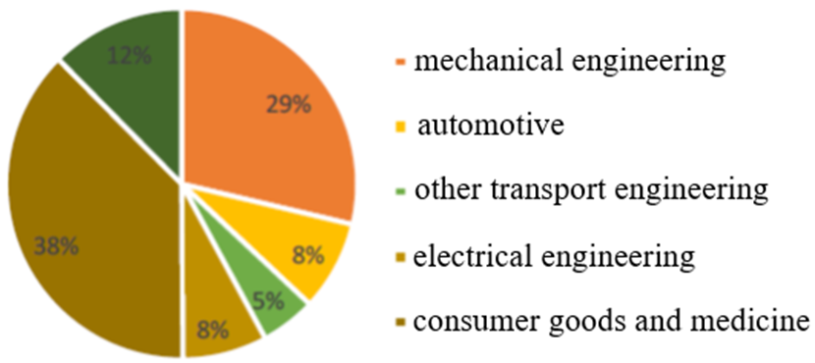

Source: ISSF.

Figure 1. Applications of stainless steel in 2020 [6]

Figure 2 shows data on the production of corrosion-resistant steels in 2010-2021. As you can see, this figure is steadily growing. Asia, a rapidly growing economy, accounts for most of the world's stainless-steel production. Among Asian countries, China has a particularly large production of stainless steels (Figure 3).

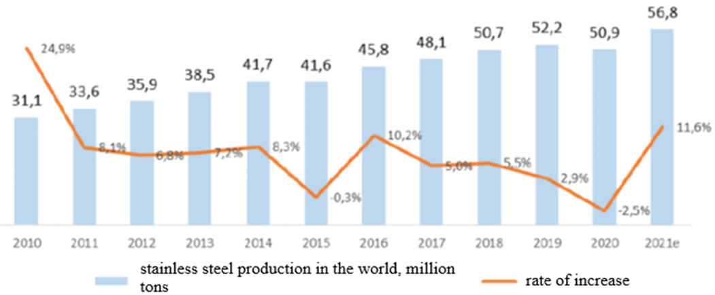

Source: International Stainless-Steel Forum (ISSF), MEPS.

Figure 2. World production of stainless steel [6]

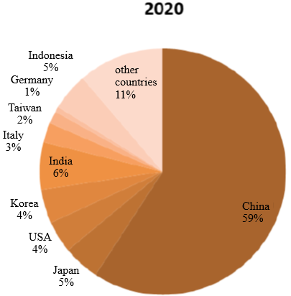

Source: International Stainless-Steel Forum (ISSF), MEPS.

Figure 3. Shares of the largest stainless steel-producing countries in world steelmaking [6]

Despite the wide range, large volume of products produced and the variety of properties of corrosion-resistant steels, their scope is usually limited to dilute solutions of salts, acids and alkalis, the operating temperature rarely exceeds 250 °C. For more aggressive environments and high temperatures, superalloyed iron-nickel alloys have been developed [7]. The main alloying components of these alloys are chromium and molybdenum. In oxygen-containing media, chromium ensures the formation of a protective oxide film, and in oxygen-free media, it prevents the formation of embrittling intermetallic compounds such as Ni3Mo, Ni4Mo. Molybdenum is the most effective element that increases the corrosion potential of the alloy in such aggressive ones as molten chlorides, fluorides, etc. [8]. Therefore, alloys of the Ni-Cr-Mo and Fe-Ni-Cr-Mo systems have been selected mainly for work in aggressive environments at temperatures above 550 С. The corrosive behavior of alloys under these conditions is described in a sufficient number of works, for example [8-15]. Basically, they discuss the effect of the chemical composition on the corrosion rate and the sequence in which different components emerge from the alloy. From this point of view, chromium turns out to be the least stable, which is consistent with the data [8, 15]. However, in these works, practically no attention is paid to the influence of structural factors: phase composition, morphology of precipitates of second phases, density of defects, nature of their distribution, texture, grain size, grain boundaries, their type and distribution - on the corrosion behavior of alloys. At the same time, there is evidence of a significant potential for increasing the corrosion resistance of steels and alloys by controlling their structural-phase state. It is known that the formation of second phases leads to a depletion of the solid solution in alloying elements, which reduces the corrosion potential of the alloy and increases the corrosion rate [16-19]. It should be noted that we are talking mainly about the precipitation of the second phases along the boundaries. At the same time, there are works on the positive effect of intermetallic compounds on the corrosion resistance of steels and alloys [20, 21].

In addition to the phase composition, the structural state of the alloys also affects the corrosion resistance. It is known [22] that defects in the crystal structure increase the diffusion mobility of atoms in alloys, which leads to a change, including the corrosion behavior of alloys.

Basically [1] it was noted the negative effect of defects on the corrosion resistance of metals. For example, in [23] it is noted that for corrosion-resistant steels, the density of dislocations is a determining factor for a tendency to pitting. According to [2], a decrease in the grain size should lead to an increase in the corrosion resistance of the alloys. This is confirmed by studies [24, 25], however, in [26], an absolutely opposite effect was recorded: an increase in the grain size reduces the tendency of the alloy to intergranular corrosion, and the authors also note the positive effect of a large number of twin boundaries. In this aspect, it is interesting to study the influence of the boundary energy on the corrosion behavior of alloys. The works [27-29] noted the positive influence of special boundaries of the Σ3 type and other Σ≤29 both on the resistance to pitting, and to intergranular corrosion and intergranular stress cracking. The work [30] similarly indicates a lower tendency to telluric embrittlement of nickel samples, where a larger number of boundaries of the Σ3 type have formed. In some works [31, 32], the authors draw attention to the fact that the jagged structure of grain boundaries is even better from the point of view of corrosion resistance of alloys.

Approaches to managing the type of grain boundaries or "boundary engineering" are given in the works [33, 34]. Basically, it is proposed to carry out deformation-heat treatment with parameters at which the alloy does not recrystallize. It is recommended to select small degrees of cold plastic deformation followed by prolonged annealing at temperatures below the recrystallization temperature. The authors of the work [35] gave a physical description of the processes of formation of special boundaries during thermomechanical processing of alloys with a face-centered cubic lattice. Another aspect that should be considered within the framework of the possibility of increasing the corrosion resistance of alloys is the control of their texture. In works [36, 37] it is shown the effect of surface texture on the tendency to intergranular cracking of ferrite- pearlitic pipe steel and pitting of austenitic corrosion-resistant steel of type 316L. In the latter case, the orientations {111} and {100} have a positive effect. The authors of [38] note that an increase in the degree of reduction during cold rolling increases the proportion of grain boundaries of the Σ3 type due to the formation of crystal planes {110} and {111} on the surface of the samples. That is, texture control is also carried out by deformation and heat treatments. Also, here it is possible to realize the potential of additive technologies. For example, in [39] it is shown that by changing the strategy of building the sample during selective laser melting, it is possible to control the texture of the alloy. Thus, to provide favorable orientations of crystallites from the point of view of corrosion resistance and physical and mechanical properties. But at the same time, one should not forget about the features of the samples obtained by 3D printing: non-fading, high porosity, excess phases, boundaries of melt baths, etc. All these defects lead to a deterioration in the corrosion resistance of the samples in comparison with the samples obtained by traditional metallurgical technology, as shown for the example of steel 316L [40]. In this case, recrystallization annealing made it possible to improve the corrosion resistance of SLM steel 316L due to the homogeneity of the structure and a thicker passive film.

**2. Methodology**

In this section, we provide a list of equipment and the main research methods that the laboratory team uses to study corrosion-resistant steels and alloys. In the field of structural studies and microanalysis of the obtained materials:

- transmission electron microscope JEM 2100 with Oxford Instruments Inca EnergyTEM 250 energy-dispersive X-ray analysis system;

- JEOL JSM-6490LV scanning electron microscope with Oxford Instruments Inca Energy 350 combined wave and energy dispersive X-ray spectral analysis system, as well as EBSD system;

- two-beam electron-ion scanning microscope Zeiss Auriga with Oxford Instruments Inca Energy 350 energy-dispersive X-ray spectral analysis system, as well as EBSD system;

- X-ray diffractometers Bruker D8 Advance, equipped with a texture attachment, position-sensitive detector, AntonPaar HTK1200N temperature chamber for operation at temperatures up to 1200 ℃ in protective media and vacuum;

- optical light microscopes Olympus GX51, Nikon Epiphot 200, with image display on a computer screen and the ability to calculate the resulting structures using specialized programs such as SIAMS-700, NIS Basic.

In the field of determining the physical and mechanical characteristics of the materials obtained:

- device for synchronous thermal analysis STA 449 C Jupiter with the ability to determine thermophysical properties (heat capacity, enthalpies of transformations), temperature intervals of phase transitions and mass changes from room temperature to 1600 ℃;

- device for dynamic mechanical analysis DMA 242 C with the ability to determine the characteristics of the modulus of elasticity and internal friction and others in the temperature range from minus 170 to 600 ℃;

- laser flash device LFA 457 MicroFlash to determine the characteristics of thermal diffusivity and thermal conductivity in the temperature range from room temperature to 1100 ℃;

- Linseis L78VD1600C dilatometer for determining the coefficient of linear thermal expansion and plotting thermokinetic diagrams of transformations during heating and cooling (from room temperature to 1600 ℃, from minus 170 to 600 ℃);

- Instron 3382 testing machine for determining mechanical properties at room and elevated temperatures (up to 1200 ℃);

- universal electrodynamic test stand Instron CEAST.

There is an MBraunUnilab box in the corrosion test area.

In the area of material handling and sample preparation:

- sample preparation devices for transmission and scanning electron microscopy Struers TenuPol-5;

- press for hot fitting of samples Struers CitoPress;

- semi-automatic polishing and grinding machine Struers LaboPol;

- electroerosive automatic machine Ecocut;

- disk cutting machine ATM Diamond 220;

- electric oven with controlled atmosphere Naberterm 8/16 Mo;

- Installation of plasma-spark agglomeration of powder materials FCT Systeme HP D 25.

**3. Results and Discussion**

The scientific results of the laboratory team are presented in this section. Work on the study of phase and structural transformations, as well as the properties of corrosion-resistant alloys based on nickel and iron, was started by the project team at the end of the first decade of the 21st century. In [41, 42], the regularities of the formation of intermetallic phases in austenitic alloys of the Fe-Ni-Cr-Mo system, depending on the parameters of deformation and heat treatments, were established. Using modern metal-physical research methods it was determined that the main intermetallic phase in these alloys is the σ-phase. Orientation relationships between it and the austenitic matrix have been established. The development of these works was the study of the features of the formation of excess phases in highly alloyed austenitic nickel and iron-nickel alloys. The effect of preliminary cold plastic deformation (CPD) on the morphology of the precipitates of the σ-phase was established. A small degree of deformation (e = 0.1...0.4) does not have a significant effect on the morphology of the σ-phase at the beginning of precipitation: lamellar particles are formed along the grain boundaries; during long exposures, intragranular lamellar precipitates appear, which grow along the austenite (111) planes. A large degree of deformation (e = 0.5...1.22) increases the density of defects and, accordingly, the number of nuclei. This provides a reduction in the average particle size. This provides a reduction in the average particle size. Their equiaxed shape does not change upon annealing. A scheme of the morphology of the precipitation of the σ-phase in corrosion-resistant γ-alloys based on Fe and Ni is constructed depending on the degree of efficiency, temperature, and aging time (Figure 4) [43–46].

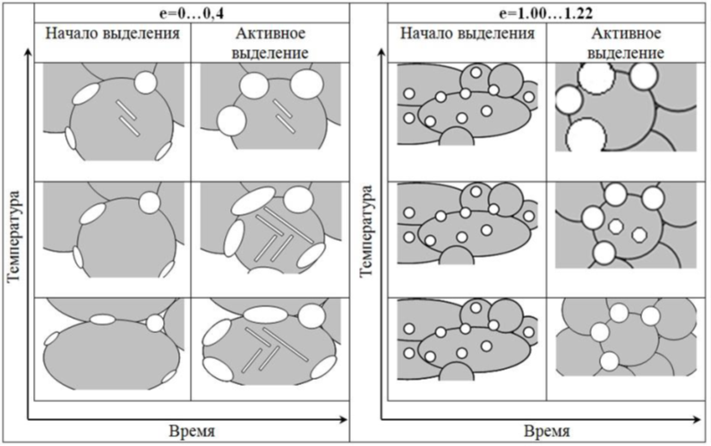

Figure 4. Change in the morphology of the σ-phase in austenitic alloys EK77 and G35 depending on the degree of CPD and annealing modes [41, 42]

Several works [47–50] are devoted to the study of the properties of such materials. On the example of the alloy VDM ® Alloy C-4, the prospects of using physical research methods to determine the temperatures of formation and destruction of both short-range and long-range orders in nickel-chromium-molybdenum alloys are shown. These methods are less expensive and more efficient than microstructural studies. The physical properties should be studied in a complex because their sensitivity to the appearance of short-range ordering differs and is not always sufficient. Formation of structures with short-range ordering affects the most strongly the elastic modulus, while degradation of the ordered structures is manifested well on the curves describing the heat capacity and on the dilatometric curves. Texture studies were also carried out [51]. Orientation microscopy (EBSD) was used to study the structural and textural states of a nickel-based alloy (Ni - Cr - Mo) after cold rolling and subsequent annealing. It is shown that a multicomponent rolling texture is formed during deformation. The special boundary Σ3 formed at the beginning of deformation is preserved during deformation as an energetically stable object. During recrystallization, a crystallographic texture is formed, the main components of which are associated with deformation orientations through special misorientations [52]. Several original experiments in the effect of iron-nickel alloy melting regimes on their phase-structural state in the solid state during subsequent heat treatment have been carried out. Using the EK77 alloy as an example, it has been established that a significant melt overheating above the liquidus temperature (by 305 ℃) during aging of the homogenized ingot increases the incubation period for the σ-phase formation. It has been determined that in an ingot smelted at a slight overheating above the liquidus temperature (by 43 ℃), an accelerated precipitation of the σ-phase occurs, the first portions of which gravitate towards the former interdendritic regions. This effect is leveled at the stage of precipitation growth. The degree of superheating of the liquid metal above the liquidus temperature strongly affects the austenite structure. In the case of a slight overheating of the melt above the liquidus temperature (by 43 ℃), austenite is tend to delamination during aging, and dislocations form flat accumulations. Increasing the superheat temperature to 305℃ reduces the tendency to delamination and leads to the formation of a polygonized structure at long exposure times [53]. It was also determined that the initial structure of the alloy before remelting determines its resistance to the separation of second phases after crystallization and homogenization. In the initially two-phase alloy, active precipitation of intermetallic compounds was recorded after aging at 900 ℃ for 5 hours. For the initially single-phase alloy, this time was 7.5 hours. Moreover, a high overheating over TLiq does not significantly increase the stability in the case of an initially two-phase state. [54]. Works on the influence of melt processing before crystallization of metals contribute to a deeper understanding of the relationship between the liquid and solid states of alloys, which is especially important in the development of selective laser melting and other additive manufacturing methods. The team also has research experience in this direction [55,56]. Using steel 316L as an example, the effect of selective laser melting on the kinetics of precipitation of the intermetallic phase was shown. It was found that with an increase in the energy density, the volume fraction of χ-phase precipitation increases. The volume fraction of χ -phase precipitation reached its maximum values in the SLM mode, which provides an energy density of 160 J/mm3 [57].

At the same time, work was carried out to study the corrosion resistance of nickel and iron-nickel alloys in various aggressive media at temperatures above 550 ℃ [58-70]. In particular, the influence of the morphology of second-phase precipitates on the corrosion resistance of alloys and their mechanical properties was studied [71, 65]. It was found that the formation of a fine-grained structure with dispersed equiaxed precipitates of the σ-phase, uniformly distributed over the volume of the y-solid solution along the boundaries of recrystallized austenite grains (Figure 7), ensures a decrease in the corrosion rate of the Hastelloy® G-35® alloy in the KCl-AlCl3 melt during 100 hours at 550℃ compared with single-phase state by 2 times from 0.53 to 0.26 mm/year. Such a phase-structural state of the alloy also provides an increase in strength properties by 30% (YS = 598 MPa, UTS = 964 MPa) relative to that declared by the manufacturer (YS = 348 MPa, UTS = 745 MPa) while maintaining the overall elongation at the level of 33%. In this case, the main hardening mechanism is the grain boundary [68].

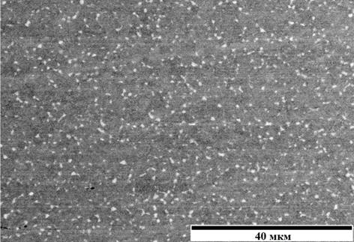

Figure 1. Microstructure of Hastelloy® G-35® after CPD (e = 1.0) and subsequent annealing (1000℃, 30 min).

**4. Conclusions**

This review of the literature and our own scientific results shows the potential for controlling the structural-phase state of corrosion-resistant steels and alloys in order to increase their corrosion resistance and structural strength.

However, there are also obvious problems that need to be solved for the successful realization of this potential:

1. There is no systematic analysis of the influence of structural factors on the corrosion behavior of alloys: information is heterogeneous and not structured;

2. In general, research is focused on considering one of the factors, without studying their mutual influence and joint effect on the properties of alloys;

3. There are practically no data on the stability of a particular structural-phase state at elevated (above 500 С) temperatures.

In accordance with this, it is planned:

1. To systematize a large amount of accumulated experimental data and develop on the basis of this physical models of the influence of both individual structural factors on the corrosion behavior of alloys, and their combined effect.

2. On the basis of the proposed models, develop a strategy for obtaining the required structural-phase state that provides an optimal combination of corrosion resistance and structural strength of alloys.

3. To develop specific modes of manufacture and deformation and heat treatment of alloys to obtain the best structural- phase state from the point of view of a set of properties

**5. Bibliographic references**

1. Himmushin, F.F. Stainless steels: textbook / F.F. Himmushin. M .: metallurgy, 1967, 798 p.
2. Rosenfeld, I.L. Corrosion and protection of metals / I.L. Rosenfeld. - M .: metallurgy, 1969, 448 p.
3. D. Peckner, I.M. Bernstein (Eds.) / Handbook of Stainless Steels, McGraw-Hill Inc., 1977
4. J. Beddoes, J.G. Parr / Introduction to Stainless Steels, 3rd edition, ASM International, Materials Park, OH, USA, 1999
5. K.H. Lo, C.H. Shek, J.K.L. Lai Recent developments in stainless steels // Materials Science and Engineering R 65 (2009) 39–104
6. https://dcenter.hse.ru/data/2022/02/13/1748371511/%D0%A0%D1%8B%D0%BD%D0%BE%D0%BA_%D0%BD%D0%B5%D1%80%D0%B6%D0%B0%D0%B2%D0%B5%D1%8E%D1%89%D0%B5%D0%B3%D0%BE_%D0%BC%D0%B5%D1%82%D0%B0%D0%BB%D0%BB%D0%BE%D0%BF%D1%80%D0%BE%D0%BA%D0%B0%D1%82%D0%B0-2021.pdf
7. ASM Handbook, Volume 13B, Corrosion: Materials.
8. Kochergin, V.P. High-temperature corrosion of transition metals in ionic melts / V.P. Kochergin // Sorovsk educational journal, 1997, No. 8. P. 60-65.
9. Tomashov, N.D. Corrosion of metals in molten salts / N.D. Tomashov, N.I. Tugarinov // Protection and corrosion of steels: collection of articles / ed. N. D. Tomashova. M .: MASHGIZ, 1959 .-- S. 89-109.
10. Interaction of metallic chromium with molten sodium and potassium chlorides and their equimolar mixture / N.A. Krasilnikova, M.V. Smirnov, I.N. Ozerianaya // Proceedings of the Institute of Electrochemistry Ural. Phil. USSR Academy of Sciences: Electrochemistry of molten salt and solid electrolytes. Issue 18. Sverdlovsk, 1972.S. 119-121.
11. Peculiarities of metal corrosion in molten halides and carbonates / IN. Ozerianaya et al. // High-temperature corrosion and methods of protection against it: collection of articles. Moscow: Nauka, 1973.S. 76-83.
12. F.-Y. Ouyang, C.-H. Chang, B.-C. You, T.-K. Yeh, J.-J. Kai. Effect of Moisture on Corrosion of Ni-based Alloys in Molten Alkali Fluoride FLiNaK Salt Environments, Journal of Nuclear Materials. 2013. № 437. pp. 201-207.
13. S.-H. Cho, S.-B. Park, J.-H. Lee, J.-M. Hur, H.-S. Lee. Cyclic Corrosion Behavior of Ni-Based Superalloys in Hot Lithium Molten Salt. Oxid Met. 2012. № 78, pp. 153-165.
14. M. Liu, J. Zheng, Y. Lu, Z. Li, Y. Zou, X. Yu, X. Zhou. Investigation on Corrosion Behavior of Ni-based Alloys in Molten Fluoride Salt Using Synchrotron Radiation Techniques. Journal of Nuclear Materials, 2013, № 440, pp. 124-128.
15. Surenkov A.I., Ignatiev V.V., Abalin S.S., Konakov S.A., Uglov V.S. Corrosion and mechanical resistance of nickel alloys in molten salt nuclear reactors. Atomic Energy. T. 124, no. 1, January 2018, p. 34-39
16. Tawancy, H.M. Long-term Ageing Characteristics of some Commercial Nickel-Chromium-Molybdenum alloys / H.M. Tawancy // Journal of Materials Science. 1981. №16, pp. 2883-2889.
17. A. Kriaa, N. Hamdi, H. Sidhom. Assessment of Intergranular Corrosion of Heat Treated Austenitic Stainless Steel (AISI 316L Grade) by Electron Microscopy and Electrochemical Tests. Protection of Metals. 2008. Vol. 44, № 5, pp. 506-513.
18. Jang, A.Y. Influence of Sigma Phase on Pitting Resistance Depending on Solidification Mode in AISI 316L Weld Metal / A.Y. Jang and H.W. LEE // Metallurgical and Materials Transactions A. 2012. Vol. 43A, pp. 1736-1741.
19. M. Prohaska, G. Mori, R. Grill, G. Tischler and S. Mitsche. Investigations on susceptibility to intergranular corrosion of thermo-mechanically rolled corrosion-resistant materials 316L and Alloy 825 Materials and Corrosion 2013, 64, No. 4 290¬299.
20. Lua X.-C., Li S., Jiang X. Effects of о-phase in stainless steels on corrosive wear behavior in sulfuric acid // Wear 2001. V.251. P.1234-1238
21. Belikov S.V., Abramov A.V., Polovov I.B. et al. Reserves for increasing the strength and corrosion resistance of industrial Ni - Cr - Mo alloys in high-temperature ionic liquids due to the creation of an austenitic-intermetallic structure. heat treatment of metals, 2019 No. 12 (774), p. 53 ... 59
22. Novikov I.I. Theory of heat treatment of metals: textbook / I.I. Novikov. Moscow: Metallurgy, 1986.392 p.
23. Peguet L., Malki B., Baroux B.. Influence of cold working on the pitting corrosion resistance of stainless steels Corrosion Science 49 (2007) 1933-1948.
24. Chuvildeev V.N., Melekhin N.V., Nokhrin A.V., Lopatin Yu.G., Kozlova N.A., Piskunov A.V., Stepanov S.P., Chegurov M.K., Boldin M.S. On the possibility of simultaneous increase in strength and corrosion resistance in nano - and microcrystalline titanium alloys. Modern problems of science and education. - 2012. - No. 6; URL: www.science-education.ru/106-7930.
25. Tekin K.C., Malayoglu U. Assessing the Tribocorrosion Performance of Three Different Nickel-Based Superalloys. Tribol Lett. 2010. № 37. pp. 563-572.
26. Li S.-X., He Y.-N., Yu S.-R., Zhang P.-Y. Evaluation of the Effect of Grain Size on Chromium Carbide Precipitation and Intergranular Corrosion of 316L Stainless Steel. Corrosion Science. 2013. № 66, pp. 211-216.
27. Pradhan S.K., Bhuyan P., Mandal S. Influence of the individual microstructural features on pitting corrosion in type 304 austenitic stainless steel Corrosion Science 158 (2019) 108091
28. Marrow T.J., Babout L., Jivkov A.P., Wood P., Engelberg D., Stevens N., Withers P.J., Newman R.C. Three dimensional observations and modelling of intergranular stress corrosion cracking in austenitic stainless steel. Journal of Nuclear Materials 352 (2006) 62-74
29. Tan L., Sridharan K., Allen T.R., Nanstad R.K., McClintock D.A. Microstructure tailoring for property improvements by grain boundary engineering Journal of Nuclear Materials 374 (2008) 270-280
30. Wang C. Y., Han H., Wickramaratne D., Zhang W., Wang H., Ye X. X., Guo Y. L., Shao K. and Huai P. Diffusion of tellurium at nickel grain boundaries: a first-principles study. RSC Adv., 2017, 7, 8421-8428
31. Bhuyan P., Reddy K.V., Pradhan S.K., Snehanshu Pal, Mitra R., Mandal S. A potential insight into the serration behaviour of Σ3n (n<=3) boundaries in Alloy 617 Materials Chemistry and Physics 248 (2020) 122919
32. Kim H.P., Choi M.J., Kim S.W., Kim D.J., Lim Y.S., Hwang S.S. Effects of grain boundary morphologies on stress corrosion cracking of alloy 600. Arch. Metall. Mater. 62 (2017), 2B, 1415-1419
33. Shimada M., Kokawa H., Wang Z.J., Sato Y.S., Karibe I. Optimization of grain boundary character distribution for intergranular corrosion resistant 304 stainless steel by twininduced grain boundary engineering Acta Materialia 50 (2002) 2331-2341
34. Kaithwas C.K., Bhuyan P., Mandal S. Assessing the potential of sparsely nucleated recrystallized grains to lead grain boundary engineering during extending annealing in Alloy 600H. Materials Characterization 168 (2020) 110538
35. Kumar M., Schwartz A.J, King W.E. Microstructural evolution during grain boundary engineering of low to medium stacking fault energy fcc materials. Acta Materialia 50 (2002) 2599-2612
36. Arafin M.A., Szpunar J.A. A new understanding of intergranular stress corrosion cracking resistance of pipeline steel through grain boundary character and crystallographic texture studies. Corrosion Science 51 (2009) 119-128
37. Shahryari A., Szpunar J.A., Omanovic S. The influence of crystallographic orientation distribution on 316LVM stainless steel pitting behavior. Corrosion Science 51 (2009) 677-682
38. Zhang L., Szpunar J.A., Basu R., Dong J., Zhang M. Influence of cold deformation on the corrosion behavior of Ni-Fe-Cr alloy 028. Journal of Alloys and Compounds 616 (2014) 235-242
39. Du D., Dong A., Shu D., Zhu G., Sun B., Lic X., Enrique Lavernia. Influence of build orientation on microstructure, mechanical and corrosion behavior of Inconel 718 processed by selective laser melting. Materials Science & Engineering A 760 (2019) 469-480
40. Kong D., Ni X., Dong C., Zhang L., Man C., Yao J., Xiao K., Li X. Heat treatment effect on the microstructure and corrosion behavior of 316L stainless steel fabricated by selective laser melting for proton exchange membrane fuel cells. Electrochimica Acta 276 (2018) 293-303
41. Popov, A.A., Bannikova, A.S., Belikov, S.V. Precipitation of the sigma phase in high-alloy austenitic chromium-nickel- molybdenum alloys // Physics of Metals and Metallography Volume 108, Issue 6, December 2009, Pages 586-592
42. Bannikova A.S., Belikov S.V., Karabanalov M.S., Popov A.A., Zhilyakov A.Yu. Precipitation of the sigma phase in austenitic alloys Fe-30Cr-30Ni-3Mo // Collection of materials of the XX Ural school of thermometallurgists "Actual problems of physical metallurgy of steels and alloys", dedicated to the 100th anniversary of the birth of N.N. Lipchina February 1 - 5, 2010. Yekaterinburg: Publishing house USTU - UPI, 2010. p. 145 [in Russian]
43. P. V. Pulnikov, A. V. Abramov, R. V. Kamalov, and A. Yu. Study of the precipitation of the second phases in the Hastelloy G35 alloy // Collection of scientific papers of the XIV International scientific and technical Ural school-seminar of metallurgists - young scientists, Yekaterinburg, November 11-15, 2013. Yekaterinburg: UrFU. , 2013. p. 118 [in Russian]
44. Belikov S.V., Zhilyakov A.Y., Popov A.A., Karabanalov M.S., Polovov I.B. Special Features of Formation of Excess Phases During Aging of Corrosion-Resistant High-Alloy Austenitic Alloys Based on Fe And Ni // Metal Science and Heat Treatment, Vol. 56, Nos. Nos. 11 - 12, March, 2015, pp. 637...645
45. Khalilov A.E., Gibadullina A.F., Belikov S.V., Zhilyakov A.Yu. Investigation of the precipitation of the second phases in C4 and KhN65MVU alloys // Ural School of Young Metallurgists: Proceedings of the XVIII International Scientific and Technical Ural School-Seminar of Metallurgists - Young Scientists. Yekaterinburg, November 21-23, 2017 - Yekaterinburg: UrFU, 2017. 419...422 p. [in Russian]
46. Popov N.A., Lugovaya K.I., Zhilyakov A.Y. Features of the Formation of Structure and Phases in Single-Crystal High- Temperature Alloys and Their Effect on Mechanical Properties // Materials Science Forum, 2019, Vol. 946, pp 145...149
47. Ilikbaev I.V., Shvedov D.A., Belikov S.V., Zhilyakov A.Yu., Anomalies in the physical properties of corrosion-resistant alloys of the Ni-Cr-Mo system // Ural School of Young Metallurgists: Proceedings of the XVIII International Scientific and Technical Ural school-seminar of metallologists - young scientists. Yekaterinburg, November 21-23, 2017 - Yekaterinburg: UrFU, 2017. 423.425 p. [in Russian]
48. Ilikbaev I.V., Iskakova E.Yu., Yakimov N.S., Zhilyakov A.Yu. Determination of the transition temperature "short range order - disorder" in a nickel-chromium-molybdenum alloy // Collection of materials and reports of the XIX International scientific and technical Ural school-seminar of metallologists - young scientists. Yekaterinburg, November 19-23, 2018, 400. 402 p. [in Russian]
49. Zhilyakov A.Y., Belikov S.V., Polovov I.B., Gibadullina A.F., Elkina E.V. The heating rate influence on the elastic modulus temperature dependence of a corrosion-resistant nickel alloy // IOP Conf. Series: Materials Science and Engineering, 2019, Vol. 680, 012020
50. Zhilyakov A.Y., Belikov S.V., Gibadullina A.F., Polovov I.B., Ilikbaev I.V. Relation Between Short-Range and Long-Range Ordering and Physical Properties of Corrosion-Resistant Alloys of the Ni - Cr - Mo System // Metal Science and Heat Treatment vol. 61, pp. 792. 797(2020)
51. Zorina M.A., Karabanalov M.S., Terenya G.A., Zhilyakov A.Y. Structural and textural state of a corrosion-resistant super alloys Ni-Cr-Mo system after deformation // KnE Engineering, XIX International scientific-technical conference “The Ural school-seminar of metal scientists-young researchers”, 2019, pp. 281.287
52. Zorina M.A., Zhilyakov A.Yu. Karabanalov M.S. Crystallographic Textures of Strain and Recrystallization in a Superalloy of the Ni - Cr - Mo System // Metal Science and Heat Treatment vol. 62, pp. 469. 474(2020)
53. Zhilyakov A.Y., Popov A.A., Belikov S.V., Burmasov S.P., Gudov A.G., Al-Katavi A.A. A study of the effect of temperature modes of melting on the special features of structural and phase transformations in corrosion-resistant alloy ЁК77 under annealing and aging // Metal Science and Heat Treatment, Vol. 57, Nos. Nos. 7-8, November, 2015 pp. 32.38
54. Zhilyakov A.Y., Belikov S.V., Burmasov S.P., Gudov A.G.Phase Composition Influence on Melt Viscosity and Ingot Structure Formation Features in EK77 Alloy // Materials Science Forum Vol. 907, pp. 43.49. 2017
55. Loginov Yu.N., Belikov S.V., Stepanov S.I., Golodnov A.I., Gilev M.V. Plates for osteosynthesis as a product of 3d-printing additive technology // Foundry worker of Russia No. 4 2020 P. 32-35;
56. Loginov Yu.N., Stepanov S.I., Belikov S.V., Golodnov A.I., Mukanov G.Zh., Grekhov S.K. Additive technologies for cellular metal structures and elements of digitalization of their design // Foundry worker of Russia No. 8 2020 P. 33-34;
57. Kamantsev I.S., Loginov Yu.N., Belikov S.V., Stepanov S.I., Karabanalov M.S., Golodnov A.I. Features of the destruction of cellular structures obtained by laser selective alloying // Diagnostics, resource and mechanics of materials and structures. No. 4 2020 P. 35-47
58. D.S. Popkova, I.M. Ruslanov, A.Y. Zhilyakov, S.V. Belikov The effect of the selective laser melting mode on second phases precipitation in 316L steel during subsequent heat treatment // IOP Conf. Series: Materials Science and Engineering 1029 (2021) 012053
59. Abramov A.V., Karpov V.V., Zhilyakov A.Yu., Gibadullina A.F., Polovov I.B., Volkovich V.A., Belikov S.V., Shak A.V., Rebrin, O.I. Corrosion of Corrosion-Resistant and High-Temperature Nickel-Based Alloys in Chloroaluminate Melts // ECS Trans. 2014 volume 64, issue 4, 217.226;
60. Karpov V.V., Abramov A.V., Zhilyakov A.Yu., Belikov S.V., Volkovich V.A., Polovov I.B., Rebrin O.I. High-Temperature Corrosion of Metals in the Salt and Metallic Melts Containing Rare Earths // AIP Conference Proceedings: Physics, Technologies and Innovation (PTI-2016): Proceedings of the III International Young Researchers' Conference. 1767, 020011 (2016);
61. Polovov I.B., Abramov A.V., Karpov V.V., Gibadullina A.F., Zhilyakov A.Yu., Dedov K.V., Belikov S.V., Shak A.V., Volkovich V.A., Rebrin O.I. Corrosion of nickel-based superalloys in molten chloroaluminates // ECS Trans. 2017 volume 77, issue 11, 753.766;
62. Polovov I.B., Abramov A.V., Dedov K.V., Karpov V.V., Zhilyakov A.Yu., Gibadullina A.F., Belikov S.V., Volkovich V.A., Rebrin O.I. Corrosion of austenitic steels and their components in uranium-containing chloride melts // ECS Trans. 2017 volume 77, issue 11, 847.855;
63. Abramov A.V., Karpov V.V., Zhilyakov A.Yu., Belikov S.V., Volkovich V.A., Polovov I.B., Rebrin O.I. Corrosion resistance of nickel-based alloys in salt and metal melts containing REE // AIP Conference Proceedings: Physics, Technologies and Innovation (PTI-2017): Proceedings of the IV International Young Researchers' Conference. 1886, 020029 (2017);
64. Dedov K.V., Raguzina E.V., Abramov A.V., Kazakovtseva E.V., Zhilyakov A.Y., Polovov I.B., Volkovich V.A., Shak A.V., Nikitina E.V., Rebrin O.I. Corrosion behavior of EP-823 type steel in uranium containing chloride melts // AIP Conference Proceedings 2018, 020017 (2018)
65. Karpov V.A., Abramov A.V., Dedov K.V., Shak A.V., Zhilyakov A.Y., Polovov I.B., Belikov S.V., Rebrin O.I. Corrosion of Various Types of Stainless Steel in Chloroaluminate Melts // Russian Metallurgy (Metally), 2019, vol. 2019, 190...193
66. Polovov I.B., Gibadullina A.F., Alimgulov R.R., Karpov V.V., Abramov A.V., Zhilyakov A.Y., Khotinov V.A., Belikov S.V. The effect of microstructure on the corrosion resistance of VDM® alloy C-4 in molten salts // Journal of Alloys and Compounds, 2019, Vol. 810, 151758
67. Zhilyakov A.Yu., Belikov S.V., Polovov I.B., Gibadullina A.F., Elkina E.V. The heating rate influence on the elastic modulus temperature dependence of a corrosion-resistant nickel alloy // IOP Conf. Series: Materials Science and Engineering, 2019, Vol. 680, 012020
68. Zhilyakov A. Y., Belikov S.V., Abramov A.V., Polovov I.B., Popov A.A. Reserves of Elevation of Strength and Corrosion Resistance of Commercial Ni - Cr - Mo Alloys in High-Temperature Ionic Liquids Due to Creation of Austenitic-Intermetallic Structure // Metal Science and Heat Treatment vol. 61, pp. 798.803(2020)
69. Zhilyakov A.Y., Ilikbaev I.V., Belikov S.V., Gibadullina A.F., Polovov I.B. Relation Between Short-Range and Long-Range Ordering and Physical Properties of Corrosion-Resistant Alloys of the Ni - Cr - Mo System // Metal Science and Heat Treatment vol. 61, pp. 792.797(2020)
70. Polovov I.B., Abramov A.V., Alimgulov R.R., Zolotarev D.A., Trubcheninova A.I., Gibadullina A.F., Volkovich V.A., Zhilyakov A.Y., Khotinov V.A., Belikov S.V. Corrosion of Metallic Materials in the Molten FLiNaK // ECS Trans. 2020 volume 98, issue 10, pp. 453.462.
71. Alimgulov, R.R., Abramov A.V., Trubcheninova A.N., Polovov I.B., Zhilyakov A.Y., Belikov S.V., Rebrin O.I. Corrosion of Metallic Materials in 3LiCl-2KCl and (3LiCl-2KCl)-UCl3 // ECS Trans. 2020 volume 98, issue 10, pp. 307.315.