XI International Scientific Conference
on Mechanical Engineering
The eFusion technology as a part of solution for global challenges
La tecnología eFusion como parte de la solución a los problemas globales

Karol Horansky¹, Michal Cehlár², Stanislav Jacko³, Dagmar Cagáňová⁴

1- Ing. Karol Horansky, PhD., Technology cluster eFusion, The Faculty of Mining, Ecology, Process Control and Geotechnologies, Technical University in Kosice, Slovakia, karol.horansky@efusion.sk
2- Dr. h. c. prof. Ing. Michal Cehlár, PhD., The Faculty of Mining, Ecology, Process Control and Geotechnologies, Technical University in Kosice, Slovakia, michal.cehlar@tuke.sk
3- prof. Ing. Stanislav Jacko, PhD, The Faculty of Mining, Ecology, Process Control and Geotechnologies, Technical University in Kosice, Slovakia, stanislav.jacko@tuke.sk
4- prof. M.A. Dagmar CAGÁŇOVÁ, Ph.D., Faculty of Management, Comenius University in Bratislava, Slovakia, dagmar.caganova@fm.uniba.sk

Abstract: (The abstract must be structured and must not exceed 250 words in length).
- Problem to deal with: Climate change, lack of clean energy and materials together with environmental and social risk create the biggest communities’ challenges. Target to reach the climate neutral world by mid-century is adding additional constraints and challenge system even more. The one of the biggest impact and change will come from the energy transition up to 2050.
Problema a solucionar: El cambio climático, la falta de energía y materiales limpios, junto con el riesgo ambiental y social, crean los mayores desafíos de las comunidades. El objetivo de alcanzar un mundo climáticamente neutro para mediados de siglo está añadiendo restricciones adicionales y desafiando aún más el sistema. Uno de los mayores impactos y cambios vendrá de la transición energética hasta el 2050.
- Aims: The eFusion technology opens opportunities for the global use of geothermal energy as a clean source of cost-competitive, CO₂-free energy. The target system of the eFusion technology is the Enhanced Geothermal System (EGS), enabling to delivery energy at any point on Earth. The depth horizons required for EGS are economically and technologically unavailable for today’s conventional drilling technologies. The geothermal energy represents the fully manageable source of energy and can bring stability into the grid, what is not possible with other renewables sources.
Objetivos: La tecnología eFusion abre oportunidades para el uso global de la energía geotérmica como una fuente limpia de energía libre de CO2 y de coste competitivo. El sistema objeto de estudio de la tecnología eFusion es el Sistema Geotérmico Mejorado (SGM), que permite el suministro de energía en cualquier punto de la Tierra. Los horizontes de profundidad requeridos para el adecuado funcionamiento del SGM son, en la actualidad, económica y tecnológicamente inaccesibles para las tecnologías de perforación convencionales actuales. La energía geotérmica representa una fuente de energía totalmente gestionable y puede aportar estabilidad a la red, lo que no es posible con otras fuentes renovables.
- Methodology: The technical potential of hydrothermal geothermal resources is estimated at around 200 GWe and over 5 000 gigawatts thermal (GWth). The IPCC declare that geothermal energy can supply about 18% of the world’s electricity demand and meet the electricity needs of 17% of the world’s population. EGS based on eFusion technology allow to significantly extend potential share of clean, renewable, and fully manageable source of energy.
Metodología: El potencial técnico de los recursos geotérmicos hidrotermales se estima en alrededor de 200 GWe y más de 5.000 gigavatios térmicos (GWth). El IPCC declara que la energía geotérmica puede abastecer alrededor del 18% de la demanda eléctrica mundial y satisfacer las necesidades eléctricas del 17% de la población mundial. El SGM basado en la tecnología eFusion permite ampliar significativamente la proporción potencial de fuente de energía limpia, renovable y totalmente gestionable.
- Results and Discussion: The eFusion technology represents the one of breakthrough technology needed to achieve carbon neutrality by 2050, under the Paris Climate Agreement. Local sources of energy significantly decrease distribution energy losses and bring independent source of energy everywhere and allow significantly decrease our dependency on hydrocarbons.
Resultados y Discusión: Según el Acuerdo Climático de París, la tecnología eFusion representa una de las tecnologías innovadoras necesarias para lograr la neutralidad de carbono para 2050. Las fuentes de energía locales reducen significativamente las pérdidas de energía en la distribución y aportan fuentes de energía independientes a todas partes mientras que permiten disminuir significativamente nuestra dependencia de los hidrocarburos.
- Conclusions: The aim of the paper is to transform the acquired knowledge into the practice, and usable innovation potential is the basis of sustainable development, bringing forward the answers how to face the global societal challenges.
Conclusiones: El objetivo de este artículo es poner en práctica el conocimiento adquirido, y el dejar bien claro que el potencial de innovación utilizable es la base del desarrollo sostenible, presentando respuestas sobre cómo enfrentar los desafíos sociales globales.

Keyswords: eFusion; Clean Energy; Enhanced Geothermal System; Independent Source of Energy Everywhere, Power Grid Stability

Palabras Claves: eFusion; Energía limpia; Sistema Geotérmico Mejorado; Fuente de Energía Disponible en Todas Partes, Estabilidad de la Red Eléctrica

The biggest current global challenges are the climate change, lack of clean energy, lack of materials and together with environmental and social risk create the biggest communities’ imbalances, tensions and bring the world on unsustainable path.
The key problem of climate change today is its dynamics, which is more than 20 times higher than at any time in the history of the Earth and opens the question of the possibility and capabilities of the ecosystem to adapt to these changes. Energy has long been characterized by the share of up to 85% of primary energy consisting of hydrocarbons, while recent investments in renewable energy sources have been able to copy the global increase in energy consumption but have not been able to change the share of hydrocarbons in the total consumption of primary energy. Electricity makes up 20% of the total energy but produces up to 40% of the total CO₂ emissions, while the increase in electricity consumption is visible in all parts of the world. The composition of primary energy sources is as follows - 33% oil, 28% coal, 24% natural gas, 7% hydropower, 5% nuclear power and 3% renewable sources.
Data source: IPCC
Figure No. 1 Split of primary energy resource
The external manifestation of the combination of climate change and the unavailability of a clean source of energy without CO₂ emissions will be the reduction of food production, the inability of ecosystems to adapt, extreme weather events, droughts, floods, fundamental changes in temperatures, the social consequences of such changes will be the loss or freezing of money, the rapid growth of unemployment, the reduction of prime economy, stoppage of GDP growth, state bankruptcies, deterioration of accessibility and quality of public life such as education, healthcare, social sector and others.
As a political response to today's biggest global challenge, the signing of the Paris Climate Agreement of 2015 committed to limiting warming to 1.5 degrees by the end of this century, which requires reducing human-caused carbon dioxide emissions by 45% by 2030 and achieving carbon neutrality (the amount of carbon dioxide released into the atmosphere by humans should not exceed the amount that is pumped out of the atmosphere by itself or that disappears from it through natural processes). The solution to this political commitment is substantial investment in the areas of science and research with a focus on carbon-free technologies. However, the inertia of climate change and the necessary period of transition to these technologies will still cause serious global changes. Energy transition up to 2050 for rapid scenario for 1.5 degrees of Celsius is in figure No. 2.
Data source: IPCC
Figure No. 2 Fuel transition up to 2050 by rapid scenario.
The global energy demand continues to grow, at least for a period, driven by increasing prosperity and living standards in the emerging world. Significant inequalities in energy consumption and access to energy persist. The structure of energy demand is likely to change over time: declining role of fossil fuels, offset by an increasing share of renewable energy and a growing role for electricity. These changes underpin core beliefs about how the structure of energy demand may change. A transition to a lower carbon energy system is likely to lead to fundamental restructuring of the global energy system, with a more diverse energy mix, greater consumer choice, more localized energy markets, and increasing levels of integration and competition. These changes underpin core beliefs about how the global energy system may restructure in a low-carbon transition. Demand for oil falls over the next 30 years. The scale and pace of this decline is driven by the increasing efficiency and electrification of road transportation. The natural gas is more resilient than for oil, underpinned by the role of natural gas in supporting fast growing developing economies as they decarbonized and reduce their reliance on coal, and as a source of near-zero carbon energy when combined with carbon capture use and storage (CCUS). Renewable energy, led by wind and solar power, is the fastest growing source of energy over the next 30 years, supported by a significant increase in the development and investment in new wind and solar capacity. The importance of electricity in final energy consumption increases materially over the next 30 years.
In order to fulfill the commitments of the Paris Declaration and achieve zero CO₂ emissions in 2040 in Europe, a combination of several innovations and technologies is necessary in the economy, while it is expected that it will be a combination of solutions and carbon neutrality will be achieved from 44% by increasing efficiency, from 36% by renewable sources, 2% by fuel change, 6% by increasing the share of nuclear energy, 9% by new technologies for capturing and storing CO2 and 2% by other innovations, as shown in Figure No.3.
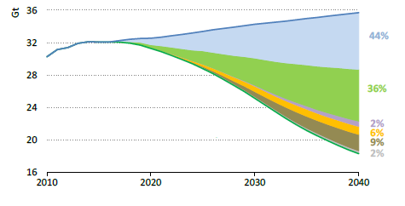
Data source: IEA
Figure No. 3 Reduction of CO2 emissions based on actions.
The part of path for reaching the efficiency will be based on electrification, digitalization, and advisors and analytics systems. Process electrification is the fastest way to reduce greenhouse gas emissions to meet the Paris Agreement and to achieve company commitments and pledges made via initiatives such as the RE100 or the Science Based Targets (SBTi). Therefore, it is anticipated that the number and size of electrical systems will need to increase to take over from traditional fossil fuels. With growing electrical systems is important to have a holistic approach by including the complete power system and distribution architecture. For the best results, a complete vertical approach is needed. Combining power distribution systems with process automation and power systems architectures has the potential to optimize CO2 reduction. The complete power system can be further optimized in terms of cost and reliability through modeling and simulation, with software that can optimize electricity power systems based on their digital twin equivalents. Through this type of end-to-end design, complex mission-critical power systems can be streamlined, and integration of renewables, microgrids, fuel cells, and battery storage technologies to the power grid can be improved and accelerated. The next phase of electrification is digitalization. With all those assets deployed it becomes important to connect the devices. IoT-enabled power management architectures with connected devices are the perfect choice for intelligent distribution systems. Equipped with smart sensors and 24/7 connectivity, real-time data analytics support effective decision making. This can aid the safety of both people and equipment, improve equipment reliability through predictive maintenance, simplify asset management through digital features, and enhance network security.
The IPCC defines three main scenarios for global CO2 reduction, “Rapid” scenario represents goal to limit global warming to well below 2 Celsius in compared to pre-industrial level, “Net Zero” represents goal to limit global warming to well below 1,5 degrees Celsius, compared to pre-industrial level and “Business-as-usual” scenario represents future patterns of activity which assumes that there will be no significant change in people's attitudes and priorities, or no major changes in technology, economics, or policies, so that normal circumstances can be expected to continue unchanged. The reduction of CO2 emissions, based on these scenarios is shown in Figure No. 4.
Figure No. 4 Reduction of CO2 emissions based on scenarios.
The main driver for CO2 reduction will be costs of energy and products. These costs will include the CO2 taxes, with different approaches based on countries development level. Nevertheless, the CO2 tax level of and the future dynamic of CO2 tax cost will lead to significant change in people's attitudes and priorities and will support new green technology deployment. The world is on an unsustainable path. A rapid and sustained fall in carbon emissions is likely to require a series of policy measures, led by a significant increase in carbon prices. These policies may need to be reinforced by shifts in societal behaviors and preferences. Delaying these policies measures and societal shifts may lead to significant economic costs and disruption.

Data source: IPCC

Figure No. 5 Average carbon prices and primary energy consumption by source.
The primary energy consumption by source expects significant growth of renewables mainly wind and solar with decreasing cost of investment into the solar and wind energy. The growth is expected in renewables like geothermal and biomass. The share of hydro in global power generation is broadly stable in all three scenarios at around 15%. Electricity demand grows robustly as the world continues to electrify.
Data source: IPCC

Figure No. 6 Renewable energy in power sector and CAPEX of wind and solar energy by scenarios.
The significant growth of solar and wind power which are representing not manageable source of energy, and this approach will bring a new technical task related to the grid stability, and will lead to innovation in energy storage, grid stability systems and grid interoperability. Current limits in energy storage systems based on the volume is described in Figure No. 7, will create the pressure for deployment of new manageable renewables. Renewables lead the transition to a lower-carbon energy mix. The energy transition requires significant levels of investment, with material shifts in the pattern of that investment across different energy sources. Rapid and Net Zero scenarios imply a significant increase in investment in wind and solar power capacity relative to the past. Hydrogen plays an increasing role as the world transitions to a low-carbon energy system CCUS and negative emission technologies will play a significant role. The storage of high energy capacity in long discharge time is possible only in Power-to-Gas systems where is possible to storage TWh capacity in discharge time more than 1 000 hours. Storage of energy in Power-to-Gas systems is working solution for energy, which can’t be use immediately in the grid and installed renewable capacity will be in this case reduce the output power, as just-in-time utilization is not possible. Energy efficiency conversion of electricity into the green hydrogen is not the issue, as otherwise we will lose the energy. In any other case is much more effective instead to produce green H2 to send clean energy directly into the power grid.
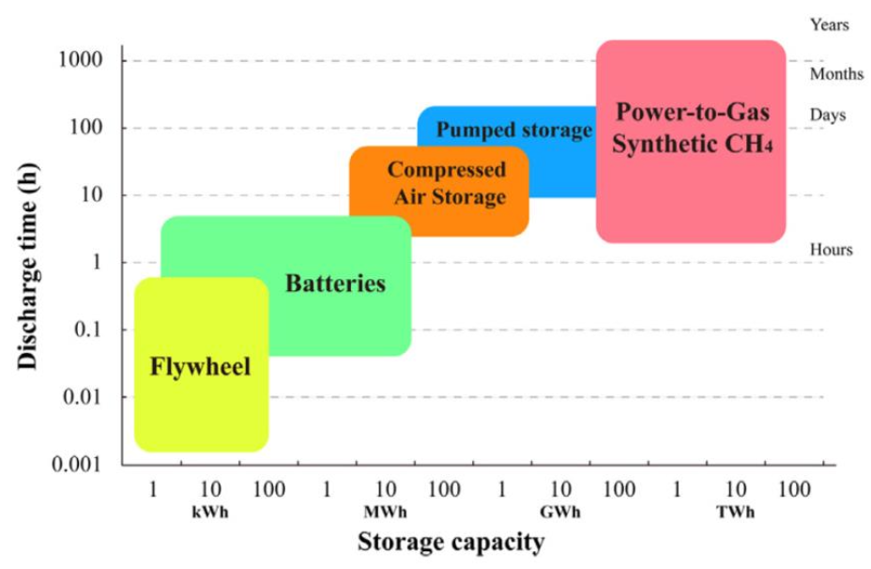
Data source: IEA

Figure No. 7 The Energy storage technologies.
The geothermal energy is unevenly heat stored in the Earth’s crust. Most high-temperature geothermal resources are linked with active volcanoes areas, concentrated around the Pacific Ring of Fire, the mid-Atlantic ridge, the East African Rift and in the southern parts of Europe. Geothermal energy competitively generated electricity at a LCOE of USD 0.068/kWh for new plants commissioned in 2021. The biggest advantage of geothermal energy is manageability of this kind of renewable energy source. Additional advantage of geothermal energy is that this kind of energy represent the local source of energy it means decreasing of grid energy losses, allows to utilize heat energy and electricity and represent independency on fuel import from abroad. Global geothermal energy utilization is displayed in figures No. 8, 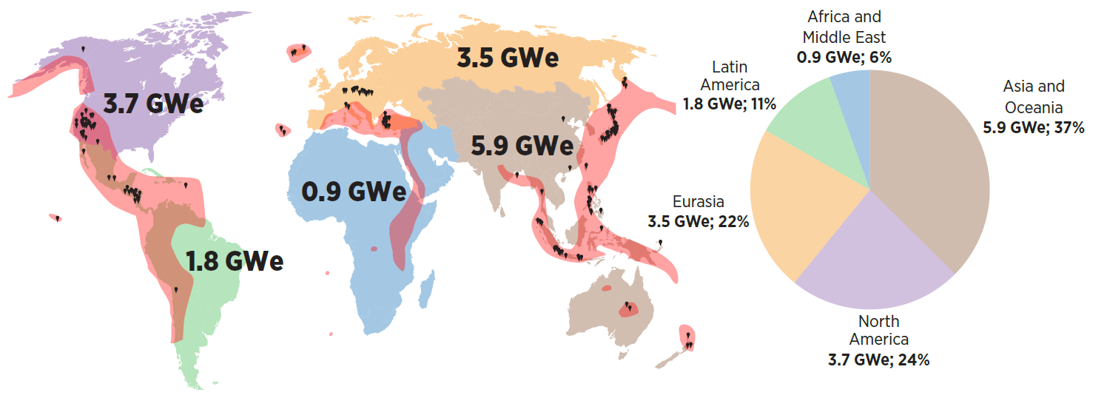
Data source: IRENA, 2023
Figure No. 8 Installed geothermal electricity capacity, by region, 2021.
and No. 9.
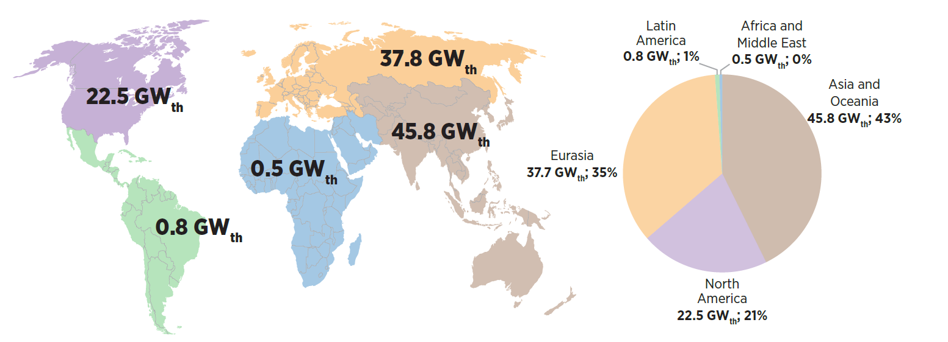
Data source: IRENA, 2023
Figure No. 9 Installed Geothermal heating and cooling installed capacity, by region, 2021.
The installed geothermal electricity capacity, heating and cooling installed capacity represent only 0,5 % share of total installed renewables capacity. The extremely low share of geothermal energy in renewable mix is coming from risks and costs related to underground geothermal field. Investor must invest 20% of CAPEX to reduce risk to level where project bankability occurs and still after this huge investment into the project, the project could be stopped due the findings coming from test drilling.
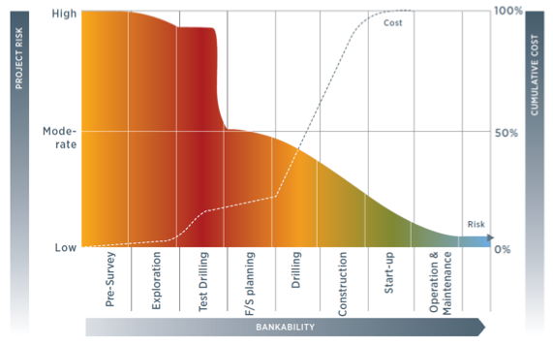
Data source: IRENA, 2023

Figure No. 10 Project risk and, Bankability and CAPEX development in geothermal project.
The growing of global geothermal energy utilization is depending on risk and costs reduction, related to underground part of geothermal power plant. This can be reached only by innovation, science and technology development in areas related to geothermal field identification and drilling technology. The geothermal share in global renewables represent main standard hydro-geothermal systems, not HDR.
The Faculty of Mining, Ecology, Process Control and Geotechnologies of Technical University in Kosice, Slovakia concentrates the development capacities of the research, production, supply, and engineering activities to ensure the efficient use of the Earth resources.
Primarily, the development is focused on the eFusion technology (new drilling technology), which is unique from a global perspective and is the result of the concentration of science and research capacities from 25 areas integrated into a functional unit.
The eFusion technology represents a contactless, cost-effective way to build deep wells unavailable for conventional drilling and bring economic and technical advantages listed below:
Economic advantages are reduction of mining construction costs by 55% in direct comparison with BAT on the market and reduction of mining construction time by 65% in direct comparison with BAT on the market.
Technical advantages
- Represents a contactless way to build deep wells unavailable for conventional drilling.
- Does not contain any rotating parts,
- Represents a compact/efficient concept enabling simple installation, maintenance, and operation to achieve top efficiency in the construction of mining works,
- Has no limits in terms of a diameter and directional control,
- Allows to dig the required diameters upon modular construction,
- Is characterized by CO2-free clean operation without a risk of pollution of land resources,
- The complete elimination of the need to build a standard mining work − casing of the bore and flushing of the leachate, which significantly shortens the implementation time of the work.
The eFusion technology brings wide applications. One of the target applications of eFusion technology is a source of clean and price-competitive energy necessary to achieve carbon neutrality by 2050 under the ratified 2015 Paris Climate Agreement, with a commitment to limit global warming up to 1.5 degrees by the end of this century without creating higher demand on raw materials. The eFusion technology opens opportunities for the global use of geothermal energy as a clean source of cost-competitive, CO₂-free energy. The target system of the eFusion technology is the Enhanced Geothermal System (EGS), enabling to pump up energy at any point on Earth. The depth horizons required for EGS are economically and technologically unavailable for today’s conventional drilling technologies. The advantage of such a solution is the creation of local sources of electricity and heat energy without the needs to transport energy across the continent and without the needs to build new transport corridors. The energy produced from these energy sources can be used for green hydrogen generation and for the sustainable hydrogen economy with goal to achieve the carbon neutrality by 2050.
The energy source for the technology is hydrogen, while the external manifestation of the technology is a controlled and vectored stream of heat, pressure, and sonic energy in the required proportion. The eFusion technology represents a non-contact, cost-effective way of building deep wells inaccessible to conventional drilling at an order of magnitude lower costs. The required depth horizons for EGS are economically and technologically unavailable for today's conventional drilling technologies.
Estimates of the electricity generating potential of geothermal energy range from 35 to 2000 GW, depending on the scale of investment. This estimate does not include non-electric heat obtained from cogeneration, geothermal heat pumps and other direct uses.
A report from the Massachusetts Institute of Technology (MIT), which included the potential of expanded geothermal systems, estimated that investing $1 billion in research and development over 15 years would allow the creation of 100 GW of electrical generation capacity by 2050 in the United States alone. The MIT report estimated that more than 200 Zetta Joules (ZJ) could be exported, with the potential to increase this to more than 2,000 ZJ with improved technology. The report estimated the range of CO₂-free geothermal energy available, with improved technology, is sufficient to supply all current energy needs for several millennia.
The most expensive and technologically demanding part in the geothermal system is the construction and development of the geothermal integral field, which is conditioned by the current state of available technology in the world.
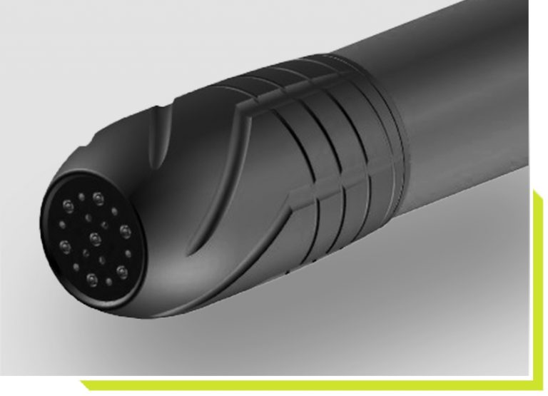
The eFusion technology precisely solves this part of the geothermal system with the aim of making available competitively priced energy and achieving carbon neutrality. The upcoming 3rd generation of the eFusion technology working tool is directly intended for the construction and development of a geothermal integral field for the EGS system and is currently being prepared for extensive testing.
Data source: FBERG, eFusion
Picture No. 11 The eFusion drilling head 3rd generation
Additional applications for the eFusion technology are:
- O&G (Oil and Gas) sector – Opening and closing of wells,
- Energy sector − Significant expansion of EGS for the use of dry terrestrial heat; solutions for the safe disposal of nuclear energy waste,
- Construction sector − Construction of the underground transport and other infrastructure, like tunels,
- Mining sector − Construction of mining works and boreholes; slim mining,
The eFusion Geothermal Energy application
- Utilization of the enhanced geothermal system  - Clean and price competitive energy for global needs  - Geothermal power plant anywhere  - Local sources of electricity and heat energy  - Electricity source for hydrogen applications and hydrogen economy  - The clean energy as solution for global challenges | 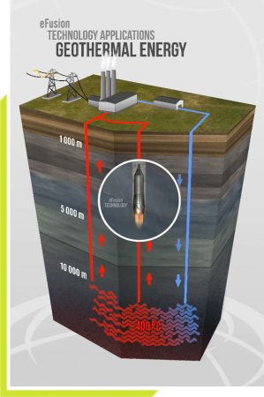
Data source: FBERG, eFusion
Picture No. 12 The eFusion technology in Enhanced geothermal system application

The transformation of the results from R&Ds and acquired knowledge into the practice, the innovation paths are one of the possible directions how to decrease impact of the climate change, lack of clean energy, lack of materials which are the biggest current global challenges, and which are leading into the biggest communities’ imbalances, tensions and bring the world on unsustainable path. The innovations must bring the solutions for CO2 emission decrease, fuel change, the efficiency increase and solve the challenges with lack of materials. The growth of utilization of renewable resources is in contradiction with lack of materials, as utilization of renewable energy and green technologies are characteristic by higher mineral demand. The clean energy demand, mainly electrical energy, is the common denominator for current technologies and solutions for climate change and lack of materials. Concertation of minerals in raw materials is going down worldwide and we need 2 times more energy than 20 years before for the same mineral extraction. Carbon capture utilization and storage will create additional energy demand, the increasing efficiency will be delivered mainly from electrification, digitalization and process automation and decreasing energy transportation losses with more local energy production. The eFusion technology opens opportunities for use of geothermal energy, as a clean source of cost-competitive, CO₂-free energy, at any point on Earth. The depth horizons required for EGS are economically and technologically unavailable for today’s conventional drilling technologies. The advantage of such a solution is the creation of local sources of electricity and heat energy without the needs to transport energy across the continent and without the needs to build new transport corridors. The eFusion technology is in the final stage of development with aim to transform the acquired knowledge into the practice, in short possible time. The clean energy is the common denominator for solution for main global challenges and ambition of the eFusion technology is to be a usable innovation with potential partly face the with main global challenges and bring enough volume of clean energy.

Acknowledgment
The paper has been written with the Operational Program Integrated Infrastructure for the project: National infrastructure for supporting technology transfer in Slovakia II - NITT SK European Research Development Fund.
References
IPCC (2022), Climate Change 2022: Impacts, Adaptation and Vulnerability, https://report.ipcc.ch/ar6/wg2/IPCC_AR6_WGII_FullReport.pdf
IEA (2020), Renewables 2021, https://www.iea.org/reports/renewables-2020
IEA (International Energy Agency) (2020a), World Energy Outlook 2020, https://www.iea.org/reports/world-energy-outlook-2020
USGS (United States Geological Survey) (2021), Mineral Commodity Summaries 2021, USGS, Boulder, Colorado.
Eurometaux (2019), Metals for a Climate Neutral Europe: A 2050 Blueprint, https://eurometaux.eu/media/2005/full-report-8-56-17.pdf
IEA (International Energy Agency) (2021a), Global EV Outlook 2021, https://www.iea.org/reports/global-ev-outlook-2021
OECD (Organisation for Economic Co-operation and Development) (2019), Global material resources outlook to 2060, OECD, Paris, https://www.oecd.org/environment/global-material-resourcesoutlook-to-2060-9789264307452-en.htm
S&P Global (2021), S&P Global Market Intelligence Platform (database), accessed multiple times in November 2020 – March 2021.
World Bank (2020), Minerals for Climate Action: The Mineral Intensity of the Clean Energy Transition, World Bank, Washington, DC, https://pubdocs.worldbank.org/en/961711588875536384/Minerals-for-Climate-Action-The-Mineral-Intensity-of-the-Clean-Energy-Transition
The Faculty of Mining, Ecology, Process Control and Geotechnologies of Technical University in Kosice, Slovakia (2022), Energy Transition up to 2050, Kosice, Slovakia
The Faculty of Mining, Ecology, Process Control and Geotechnologies of Technical University in Kosice, Slovakia (2023), eFusion technology, Kosice, Slovakia
The Faculty of Mining, Ecology, Process Control and Geotechnologies of Technical University in Kosice, Slovakia (2023), Geothermal energy in the eFusion system, application theoretical-practical assumptions, Kosice, Slovakia
He, L.; Zhou, X.; Sun, D. Fully analytical solution in time and space domains on temperature in multi-barrier nuclear waste repository. Comput. Geotech. 2023, 154, 105164. doi: 10.1016/j.compgeo.2022.105164
Chang, K.W.; LaForce, T.; Price, L.L. Hydro-thermal impacts on near-field flow and transport in a shale-hosted nuclear waste repository. Tunn. Undergr. Space Technol. 2022, 130, 104765. doi: 10.1016/j.tust.2022.1047652022
Ojovan, M.I., Steinmetz, H.J. Approaches to disposal of nuclear waste. Energies 2022, 15, 7804. doi: 10.3390/en15207804
Sasaki, T.; Rutqvist, J. Estimation of stress and stress-induced permeability change in a geological nuclear waste repository in a thermo-hydrologically coupled simulation. Comput. Geotech. 2021, 129, 103866. doi: 10.1016/j.compgeo.2020.103866
Jin, P.; Xue, Y.; Chen, B.; Sun, D.; Wang, L. An analytical solution of temperature near nuclear waste canister under three-dimensional heat transfer condition. Prog. Nucl. Energy 2022, 143, 104051. doi: 10.1016/j.pnucene.2021.104051
Reich, S.; Zalas, R. Error bounds for the method of simultaneous projections with infinitely many subspaces. J. Approx. Theory 2021, 272, 105648. doi: 10.1016/j.jat.2021.105648
Finsterle, S.; Muller, R.A.; Grimsich, J.; Bates, E.A.; Midgley, J. Post-closure safety analysis of nuclear waste disposal in deep vertical boreholes. Energies 2021, 14, 6356. doi: 10.3390/en14196356

