**XII Conferencia Internacional de Ingeniería Mecánica COMEC 2023**

**Comparative study of oxidation influences on mechanical properties and weldability on different welding processes**

***Estudio comparativo de las influencias de la oxidación en las propiedades mecánicas y la soldabilidad en diferentes procesos de soldadura.***

**Thiago Guerra1, Júlio Cézar Salvatico Pinto2, Mateus Schmitt3, Natã Cirino dos Santos4, Matheus Schmidt Vitali5, Ademiro Alves da Rocha6, Enerdan Fernando Dal Ponte7, Eliseu Avelino Zanella Junior8.**

1- Thiago Guerra. Centro Universitário Univel, Brazil. E-mail: [guerrathiago@gmail.com](mailto:guerrathiago@gmail.com)

2- Júlio Cézar Salvatico Pinto. Centro Universitário Univel, Brazil. E-mail: [juliocezarsalvatico@outlook.com](mailto:juliocezarsalvatico@outlook.com)

3- Mateus Schmitt. Centro Universitário Univel, Brazil. E-mail: [mateus-schmitt04@hotmail.com](mailto:mateus-schmitt04@hotmail.com)

4- Natã Cirino dos Santos. Centro Universitário Univel, Brazil. E-mail: [nata.cimaqind@gmail.com](mailto:nata.cimaqind@gmail.com)

5- Matheus Schmidt Vitali. Centro Universitário Univel, Brazil. E-mail: [matheus_sv1@hotmail.com](mailto:matheus_sv1@hotmail.com)

6- Ademiro Alves da Rocha. Centro Universitário Univel, Brazil. E-mail: [ademiro.rocha@univel.br](mailto:ademiro.rocha@univel.br)

7- Enerdan Fernando Dal Ponte. Centro Universitário Univel, Brazil. E-mail: [efdaltonte@hotmail.com](mailto:efdaltonte@hotmail.com)

8- Eliseu Avelino Zanella Junior. Centro Universitário Univel, Brazil. E-mail: [eliseu.zanella@univel.br](mailto:eliseu.zanella@univel.br)

Abstract: In the modern productive system, welding has become an alternative and an important substitute for mechanical joining processes, such as screws and rivets. Oxidation is defined as a phenomenon in which a material progressively deteriorates when exposed to varying environmental conditions, such as a contaminated industrial atmosphere. The purpose of this work is to propose a study on interference due to induced corrosive processes that may occur in the weldability of ASTM A36 steel sheets, comparing two different welding processes, namely SMAW - Shielded Metal Arc Welding and GMAW - Gas Metal Arc welding. In this way, reference specimens were listed, stored in air, compared to others stored in a corrosive environment during a pre-established period of time. The masses of the samples were measured before and after packaging, so that the corrosion rate in them could be measured. In order to check cracks and surface discontinuities in the welded joints, visual tests and the application of penetrating liquid were carried out. They were also subjected to a hardness test across the applied cord so that their variation could be measured. In this way, through the analyzes carried out, it was possible to observe, during the welding, a worsening in the weldability of the samples. The degree of oxidation of each sample directly affected the quality of the welding process used. The number of defects related to the welding process, such as discontinuities and weld spatter, increased as the exposure time of the samples also increased.

**Keyswords:** Welding; Oxidation; ASTM A36; Hardness test; Weldability.

***Palabras Claves:*** *Soldadura; Oxidación; ASTM A36; Examen de dureza; Soldabilidad.*

**1. Introduction**

In industry, producing a single piece is often costly and unfeasible. In this way, welding, in the form of metallurgical joining, becomes an alternative and in many situations an important substitute for mechanical joining processes, such as screws, rivets, etc.

Welding processes stand out for being extremely important as the main technique for manufacturing metallic parts and components (Modenesi, Marques and Santos, 2012). Due to the versatility of welding processes, these are widely applied especially to metals. Thus, the importance of the good quality necessary in the execution of these processes is highlighted.

According to Hassmann (2016), steel is an alloy in which iron contains the highest percentage by weight and carbon represents the most important alloying element. The author highlights the fact that the composition/content of the carbon element exerts a great influence on the properties of the metal. The higher the carbon content, the greater the hardness of the steel and the greater the resistance and yield limits, however, the lower the ductility and weldability.

ASTM A36 is a fine-grained structural carbon steel, with a ferritic-pearlitic structure, it is a low-carbon steel that has good weldability, in relation to its application, it is widely used in common structures and applications in industry.

The concept of weldability is characterized by the American Welding Society (2003) as the ability of a material to be welded to the manufacturing requirements imposed by a structural design, so that the welded material can behave adequately and uniformly when subjected to various requests. Due to the different applications of metals in industry, steels are subjected to different exposure conditions, these conditions can promote the degradation of the material. One of these forms of degradation is called oxidation. The focus of this work lies in the process on ASTM A36 steel plates.

The purpose of this work is to propose a study on interference due to induced corrosive processes that may occur in the weldability of ASTM A36 steel sheets, comparing two different welding processes, namely SMAW - Shielded Metal Arc Welding and GMAW - Gas Metal Arc welding. The goals are to submit and analyze visually and mechanically the influences that may occur on the welded joint performed by both welding processes of an ASTM A36 steel after it has been exposed and manipulated in an oxidative environment for different periods of time.

**2. Methodology**

In order to achieve standardization of the test samples, initially the manual sanding procedure was carried out on both sides of the ASTM A36 steel sheets. The purpose of this procedure is to remove possible surface contaminants. An angle grinder and flap discs were used for this stage.

In sequence, markings were made on each specimen to distinguish which scenario it was subjected to and the exposure time in the environment. To carry out this step, a metal punch was used. To measure the mass of all sheets, before and after they were placed in a corrosive environment, as well as before and after the welding procedure, a hydrostatic precision balance model BK8000 was used.

Therefore, the first mass measurement was carried out after the appropriate preparations of the specimens and before the samples were packaged. This measurement served as a control mass for each sample throughout the entire study. The second mass measurement was carried out after the samples were removed from packaging and dried. The third measurement was after the welding process.

In sequence, with their masses measured and recorded, the sheets were placed in a curing chamber with an oxidative environment. The purpose of this step was to simulate a situation in which the test specimens were exposed to a corrosive environment. This environment was basically made up of saline water, with sea salt being added until its maximum solubility point was reached.

In order for there to be contact between the two surfaces of the sheets and the corrosive environment, thus ensuring total interaction, supports of negligible dimensions whose function is only to avoid contact between the surfaces of different simples were used.

For welding, beads were developed under sheet metal on the test specimens, the welding parameters voltage, electric current and welding speed were fixedly defined. In this way, approximately equal welding energy was obtained for all samples, in order to create weld beads with similar aspects.

Four (duplicate) plates were used for each period of welding rounds.

These rounds were carried out every 7 days under the following conditions: 2 control plates, stored outside the water – in the air; 2 sheets in severe packaging – into the water;

In this way, the samples were arranged to obtain 2 distinct environments, the first being a milder environment, and the other being a harsh environment. The Tables 1 and 2 relates each sample and its type of environment:

|  |  |  |  |
| --- | --- | --- | --- |
| **Week 1** | **Sample** | **Week 2** | **Sample** |
| A1 | 1 | A2 | 5 |
| B1 | 2 | B2 | 6 |
| C1 | 3 | C2 | 7 |
| D1 | 4 | D2 | 8 |
| **Week 3** | **Sample** | **Week 4** | **Sample** |
| A3 | 9 | A4 | 13 |
| B3 | 10 | B4 | 14 |
| C3 | 11 | C4 | 15 |
| D3 | 12 | D4 | 16 |

Table 1. Sample numbers for Gas Metal Arch Welding (GMAW) (Own elaboration)

|  |  |  |  |
| --- | --- | --- | --- |
| **Week 1** | **Sample** | **Week 2** | **Sample** |
| A1 | 19 | A2 | 23 |
| B1 | 20 | B2 | 24 |
| C1 | 21 | C2 | 25 |
| D1 | 22 | D2 | 26 |
| **Week 3** | **Sample** | **Week 4** | **Sample** |
| A3 | 27 | A4 | 31 |
| B3 | 28 | B4 | 32 |
| C3 | 29 | C4 | 33 |
| D3 | 30 | D4 | 34 |

Table 2. Sample numbers for Shielded Metal Arch Welding (SMAW) (Own elaboration)

Where:

Blue: “Control sample” exposed to air before and after the welding;

Red: Immersed in water before and after welding sample;

Yellow: Immersed in water and exposed to air after welding sample;

Green: Exposed to air and immersed in water after welding sample;

For the Gas Metal Arc Welding (GMAW) process, the parameters of the welding equipment were adjusted using a MIG/MAG inverter machine for welding. The process was carried out in accordance with the WPS in Figure 1.

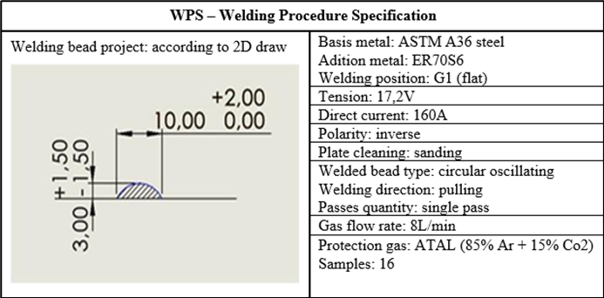

Figure 1. Welding parameters for GMAW process (Own elaboration)

Each of the plates had discard plates, fixed by means of welding points at their ends, indicating the starting and ending area of ​​the weld bead, in order to completely preserve and analyze the welded specimen.

For the SMAW - Shielded Metal Arc Welding process, the process was carried out in accordance with the WPS in Figure 2.

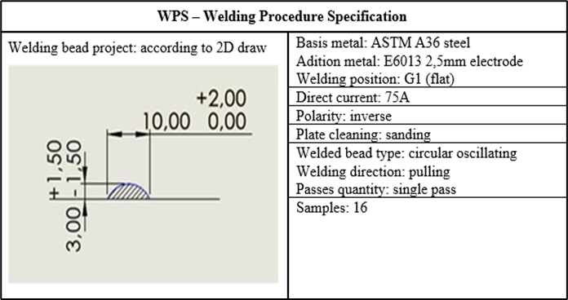

Figure 2. Welding parameters for SMAW process (Own elaboration)

After the welding round, the masses of all samples were measured, with the purpose of identifying the mass of material added by the process. The amount of weld spatter generated on both left and right sides of the welded bead was also verified and recorded.

Subsequently, one of the samples was re-stored in the environment, in this case, in the air, the other sample of the previously welded duplicate of each condition was re-allocated again in the more severe oxidative environment. This second conditioning served to evaluate the scenario that the oxidative environment could promote in the welded region.

An important result for the analyzes carried out in the present work was the determination of the corrosion rate. According to Equation 1, the corrosion rate was determined by the difference in the measured masses and the elapsed time of storage in each oxidative environment.

(1)

Equation 1. Corrosion rate (Callister, 2005)

Where:

K is the corrosion rate (mm/year);

M is the mass loss (g);

a is the exposed surface area, (cm2);

t is the exposure time (h);

ρ is the specific mass of the steel, (g/cm3).

In order to check cracks and surface discontinuities in the welded beads of the specimens, tests were carried out with penetrating and revealing liquids. In the words of Andreucci (2014), penetrant liquid tests are non-destructive tests that aim to identify cracks or surface discontinuities found in a material.

Therefore, the penetrant liquid test aims to ensure the credibility of a product, by obtaining a visual picture where aspects of discontinuity on the surface of the part become noticeable without causing damages to it (Roque, 2020). In this way, seeking a certain degree of quantification, images were recorded in order to make a comparative test between the samples.

In order to identify the influences of the corrosive process on the weld bead, the samples were subjected to hardness tests. Through the tests, relationships could be made between the effects of the welding process and the changes in the material in relation to the hardness obtained in the test, a HBRV-187.5D model was used for this.

For the test, the hardness on the Hardness Rockwell B scale (HRB) was used, indicated for hard materials, consequently indicated for ASTM A36 steel, applying a load of 100 kgf. For the indentations, the spherical indenter model indicated by “HRB” was used.

To obtain the hardness results, the averages of the indentations made on the plates were calculated, with these indentations made on both sides of the welded bead, with 3 lines: an indentation line in the center of the plate, an indentation line 10 mm above from the center of the plate, and an indentation line 10 mm below the center of the plate.

In each line, indentations were made at 3 different points in the perpendicular direction to the welded bead. The first indentation was made at an established distance of approximately 1 mm from the welded bead, and the other two every 3 mm, thus obtaining 3 rows and 3 columns on each side of the welded bead.

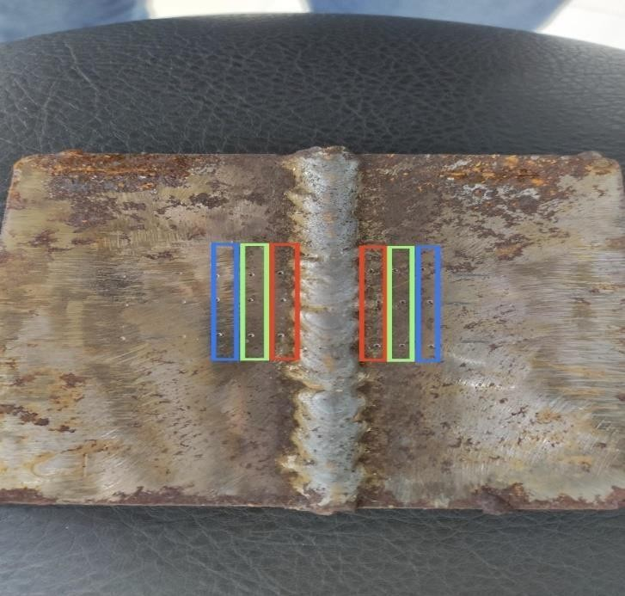In order to obtain different hardness values ​​based on the established distance from the welded bead, the average of the hardness values ​​on both sides of the welded bead was obtained using the highlighted columns as shown in Figure 3.

Figure 3. Highlighted columns on both sides of the welded bead (Own elaboration)

**3. Results and Discussion**

As expected, it was possible to visualize the progressive loss of mass and a tendency towards a greater number of spatters according to a longer exposure time of the samples in the harsher environment. This behavior has been noticed on both welding procedures.

The spatter amount for each sample was counted on both sides of the welded bead and registered right after the welding procedure was concluded. This data can be seen in Tables 3 and 4. The figure 4 shows the counting of the spatter in the sample number 1.

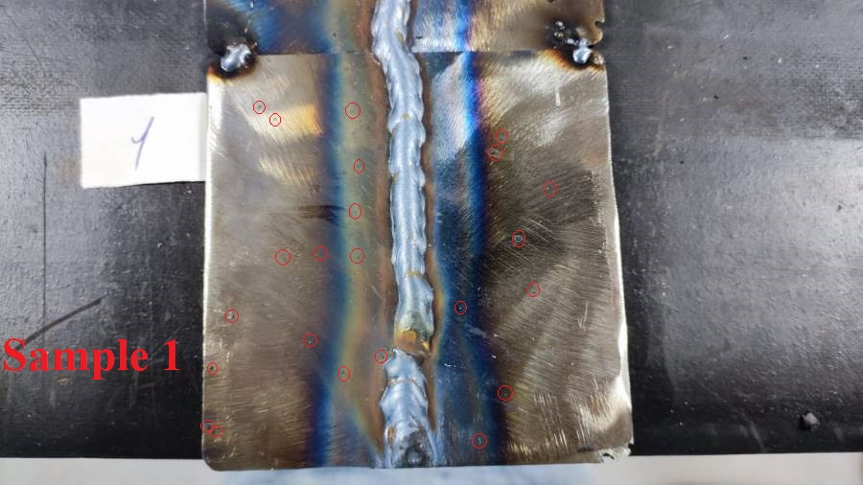

Figure 4. Spatter amount counting in both sides of welded bead (Own elaboration)

In this case, it resulted in 15 spatters at the left side and 8 at the right side of the welded bead.

|  |  |  |  |  |  |  |
| --- | --- | --- | --- | --- | --- | --- |
| **Sample** | **Initial**  **mass (g)** | **Mass after 1°**  **packaging (g)** | **Mass**  **after**  **welding (g)** | **Mass after 2°**  **packaging (g)** | **Spatter amount on left side** | **Spatter amount on right side** |
| **1** | 216 | 215.9 | 225.3 |  | 15 | 8 |
| **2** | 219.5 | 219.4 | 228.6 | 228.5 | 20 | 13 |
| **3** | 228.6 | 228.5 | 236.3 |  | 25 | 12 |
| **4** | 213.9 | 213.8 | 223.7 | 223.6 | 14 | 8 |
| **5** | 213 | 212.8 | 223.8 |  | 19 | 11 |
| **6** | 227 | 226.7 | 238.8 | 238.7 | 29 | 14 |
| **7** | 228 | 227.7 | 240.3 |  | 27 | 19 |
| **8** | 228.5 | 228.3 | 239.2 | 239 | 18 | 12 |
| **9** | 225.1 | 224.8 | 238.8 |  | 21 | 16 |
| **10** | 225.5 | 225 | 236.8 | 236.6 | 29 | 18 |
| **11** | 227 | 226.5 | 238.7 |  | 34 | 18 |
| **12** | 227.7 | 227.4 | 241.5 | 241.3 | 32 | 19 |
| **13** | 226.6 | 226.2 | 238.7 |  | 33 | 12 |
| **14** | 226 | 225.5 | 236.4 | 236.1 | 37 | 26 |
| **15** | 223.7 | 223 | 234.6 |  | 39 | 20 |
| **16** | 218.6 | 218.2 | 229.4 | 229.1 | 34 | 18 |

Table 3. Recorded masses and spatter amount for the Gas Metal Arc Welding procedure (Own elaboration)

As supposed, the samples of the first week (samples 1 to 4) had the lowest mass loss, and the samples of the last week (samples 13 to 16) had the greater mass lose. Regarding the spatter amount recorded on the samples, a relevant observation lies in its distribution, which was higher on the left side of the welded bead in all samples, such fact can be justified by the direction in which the bead was delivered during welding.

|  |  |  |  |  |  |  |
| --- | --- | --- | --- | --- | --- | --- |
| **Sample** | **Initial**  **mass (g)** | **Mass after 1°**  **packaging (g)** | **Mass**  **after**  **welding (g)** | **Mass after 2°**  **packaging (g)** | **Spatter amount on left side** | **Spatter amount on right side** |
| **19** | 218.2 | 218.1 | 225.2 |  | 17 | 34 |
| **20** | 225g | 224.9 | 231.4 | 231.3 | 18 | 36 |
| **21** | 227.4 | 227.3 | 233.1 |  | 22 | 40 |
| **22** | 228.5 | 228.4 | 234.4 | 234.4 | 16 | 35 |
| **23** | 227.9 | 227.7 | 234.5 |  | 24 | 44 |
| **24** | 229.7 | 229.4 | 236.6 | 236.5 | 35 | 46 |
| **25** | 217.3 | 217 | 224.2 |  | 37 | 68 |
| **26** | 213.5 | 213.3 | 220 | 220 | 28 | 42 |
| **27** | 227.4 | 227.1 | 234.4 |  | 21 | 50 |
| **28** | 216.8 | 216.4 | 223.9 | 223.8 | 41 | 59 |
| **29** | 221.9 | 221.5 | 229.1 |  | 22 | 51 |
| **30** | 224.4 | 224.3 | 231.2 | 231.1 | 20 | 43 |
| **31** | 224.7 | 224.4 | 231.4 |  | 23 | 52 |
| **32** | 227.3 | 226.7 | 235.8 | 235.8 | 22 | 61 |
| **33** | 226.7 | 226.1 | 234.8 |  | 27 | 56 |
| **34** | 229 | 228.8 | 237.1 | 237.1 | 25 | 49 |

Table 4. Recorded masses and spatter amount for the Shielded Metal Arc Welding procedure (Own elaboration)

For the SMAW procedure, it was verified that the mass loss presents the same pattern as the GMAW procedure, in which the longer the exposure in the oxidative environment, the greater was the the mass loss. The most noticeable difference lies in the spatter amount being bigger in the right side of the welded bead. This condition has been previously explained on the GMAW procedure.

Regarding the corrosion rate, previously described in Equation 1, it resulted in similar results, as the mass losses was also similar. The Tables 5 and 6 describes the data for the GMAW and SMAW procedures, respectively.

|  |  |  |  |
| --- | --- | --- | --- |
| **Sample** | **Corosion rate**  **(mm/year)** | **Sample** | **Corosion rate**  **(mm/year)** |
| **1** | 0.0664 | **9** | 0.0664 |
| **2** | 0.0664 | **10** | 0.1107 |
| **3** | 0.0664 | **11** | 0.1107 |
| **4** | 0.0664 | **12** | 0.0664 |
| **5** | 0.0664 | **13** | 0.0664 |
| **6** | 0.0996 | **14** | 0.0830 |
| **7** | 0.0996 | **15** | 0.1162 |
| **8** | 0.0664 | **16** | 0.0664 |

Table 5. Corrosion rate according to Equation 1 (Own elaboration)

|  |  |  |  |
| --- | --- | --- | --- |
| **Sample** | **Corosion rate**  **(mm/year)** | **Sample** | **Corosion rate**  **(mm/year)** |
| **19** | 0.0664 | **27** | 0.0664 |
| **20** | 0.0664 | **28** | 0.1107 |
| **21** | 0.0664 | **29** | 0.1107 |
| **22** | 0.6664 | **30** | 0.0664 |
| **23** | 0.6664 | **31** | 0.0498 |
| **24** | 0.0996 | **32** | 0.0830 |
| **25** | 0.0996 | **33** | 0.1162 |
| **26** | 0.6664 | **34** | 0.0332 |

Table 6. Corrosion rate according to Equation 1 (Own elaboration)

Regarding on the penetrating liquid tests, the results were arranged as follows: samples from both GMAW and SMAW processes were placed side by side, according to the environment in which they were acconditioned. In this way, it becomes an interesting analysis of the results as it can be seen both the differences between welding procedures and the environment in which such samples were submitted.

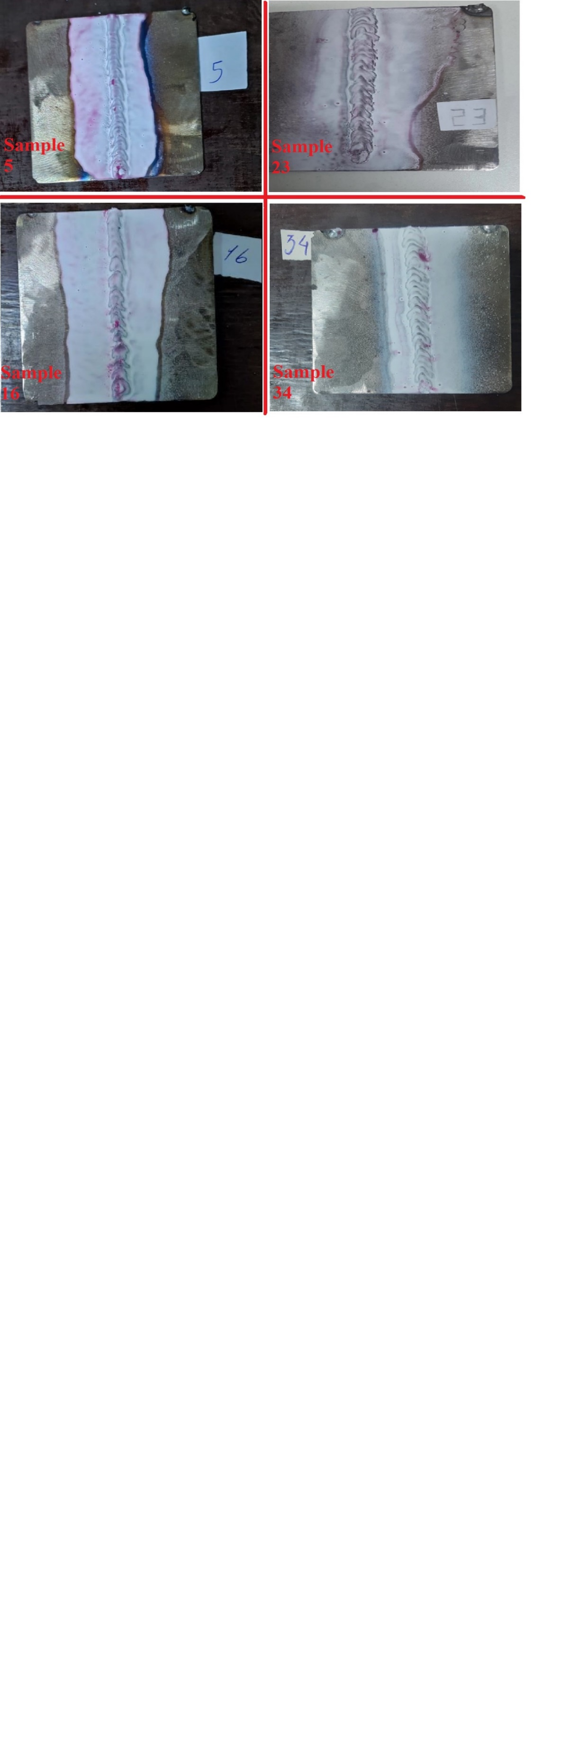

Figure 5. Penetrant liquid results for both GMAW and SMAW in milder environment (Own elaboration)

As presented in Figure 5, it was noticeable by the penetrant liquid test that the samples of the GMAW procedure (samples 5 and 16), the development and progression of certain discontinuities upon and in the surroudings of the welded bead increased as the time exposure of them in such environment increased. For the SMAW procedure (samples 23 and 34), the same pattern was observed, but with less critical changes presented in the results.

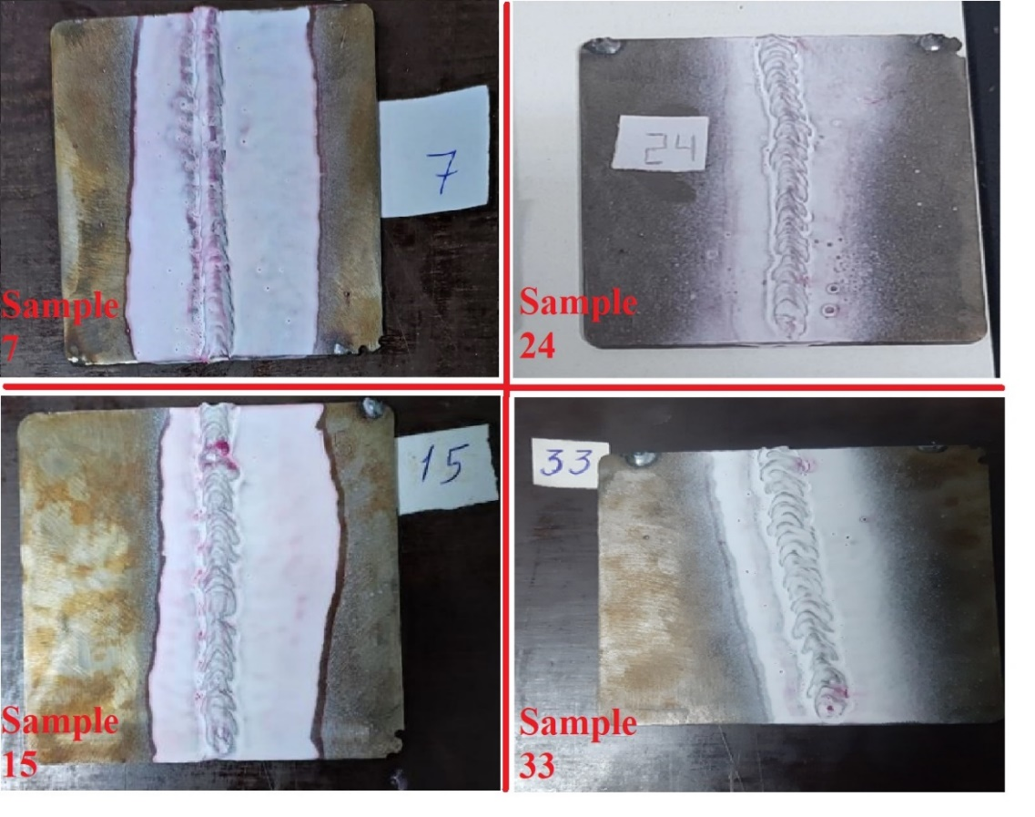

Figure 6. Penetrant liquid results for both GMAW and SMAW in harsher environment (Own elaboration)

In this section, the penetrant liquid test delivers similar results for both GMAW (samples 7 and 15), and SMAW (samples 24 and 33), in which the development and progression of discontinuities in the welded bead increased as the time exposure of them in such environment increased. An observation to be done lies in the fact that it had a milder development and progression of such discontinuities.

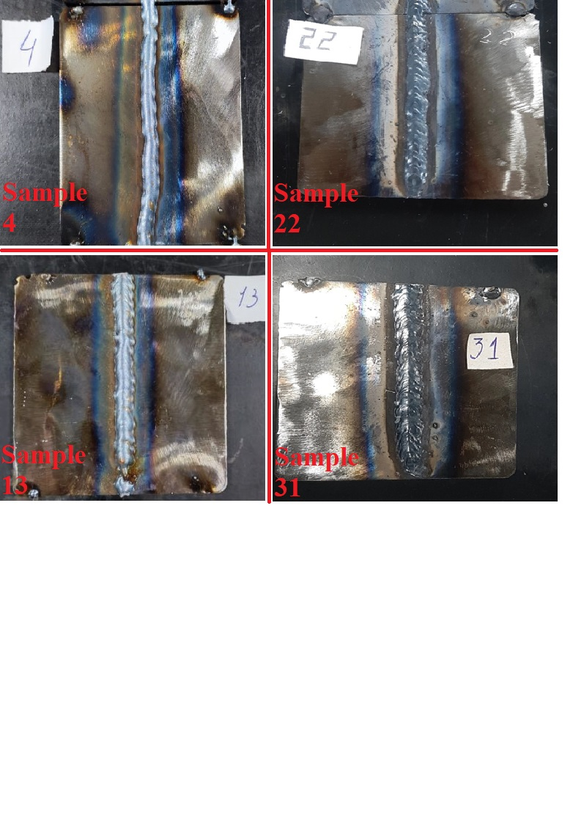

Figure 7. Welded bead aspects for both GMAW and SMAW in milder environment (Own elaboration)

The welded bead for both GMAW and SMAW presented satisfactory features for the welding procedures of the first week, as presents the samples 4 (GMAW) and 22 (SMAW) in Figure 7. In the fourth and last week of the study, it gets fairy visible certain discontinuities in the ending area of the welded bead, indicating that the weldability of the samples in this stage was compromised.

Regarding the spatter amount, both the 2 GMAW samples resulted in fewer amounts when compared to the SMAW ones. In sample 31, for the SMAW procedure, it gets also noticeable a greater spatter amount when compared to the sample 22.

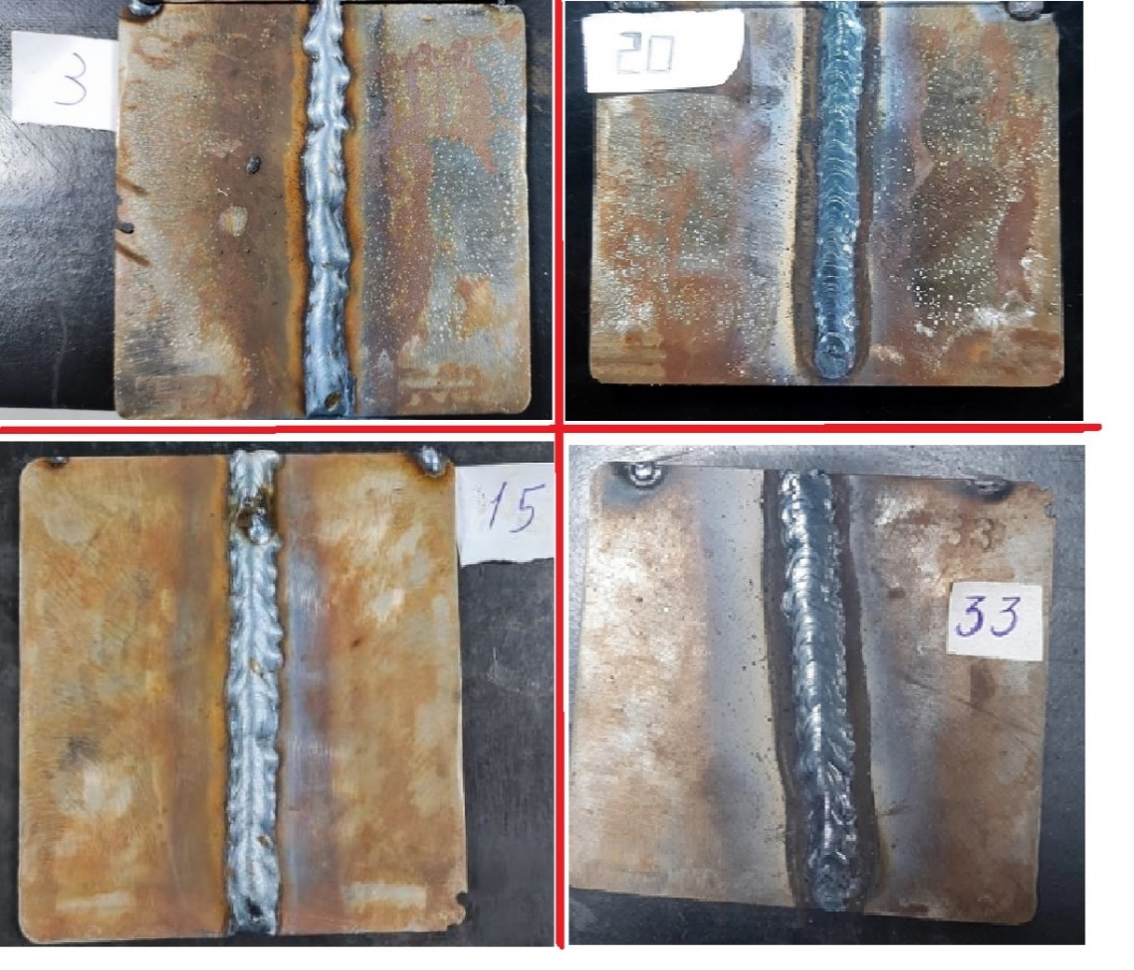

Figure 8. Welded bead aspects for both GMAW and SMAW in harsher environment (Own elaboration)

The welded bead for both welding procedures presented satisfactory features on the first week, as presents the samples 3 (GMAW) and 20 (SMAW) in Figure 8. The influences of the oxidative process on the weldability of the samples became more visible in this welding round, with more evident discontinuities of the welded bead for the sample 15 (GMAW), indicating that the weldability of the samples in this stage was compromised.

In the fourth week, a greater difficulty for both welding procedures was noted, requiring more time for the welding of each sample, however, this fact was more present on the GMAW procedure. A hypotesis lies in the sensibilty of this type of welding.

The Table 7 relates the Hardness values for the points previously explained for the GMAW procedure.

|  |  |  |  |  |  |  |
| --- | --- | --- | --- | --- | --- | --- |
| **Left side** | | | | **Right side** | | |
| **Sample** | **1º point** | **2º point** | **3º point** | **1º point** | **2º point** | **3º point** |
| **1** | 71,6 | 74,6 | 77,6 | 72 | 74,6 | 78 |
| **2** | 68,3 | 69,6 | 71,3 | 66 | 69 | 72 |
| **3** | 67,3 | 68 | 72 | 66,3 | 68,3 | 72 |
| **4** | 69 | 71,3 | 75 | 65,6 | 70 | 75 |
| **5** | 70 | 74,3 | 77 | 71 | 74,6 | 77 |
| **6** | 63,3 | 66,6 | 71 | 62,3 | 68,3 | 71,3 |
| **7** | 61,3 | 67,3 | 72,6 | 61,3 | 70,3 | 75,3 |
| **8** | 65,6 | 68,3 | 74 | 63,6 | 69,6 | 74,6 |
| **9** | 65,3 | 70 | 74,6 | 66,3 | 72,6 | 74,6 |
| **10** | 63,3 | 66 | 72,3 | 62 | 68 | 71,6 |
| **11** | 62,3 | 67,3 | 70,3 | 61,3 | 69,6 | 72,3 |
| **12** | 64,6 | 69,6 | 73,3 | 67,6 | 73 | 74,3 |
| **13** | 65 | 74 | 75,3 | 67,6 | 72,3 | 74,6 |
| **14** | 61,6 | 65 | 71,3 | 62,3 | 69,3 | 71,6 |
| **15** | 58,6 | 62 | 67,6 | 61 | 63,6 | 67,3 |
| **16** | 64 | 67,3 | 71 | 62 | 67 | 70,3 |

Table 7. Average hardness values ​​in HRB scale from the defined points (Own elaboration)

According to Table 7, the results are consistent with what was expected based on the corrosion rate obtained, reaching values ​​that follow a hardness pattern proportional to the corrosion rate. The hardness values ​​obtained had suffered a decrease exponentially.

The Table 8 relates the Hardness values for the points previously explained for the SMAW procedure.

|  |  |  |  |  |  |  |
| --- | --- | --- | --- | --- | --- | --- |
| **Left side** | | | | **Right side** | | |
| **Sample** | **1º point** | **2º point** | **3º point** | **1º point** | **2º point** | **3º point** |
| **19** | 69 | 70 | 75 | 68 | 70 | 73 |
| **20** | 63 | 64.5 | 69.5 | 63 | 65.5 | 68 |
| **21** | 62 | 67.5 | 70.5 | 61.5 | 64.5 | 67.5 |
| **22** | 64.8 | 66.5 | 69 | 61 | 65 | 66 |
| **23** | 65.5 | 68.5 | 71 | 63.8 | 66 | 67 |
| **24** | 62.5 | 64.5 | 70 | 62 | 64 | 66.5 |
| **25** | 68 | 70 | 73 | 66.8 | 70 | 72 |
| **26** | 67 | 68.5 | 72 | 64 | 66.5 | 67 |
| **27** | 66 | 68 | 69 | 66 | 67 | 70 |
| **28** | 64 | 66.5 | 68.5 | 62.5 | 64.5 | 70 |
| **29** | 67 | 68.5 | 70 | 61 | 66 | 69 |
| **30** | 64.8 | 69 | 72 | 69 | 70 | 73 |
| **31** | 71 | 74.5 | 79.6 | 70 | 72.5 | 77 |
| **32** | 60.5 | 68.8 | 72.8 | 65 | 68 | 74 |
| **33** | 61.5 | 65 | 68.3 | 58.8 | 63.6 | 69.5 |
| **34** | 63.8 | 67.5 | 70.3 | 62.8 | 68 | 71.6 |

Table 8. Average hardness values ​​in HRB scale from the defined points (Own elaboration)

The results for the SMAW procedure also follow the same pattern that was expected based on the corrosion rate obtained, presenting similar hardness values, also proportional to the corrosion rate. With the results of both welding procedures, a relation between corrosion and hardness around the welded bead can be made.

**4. Conclusions**

Given the results obtained, some important conclusions can be raised:

As expected, the weldability during the study became exponentially affected based on certain corrosion rates, with a noticeable fact that it was faced greater difficulty in welding the samples of the 4° week.

During the welding of the sheets, in both welding procedures, a greater difficulty was noticeable due to a progression of the corrosion phenomenon, confirmed by the fact that the sheets from the first week achieved satisfactory weldability and generated adequate results both visually, in the welded bead and penetrant liquid tests, as well as mechanically in hardness tests, in contrast to the samples that were in a longer time exposed.

Regarding the hardness test carried out on the samples, results were also consistent with what was expected based on the corrosion rate obtained, obtaining values ​​that follow a hardness pattern proportional to the corrosion rate. In other words, the longer the exposure time of the samples, as well as the more severe their packaging, and consequently the higher the corrosion rate, the lower the hardness values ​​obtained.

The measured hardness results also followed a pattern according to the distance from the welded bead, with the hardness values ​​being lower as the indentations got closer to the welded bead.

Comparing both procedures, even presenting similar mass loss and corrosion rate, the welded samples for the SMAW procedure presented more spatter amount. These samples also had less influences on the welded bead when compared to the GMAW procedure, as seem in the penetrant liquid tests.

Thus, with the results achieved throughout the study, it can be conclusively stated that the corrosive characteristics directly influence the welding process, affecting the weldability, the quality of the welded joint and the mechanical properties of the metal.

**5. Bibliographic references**

1- Andreucci, R. Líquidos penetrantes. ABENDI Associação Brasileira de Ensaios não Destrutivos, São Paulo, p. 70, 2014.

2- American Welding Society, Welding Handbook. Test Methods for Evaluation Welded Joints. USA, 2003.

3- Callister, W. Sciense and Engineering materials– An introduction, 5th ed., John Wiley, 2005.

4- Cinitha, A.; Umesha, P. K.; Iyer, N. R. An overview of corrosion and experimental studies on corroded mild steel compression members. KSCE Journal of Civil Engineering, v. 18, n. 6, p. 1735- 1744, 2014.

5- Hassmann, A. Estudo comparativo de aço-carbono microligado e aços-carbono ligados para fabricação de parafusos forjados a frio. Monograph presented in the Course Completion Work – Stage II, of the Mechanical Engineering Course at Centro Universitário Univates, as a requirement for obtaining the Bachelor's degree in Mechanical Engineering. Lajeado, 2016.

6- Modenesi, P. J; Marques, P. V; Santos, D. B. Introdução à metalurgia da soldagem. 2012. 208 f. Post-graduation. Metallurgic engineering and materials department, Federal University of Minas Gerais, Belo Horizonte: UFMG, 2012.

7- Roque, J. C. D. L. Avaliação do desempenho de técnicas não destrutivas: um estudo de caso na inspeção de juntas soldadas em tubulação de transferência de amônia nidra. Presented dissertation to the Specialization Course in Welding Engineering at the Department of Mechanical Engineering, Federal University of Minas Gerais. Belo Horizonte, p. 62. 2020.

8- Zientarski, R. K. Análise de influência dos parâmetros de soldagem a arco elétrico com atmosfera de proteção gasosa (GMAW) nas propriedades mecânicas e microestruturais do aço ASTM A36. Course completion work, presented to the Mechanical Engineering Course, at the Federal University of Santa Maria (UFSM, RS), as a partial requirement to obtain the title of Mechanical Engineer. Santa Maria, 2019.