**WELDING AND MATERIALS SYMPOSIUM**

**Weld Bead Analysis on TIG Welding on Room Temperature and 100°C on Aluminum 6351-T6**

***Análisis del cordón de soldadura TIG en temperatura ambiente y a 100°C en aluminio 6351-T6***

**Matheus Schmidt Vitali1, Natã Cirino dos Santos2, Thiago Guerra³.**

1- Matheus Schmidt Vitali. Univel Centro Universitário, Brazil. E-mail: matheus_sv1@hotmail.com

2- Natã Cirino dos Santos. Univel Centro Universitário, Brazil. E-mail: nata.cimaqind@gmail.com

3- Thiago Guerra. Univel Centro Universitário, Brazil. E-mail:

guerrathiago@gmail.com

**Abstract:** The research will be conducted to understand the interference of welding and find the best way of weld interaction in the aluminum alloy 6351-T6. Thus, it will address a review of the existing literature and present ways to avoid failures in the process that lead to material breakage and, consequently, attempt to reduce waste. The goal is to analyze and compare the weld interactions in aluminum 6351-T6 metal alloys, where one bar will undergo a heating process at a temperature of approximately 100°C, and the other bar will not be subjected to the heating process before welding. this process will be carried out using TIG welding, with the assistance of visual and hardness tests to obtain data and results. In this way, we can select the best method for welding in this type of alloy, contributing to improved weld penetration, consistency in results, and maintenance of acceptable hardness.

**Keyswords:** Aluminum; Welding; TIG; Alloy.

***Palabras Claves:*** Aluminio; Soldadura; TIG; Aleación.

**1. Introduction**

Aluminum (Al) is a chemical element with an atomic number of 13 and a mass of 27u. It is a solid at room temperature and the most common metal in the Earth's crust. Characterized by its lightness, softness, and strength, it has a dull and silvery appearance due to the oxides that form its thin surface layer when exposed to air. It is non-toxic, non-magnetic, and does not generate sparks through friction. In alloy form, its tensile strength reaches 400 MPa, while in its pure state, it is around 19 MPa. (KOTZ et al, 2005; BROWN et al, 2005) Among metallic alloys, the aluminum alloy 6351 is of great importance in the industry, mainly used in the aerospace and automotive industries and widely used in mountaineering equipment such as carabiners, brakes, and other applications (ASM HANDBOOK, 1998). This alloy is commercially known as Duralumin, and it exhibits high mechanical strength, excellent machinability, high corrosion resistance, and is suitable for anodizing. Its composition includes 97.35% Aluminum (Al), 1% Silicon (Si), 0.6% Magnesium (Mg), 0.4% Iron (Fe), 0.1% Copper (Cu), 0.45% Manganese (Mn), and 0.1% impurities. Its name does not derive from "hard aluminum" but from Düren, a German city where it was discovered in 1906 by the chemist Alfred Wilm. (WEINGAERTNER et al, 1991; SCHROETER et al, 1991) Aluminum can be welded using various processes, with many of them using filler metal in the form of coated electrodes, rods, or bare wire electrodes. The American Welding Society (AWS) establishes the AWS A5.10 standard, which specifies the classification and requirements for rods and wires in aluminum alloys used in oxyfuel welding, gas shielded (TIG, MIG MAG), and plasma welding processes. (ALCÂNTARA N.G, 1991).

This research aims to analyze the weld interaction in the TIG welding process. Two samples of aluminum alloy 6351-T6 will be used, with one undergoing a heat treatment before welding, and the other will have welding applied at room temperature. The study will cover topics related to welding processes, including a brief historical overview, aluminum and its alloys, heat treatments, and heat treatments applied to the aluminum alloy. Material tests such as metallography, liquid penetrant testing, and visual inspection will be conducted. Finally, the research will conclude with an analysis of the obtained results.

**2. Methodology**

The material used for this work was a solid shaft made of an aluminum alloy 6351-T6. This material has the following dimensions, with a diameter of 50.8mm (2 inches) throughout its entire length, as shown in Figure 1. From this material, samples with a length of 140mm will be taken, as depicted in Figure 2, which is a 3D drawing created using software.

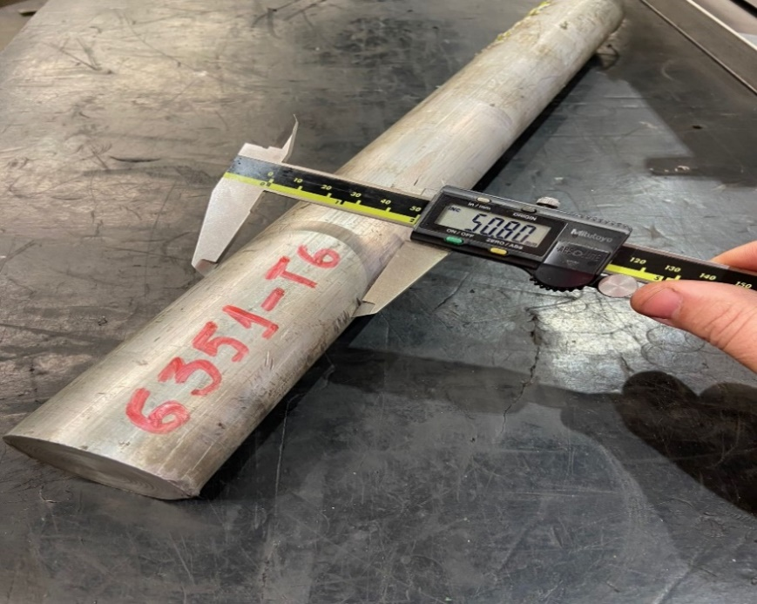

Figure 1. Aluminum alloy 6351-T6 (Own elaboration).

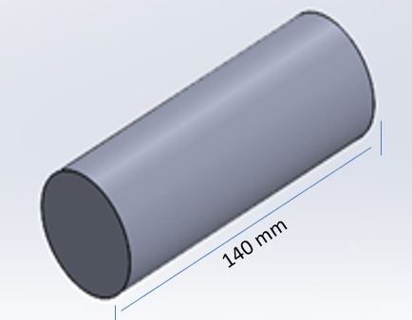

Figure 2. 3D drawing of aluminum alloy 6351-T6 (Own elaboration).

After the samples were cut to a length of 140mm, they underwent a split cut, dividing them into two equal parts, using a circular band saw machine, as shown in Figure 3, which is a drawing created using software, illustrating the split cut of the aluminum alloy 6351-T6. Following the ASTM E10-93 standard, a hardness test was conducted in the laboratory on the samples using a benchtop hardness tester, as depicted in Figure 4, which shows the hardness testing apparatus.

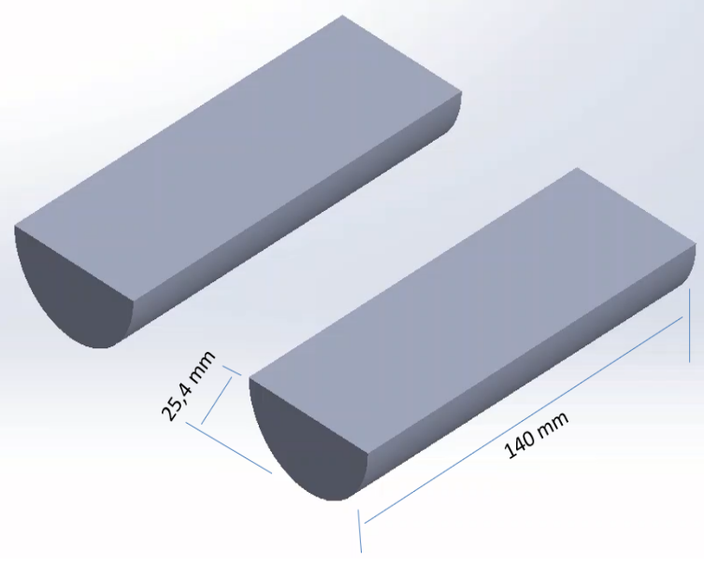

Figure 3. Bipartite 3D drawing of aluminum alloy 6351-T6 (Own elaboration).

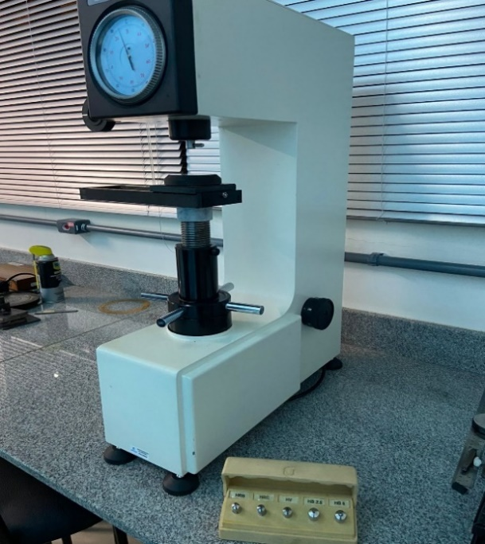

Figure 4. Analog benchtop hardness tester. Model: HBRV-187.5D, brand: Edutec (Own elaboration).

After the hardness test, the samples underwent a cleaning process using a steel brush to remove impurities and 92%/96% ethyl alcohol (Figure 5) with the assistance of a clean cloth to remove oil and grease that could directly affect the sample where welding will be performed.

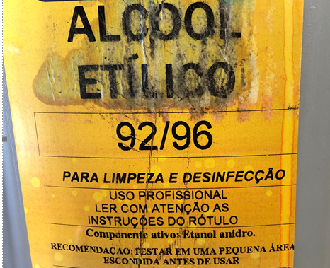

Figure 5. Ethyl alcohol 92/96 (Own elaboration).

The process used for welding the aluminum alloy 6351-T6 test specimens was TIG (Tungsten Inert Gas), following the welding procedure specifications (EPS) as shown in Table 1. To perform the welding, a Castolin Eutectic DPT 350 HD device and argon shielding gas were used, both of which are presented in Figure 6 and 7.

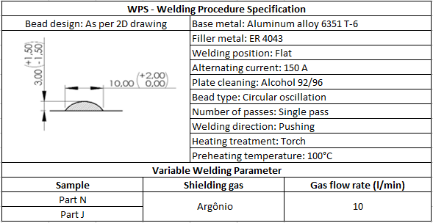

Table 1. Welding Procedure Specification (Own elaboration).

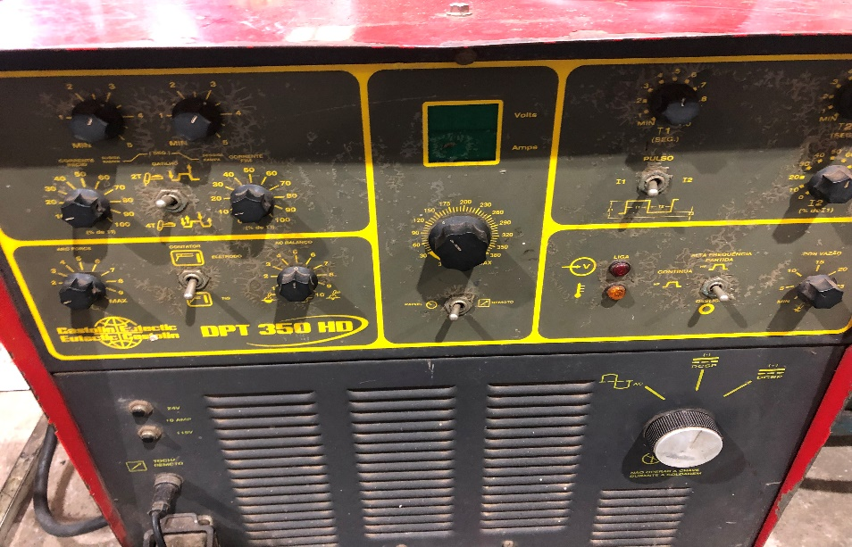

Figure 6. Castolin Eutectic DPT 350 HD welding machine (Own elaboration).

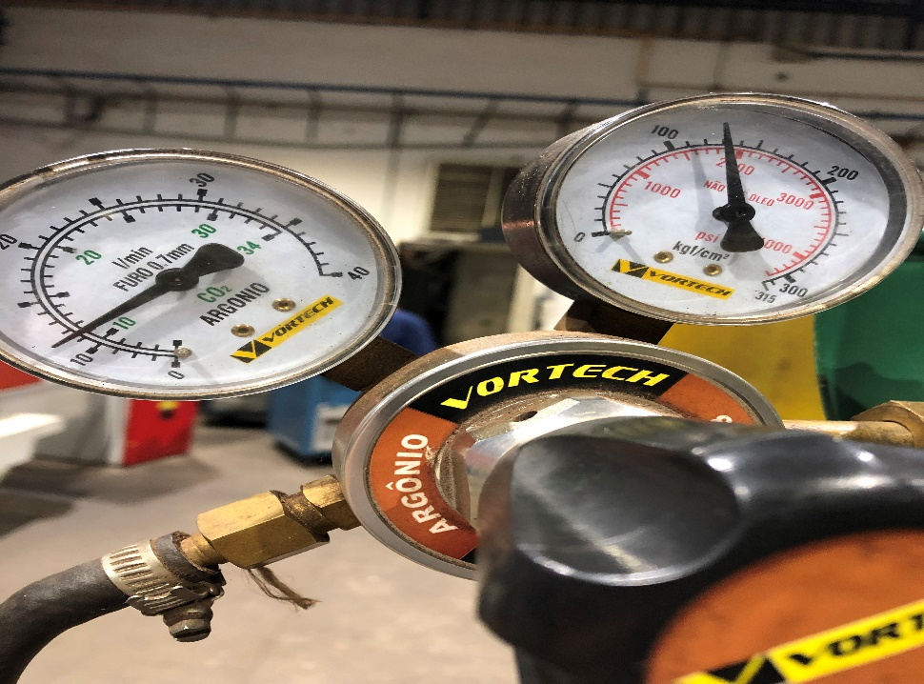

Figure 7. Argon shielding gas (Own elaboration).

One sample underwent a welding process beneath the surface with the addition of consumable aluminum electrode ER 4043 and a non-consumable electrode with a 2.4mm diameter containing 2% thorium, as shown in Figure 1.3. A 10L/M argon gas pressure, as presented in Figure 1.20, was used. The voltage and amperage settings were the same for all samples.

The other sample underwent a heating process to reach approximately 100°C, monitored using a pyrometer to maintain this temperature range, as shown in Figure 8. An industrial torch, as presented in Figure 9, was used in the same direction where the welding would be performed. After this process, welding was carried out with the addition of consumable aluminum electrode ER 4043 on the sample's surface, using the same 10L/M argon gas pressure as shown in Figure 7, and the same voltage and amperage settings applied to the other samples.

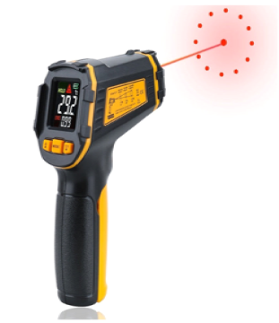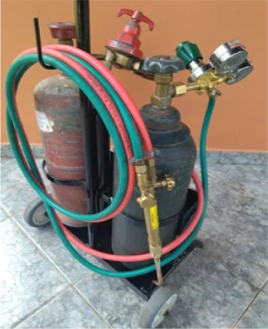

Figure 8. Pyrometer (Instrumbrasil, 2023). Figure 9. Industrial torch (Own elaboration).

Hardness measurements were taken on the welded material along its entire length after the samples were welded, using the hardness measurement device shown in Figure 4. Figure 10, aided by software, illustrates how the welding was carried out.

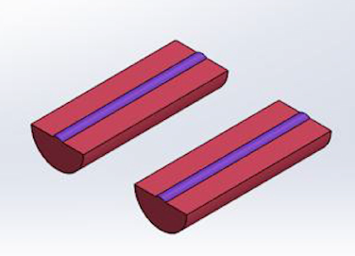

Figure 10. 3D welded bipartite drawing of aluminum alloy 6351-T6 (Own elaboration).

The materials were separated as follows: the sample of the material that underwent the welding process with heating was named sample N, and the other sample of the material that underwent only welding was named sample J. Therefore, we have a pair of different materials in their processes before and after welding.

After the welding was completed, a penetrant liquid test was conducted following the NBR 16450 standard from June 2021. The purpose of the penetrant liquid inspection method is to ensure the reliability of an item by generating a clear and evident image of the flaws present on its surface, as illustrated in Figure 11, without inducing any damage to the structure of the part (ROQUE, 2020).

In order to achieve good performance during liquid penetrant testing, it is necessary to follow several steps in its procedure:

a) Surface Preparation;

b) Application of the Penetrant;

c) Removal of Excess Penetrant;

d) Development;

e) Evaluation and Inspection;

f) Decontamination of the Part.

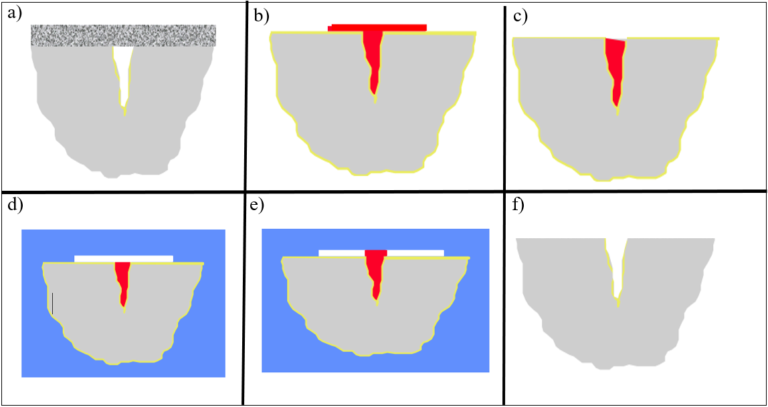

Figure 11. Penetrant liquid (Andreucci, 2014, p. 5-7).

The samples that underwent the welding process with preheating and without preheating were sliced into 8 equal parts, with each sample labeled from 1 to 8 in sequence. Figure 12 illustrates a drawing created by software depicting how the cutting will be performed on all samples N and J. Figure 13 presents the drawing for one of the samples, showing how the hardness test will be conducted. Both hardness and liquid penetrant tests will be conducted on all samples. Subsequently, they underwent a sanding process in the laboratory using a polishing grinder, as shown in Figure 14, with abrasive grit sizes of 220, 320, 400, 600, and 1200. After this, polishing was carried out using diamond paste with particle sizes of 6, 3, and 1μm.

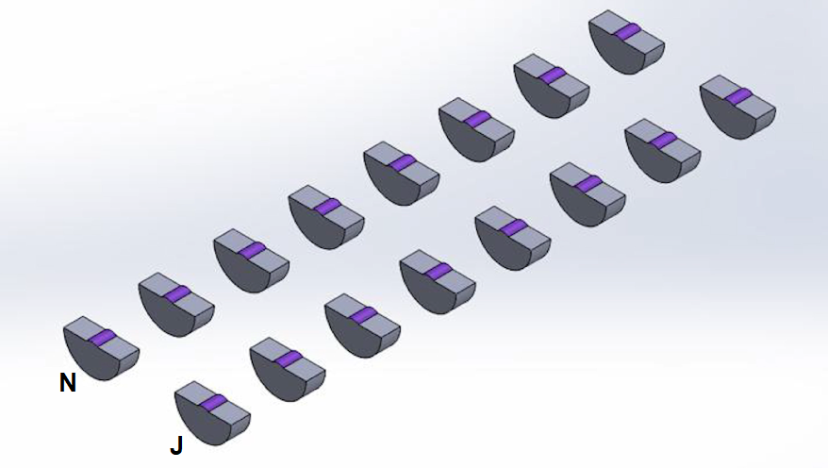

Figure 12. 3D drawing of samples N and J cut into 8 parts (Own elaboration).

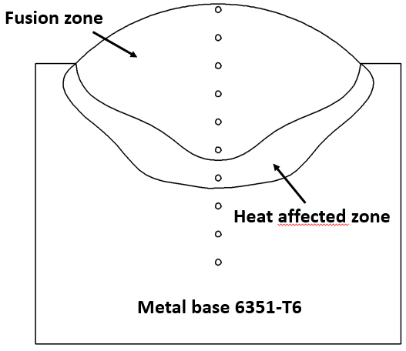

**(2)**

**(3; 4)**

**(1)**

Figure 13. 3D drawing of hardness test sample (Own elaboration).

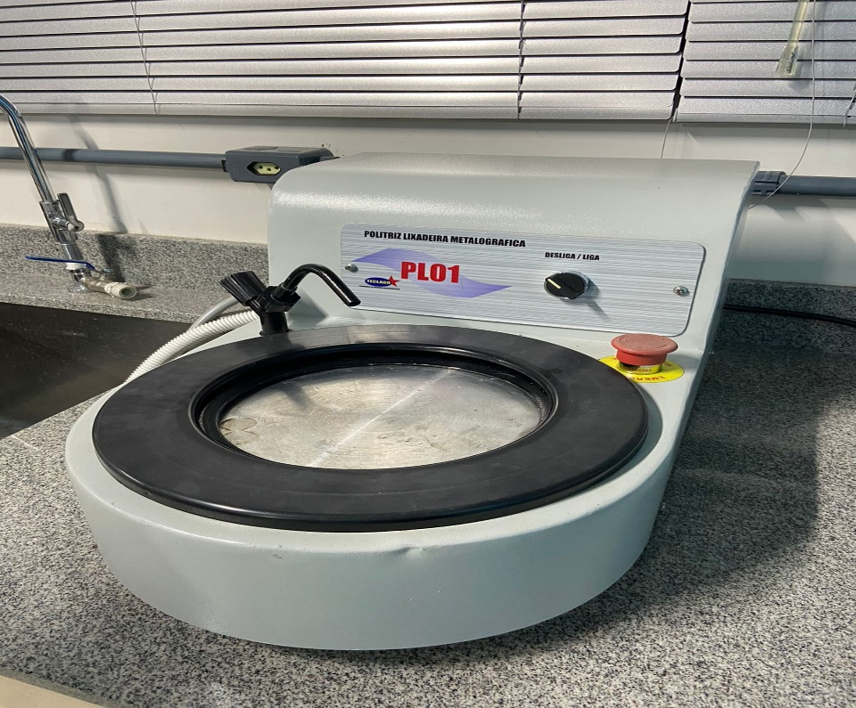

Figure 14. Polishing Grinder PL 01 (Own elaboration).

**3. Results and Discussion**

The practical research conducted aimed to evaluate the results of welding on an aluminum alloy 6351-T6, using two test specimens: one with preheating at 100°C, aided by a blowtorch, and another without preheating, as illustrated in Figure 15.

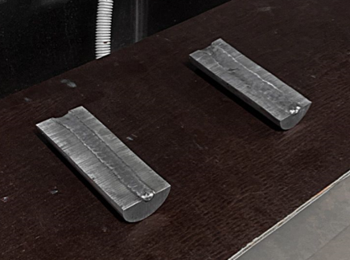

Figure 15. Welded samples (Own elaboration).

Welding is a process that involves joining two metallic pieces by melting and fusing their surfaces. In the case of aluminum alloy 6351-T6, it is important to preheat to ensure uniformity and proper weld penetration. The visual inspections conducted with penetrant liquid did not reveal any non-conformities such as cracks or porosity in both samples (Figure 16).

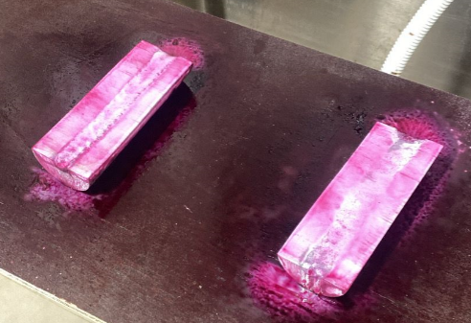

Figure 16. Liquid Penetrant Test (Own elaboration).

The test specimen that underwent preheating at 100°C showed the best results in the research. Through the analysis of weld penetration and its uniformity, it was possible to observe that the preheated sample showed better quality compared to the non-preheated sample.

Additionally, a hardness measurement was performed on both samples to verify if the variation remained within acceptable limits (Figure 17). The preheated sample exhibited a hardness variation within the acceptable standards, indicating a successful welding.

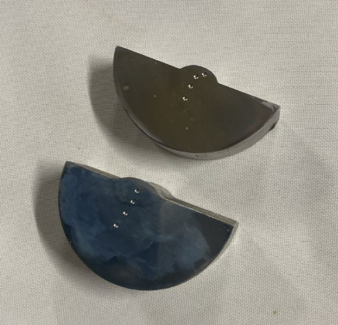

Figure 17: Hardness test (Own elaboration).

On the other hand, the specimen that did not undergo preheating showed more difficulty in welding. The weld did not show much penetration into the material, indicating a lower adhesion between the surfaces. This can be attributed to the stresses existing in the unheated part, which impede the fusion of the metal.

Furthermore, in the hardness test, the sample without preheating showed a non-homogeneous hardness ratio. This means that the hardness of the material was not uniformly distributed, which can compromise the strength and durability of the weld. These results reinforce the importance of preheating in the welding of aluminum alloy 6351-T6, ensuring good weld quality and homogeneous hardness throughout the specimen.

Thus, four Brinell hardness indentations were performed on both samples, with point 1 as the region of the filler metal, point 2 in the heat-affected zone, and points 3 and 4 in the base metal (Figure 13), according to Table 2 below.

|  |  |  |  |
| --- | --- | --- | --- |
| With preheating | | Without preheating | |
| 1 | 61.327 HB | 1 | 54.233 HB |
| 2 | 59.579 HB | 2 | 60.972 HB |
| 3 | 50.793 HB | 3 | 56.818 HB |
| 4 | 49.982 HB | 4 | 51.252 HB |

Table 2. Brinell hardness measurements (Own elaboration).

The 100°C preheating assisted in reducing the stresses on the metal during the welding process, providing better fusion between the surfaces and avoiding potential flaws such as porosity and cracks.

In the conducted experiment, a vertical hardness test was carried out on a sample of 6351-T6 aluminum alloy (Figure 18). The sample was fixed on the hardness tester using a support, with an approximate distance of 2mm from the filler metal.

The objective of this test was to determine the hardness of the sample at three points near the location where the filler metal was applied. A slight variation in hardness was observed in the analyzed points.

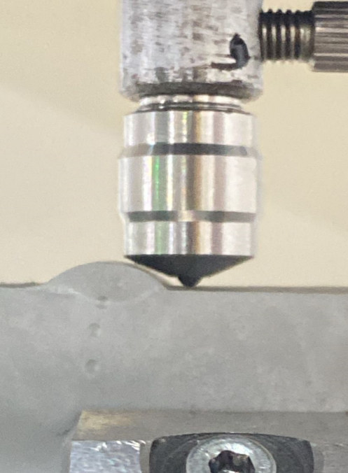

Figure 18. Vertical hardness test (Own elaboration).

At the first point, where the test was conducted near the filler metal, the obtained hardness value was 61 HB (Brinell hardness scale). In the second point, the hardness was 60 HB, and in the third point, the hardness was 59 HB.

The Brinell hardness scale is used to measure the resistance of a material to the penetration of a spherical indenter. In this case, the aluminum alloy sample was subjected to a load, and a sphere was pressed against the surface of the sample. The area of the impression left by the sphere is measured and used to calculate the hardness.

The variation in hardness found in the points near the filler metal can be attributed to different factors, such as the homogeneity of the alloy, the distribution of metallic alloys in the sample, among others.

It is important to emphasize that hardness is a mechanical property used to evaluate the resistance of a material to plastic deformation or wear. Through this test, it is possible to obtain information about the quality and resistance of the 6351-T6 aluminum alloy sample.

In summary, the vertically conducted hardness test on the 6351-T6 aluminum alloy sample showed a slight variation in the points near the filler metal, with hardness values of 61 HB, 60 HB, and 59 HB, respectively. This analysis allows for evaluating the resistance and quality of the sample in terms of its resistance to plastic deformation and wear.

**4. Conclusions**

Preheating is a crucial procedure in welding 6351-T6 aluminum alloy, as proven by practical investigation results. The temperature of 100°C has been identified as the ideal temperature for preheating in this specific alloy.

Using preheating before welding has several benefits. One of the main benefits is the improvement in weld penetration. When the aluminum alloy is preheated, this allows the metal to reach a temperature closer to the melting temperature during the welding process. This makes the metal more receptive to weld penetration, resulting in a stronger, more durable joint.

Furthermore, preheating also helps ensure uniformity in welding results. By heating the workpiece before welding, it is possible to eliminate any temperature differences between different parts of the workpiece. This ensures that the weld is applied consistently across the entire part, preventing failures or inconsistencies in the welded joint.

Another important aspect is that preheating contributes to maintaining acceptable hardness in the 6351-T6 aluminum alloy. During the welding process, the metal is heated and cooled rapidly, which can result in changes in the structure and mechanical properties of the material. However, when the metal is preheated, these changes are minimized.

Based on the results of this investigation, it is highly recommended that preheating be used in future welding procedures involving 6351-T6 aluminum alloy. This practice will help ensure a quality weld, with adequate penetration, uniform results and acceptable hardness. Preheating is a simple yet effective preventative measure that can make a big difference in the final welding results.

**5. Bibliographic references**

1 – Alcântara, N.G. de. (1991). *Tecnologia de Soldagem.* Universidade Federal de São Carlos, DEMA, São Carlos – SP.

2 - Andrucci, R. (2014, fevereiro*). Líquidos Penetrantes.* ABENDI Associação Brasileira de Ensaios não Destrutivos, São Paulo, pp. 5-7.

3 - ASM Handbook. (1998). *Casting* (9th ed., Vol. 15, p. 1659).

4 - Instrum Brasil. (2023). Recuperado de https://www.instrumbrasil.com.br/

5 - Kotz, J. C., & Treichel Jr., P. M. (2005). *Química Geral 1 e reações químicas* (Vol. 1). Thomson Learning/Pioneira.

6 - Weingaertner, W. L., & Schroeter, R. B. (1991). *Composição Química e Tratamento Térmico das Ligas Trabalháveis.* In: Tecnologia de Usinagem do Alumínio e suas Ligas (2ª ed., São Paulo: Alcan Alumínio do Brasil S.A.